1. What are the Boolean data type's two values? How do you go about writing them?

It has two possible values True, False

When value is returned. true=1, false= 0

1. What are the three different types of Boolean operators?

AND OR and NOT

1. Make a list of each Boolean operator's truth tables (i.e. every possible combination of Boolean values for the operator and what it evaluate ).

True = 1 , False = 0

|  |  |  |  |  |
| --- | --- | --- | --- | --- |
| Condition 1  X | Condition 2  Y | NOT X | X and Y | X or Y |
| False | False | True | False | False |
| False | True | True | False | True |
| True | False | False | False | True |
| True | True | False | True | True |

4. What are the values of the following expressions?

(5 > 4) and (3 == 5) - **False**

not (5 > 4) - **False**

(5 > 4) or (3 == 5) - **True**

not ((5 > 4) or (3 == 5)) - **False**

(True and True) and (True == False) - **False**

(not False) or (not True) **- True**

1. What are the six different types of reference operators?

Arithmetic Operator

Assignment Operator

Comparison Operator

Logical Operator

Identity operator

Bitwise Operator

1. How do you tell the difference between the equal to and assignment operators?

The “=” is an assignment operator is used to assign the value on the right to the variable on the left.

The '==' operator checks whether the two given operands are equal or not. If so, it returns true. Otherwise it returns false.

7. Describe a condition and when you would use one.

assignment operator

x= (a+b)

y = x

x = 10

y = 20

if (x == y) :

print("Condition is satisfied")

else:

print("Condition is unsatisfied")

output : Condition is unsatisfied

8. Recognize the following three blocks in this code:

spam = 0

if spam == 10:

print('eggs')

if spam > 5:

print('bacon')

else:

print('ham')

print('spam')

print('spam')

It will print : spam

Explanation: If spam is equal to 10 then it will print ‘eggs’ and here spam has assigned initially value so it wont go in that loop, and for second if loop., it has 0 > 5 which is again wrong so it will go to else part and will print spam

9. Create a programme that prints. If 1 is stored in spam, prints Hello; if 2 is stored in spam, prints Howdy; and if 3 is stored in spam, prints Salutations! if there's something else in spam.

x = int(input("Enter the value 1,2,3 " ))

if (x == 1):

print("Hello")

elif(x == 2):

print("Howdy")

elif(x ==3):

print("Salutations!")

else:

print("Number is not 1,2,3")

10.If your programme is stuck in an endless loop, what keys can you press?

ctrl + c

11. How can you tell the difference between break and continue?

Break will immediately stop execution

Continue all statement next to it will be skipped and loop control goes to next iteration

12. In a for loop, what is the difference between range(10), range(0, 10), and range(0, 10, 1)?

It will give same output :

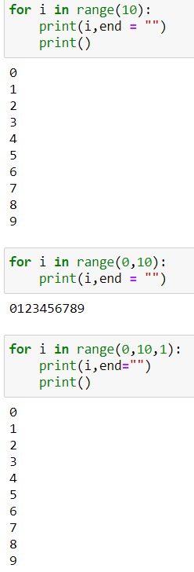

13. Using a for loop, write a short programme that prints the numbers 1 to 10 Then, using a while loop, create an identical programme that prints the numbers 1 to 10.

for i in range(0,10):

print(i,end="")

print()

i = 1

while (i < 11):

print(i)

i +=1

14. If you had a bacon() function within a spam module, what would you call it after importing spam?

We can call it by spam.bacon()