**Libraries and Softwares**

Note : Without these softwares and libraries, you wont be able to run codes which we will be explaining in session. So, kindly take it seriously and install all these before coming to the session,

Install pip :

Link : <https://pip.pypa.io/en/stable/installing/>

You can also look for apt_get or easy_install if pip doesn’t work for you.

Install anaconda :

Link : <https://www.anaconda.com/download/>

After installing anaconda, open “environments” on left hand side.Then click on Create on bottom-left hand side :

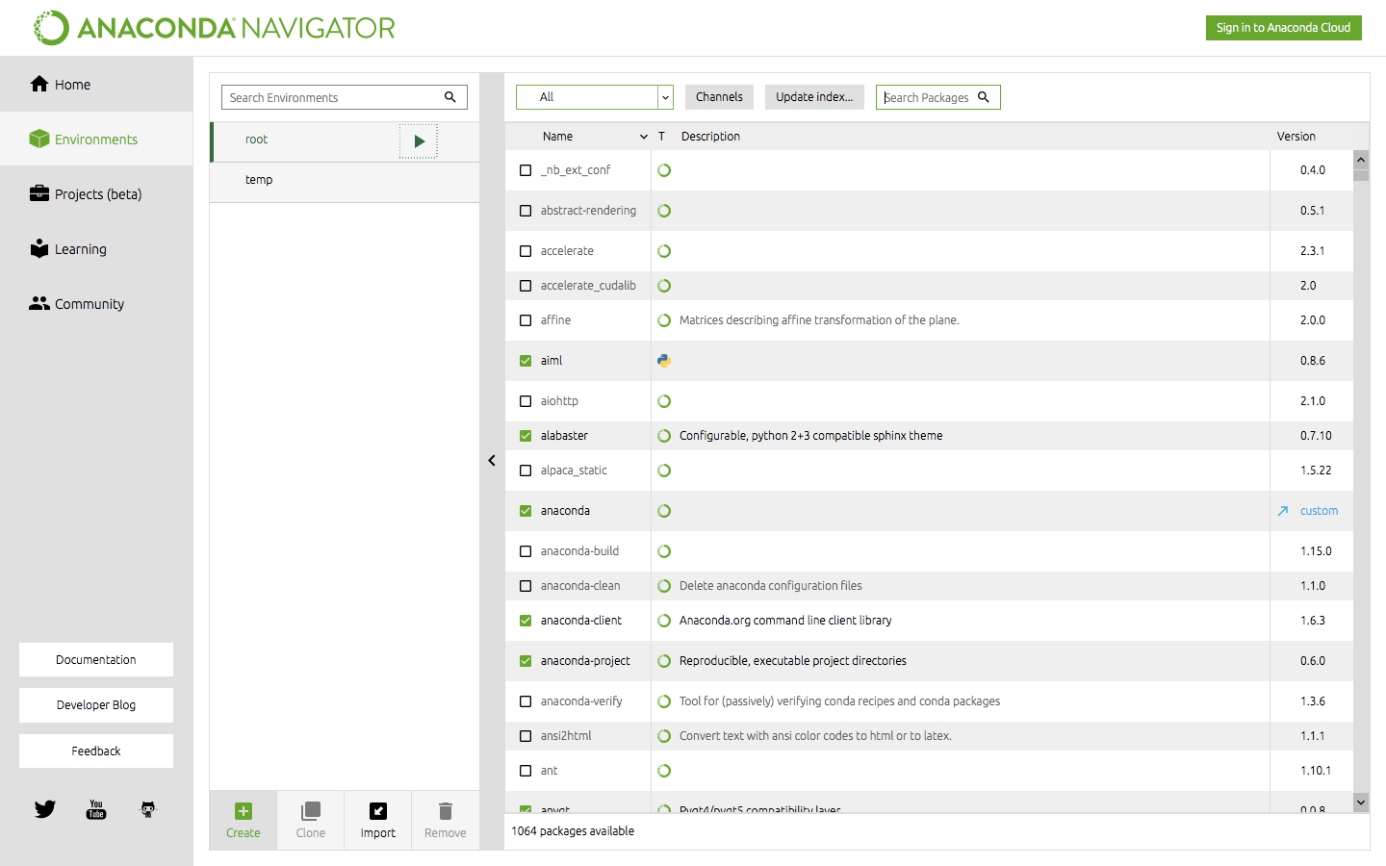

Name it and choose packages as Python-2.7

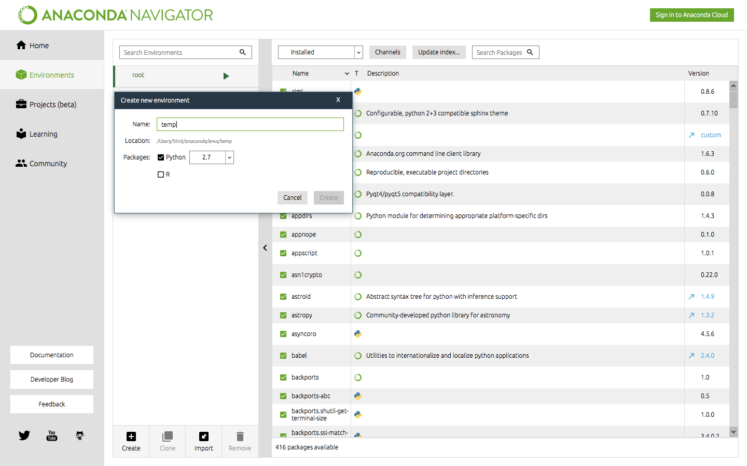

Click on arrow near temp and click on open terminal :

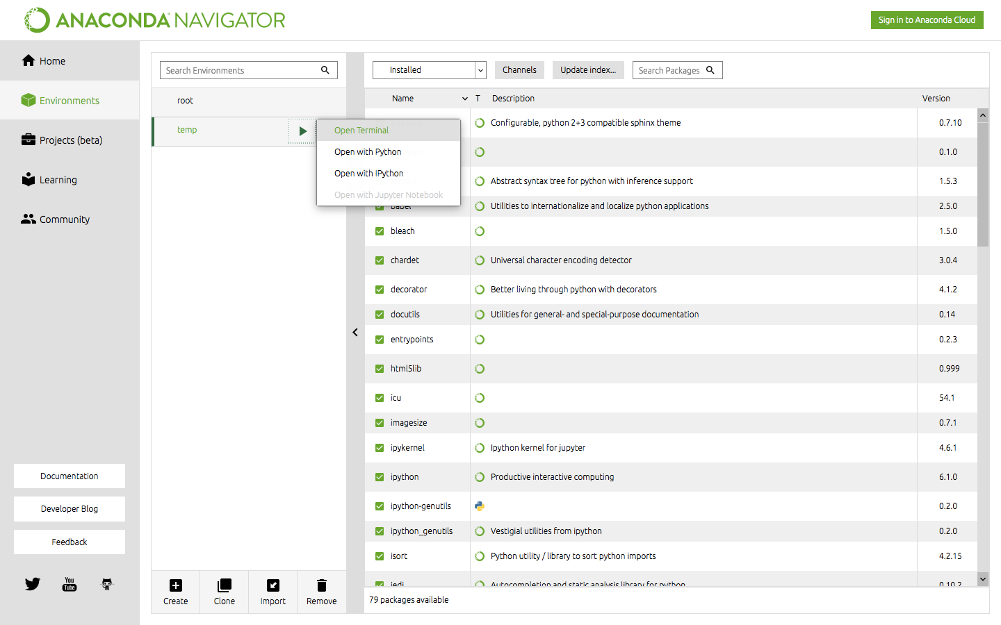

Here, install all the libraries.

For example, if you want to install tensorflow :

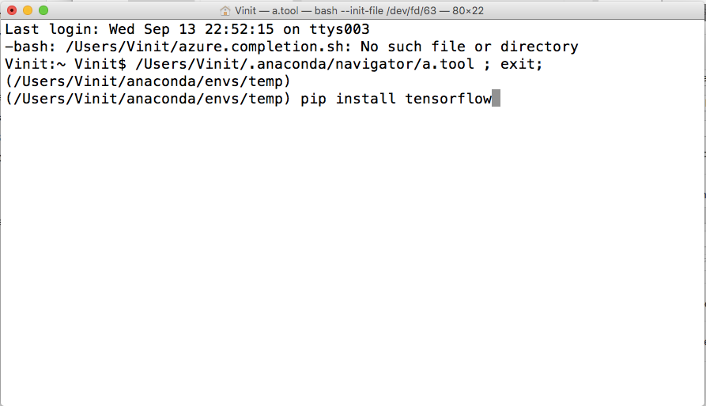

Install tensorflow :

Link : <https://www.tensorflow.org/install/>

You can take the help of internet and download libraries mention below.   
Install all these libraries in terminal/command prompt , as explained above.

* numpy
* scikit-learn
* opencv, cv2
* tensorflow(link given above)
* nltk

Again, come back to anaconda :

Go to Home on the left hand side, and choose Applications on —> temp(or the name which you had given).

Install

* spyder
* jupyter notebook

It would be better if you install git also in your laptop.

You can get many videos and links for this.

Create account on github — <https://github.com>  
  
Install git — <https://git-scm.com/book/en/v2/Getting-Started-Installing-Git>

After creating account on github, you can follow :

username : bodhwani — Link : <https://github.com/bodhwani>

for getting more updates on Artificial Intelligence workshop.

You can star this repository — Link : <https://github.com/bodhwani/awesome-Artificial-Intelligence>, as we will be teaching from this repository.

Queries :

Contact : Vinit - 9585588460 , vinitbodhwani123@gmail.com

Shivam - 7597818703 , shivamchawla60@gmail.com