COA ASSIGNMENT 01

Aaditya Yuvaraj Hande
(202401040028)
Roll No. 17
Batch : A1

1. A: Addition of 2 Numbers

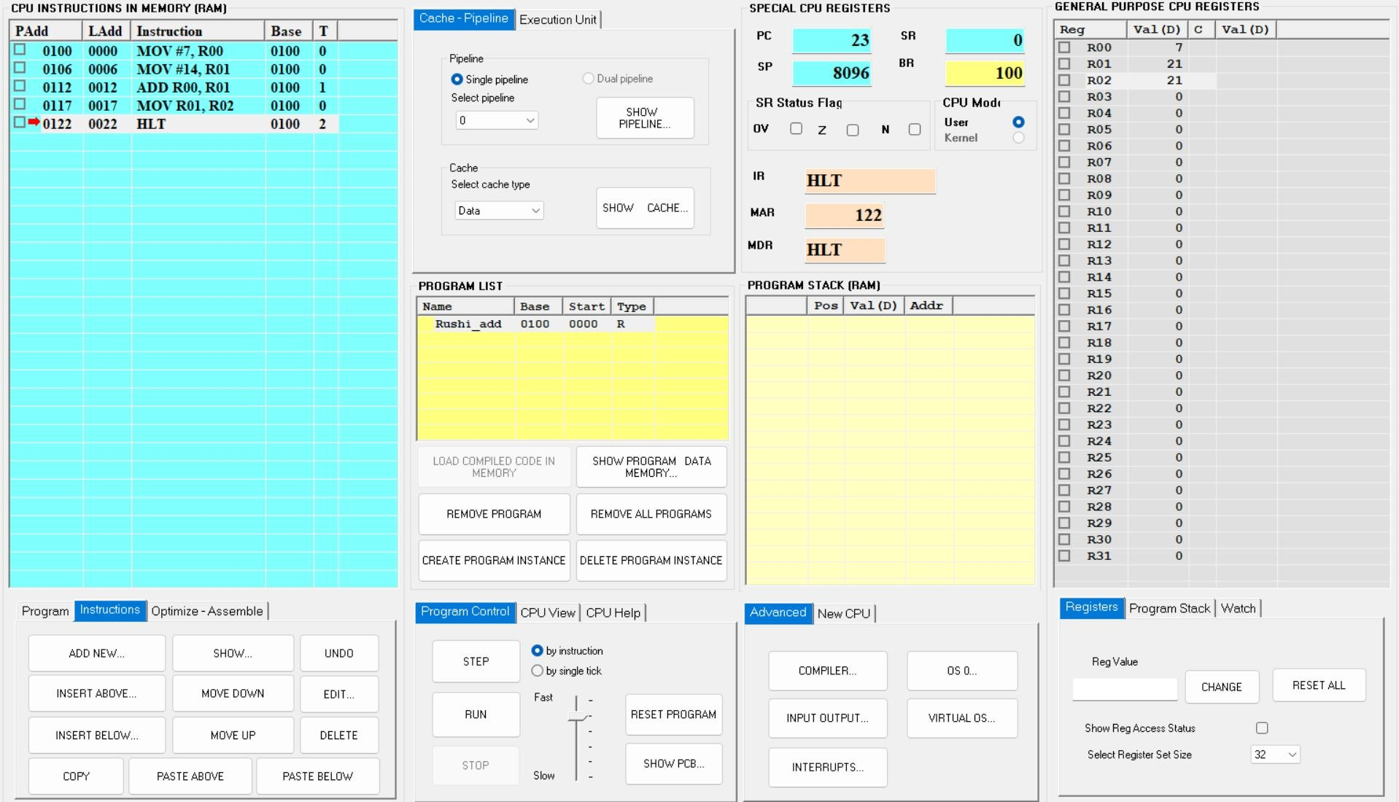

ALP:
MOV #7, R00
MOV #14, R01 ADD R00, R01 MOV R01, R02 HLT

Addition of 2 Numbers, Taking Input

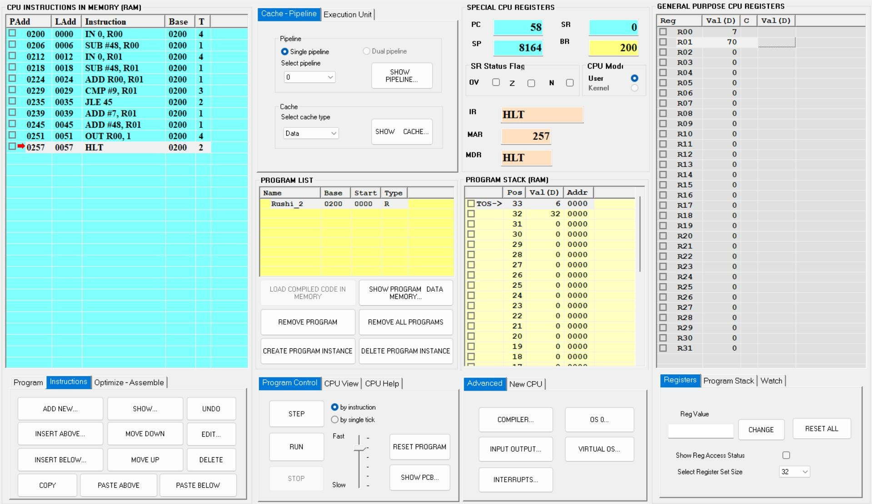
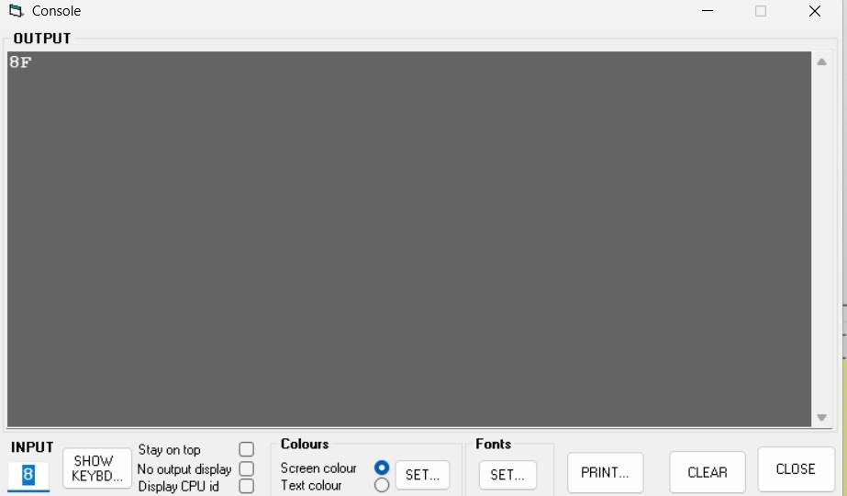

ALP:
IN 0, R00
SUB #48, R00
IN 0, RO1
SUB #48, R01
ADD R00, R01
CMP #9, R01
JLE 45
ADD #7, R01
ADD #48, R01 ; logical address – 45
OUT R01, 1
HLT

Input:
First Number: 7
Second Number: 8
Addition = 15
Output:
= 15+7+48
= 70 ASCII Value -> F
Result Output = F

1. B: Average of Two Numbers

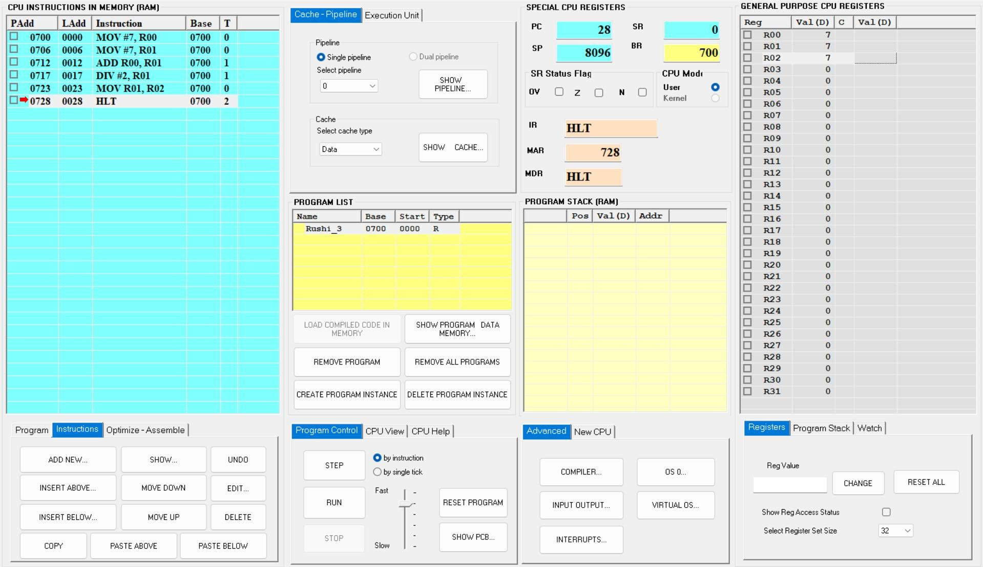

ALP:

MOV #7, R00
MOV #7, R01
ADD R00, R01
DIV #2, R01
MOV R01, R02
STB R02, 0
HLT
1. B: Average of Three Numbers

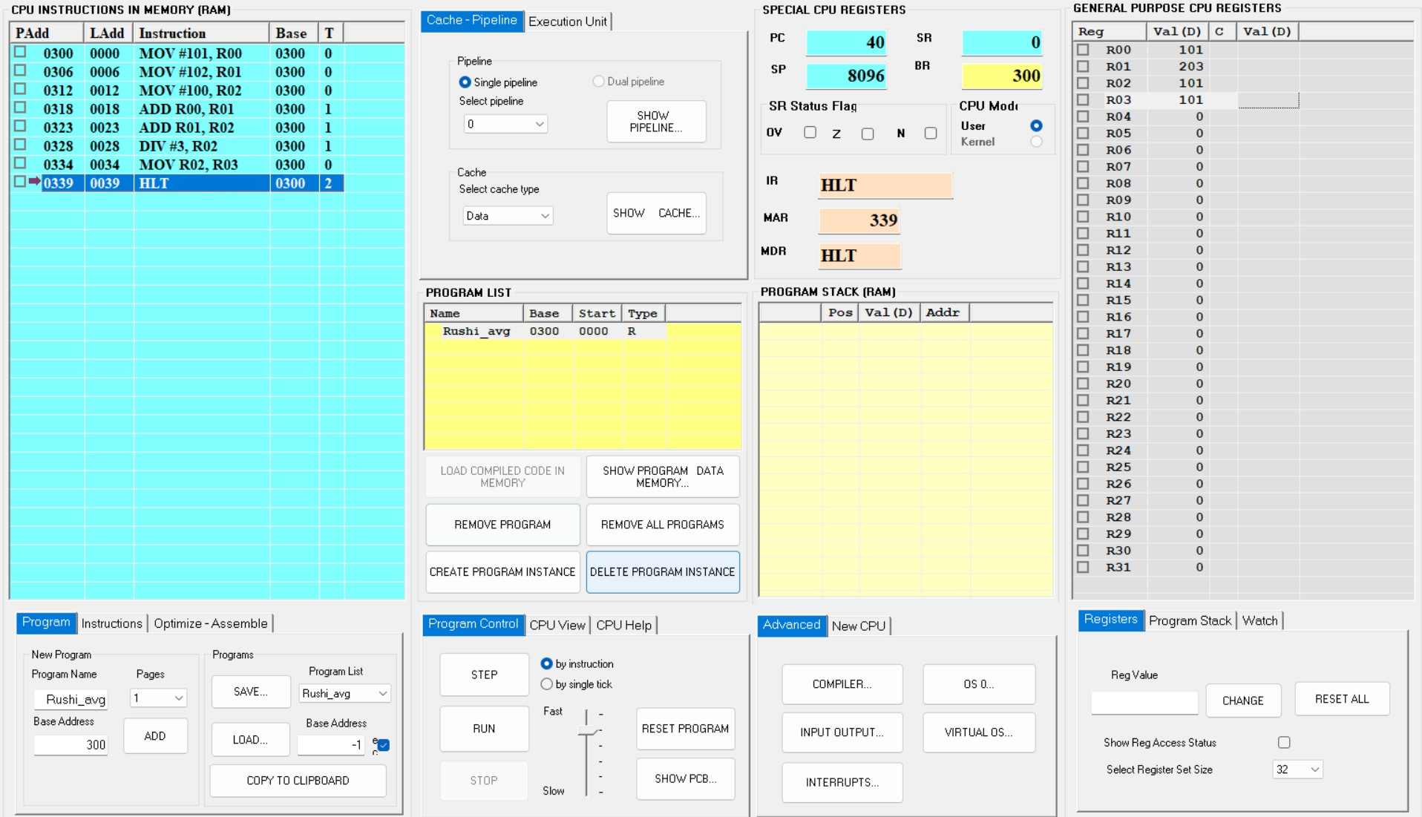

ALP:
MOV #101, R00
MOV #102, R01
Mov #100, R02
ADD R00, R01
ADD R01, R02
DIV #3, R02
MOV R02, R03 STB R03, 0 HLT

