Computer Organization & Architecture (COA) Assignment No -2

Aaditya Yuvaraj Hande
Roll No. 17
Batch A1
PRN 202401040028
Write ALP by taking the number as input for
- If else (Greater number)
- Successive Addition

- If else (Greater number)
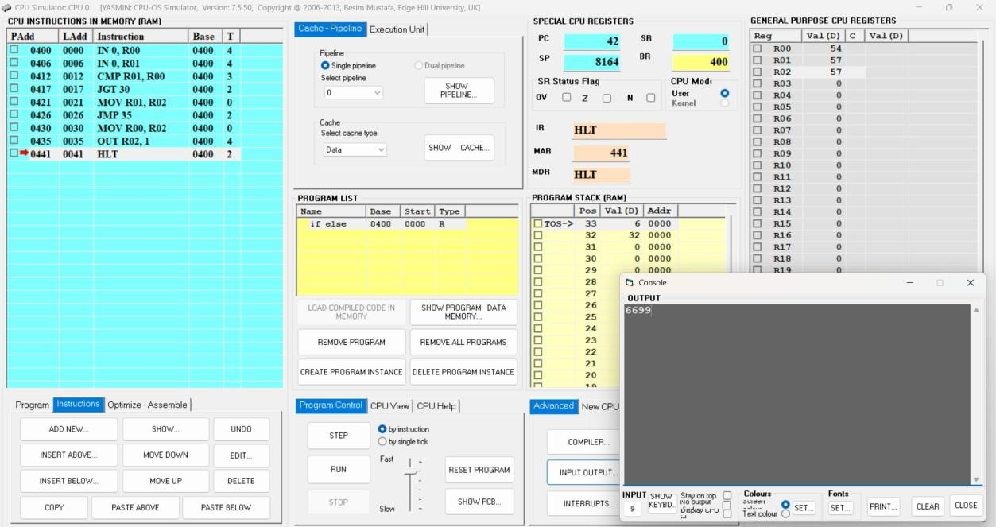

- Successive Addition
