COA ASSIGNMENT 03

Aaditya Hande
Roll No – 17
Batch – A1
PRN - 202401040028

ALP (64) for Addition of Two Numbers
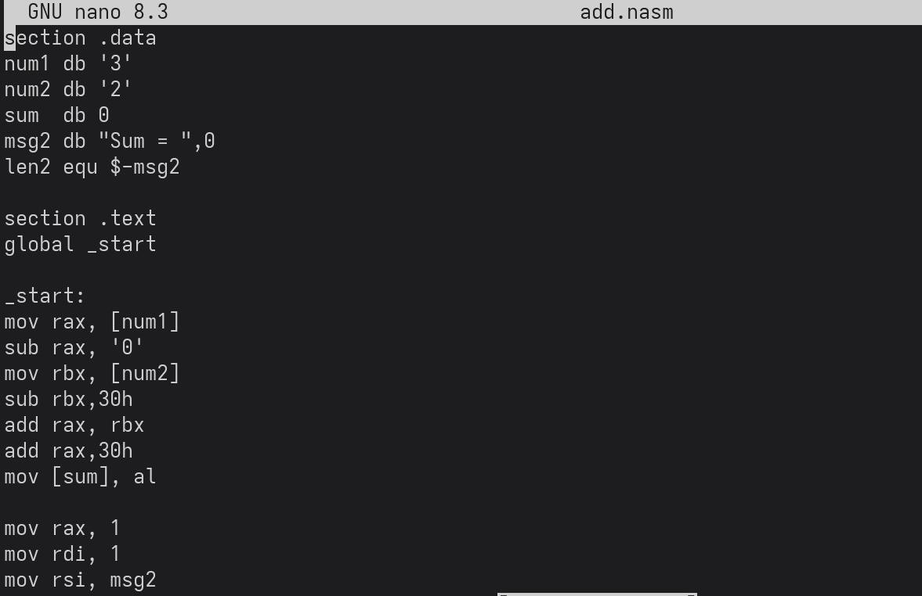

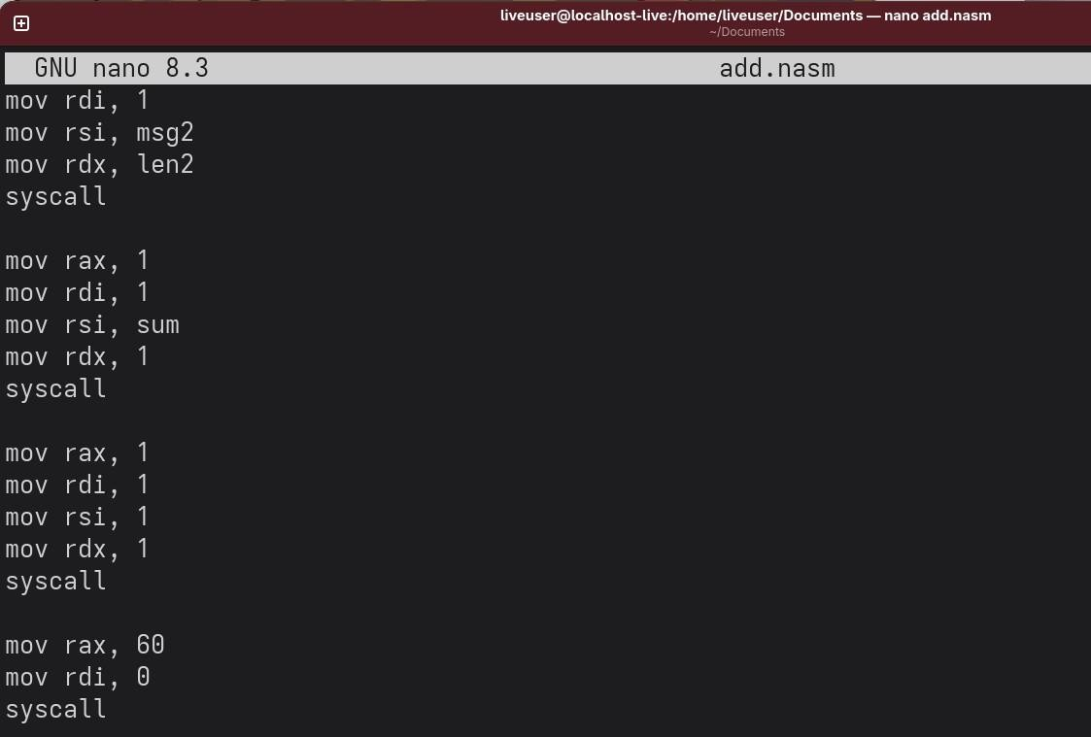

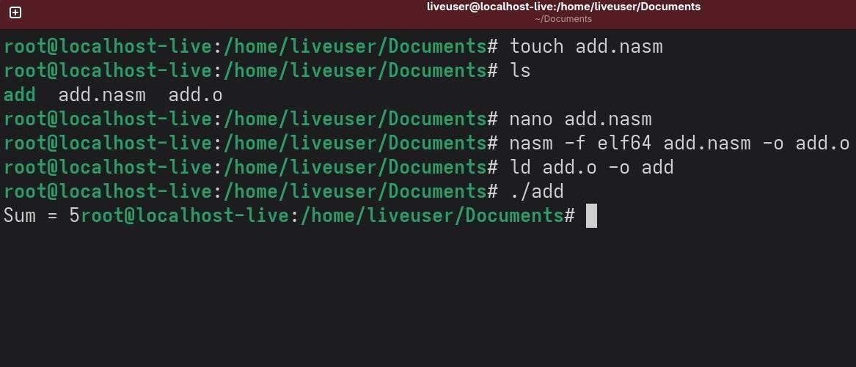
Output:

Num1 = 3,
Num = 2
Sum = 5

  - - ALP (64) for Addition of Two Numbers
(Using Keyboard, Macros and Procedures)
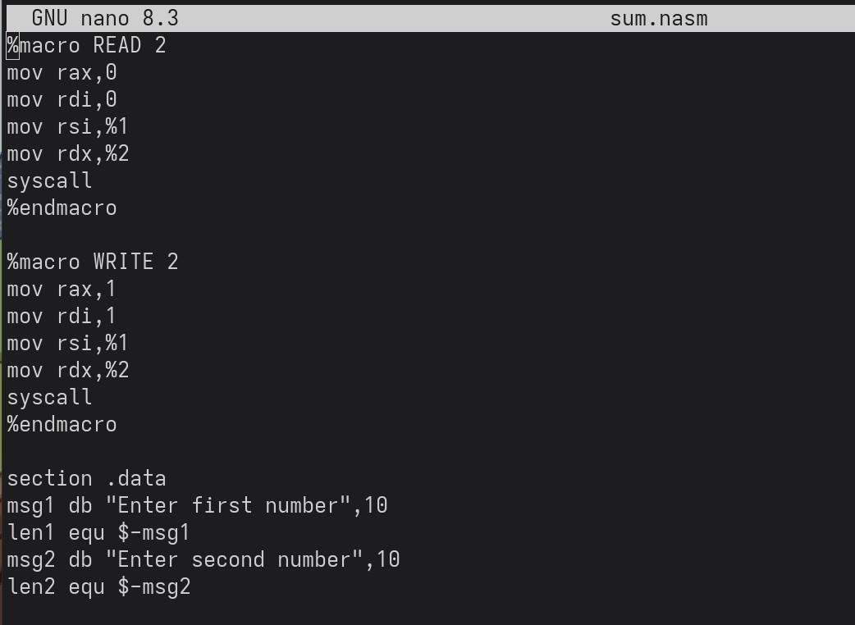





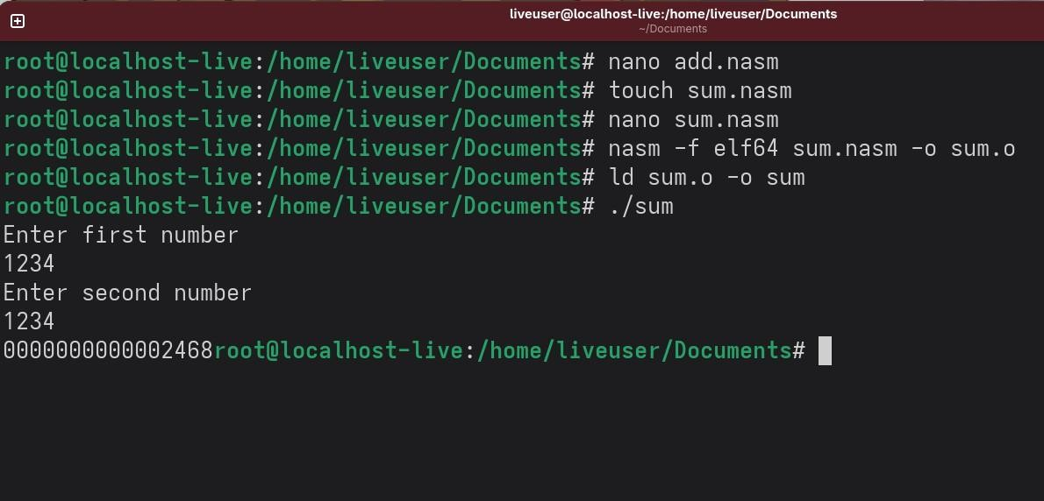
Output:

