An Internship Report
Of
Ethical Hacking Virtual Internship

Submitted
To

School of Computer Science and Engineering
IILM University, Greater Noida, U.P.

In partial fulfilment of the requirement of degree of
B.Tech (Computer Science and Engineering)

By

Roll Number of Student: 2410030080
Name of Student: AADITYA NATH SHARMA
Batch: 2024-2028

CANDIDATE'S DECLARATION

I, AADITYA NATH SHARMA, do hereby declare that the internship report titled “Ethical Hacking Virtual Internship” has been completed by me to fulfil the requirement for the award of the degree of Bachelor of Technology in Computer Science and Engineering. All the references have been quoted and I have not taken as such any material from any other source. I affirm that this report is my own and has not been submitted to any other institute for any degree/diploma requirement, and further I shall be solely responsible for any kind of copyright violation in this regard.
Signature:-
Student Name: AADITYA NATH SHARMA
Roll No.: 2410030080

ACKNOWLEDGEMENT

I am using this opportunity to express my gratitude to everyone who supported me throughout the Internship Program. I am thankful for their aspiring guidance, invaluably constructive criticism and friendly advice during this work. I am sincerely grateful to them for sharing their truthful and illuminating views on a number of issues related to this work.
I would like to thank the AICTE – EduSkills Virtual Internship Program team and EduSkills Academy for providing me the opportunity and the structured platform to learn and gain hands-on exposure in the domain of Ethical Hacking. I am also thankful to my institute, IILM University, Greater Noida, and the faculty of the School of Computer Science and Engineering for their continuous support and encouragement.
I express my gratitude to my parents for their blessings.
Signature:-
Student Name: AADITYA NATH SHARMA
Roll No.: 2410030080

TABLE OF CONTENTS

Chapter No. | Chapter Name | Page Nos.
 | Cover Page | —
1. | Candidate's Declaration | i
2. | Acknowledgement | ii
3. | Internship Completion Certificate | —
4. | Project Description | 1
 | 4.1 Introduction | 1
 | 4.2 Organization Profile | 2
 | 4.3 Problem Statement | 2
 | 4.4 Project Objectives | 3
 | 4.5 Scope of the Project | 3
 | 4.6 Technologies and Tools Used | 4
 | 4.7 System Architecture | 4
 | 4.8 Methodology | 5
 | 4.9 Expected Outcomes | 7
 | 4.10 Certificates of Completion and Communication Proof | 7
5. | Bibliography/References | 8

3. INTERNSHIP COMPLETION CERTIFICATE
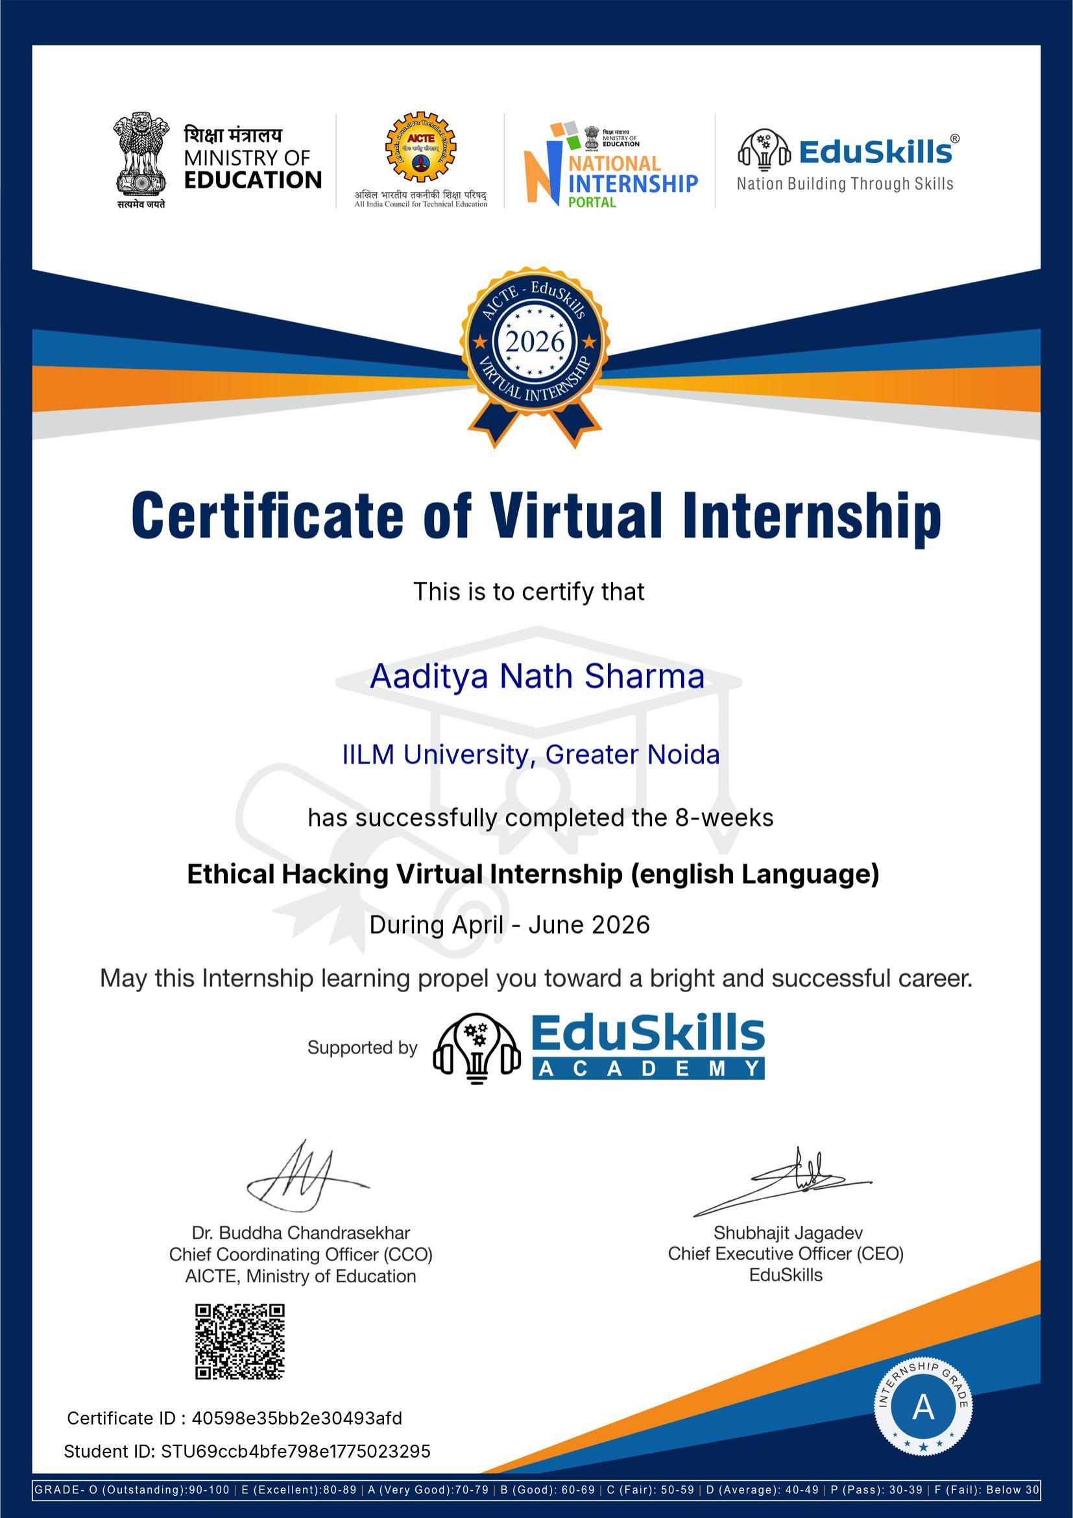

4. PROJECT DESCRIPTION
4.1 Introduction
This report presents a detailed account of the 8-week Virtual Internship undertaken under the AICTE – EduSkills Virtual Internship Program, in the domain of “Ethical Hacking (English Language)”, offered by EduSkills Academy. The internship was carried out from April 2026 to June 2026 as part of the requirement of the Bachelor of Technology (Computer Science and Engineering) programme at IILM University, Greater Noida. The primary aim of this internship was to build a strong practical foundation in cybersecurity and ethical hacking, covering security fundamentals, social engineering, malware analysis, networking essentials, and hands-on penetration testing using Kali Linux.
The internship followed a structured, week-wise curriculum combining conceptual learning with hands-on assignments, weekly assessments, and a Capstone Project. On successful completion of all the requirements, including the Internship Grade Point Assessment, a Virtual Internship Certificate with a Grade “A” (Very Good) was awarded by EduSkills Academy under the patronage of AICTE and the National Internship Portal.
4.2 Organization Profile
EduSkills Academy is an ISO 9001:2015 and ISO/IEC 20000-1:2018 certified organization working under the theme “Nation Building Through Skills”. EduSkills partners with the All India Council for Technical Education (AICTE) to run the AICTE – EduSkills Virtual Internship Program under the patronage of the AICTE National Internship Portal. For the Ethical Hacking track, EduSkills designed an industry-aligned, week-wise curriculum covering the core domains of cybersecurity and penetration testing, delivered through structured learning modules, weekly assessments, and a Capstone Project, to help engineering students build practical ethical-hacking capability.
4.3 Problem Statement
Although a large number of engineering students learn the theoretical foundations of cybersecurity and networking during their academic coursework, very few get structured, hands-on exposure to identifying, analyzing, and mitigating real-world security threats using an industry-standard toolset such as Kali Linux. Concepts such as social engineering, malware analysis, and penetration testing are often understood only at a theoretical level, with little practice in reconnaissance, vulnerability assessment, and exploitation reporting. The problem addressed by this internship was to practically learn and apply the ethical-hacking workflow – from understanding the legality and purpose of ethical hacking, to identifying security threats and social-engineering attacks, to performing hands-on penetration testing and vulnerability assessment of web applications using Kali Linux.
4.4 Project Objectives
- To understand the purpose, legality, tools, and techniques of ethical hacking used to prevent cyber threats.
- To understand core cybersecurity principles, threat types, and protection practices for systems and data.
- To identify and prevent social engineering attacks such as phishing and impersonation.
- To learn different types of malware and how to identify, analyze, and mitigate their effects.
- To understand networking essentials, including protocols, IP addressing, and basic device configuration.
- To learn the basics, navigation, and toolset of Kali Linux for ethical hacking and penetration testing.
- To build simple web applications and assess their vulnerabilities through practical capstone projects.
- To perform hands-on penetration testing using Kali Linux tools and report the vulnerabilities identified.
- To successfully clear the Capstone Project / Internship Grade Point Assessment.
4.5 Scope of the Project
The scope of this internship spans the complete ethical-hacking workflow – starting from understanding the legal and procedural foundations of ethical hacking, moving through cybersecurity fundamentals, social engineering awareness, and malware analysis, and extending into networking essentials and hands-on use of Kali Linux for vulnerability assessment and penetration testing. It further covers building and assessing simple web applications for vulnerabilities as part of a Capstone Project. The internship was limited to a virtual, simulation/lab-based learning environment provided by EduSkills Academy, and did not involve testing or deployment on any live organizational production system.
4.6 Technologies and Tools Used
- Operating System: Kali Linux
- Security Domains: Cybersecurity fundamentals, social engineering, malware analysis, networking essentials
- Penetration Testing: Kali Linux built-in tools for reconnaissance, scanning, and exploitation
- Web Application Security: Basic web application development and vulnerability assessment
- Networking: IP addressing, protocols, and basic device configuration
- Learning Platform: AICTE – EduSkills Virtual Internship Program – structured learning modules and weekly assessments
4.7 System Architecture
The general approach followed during the internship for the Ethical Hacking learning track can be summarized in the following layers:
- Foundation Layer: Core concepts of the purpose, legality, and techniques of ethical hacking form the base of the learning track.
- Security Awareness Layer: Cybersecurity principles, threat types, and social-engineering attack patterns are studied to build protective awareness.
- Threat Analysis Layer: Different malware types are identified, analyzed, and mitigated to understand real-world attack vectors.
- Networking Layer: Networking essentials, protocols, IP addressing, and device configuration form the connectivity foundation for security testing.
- Operating Environment Layer: Kali Linux serves as the core penetration-testing platform, providing the tools required for reconnaissance and exploitation.
- Application Testing Layer: Simple web applications are built and assessed for vulnerabilities as part of the Capstone Project.
- Penetration Testing Layer: Hands-on penetration testing is performed using Kali Linux tools, with vulnerabilities identified and reported.
- Assessment Layer: Weekly assessments and the Capstone Project / Internship Grade Point Assessment track progress and final grading.
4.8 Methodology
The internship followed a structured, week-wise methodology combining conceptual learning, hands-on labs, and assessment-based evaluation, culminating in a Capstone Project, as summarized in the table below.
Week | Module | Description
1 | Introduction to Ethical Hacking | Learn the purpose, legality, tools, and techniques of ethical hacking to prevent cyber threats.
2 | Fundamentals of Security | Understand cybersecurity principles, threat types, and protection practices for systems and data.
3 | Social Engineering | Identify and prevent social engineering attacks like phishing and impersonation.
4 | Malware and Their Types | Learn different malware types and how to identify, analyze, and mitigate their effects.
5 | Networking Essentials | Understand networks, protocols, IP addressing, and basic device configurations.
6 | Introduction to Kali Linux | Learn Kali Linux basics, navigation, and tools for ethical hacking and penetration testing.
7 | Basic Web Application with Capstone Projects (Vulnerability Assessment) | Build simple web apps and assess vulnerabilities through practical projects.
8 | Penetration Testing (Using Kali Linux) | Perform hands-on penetration testing using Kali Linux tools and report vulnerabilities.
Capstone Project / Internship Grade Point Assessment
Note: There was no stipend associated with this internship.
Each week concluded with assessments to evaluate conceptual understanding and, for certain modules, submission of project documentation and assignments. In the final phase, a Capstone Project involving vulnerability assessment and penetration testing using Kali Linux was undertaken, and the overall grade was based on performance across the weekly modules, the project submissions, and the final assessment.
4.9 Expected Outcomes
- Ability to explain the purpose, legality, and techniques of ethical hacking used to prevent cyber threats.
- Practical understanding of cybersecurity principles, threat types, and protection practices for systems and data.
- Capability to identify and prevent social engineering attacks such as phishing and impersonation.
- Hands-on ability to identify, analyze, and mitigate different types of malware.
- Working knowledge of networking essentials, protocols, IP addressing, and device configuration.
- Proficiency in navigating Kali Linux and using its toolset for ethical hacking and penetration testing.
- Skill to build and assess simple web applications for vulnerabilities.
- Hands-on experience performing penetration testing and reporting vulnerabilities using Kali Linux.
- Successful clearance of the Capstone Project / Internship Grade Point Assessment, resulting in a Grade “A” (Very Good).
4.10 Certificates of Completion and Communication Proof
The Internship Offer Letter and the Internship Completion Certificate issued by EduSkills Academy, confirming successful completion of the 8-week AICTE – EduSkills Virtual Internship Program in Ethical Hacking (English Language), are attached in Chapter 3 and below as proof of completion.
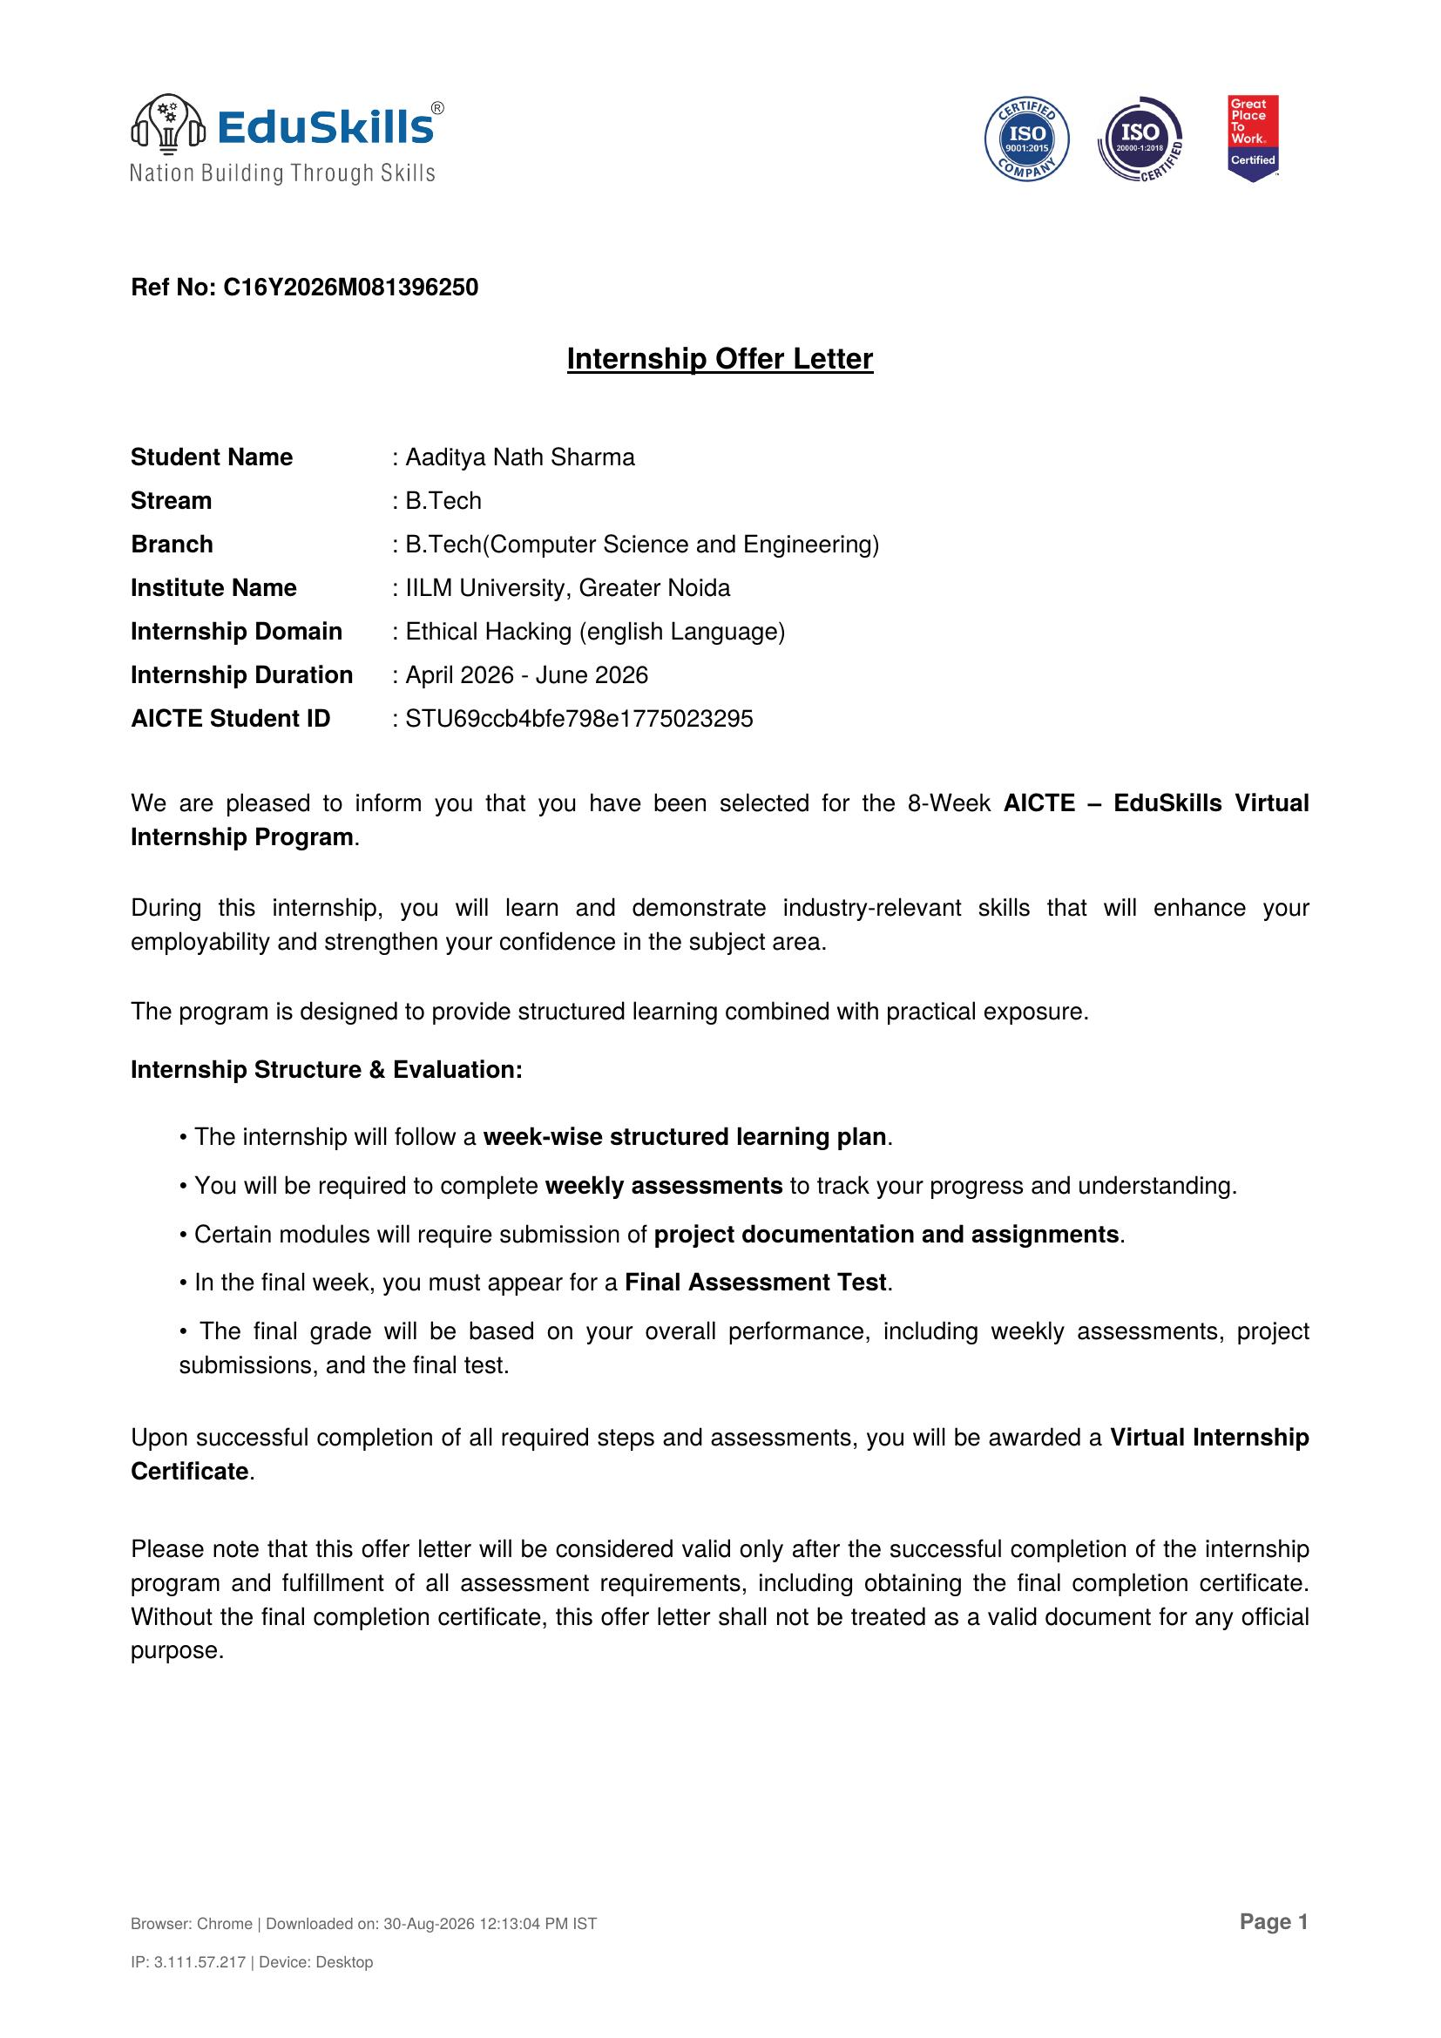

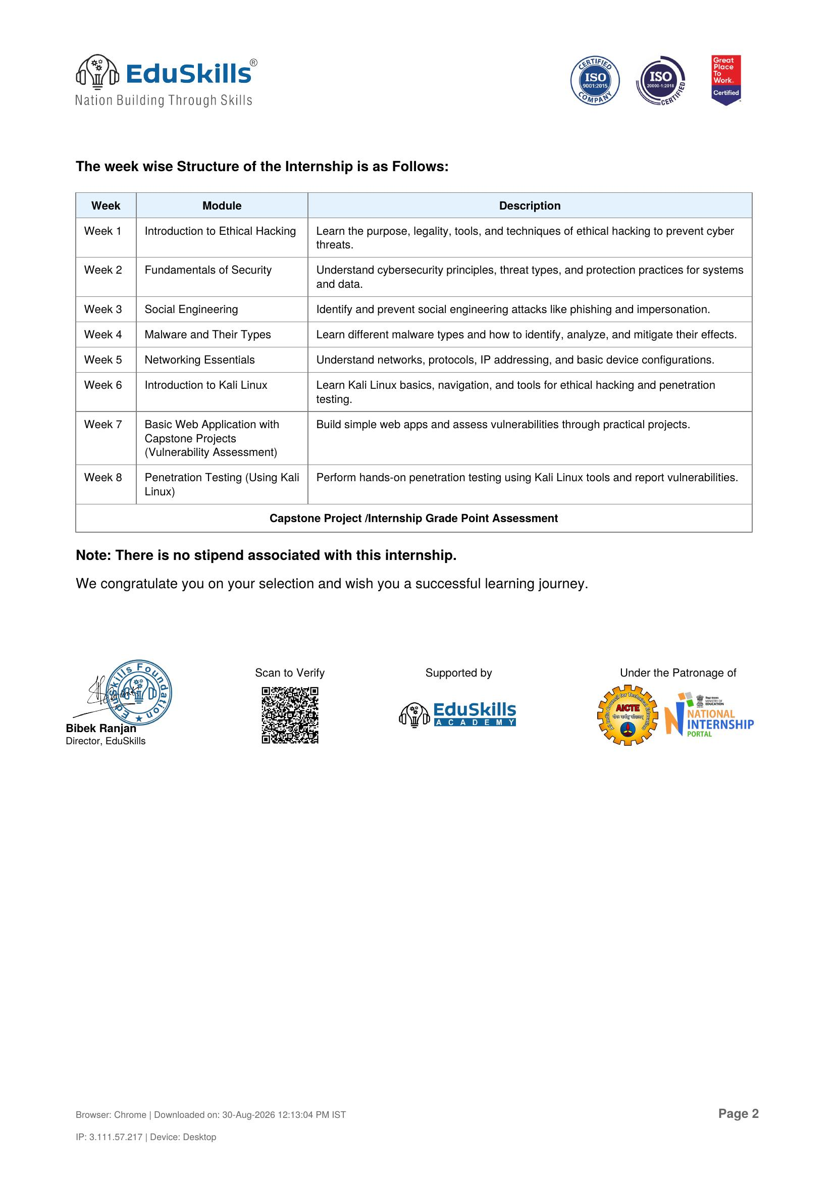

5. BIBLIOGRAPHY/REFERENCES
1. EduSkills Academy, “AICTE – EduSkills Virtual Internship Program – Ethical Hacking (English Language),” Internship Offer Letter, Ref No. C16Y2026M081396250, 2026.
2. EduSkills Academy, “Certificate of Virtual Internship – Ethical Hacking,” Certificate ID: 40598e35bb2e30493afd, Student ID: STU69ccb4bfe798e1775023295, 2026.
3. Kali Linux Official Documentation, https://www.kali.org/docs/
4. OWASP Foundation – Web Application Security, https://owasp.org/
5. National Institute of Standards and Technology (NIST), Cybersecurity Framework, https://www.nist.gov/cyberframework
6. AICTE – National Internship Portal, https://internship.aicte-india.org/
7. EduSkills Academy, https://eduskillsfoundation.org/

