SHELL SCRIPT

AADITYA P

230701001

EXP-2

BASIC CALCULATOR

#BASIC CALCULATOR
echo "Enter two no"
read a
read b

echo "add $(expr $a + $b)"

echo "sub $(expr $a - $b)"
echo "mul $(expr $a \* $b)"
echo "div $(expr $a / $b)"
echo "mod $(expr $a % $b)"

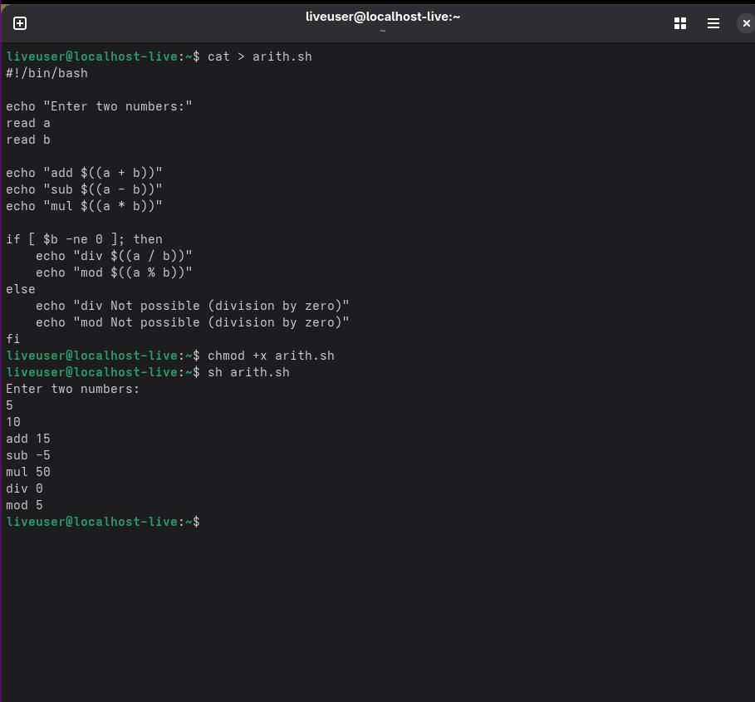

LEAP YEAR

#LEAP YEAR OR NOT
echo "Enter a year"
read year

if [ $((year % 4)) -eq 0 ];then
echo "$year is a Leap Year"
else
echo "$year is Not a Leap Year"
fi

