Business Requirements Document
(260 Brands)
Date: Sept 14, 2025
Lead Owner: Mitesh Client Name: 260 Brands
Prepared by: Khushal Signature: _______________

1. Overview
To implement a custom solution for 260 Brands that digitizes and streamlines their operations across Attendance, Inventory, Sales, Visit Tracking, Complaint Handling, and Payment Collection. The system will provide a centralized platform for daily field activities, sales processes, and customer interactions. Real-time updates, role-based access, and reporting tools will ensure smooth business operations.

2. App Story
The system for 260 Brands will serve as a digital backbone for their field operations—tracking attendance, order flow, stock allocation, payments, and customer visits. Employees and supervisors will manage tasks in real-time with a mobile-ready, role-based interface and dynamic report generation.

3. Targeted Users
- Owner – Full access to all modules, analytics, and settings.
- Sales Supervisor – Assign beats/products, manage orders, monitor performance.
- Employee – Clock in/out, apply for leave, manage assigned inventory.
- Sales Agent – Place orders, collect payments, generate lead, log visits and complaints.
- Tricycle Rider – Record marketing visits only.
- Area Sales Manager – Full access to all modules
- Regional Sales Manager –
- Sales Head

4. Scope Of Work
This section outlines the scope of work for the development and integration of various modules with current status.
No. | Requirement | Current Status
1 | Customer Master | Completed
2 | Product Master | Completed
3 | Employee Master | Completed
4 | Store Master | Completed
5 | Customer GEO Tagging | Completed
6 | Employee Attendance | Completed
7 | Daily Visits | Completed
8 | Beat Planning | Completed
9 | Order Book | Completed
10 | Product Catalog | Completed
11 | Customer Complain Tickets | Completed
12 | Modern Trade (Closing stock) | Completed
13 | Stock Assignment | Completed
14 | Stock Return | Pending
15 | Sales Reports | Completed
16 | Visit Reports | Completed
17 | Debt VS Collection | Pending
18 | Total VS Productive VS Non-Productive calls | Pending
19 | Target VS Achieved Sales | Pending
20 | ERP/SAP Integration | Pending
21 | Performance, Efficiency Dashboards, Target & Incentive Structure | Pending
22 | AI Based Planogram Suggestions | Pending
23 | Customer Master Heat Map | Pending
24 | Market Specific Communication | Pending
25 | Database Push Notifications | Pending
26 | Ask Neome | Pending
27 | Schools | Pending
28 | Farms | Pending
29 | D2D - Nurtamilk | Pending
30 | Leave Management | Pending
31 | Change Requests | Pending
32 | Feedback | Pending
33 | Inventory | Pending
34 | Notice Board | Pending

5. Modules and Forms

5.1 Employee Master
Stores employee contact details, assigned beat, and leave balances for HR.
- Employee
- Mobile Number
- Email
- Address
- Beat (Multi Select) (From Beat Master)
- Casual Leave Balance
- Sick Leave Balance
- Total Leave Balance (Casual + Sick)
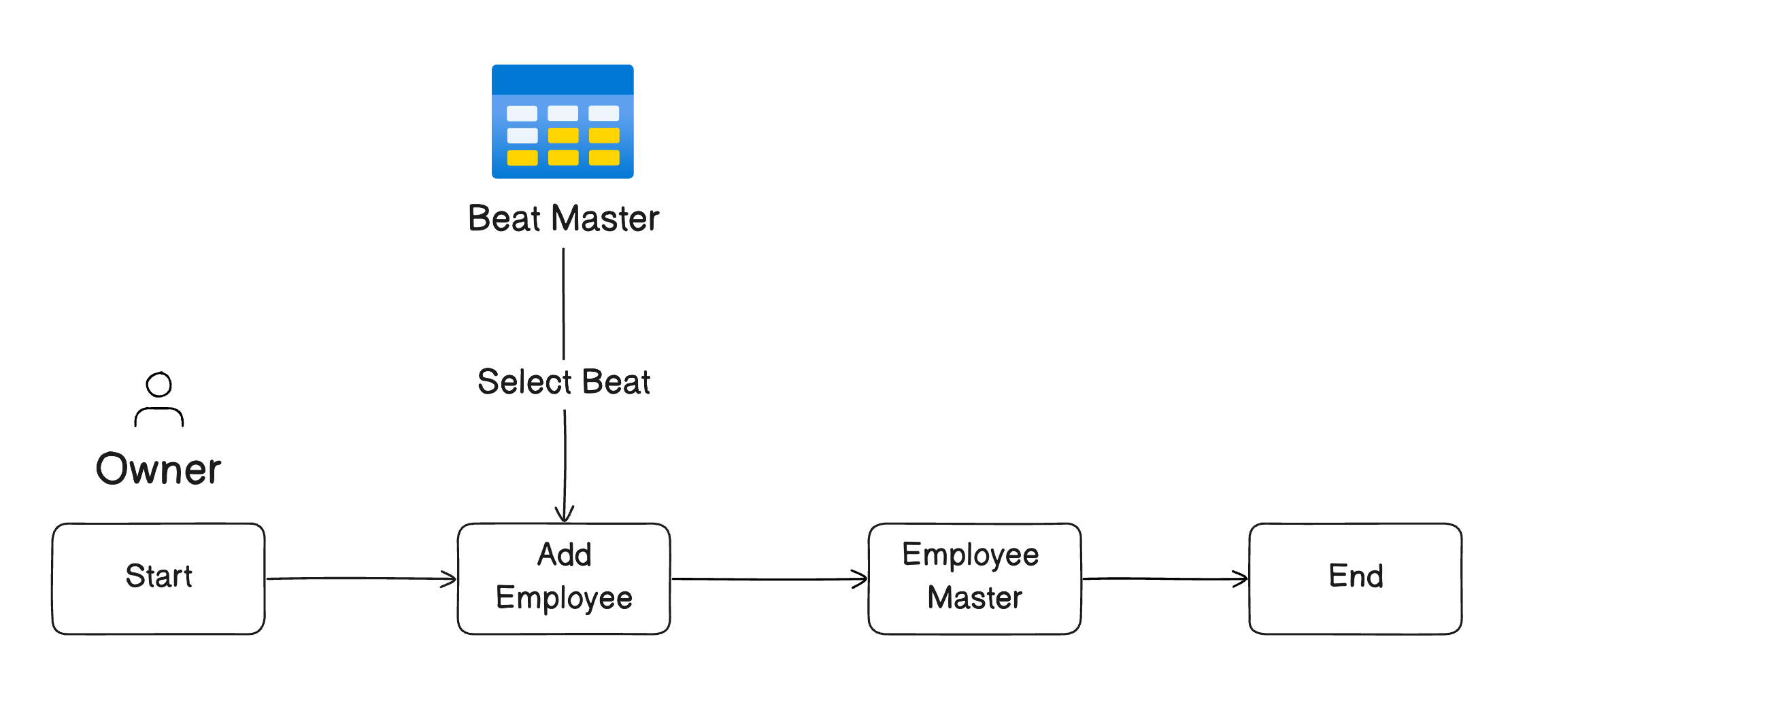

5.2 Customer Master
Captures all necessary customer details used for order processing and visit planning.

- Customer Code
- Entered By
- Name
- TPIN
- Beat (From Beat Master)
- Route (Auto fill from Beat)
- Category
- Classification
- Location
- Bill To
- Ship To
- Email
- Mobile Number
- Shop Owner
- Shop Buyer
- Image
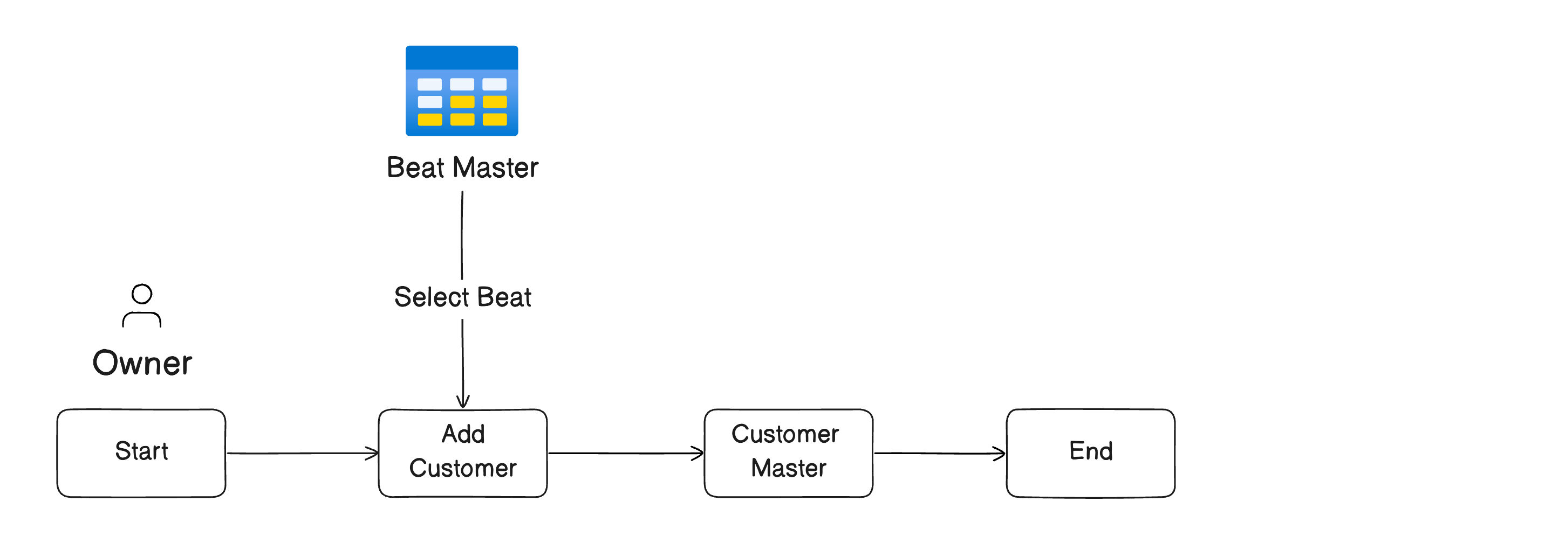

5.3 Product Master
Maintains product catalog details for order entry and inventory tracking.
- Image
- Product Code
- Product
- Case Size
- Category (From Category Master)
- Price
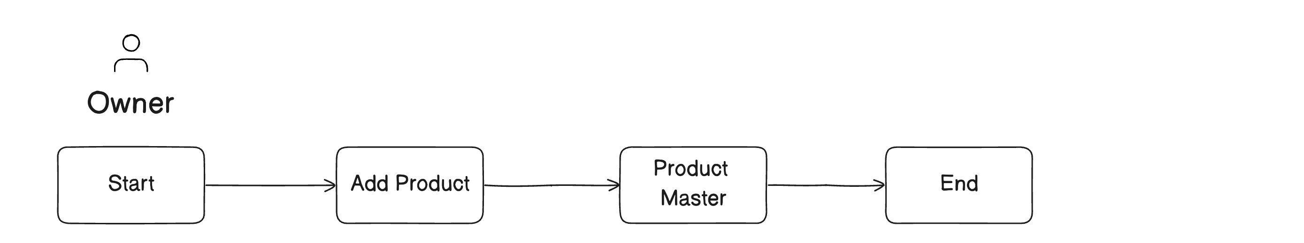

5.4 Beat Master
Defines sales beat linked with respective routes for order and visit assignment.
- Entered By
- Beat
- Route (From Route Master)
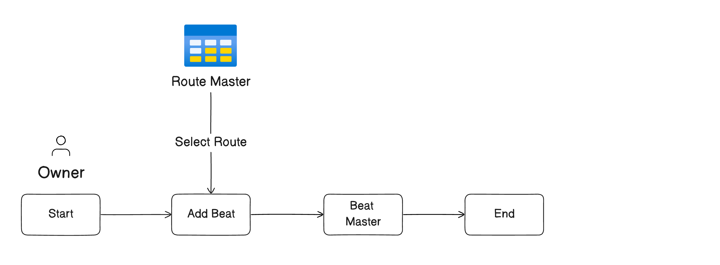

5.5 Route Master
Lists of sales routes.
- Route
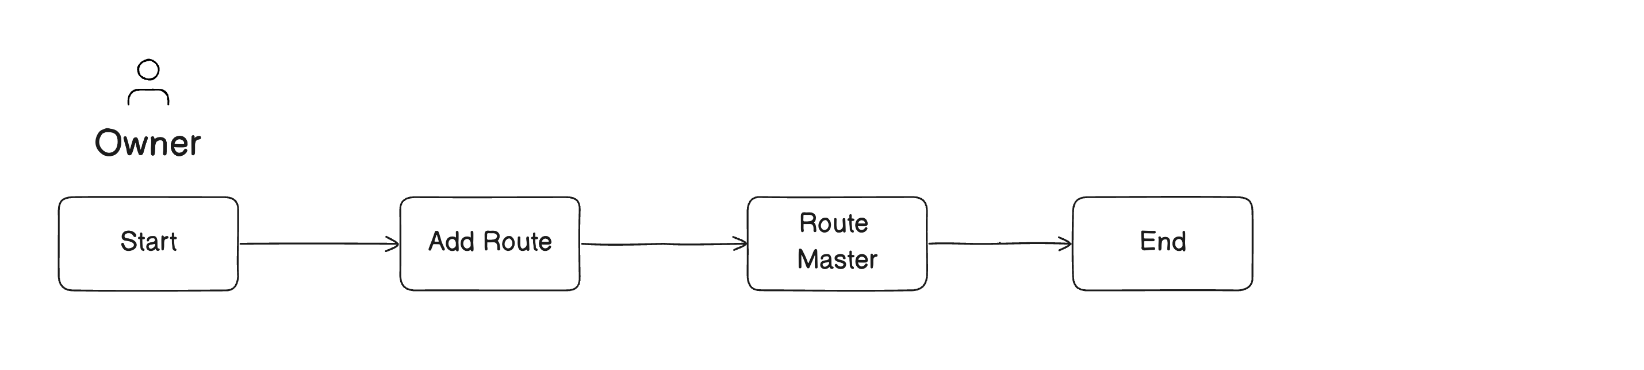

5.7 Store Master
List of stores for modern trade.
- Store name
- Store supervisor
- Email
- Supervisor mobile number
- Area name
- Location

5.6 Category Master
Product categorization used in the product master.
- Category

5.6 Competitor Master
Centralized repository of competitor product data

- Competitor name
- Products
  - Image
  - Product Code
  - Product
  - Case Size
  - Category (From Category Master)

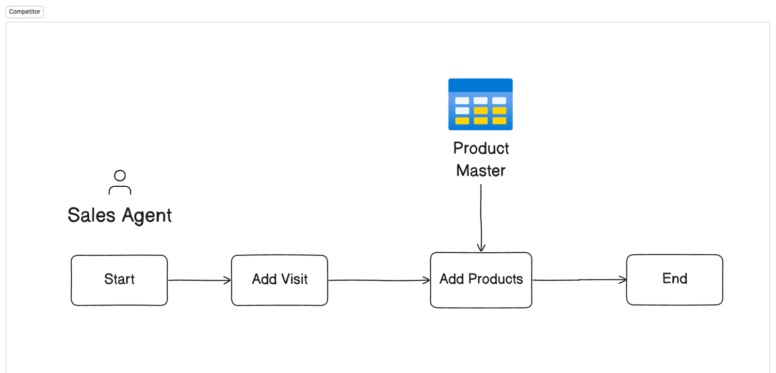

5.7 Attendance Module
Records clock-in/out times along with camera verification.
- Employee
- Clock In
- In Camera
- Clock Out
- Out Camera
- Arrival Status (OnTime/Late)
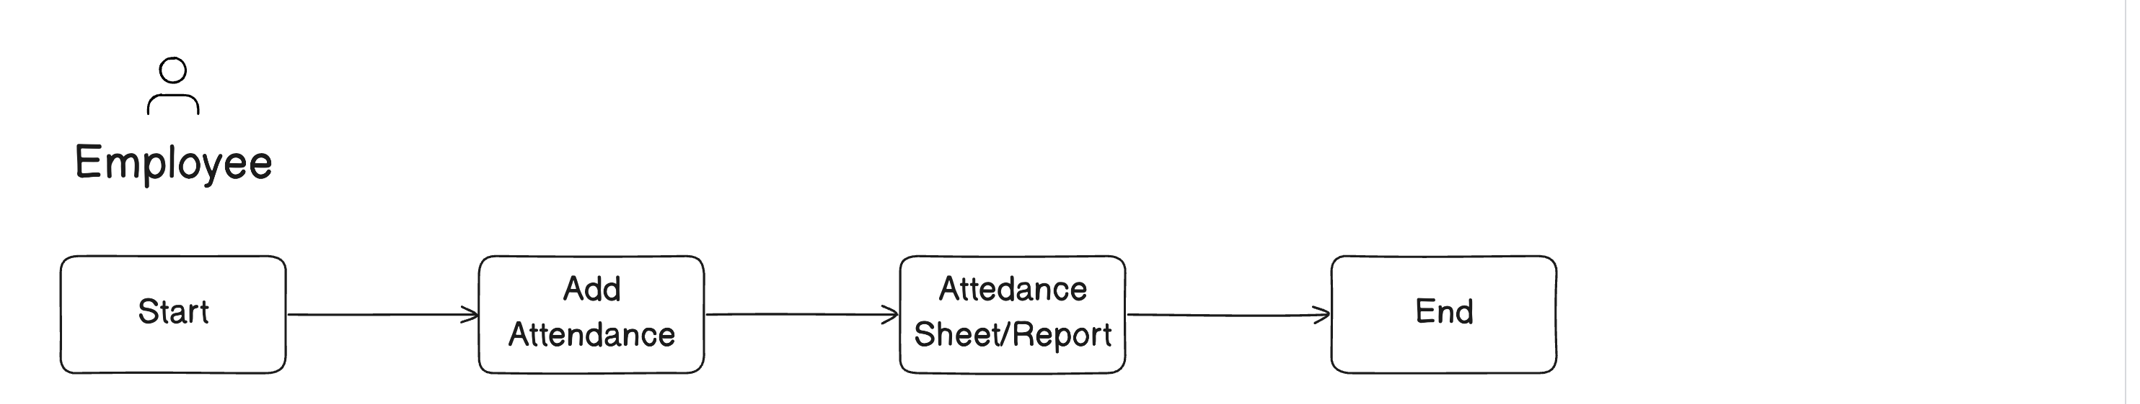

5.8 Overtime Module
Records clock-in/out times along with camera verification.
- Date
- Employee
- From Time
- To Time
- Remarks
- Status

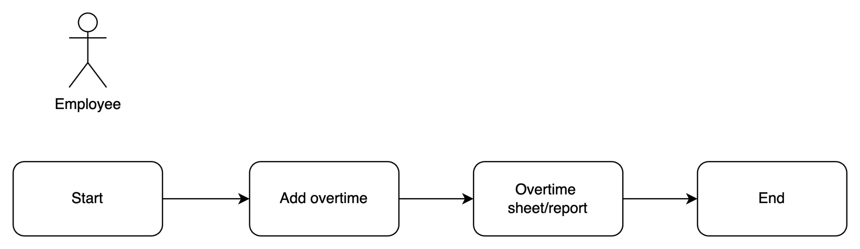

5.9 Leave Module
Allows employees to apply for casual/sick leave with automatic balance checks.
- Employee
- Casual/Sick Leave Balance (Auto)
- Leave For (Full Day/Half Day)
- Type Of Leave (Casual Leave/Sick Leave)
- From Date
- To Date
- Leave Reason
- Status (Pending/Approved/Rejected)
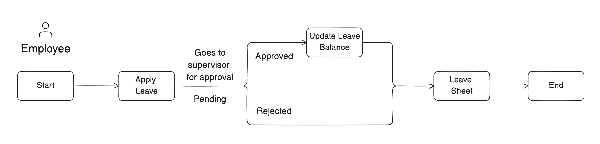

5.10 Assign Inventory
This module allows supervisors to assign product inventory to sales agents.
- DateTime
- Employee
- Products (Multi Select) (From Product Master)
- Total Amount
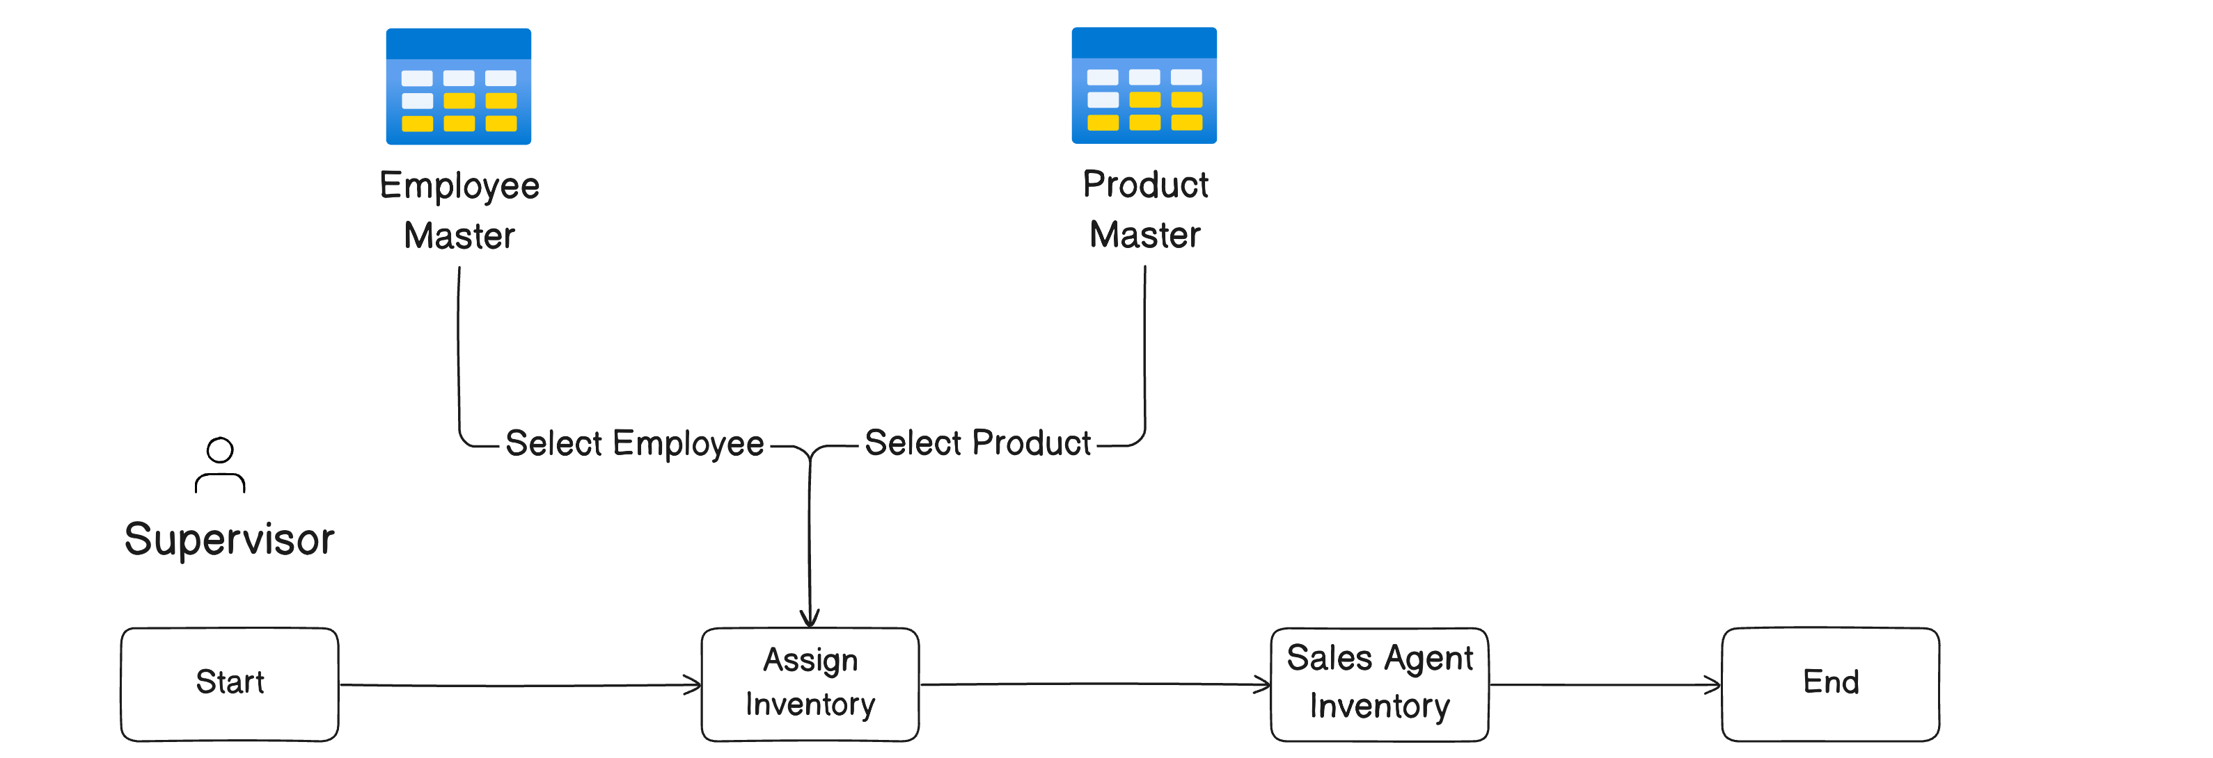

Visit Book
This module records customer visits done by sales or marketing staff for tracking interactions and outcomes.
- Date
- Visited By
- Route (Auto fill from beat)
- Beat (From Beat Master)
- Customer (From Customer Master)
- Location (Auto)
- Remarks
- Images
- Add order button
- On clicking add order, add products (from product master)
- Amount collected
- Change to be given (if any)
- Order Status

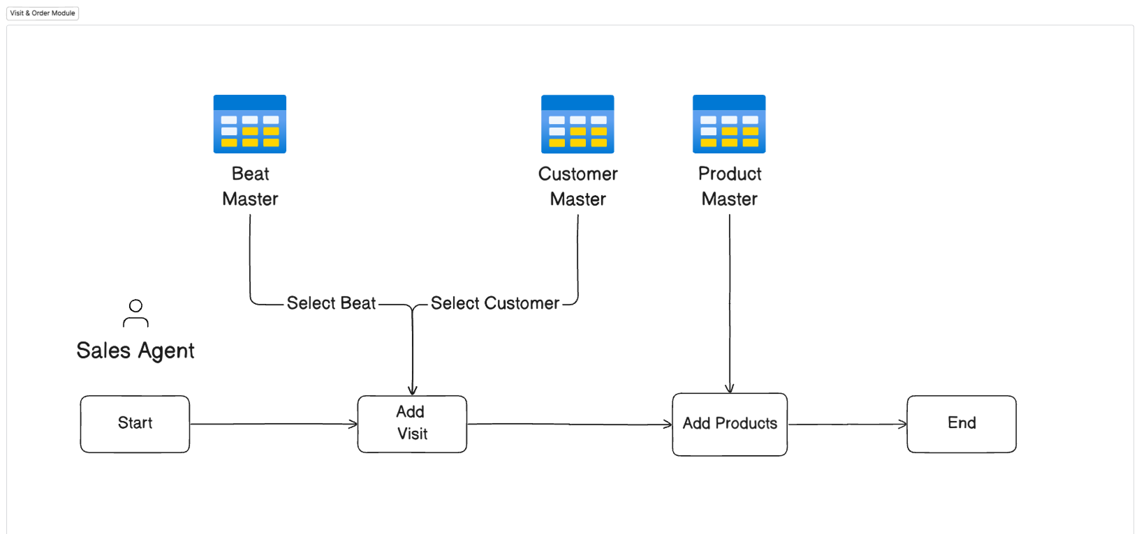

Customer Quality Complaint Module
This module allows agents to register customer product quality complaints for resolution tracking.
- ComplaintId
- Date
- Customer Complaint Number
- Complainant Name
- Address
- Mobile Number
- Product
- Package Size
- Quantity Affected
- Batch No
- Production Date
- Expiry Date
- Operator
- Shift
- Nature Of Complaint
- Description
- Signature
- Image
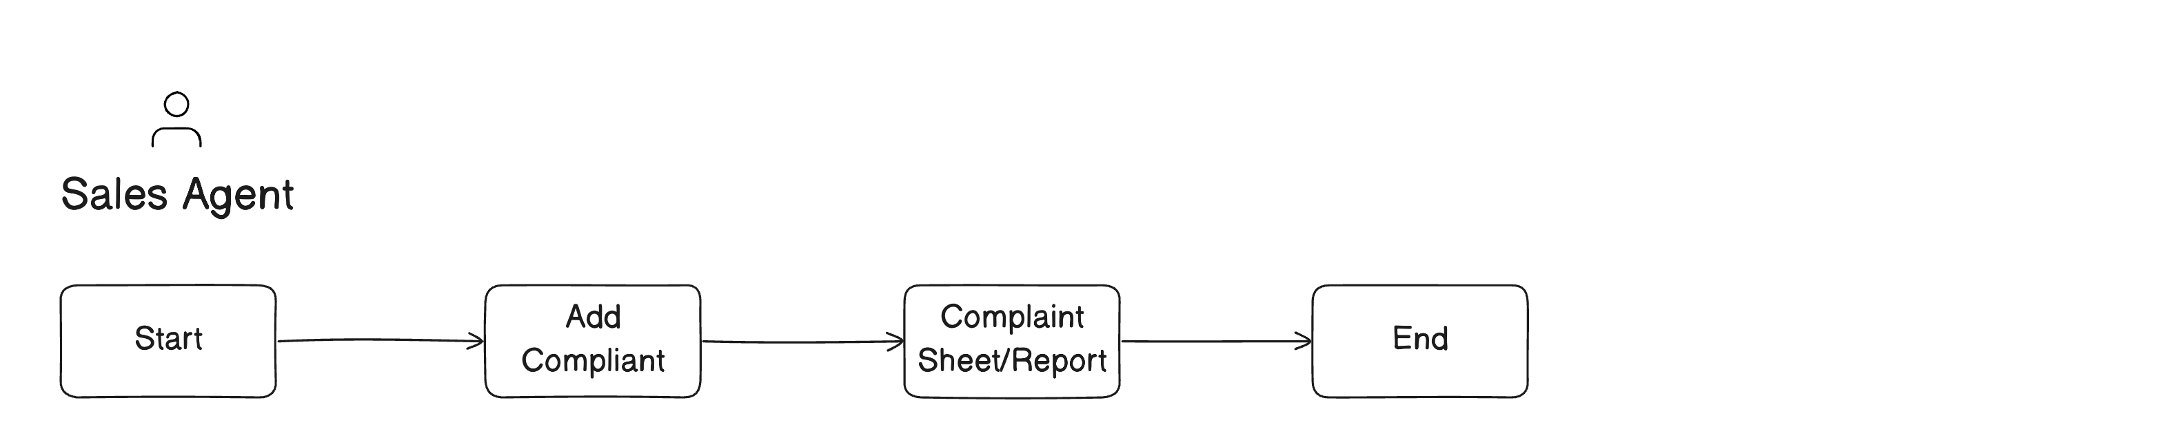

Modern Trade
This module allows sales agents to submit daily modern trade updates.
- Date
- Employee
- Store (From store master)
- Check In
- Upload images of shelf (5 images)
- Conduct stock count gird
- Product code (products from product master)
- Shelf Stock Qty
- Backroom Qty
- Expiry Date
- Total Qty (Shelf stock Qty + Backroom Qty)
- Competitor Activities (Price, Display, Promotions)
- Competitor brand (choose from competitor master)
- Prodcut name (coming from competitor master – only show those products of the brand)
- Price checkbox
- Yes - Shelf stock price
- Promo running checkbox
- Yes – Promo details
- Camera
- Camera
- Summary
- Check out
- Supervisor name
- Supervisor review
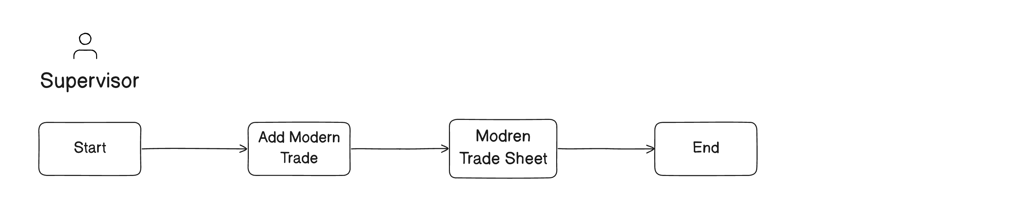

Marketing Visit
This module records customer visits done by sales or marketing staff for tracking interactions and outcomes.
- Date
- Visited By
- Visit type dropdown
- Route (Auto fill from beat)
- Beat (From Beat Master)
- Customer name
- Mobile number
- Address
- Email
- Location (Auto)
- Remarks
- Images

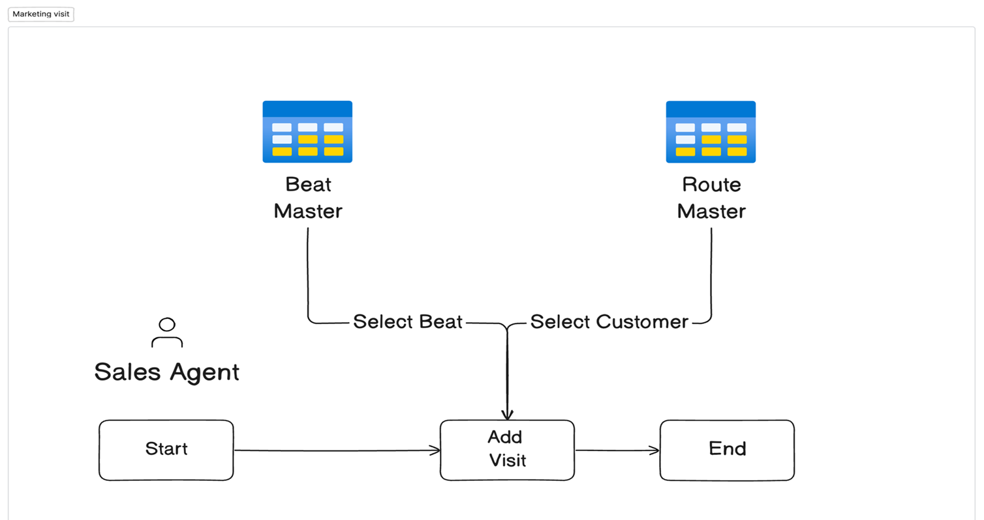

School Visit
This module records school visits done by sales or marketing staff for tracking interactions and outcomes.
- Date
- Visited By
- Procurement officer name
- School name
- Mobile number
- No of children
- Head teacher name
- Area
- Location (Auto)
- Images

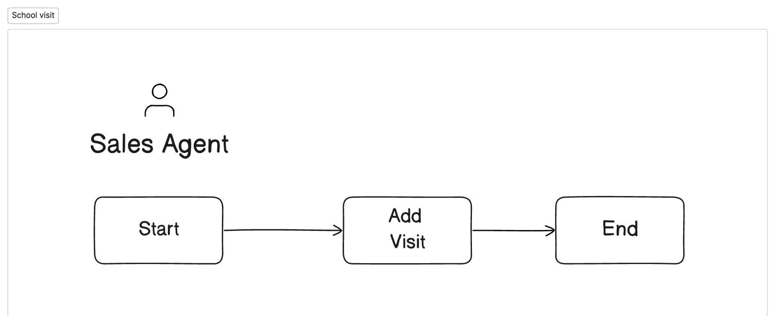

Farm Visit
This module records farm visits done by sales or marketing staff for tracking interactions and outcomes.
- Date
- Visited By
- Visitor name
- Gender
- Mobile number
- Area
- Number of people in familt
- Location (Auto)
- Camera

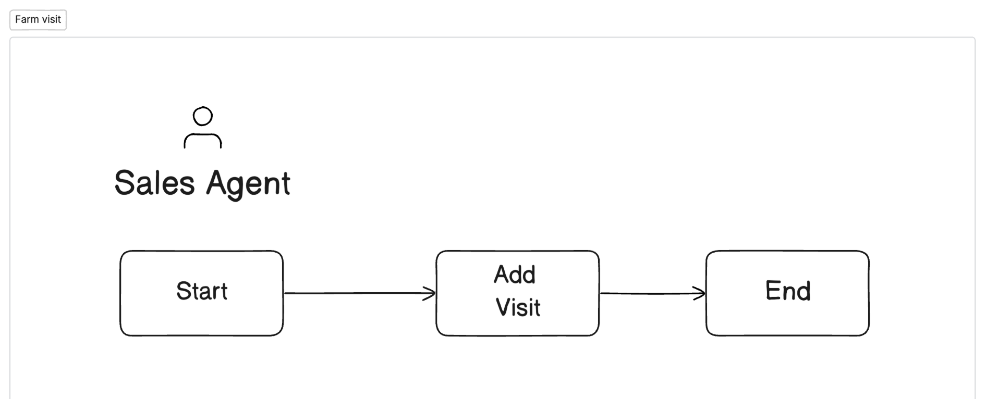

Door to door Visit
This module records door to door visits done by sales or marketing staff for tracking interactions and outcomes.
- Date
- Visited By
- Visitor name
- Gender
- Mobile number
- Area
- Number of people in family
- Location (Auto)
- Camera

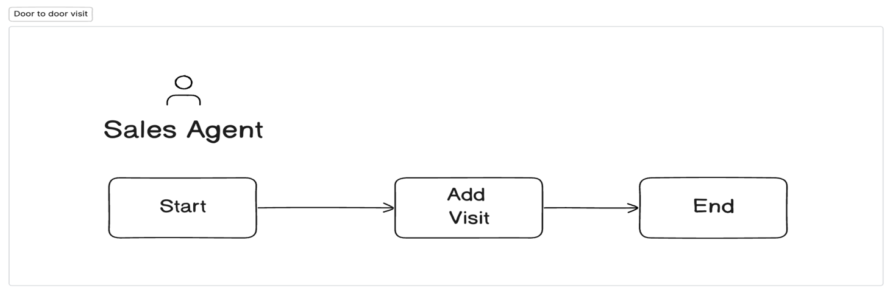

Feedback
This module records customer feedbacks.
- Date
- Entered By
- Feedback
- Question
- Response

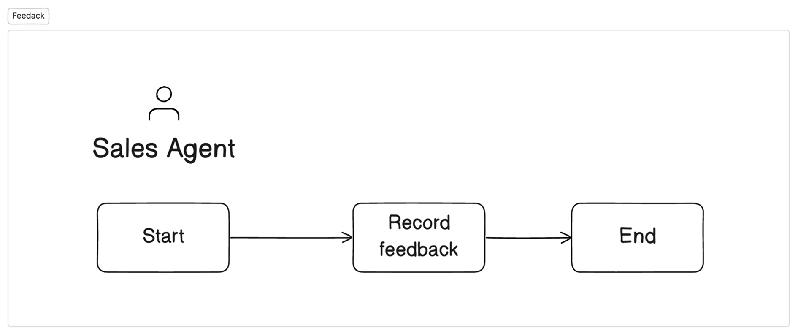

Reporting
This module allows to view custom reports.
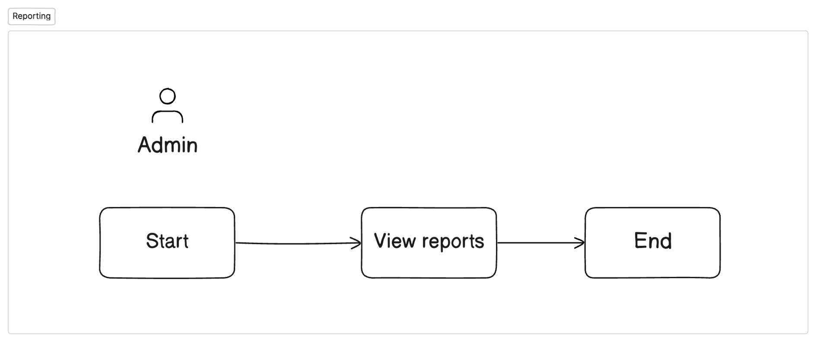

6. Additional Features
- Role-Based Access Control– Define custom permissions for each user type to ensure secure and relevant access.
- WhatsApp Integration– Automate communication for order confirmations, payment updates, and complaint resolutions.
- Push Notifications– Deliver both custom alerts and system-generated updates to users in real time.
- Camera Integration– Enable attendance logging with photo verification.
- Reports & Analytics– Auto-generate daily summaries, sales insights, visit reports, and geo-based heat maps.
- AI-Driven Features– Support form filling through NLP. Provide AI based planogram suggestions.
- Dashboards– Track sales performance, efficiency metrics, targets, and incentives with visual dashboards.
- Mobile-Responsive Design – Ensure seamless access and usability for field teams on smartphones and tablets.
- ERP/SAP Integration- Enable two-way synchronization with third-party ERP systems for customers, products, employees, stock, and invoices.

7. Flow Chart
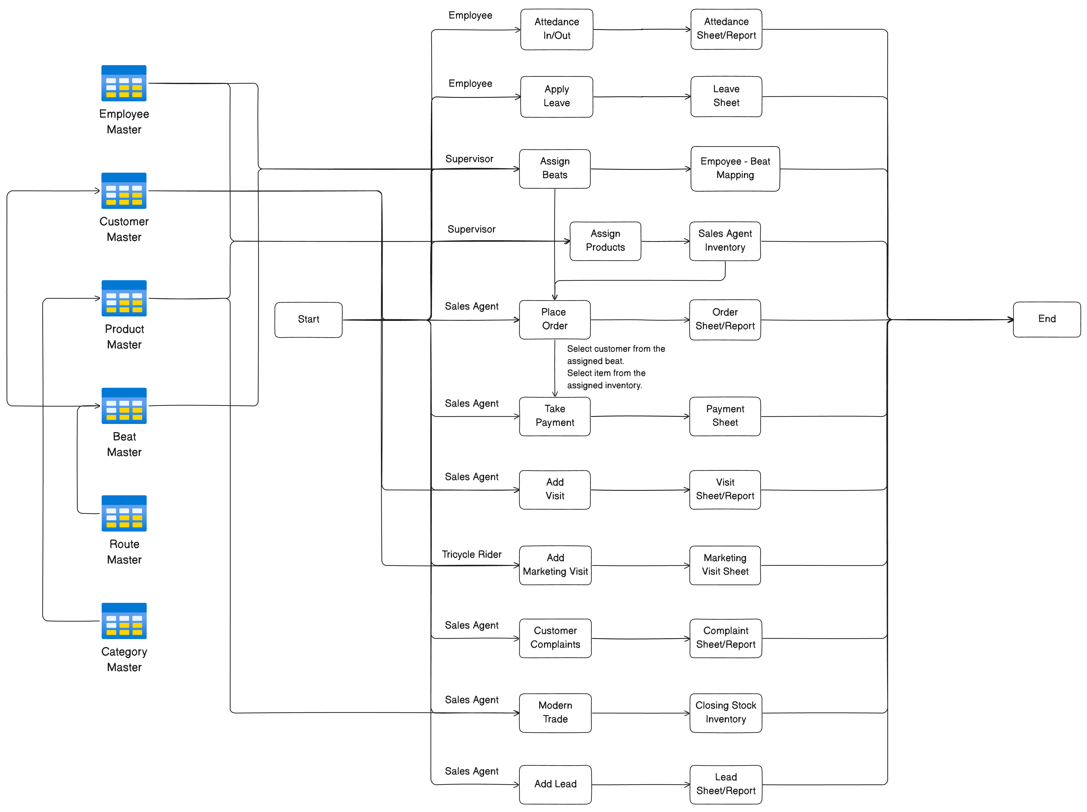

8. SAP Integration Process

8.1 Customer Master
Process to sync customers from SAP to neome.
New customer created/modified in SAP

neome plugin fetch customer from SAP

Customer details pushed in neome via plugin

Customer visible in neome app
Process to sync customers from neome to SAP.

New customer created/modified in neome

neome will send customer data to plugin

Plugin will push customer data to SAP
- Plugin will be configured using neome dashboard.
- Neome team will write the plugin for the SAP integration part.
- Existing SAP data will also be synched to neome via plugin.

8.2 Product Master
Process to sync products from SAP to neome.
New product created/modified in SAP

neome plugin fetch product from SAP

Product details pushed in neome via plugin

Product visible in neome app
Process to sync products from neome to SAP.

New product created/modified in neome

neome will send product data to plugin

Plugin will push product data to SAP
- Data sync frequency can be configured into dashboard.

8.3 Stock Details
Process to sync stock details from ERP to neome.
Stock created/modified in ERP

neome plugin fetch stock from ERP

Stock details pushed in neome via plugin

Stock visible in neome app

Process to sync stock details from neome to ERP.

New stock created/modified in neome

neome will send data to plugin

Plugin will push stock data to ERP
- Data sync frequency can be configured into dashboard.

8.4 Employee Master
Process to sync employees from SAP to neome.
New employee created/modified in SAP

neome plugin fetch employee from SAP

Employee details pushed in neome via plugin

Employee visible in neome app
Process to sync employee from neome to SAP.

New employee created/modified in neome

neome will send employee data to plugin

Plugin will push employee data to SAP

8.5 Order Invoice
Process to sync order invoice from neome to SAP.
New order placed in neome

Invoice generated in neome

Plugin will send the invoice data to SAP

Invoice visible in SAP

9. Conclusion
This BRD outlines a complete digital transformation for 260 Brands’ field and order operations. The system will ensure data-driven oversight across employee attendance, order execution, customer interaction, and inventory monitoring.

