***PROBLEM 1:***

**a) Navigate and List: a. Start by navigating to your home directory and list its contents. Then, move into a directory named "LinuxAssignment" if it exists; otherwise, create it**

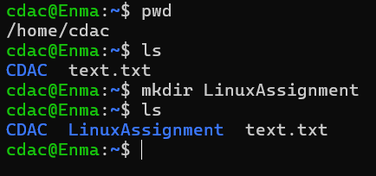>>

Step 1: use ‘pwd’ command to know the present working directory.  
Step 2: use ‘ls’ to list files and directories in current directory.  
Step 3: use ‘mkdir LinuxAssignment’ to create a new directory.  
  
  
**b) File Management: a. Inside the "LinuxAssignment" directory, create a new file named "file1.txt". Display its contents**>>  
  
  
  
  
  
  
  
  
  
Step 1: use ‘ls’ to list files and directories in current directory.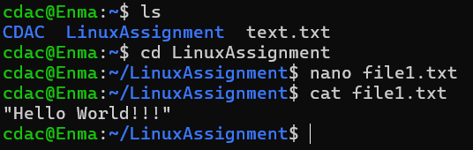  
Step 2: use ‘cd’ to change the directory to LinuxAssignment.  
Step 3: use ‘nano’ to create a file and to use the editor.  
Step 4: use ‘cat ’ to read the file and display its contents.  
  
**c) Directory Management: a. Create a new directory named "docs" inside the "LinuxAssignment" directory.**

>>

Step 1: use ‘ls’ to list files and directories in current directory.  
Step 2: use ‘cd’ to change the directory to LinuxAssignment.  
Step 3: use use ‘mkdir docs ’ to create a new directory.  
Step 4: use ‘ls’ and you can see the directory is created.  
**d) Copy and Move Files: a. Copy the "file1.txt" file into the "docs" directory and rename it to "file2.txt"**  
>>

Step 5: use ’cp file1.txt docs ’ to copy the file into the docs directory.  
Step 6: to rename the file1.txt use ’mv file1.txt file2.txt’  
  
  
  
  
  
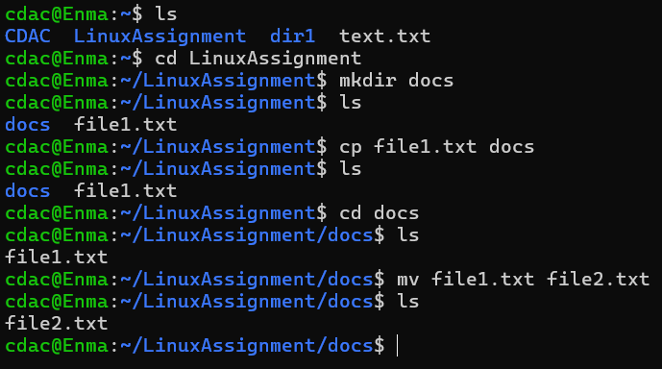  
**O/P:**

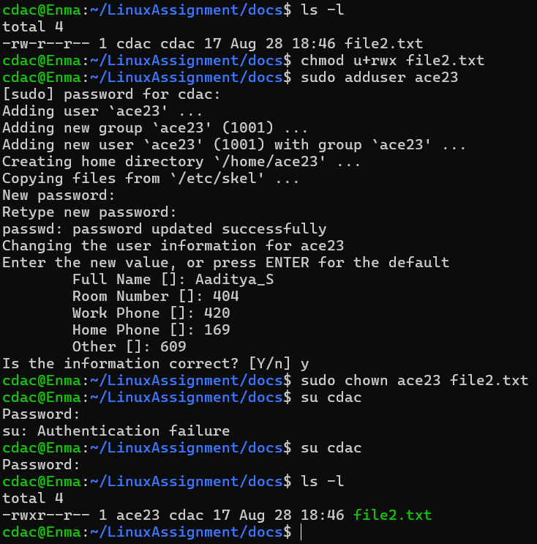**e) Permissions and Ownership: a. Change the permissions of "file2.txt" to allow read, write, and execute permissions for the owner and only read permissions for others. Then, change the owner of "file2.txt" to the current user.  
>>**Step 1: use ‘ls -l’ to list the files and as well as the permissions given to Owner/Group/Others.  
Step 2: use ‘chmod u+rwx’ to give read,write and exec permissions to the Owner of the file.  
Step 3: use ‘sudo adduser (username)’ to add another user.  
Step 4: Enter all the details asked by the CLI.  
Step 5: use ‘sudo chown (username) file2.txt’ to change the ownership of the file.  
Step 6 : use ‘su (username )’ to switch to current user.  
Step 7 : use ‘ls -l’ see the permissions given in step 2 and you can also see the change owner of file2.txt

**O/P:**

**f) Final Checklist: a. Finally, list the contents of the "LinuxAssignment" directory and the root directory to ensure that all operations were performed correctly.  
>>**  
Step 1: use ‘ls’ to list files and directories in current directory.  
Step 2 : use ‘cd /’ to go to root directory.  
Step 3: use ‘cd’ command multiple times and reach the LinuxAssignment directory.

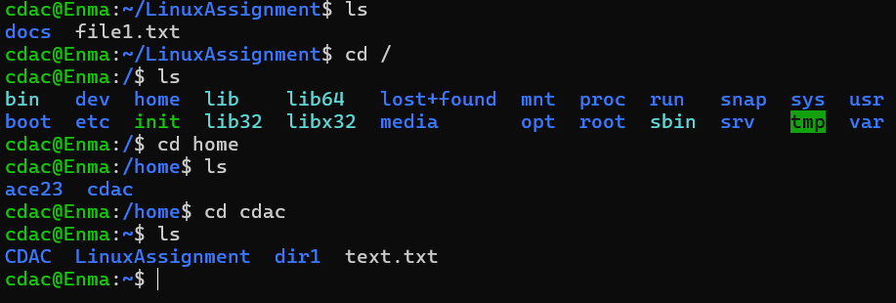**O/P:**

**g) File Searching: a. Search for all files with the extension ".txt" in the current directory and its subdirectories. b. Display lines containing a specific word in a file (provide a file name and the specific word to search).  
>>**Step 1: use ‘ls’ to list files and directories in current directory.  
Step 2: use ‘find . -type f -name "*.txt"’ to search for all the files with .txt extension in current directory and it’s subdirectories.

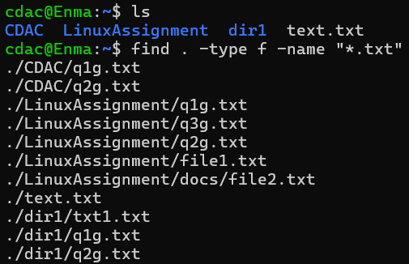

**h) System Information: a. Display the current system date and time.  
>>** use “date” command to display the current system date and time.

**O/P:**

**i) Networking:**

**a. Display the IP address of the system.**

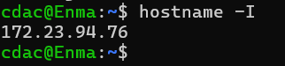>> use “hostname -I” to show the IP address assigned to the system.

O/P:

**b. Ping a remote server to check connectivity (provide a remote server address to ping).**

**>>** use “ping [www.(website).com](http://www.(website).com)” to ping a remote server to check connectivity.  
 [To get fixed responses use “ping -c (no of replies) website.com ”]

O/P:

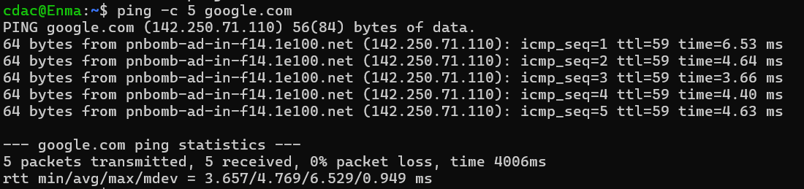

**j) File Compression:**

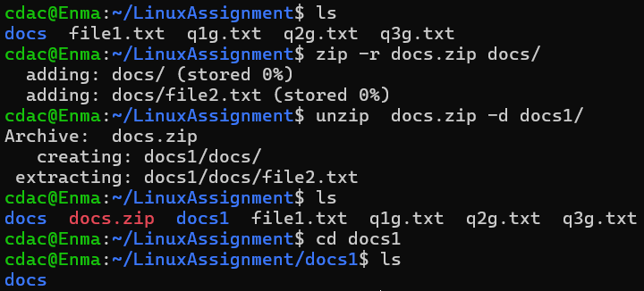**a. Compress the "docs" directory into a zip file.   
b. Extract the contents of the zip file into a new directory.  
>>** Step 1: use “sudo apt install zip” to install zip functionalities.  
 Step 2: To zip docs directory use “zip -r docs.zip docs/”  
 Step 3 : To unzip the directory and it’s files in a new directory use ”unzip docs.zip -d(directory name)”  
 [If directory does not exist, it will auto create new.]  
 Step 4: use “ls” and you can see the new directory and as well as the unzipped files.

**O/P:**

**k) File Editing:   
a. Open the "file1.txt" file in a text editor and add some text to it.   
b. Replace a specific word in the "file1.txt" file with another word (provide the original word and the word to replace it with).  
>>**Step 1: use ‘nano file1.txt’ to edit the txt file. [I/P: Hello World!!!]  
Step 2: use “ sed -i ‘s/World/Earth/g’ file1.txt” to replace the World with Earth.

**  
O/P:**

**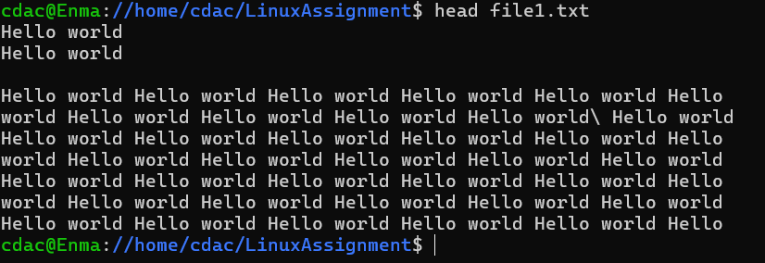*PROBLEM 2:***

**a. Suppose you have a file named "data.txt" containing important information. Display the first 10 lines of this file to quickly glance at its contents using a command.  
>>**   
Use “head (filename)” to display the first 10 lines of the file. [By default head command displays the 10 lines.]  
  
**O/P:**

**b. Now, to check the end of the file for any recent additions, display the last 5 lines of "data.txt" using another command.  
>>**  Use “tail -5 filename” to display the last 5 lines.  
  
**O/P:** 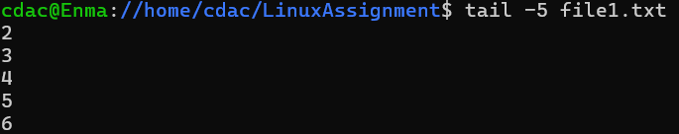

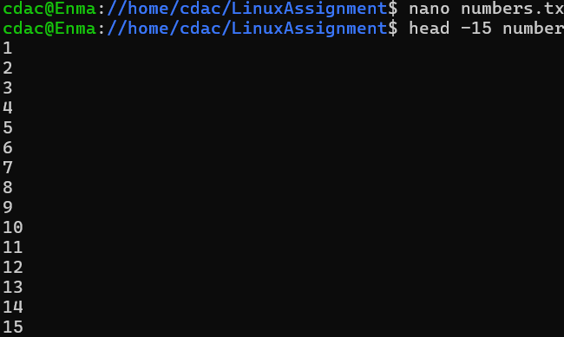**c. In a file named "numbers.txt," there are a series of numbers. Display the first 15 lines of this file to analyze the initial data set.  
>>**Step 1 : create and edit a data set file with ‘nano numbers.txt’  
Step 2: Use ‘head -15 numbers.txt’ command to display the 15 lines of the mentioned file.  
  
**O/P:**

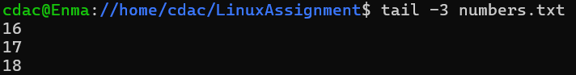 **d. To focus on the last few numbers of the dataset, display the last 3 lines of "numbers.txt".  
>>** Use ‘tail -3 numbers.txt’  
**O/P:**

**e. Imagine you have a file named "input.txt" with text content. Use a command to translate all lowercase letters to uppercase in "input.txt" and save the modified text in a new file named "output.txt."  
>>** Use ‘tr’ command which translates lowercase letters to uppercase.

**O/P:  
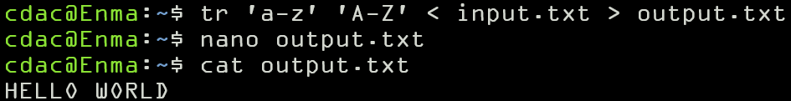**

**f. In a file named "duplicate.txt," there are several lines of text, some of which are duplicates. Use a command to display only the unique lines from "duplicate.txt."   
>>** use ‘sort’ command with | to uniq  
 sort duplicate.txt | uniq

**O/P:  
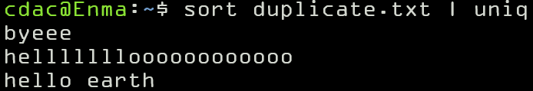**

**g. In a file named "fruit.txt," there is a list of fruits, but some fruits are repeated. Use a command to display each unique fruit along with the count of its occurrences in "fruit.txt  
>>   
O/P:**

