

PROJECT AND TEAM INFORMATION

Project Title
BEAN CLOUD

Student/Team Information

Team Name:  Team # | Team Cloud  JAVA-IV-T093
Team member 1(Team Lead)  (Uniyal, Aaditya: 240211539: 240211539@geu.ac.in): | 
Team member 2  (Shukla, Adaya: 24022806: 24022806@geu.ac.in) | 
Team member 3  (Bhandari, Jahnvi: 24022422: 24022422@geu.ac.in): | 

PROJECT PROGRESS DESCRIPTION (35 pts)

Project Abstract

MiniCloud is a locally-running, Java-based private cloud platform that replicates the core infrastructure primitives of major cloud providers such as AWS — all without relying on any external cloud services. It is designed to give developers hands-on experience with cloud infrastructure concepts in a self-contained environment.
The platform exposes five essential services through a unified console: Identity and Access Management (IAM) for JWT-secured user authentication, Compute (EC2-equivalent) for launching Docker-hosted Tomcat web servers, Object Storage (S3-equivalent) for managing file buckets via Java NIO, a Managed Database service (RDS-equivalent) for provisioning MySQL containers with persistent volumes, and a Load Balancer that distributes traffic across compute nodes using a Round-Robin algorithm.

Updated Project Approach and Architecture
MiniCloud follows a layered, service-oriented architecture comprising four distinct tiers:
- Request Layer: A JavaFX desktop dashboard communicates with the backend via Java's built-in HttpClient, sending JSON payloads with Bearer JWT tokens to all secured REST endpoints.
- Service Layer: Decoupled Spring Boot services (AuthService, DockerService, BucketService, DatabaseService) encapsulate all business logic independently, enabling parallel development across team members.
- Infrastructure Layer: The docker-java 3.3.4 library interfaces directly with the local Docker daemon to create, start, stop, and inspect containers for both Compute (Tomcat) and Database (MySQL) workloads.
- Reliability Layer: A scheduled HealthCheckService runs every 10 seconds, querying Docker container states and triggering automatic restarts on detected failures, with events logged to the AuditLog table.
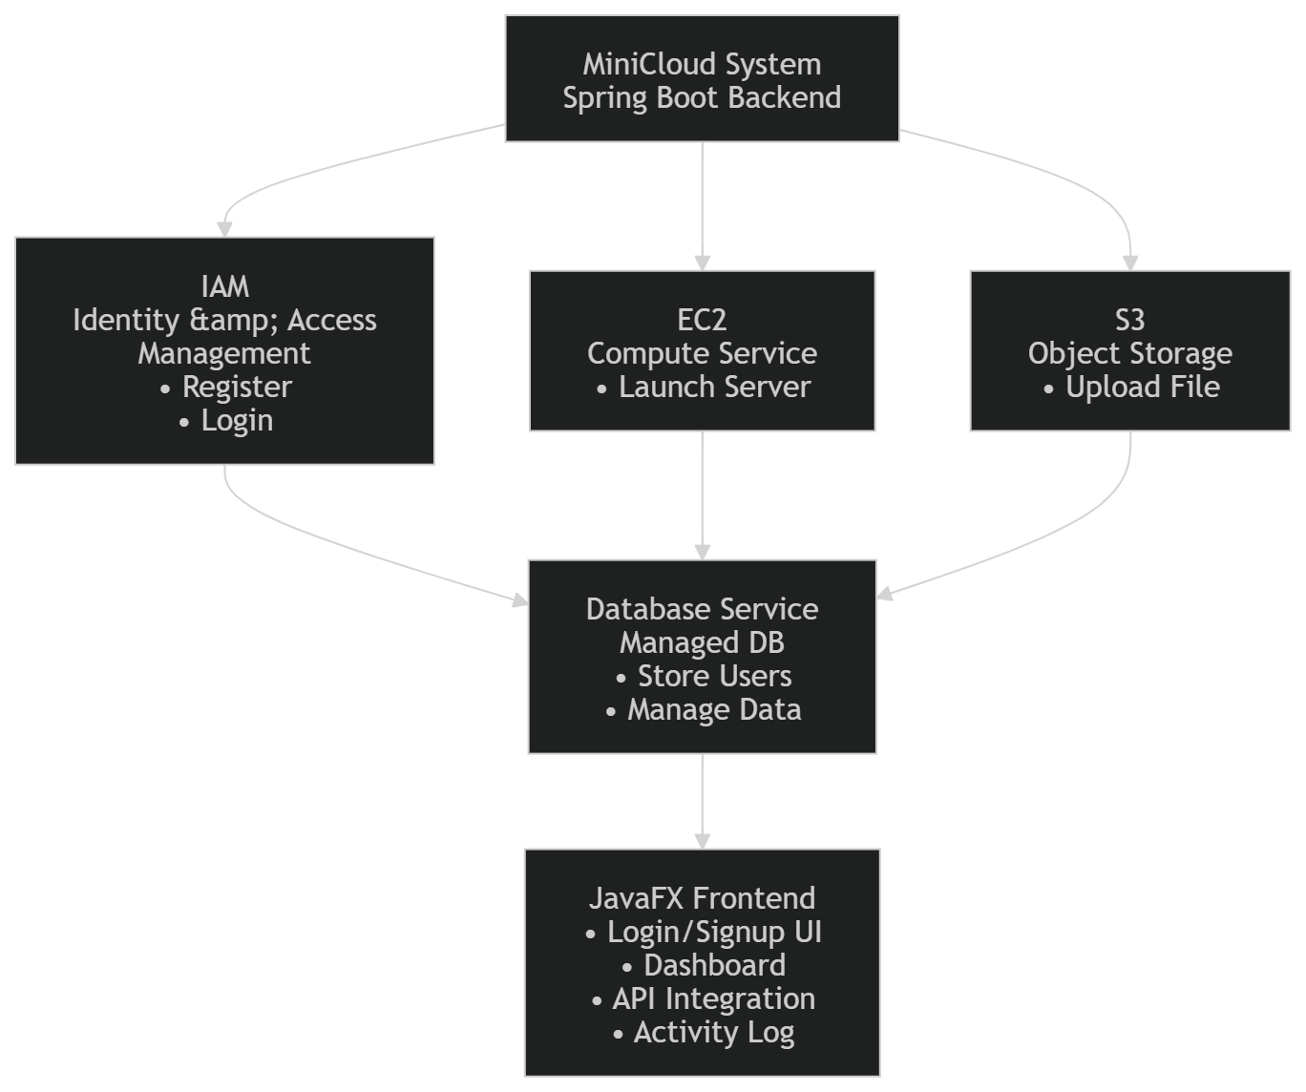

Tasks Completed
Task Completed | Team Member
- IAM — Identity & Access Management  - EC2 — Compute Service  - S3 — Object Storage  - Database — Managed DB Service  - JavaFX Frontend | Aaditya  Jahnvi  Jahnvi and Adaya  Aaditya  Adaya

Challenges/Roadblocks
- Spring Security 6 API Changes
- JavaFX Thread Safety
- Connecting to Docker
- Dynamic Port Conflict Management

Tasks Pending (7 pts)
Task Pending | Team Member (to complete the task)
- Load Balancer (In Progress)  - Health Check Engine  - Deploy and Live Metrics | Aaditya  Adaya  Jahnvi

Project Outcome/Deliverables
The primary deliverable is a fully functional MiniCloud platform with the following components:
- Spring Boot 3 REST API backend providing IAM, Compute, Storage, Database, Load Balancer, and Orchestration services.
- JavaFX desktop dashboard as the cloud management console: Login, Compute Launcher, Storage Browser, Database Provisioner, and Operations Monitor panels.
- One-Click Deploy Website Wizard provisioning a full web stack (Tomcat + MySQL + Load Balancer) through a single orchestration API call.
- Auto-Healing Health Check engine for simulated 99.9% container uptime.
- Real-time CPU/RAM metric visualization on the dashboard.
- JUnit 5 test suite and Postman collection covering all major endpoints

Progress Overview
- Project is 65-70% complete overall.
- All 4 core services are fully completed: IAM, EC2 Compute, S3 Storage, and Managed Database.
- JavaFX Login and Compute panels are complete and connected to the backend.
- JavaFX Storage and Database panels are still under development.
- Health Check, Orchestration, Live Metrics, Testing, Packaging are not yet started
- Load Balancer is under progress.

Codebase Information (2 pts)
(Repository link, branch, and information about important commits.)
- Repository link:
https://github.com/AadityaUniyal/MINI-CLOUD
- Branch:
main
- Commits:

Testing and Validation Status
Test Type | Status (Pass/Fail) | Notes
- User Registration API  - User Login  - Launch Compute Instance  - File upload to bucket  - End-to-End Integration Flow | Pass  Pass  Pass  Pass  Pass | New user created successfully  Valid credentials return a signed JWT token  Tomcat container spins up on a dynamic port  File saved under correct path  Full flow — Register → Login → Launch → Upload → Provision DB — executed successfully

Deliverables Progress
DELIVERABLES | STATUS | REMARKS
IAM | Completed | Register, login, JWT filter fully operational
EC2 | Completed | Launch, list, stop instances working
S3 | Completed | Bucket create, file upload & list working
Database | Completed | Provision, list, JDBC string generation working
JavaFX — Login + Compute Dashboard | Completed | Login & launch panels connected to backend
Load Balancer — Round-Robin Routing | In progress | Service logic in progress; API not yet exposed
Health Check / Auto-Healing Engine | Pending
Orchestration — One-Click Deploy | Pending

