**Herald College, Kathmandu** 

**Concepts and Technologies of AI**

**5CS037**

**Report on Analysis of World Happiness**

**Name:** Aaditya Chaudhary Tharu

**SID:** 2414024

**Group:**15GC1

**Tutor:** Siman Giri

**Module Leader:** Siman Giri

Table of Contents

**Title:** 2

Analysis of the World Happiness Report: Exploring South Asia and Middle East Perspectives. 3

**Introduction:** 3

**Report Section - For Each Problem:** 3

Problem – 1: Data Exploration and Understanding: 3

Figure 1.1 top 10 happiest countries by Score using a bar chart 3

Figure 3 histogram for the Score column to show its distribution 3

Figure 4 scatter plot between GDP per Capita and Score 4

**Problem – 2** 4

Figure 5 horizontal bar chart showing the Composite Score 4

Figure 6 visualization plot 4

Figure 7 scatter plot with GDP per Capita 5

Figure 8 scatter plots with trendlines for these metrics against the Score 5

**4. Analyse the reasons behind these gaps and their implications for South Asian countries.** 5

**Problem - 3** 6

Figure 10 Plot bar based on the score of each region 6

Figure 11 Compare key metrics like GDP per Capita 6

Figure 13 Outlier Detection 6

Figure 14 boxplots comparing the distribution of Score between South Asia and the Middle East 7

**Conclusion:** 7

**Title:**

Analysis of the World Happiness Report: Exploring South Asia and Middle East Perspectives.

# **Introduction:**

The World Happiness Report is a key survey assessing global happiness sample data. Happiness scores and rankings are based on data from the Gallup World Poll, which includes six aspect factors—economic production, social support, life expectancy, freedom, absence of corruption, and generosity. The importance of this report was to find dystopia and residuals of the country.  The objectives of this report were to help in learning Python libraries like NumPy, Seaborn, Pandas, Matplotlib, etc., essential skills, and knowledge about structured data (CSV) with statistics and their graphical representation. I used file handling to read/write and create a dataset that was provided to us. I analysed the South Asia and Middle East country aspects to plot their data in a histogram by comparing their key aspects with each other.

# **Report Section - For Each Problem:**

## Problem – 1: Data Exploration and Understanding:

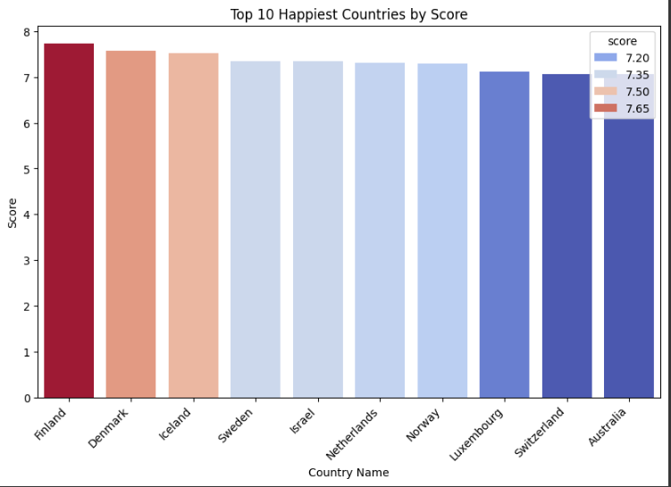

### Figure 1.1 top 10 happiest countries by Score using a bar chart

The above bar chart is visual representation of top 10 happiest countries using univariate data i.e. 'score' from the dataset ("World Happiness Report.csv"). The frequency start from 7.20 to 7.65 and Finland is happiest country among all.

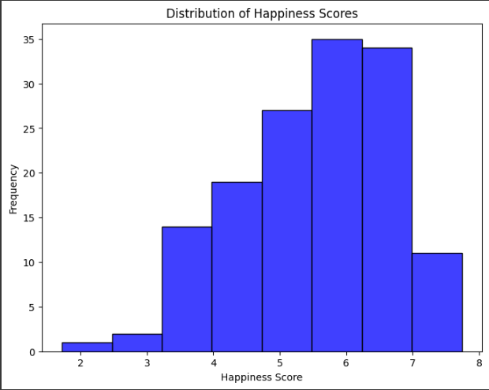

### Figure 3 histogram for the Score column to show its distribution

The above histogram is a visual representation of distribution and also interpret of the country with happiness score which start from 1.75 and end at 7.65

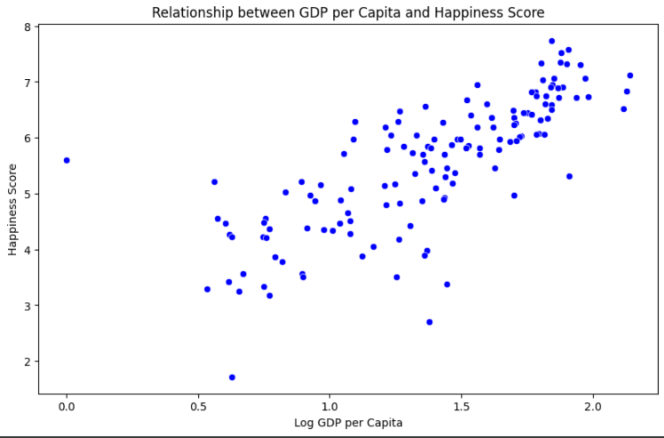

### Figure 4 scatter plot between GDP per Capita and Score

The above scatter plot is a visual representation comparing between GDP per Capita and Score to visualize their relationship.

## **Problem – 2**

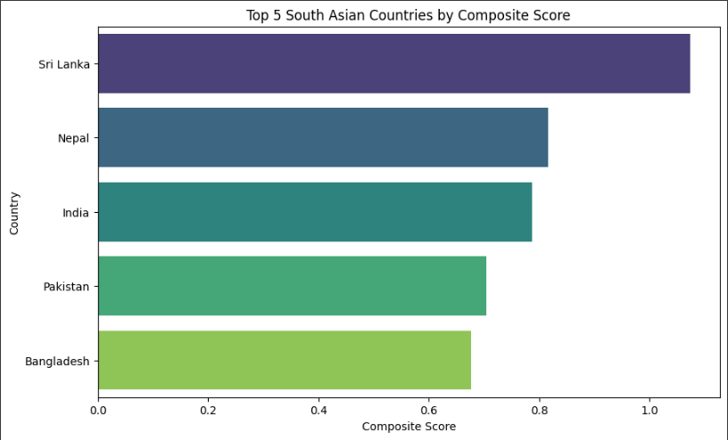

### Figure 5 horizontal bar chart showing the Composite Score

The above horizontal bar chart is a visual representation of composite score of only top 5 south Asian countries.to find the composite score I use this formula Composite Score = [0.40 × GDP per Capita + 0.30 × Social Support+ 0.30 × Healthy Life Expectancy] and the range started from 0.7 to 1.4(Bangladesh to Sri Lanka).

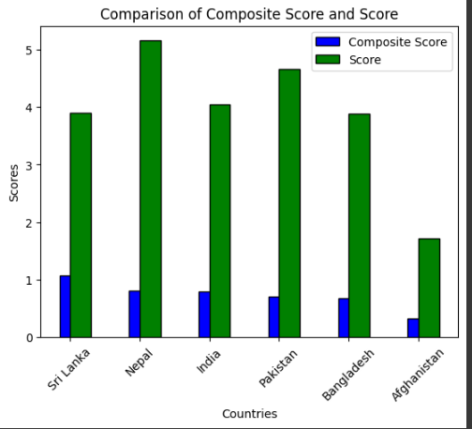

### Figure 6 visualization plot

The diagram shows the relationships between original score with composite score and original score is much higher than composite score.

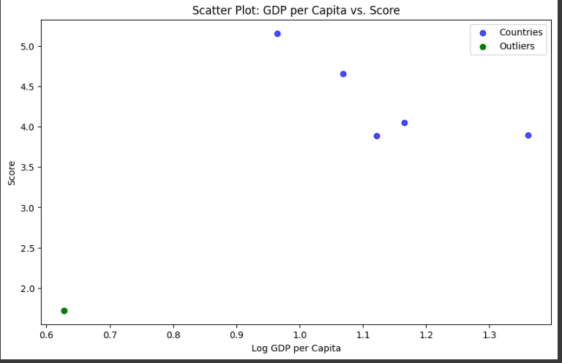

### Figure 7 scatter plot with GDP per Capita

The above scatter plot is a visual representation between GDP per Capita and score in which green point denotes outliner and blue countries. there is one outliner and remaining are south Asian country.

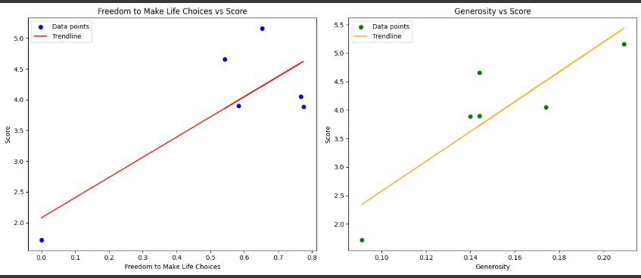

### Figure 8 scatter plots with trendlines for these metrics against the Score

The above scatter plot is a visual representation between GDP per Capita and score in which green point denotes outliner and blue countries. there is one outliner and remaining are south Asian country.

### **4. Analyse the reasons behind these gaps and their implications for South Asian countries.**

All the aspect like economic production, social support, life expectancy, freedom, corruption, and generosity have biasness in the GDP-score Gap in south Asian country. these countries have weak governance with high corruption rate, and poor social systems and political instability a prevent economic gains. In contrast, smaller gaps in Afghanistan reflect alignment between low GDP and Score. new rules regarding corruption should be implemented, social investment should be done in time can be implication of south Asian country

## **Problem - 3**

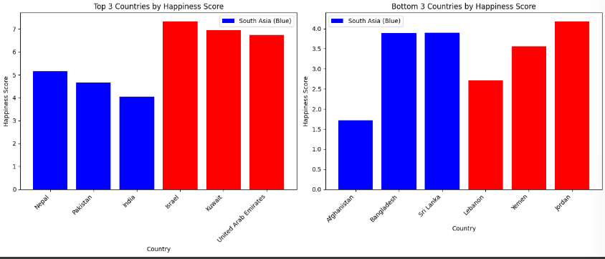

### Figure 10 Plot bar based on the score of each region

The bar charts represent comparison between top and bottom 3 countries based on their score of south Asian and middle east countries. where Israel has more and Afghanistan has less frequency than other in top and bottom happiness

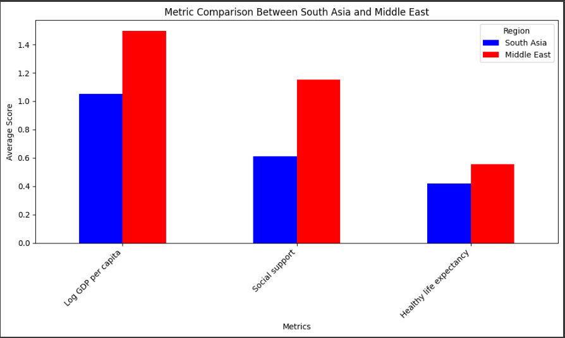

### Figure 11 Compare key metrics like GDP per Capita

The diagram is showing the result of the metrics like GDP per Capita, Social Support, and Healthy Life Expectancy of south Asian and middle east country. Middle east country has largest disparity in all 3 metrics than south Asian countries

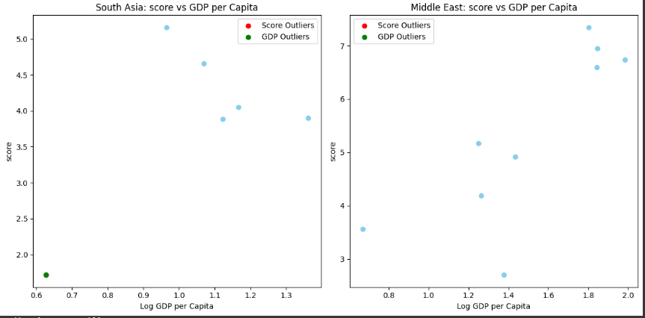

### Figure 13 Outlier Detection

The scatter plots show the relationship between (Log GDP per capita with Score). Afghanistan is an outlier in South Asia due to its significantly low values where middle east has no outliers.

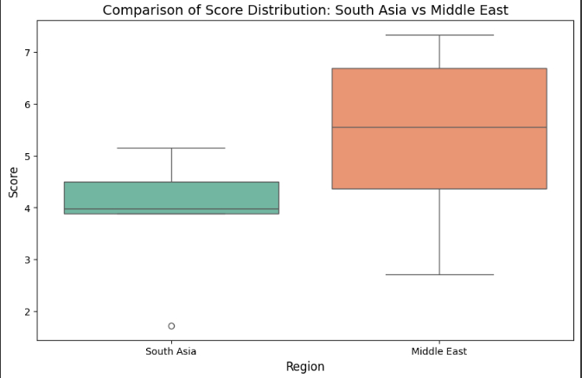

### Figure 14 boxplots comparing the distribution of Score between South Asia and the Middle East

The boxplots comparing the distribution of Score between South Asia and the Middle East. south Asian countries is more concentrated in lower median with no outline and middle east countries has more distribution with higher median and no outline

# **Conclusion:**

While doing this assignment I use different python libraries to calculate statistics of different data from dataset and illustrated them in graphical format. In 1st problem use different method to display data. In 2nd problem I use file handing to create and add column in new csv file and in 3rd problem I compare the data between south Asian and middle east countries and fine out middle east countries has more happiness score, economic production, social support, life expectancy, freedom, absence of corruption, and generosity were visualized in different chart (line graph, histogram, scatter plot, boxplot etc)

This analysis shows that score of happiness is affected by different Metrix of the country. High GDP doesn’t always have high happiness. We need to focus on solving problem which are hindering happiness score like social support, life expectancy, freedom, absence of corruption etc.

