Networking Task 01: Understanding Your Network Environment

Part A: Network Information
Findanddocumentthefollowingdetailsfromyour system:
1. Hostname (Device Name)
2. IPv4 Address
3. MAC Address
4. Default Gateway
5. DNS Server
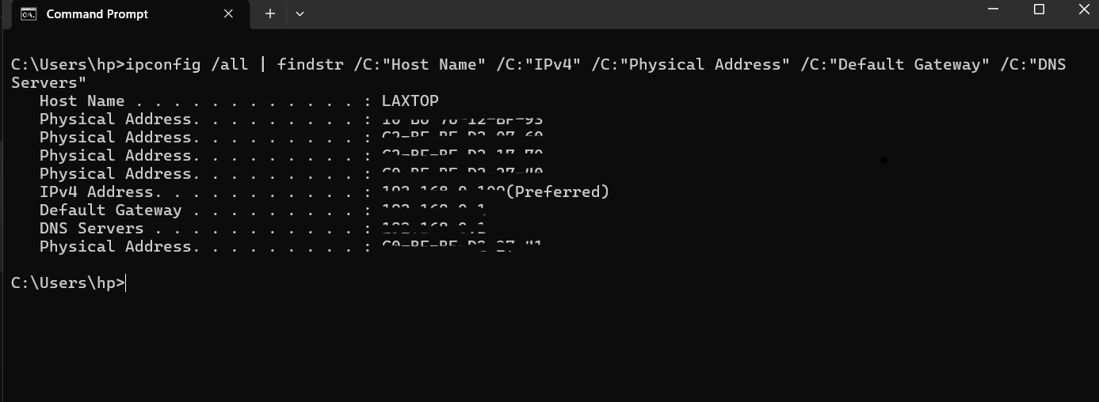

Part B: Basic Networking Concepts
Explain the following conceptsinyourownwords:

• What is an IP Address?
Unique number given to a device on a network
• What is a MAC Address?
Permanent or Physical address of the device
• What is a Default Gateway?
A Router that connects local netword to other networks
• What is DNS?
Giving a name to an IP address
• Difference between Public IP and Private IP.
Public IP is visible on the internet while private IP is used insdie local wifi.
Part C: Create a Basic Network Diagram
Create a simple diagram showing how your device connects to the internet.
Example:
Internet
↓
Router/WiFi
↓
Your Device
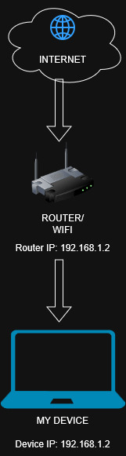

Part D: Network Connectivity Test
Windows Users
Run:
Ipconfig
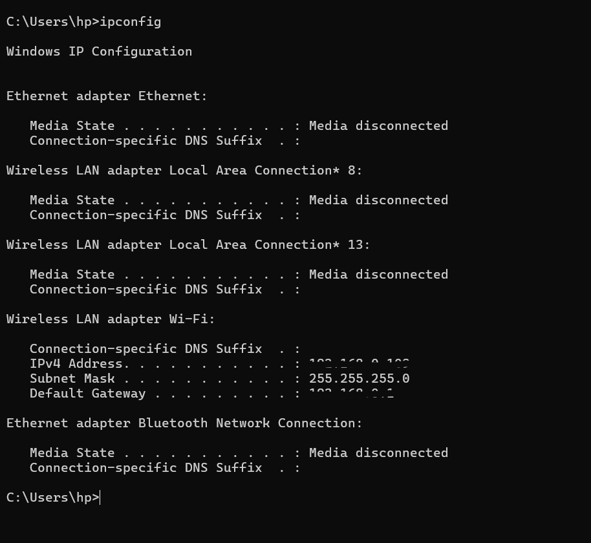

ping google.com
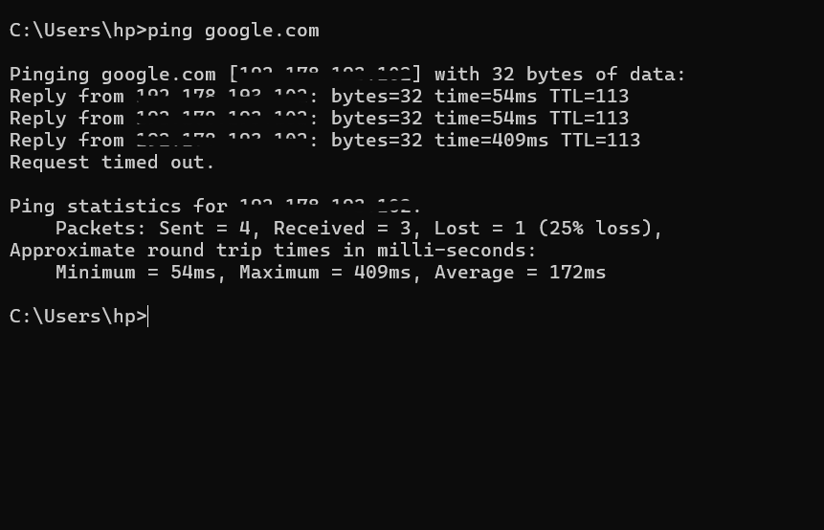
tracert google.com
