

Project Report

UseYourBrain: A Java-Based Cognitive Support System for Independent Thinking

Submitted by: Aadra Khattri
Course: B. Tech CSE(AI-ML)
Reg. No.: 25BAI11012

- CONTENTS
- Introduction
- Problem Statement
- Functional Requirements
- Non-functional Requirements
- System Architecture
- Design Decisions & Rationale
- Implementation details
- Screenshots
- Testing Approach
- Challenges faced
- Learning and Key- Takeaways
- Future Enhancements
- References

2. Introduction

Generative Artificial Intelligence has made it easier to get quick answers, generate ideas and solve problems. While these tools can be useful, depending on them too early can sometimes reduce the effort we put into thinking, researching, and forming our own ideas.

UseYourBrain is a Java-based command-line application designed to encourage independent thinking before relying on AI or other external assistance. Instead of directly providing answers, the application guides users through a structured process where they first analyse a problem, record their thoughts, consider different possibilities and reflect on their final conclusion.

The system provides three main modes: Decision Mode, Research Mode and Brainstorm Mode. It also provides Reflection & History, allowing users to review sessions from the current run and previously saved sessions. Completed sessions are stored locally using Java File I/O so that they remain available after the application is restarted.

The project demonstrates core Java programming concepts including Object-Oriented Programming, interfaces, classes, collections, file handling, exception handling, input validation and modular program design. The application is completely command-line based, making it simple to execute and test through a standard Java environment.

3. Problem Statement

The increasing availability of generative AI tools has made it possible to obtain answers, ideas and solutions within seconds. Although these tools can be useful for learning and productivity, using them immediately for every problem may discourage users from first thinking through the problem themselves.

Students and other learners often need to make decisions, research topics, or generate ideas independently, but there is no simple tool that specifically encourages them to pause, organize their thoughts, consider evidence and reflect before seeking external assistance.

UseYourBrain addresses this problem by providing a structured command-line environment where users can work through decisions, research questions and brainstorming activities on their own. The application does not generate answers using an AI model. Instead, it guides users through a sequence of questions that encourages independent reasoning and stores completed sessions for later reflection.

4. Functional Requirements

The functional requirements of the UseYourBrain system define the main operations that the application must perform for users.

4.1 Main Menu

- The system shall display a command-line main menu with options for Decision Mode, Research Mode, Brainstorm Mode, Reflection & History and Exit.
- The system shall accept and process the user's menu selection.
- The system shall handle invalid menu input and display an appropriate error message.

4.2 Decision Mode

- The system shall allow users to analyze a decision through a series of guided questions.
- The system shall collect the user's initial belief, reasoning, benefits, drawbacks, alternatives, evidence, potential blind spots and final decision.
- The system shall record whether the user's thinking changed during the process.
- The system shall display a summary of the completed decision session.

4.3 Research Mode

- The system shall allow users to enter a research question and their existing belief or understanding.
- The system shall allow users to record sources and supporting as well as challenging evidence.
- The system shall allow users to enter a final conclusion.
- The system shall display a summary of the research session.

4.4 Brainstorm Mode

- The system shall allow users to enter a topic and describe their existing knowledge.
- The system shall allow users to record multiple ideas and identify constraints.
- The system shall allow users to identify feasible ideas and select a final direction.
- The system shall display a summary of the brainstorming session.

4.5 Reflection & History

- The system shall allow users to view sessions created during the current program run.
- The system shall allow users to view previously saved sessions.
- The system shall display the session type and relevant session details.

4.6 Persistent Storage

- The system shall save completed sessions to a local text file using Java File I/O.
- The system shall append new session information without removing previously saved sessions.
- The system shall allow saved sessions to be retrieved after restarting the application.

4.7 Input Validation

- The system shall prevent empty responses for required inputs.
- The system shall validate Yes/No responses where applicable.
- The system shall handle invalid numerical menu input without terminating unexpectedly.
- The system shall prompt the user again when invalid input is provided.

5. Non-Functional Requirements

The non-functional requirements define the quality, usability, reliability and maintainability expected from the UseYourBrain application.

5.1 Usability

- The application shall provide a simple command-line interface that is easy to understand and navigate.
- Menu options and prompts shall clearly guide users through each activity.
- Error messages shall provide understandable instructions when invalid input is entered.

5.2 Reliability

- The application shall handle invalid user input without terminating unexpectedly.
- Completed sessions shall be saved locally so that they can be accessed after restarting the application.
- File-related errors shall be handled using exception handling.

5.3 Maintainability

- The application shall follow a modular structure with separate model, service and utility classes.
- Common session behavior shall be represented using the "Session" interface.
- Individual modes shall be implemented through separate service and model classes, making the system easier to modify and extend.

5.4 Performance

- The application shall respond quickly to normal user input because it performs lightweight command-line processing and local file operations.
- The system shall not require continuous network communication or external services during execution.

5.5 Portability

- The application shall run on systems with a compatible Java Development Kit (JDK).
- The project shall be executable through standard Java compilation and command-line commands without requiring a graphical interface.

5.6 Resource Efficiency

- The application shall use local text-file storage instead of requiring a separate database server.
- The system shall use standard Java collections and file handling for managing session data.

6. System Architecture

UseYourBrain follows a simple modular architecture designed for a Java command-line application. The system is divided into four main layers: Presentation Layer, Service Layer, Model Layer and History & Persistence Layer.

6.1 Presentation Layer

The presentation layer is handled by "Main.java". It provides the command-line interface and displays the main menu to the user. It accepts the user's choice and directs the program to the appropriate functionality.

6.2 Service Layer

The service layer contains the main application logic. It consists of:

- "DecisionService" – manages the Decision Mode workflow.
- "ResearchService" – manages the Research Mode workflow.
- "BrainstormService" – manages the Brainstorm Mode workflow.
- "HistoryService" – manages current session history and access to previously saved sessions.

These classes keep the main application logic separate from the data models.

6.3 Model Layer

The model layer represents the data collected during each activity. It contains:

- "DecisionSession"
- "ResearchSession"
- "BrainstormSession"
- "Session" interface

The three session classes implement the common "Session" interface, which provides a common structure for identifying and summarizing different types of sessions.

6.4 History & Persistence Layer

The persistence layer is handled by "FileManager". It uses Java File I/O to save completed sessions to the local text file "useyourbrain_history.txt".

"HistoryService" communicates with "FileManager" when previously saved sessions need to be displayed. This allows session information to remain available even after the application is restarted.

6.5 Overall Data Flow

The general flow of the system is:

User → Main.java → Service Layer → Session Model → HistoryService → FileManager → Local Text File

This modular structure separates user interaction, application logic, data representation and file storage, making the application easier to understand, test, and maintain.

7. Design Decisions & Rationale

Several design decisions were made to keep UseYourBrain simple, modular, executable through the command line and suitable for demonstrating core Java programming concepts.

7.1 Command-Line Interface

A command-line interface was selected because the project focuses on the thinking process rather than visual presentation. It also allows the application to run directly through standard Java commands without requiring a graphical environment.

7.2 Modular Structure

The application is divided into model, service and utility components. This separation keeps different responsibilities independent and makes the code easier to understand, test and maintain.

7.3 Use of an Interface

A common "Session" interface is used by "DecisionSession", "ResearchSession" and "BrainstormSession". This provides a common structure for different types of sessions while allowing each session to maintain its own specific data.

7.4 Separate Service Classes

Each major activity has its own service class. "DecisionService", "ResearchService" and "BrainstormService" handle the input and workflow for their respective modes. This avoids putting all application logic into "Main.java".

7.5 Local Text-File Storage

A local text file, "useyourbrain_history.txt", was selected for persistence because the project does not require a database. Java File I/O is sufficient for storing and retrieving the relatively small amount of session data generated by the application.

7.6 Input Validation

Input validation was included to prevent common user errors such as empty responses, invalid menu choices and invalid Yes/No responses. This improves reliability and provides a smoother command-line experience.

7.7 No External AI Dependency

The application does not depend on an external AI API. This is an intentional design choice because the purpose of UseYourBrain is to encourage users to first develop and evaluate their own thoughts rather than immediately receiving an AI-generated answer.

8. Implementation Details

UseYourBrain is implemented in Java using an object-oriented and modular approach. The project is organized into separate packages for models, services, and utility functions.

8.1 Project Structure

The main project structure is:

UseYourBrain/
├── Main.java
├── model/
│ ├── Session.java
│ ├── DecisionSession.java
│ ├── ResearchSession.java
│ └── BrainstormSession.java
├── service/
│ ├── DecisionService.java
│ ├── ResearchService.java
│ ├── BrainstormService.java
│ └── HistoryService.java
├── util/
│ └── FileManager.java
├── README.md
├── statement.md
└── .gitignore

8.2 Main Application

"Main.java" acts as the entry point of the application. It creates the required service and utility objects, displays the main menu, accepts user choices, and controls the overall application flow.

8.3 Session Models

The model package contains classes representing the information collected during each activity.

- "DecisionSession" stores information related to a decision.
- "ResearchSession" stores a research question, sources, evidence, and conclusion.
- "BrainstormSession" stores brainstorming topics, ideas, constraints, feasible ideas, and the selected direction.
- "Session" provides common methods for different session types.

8.4 Service Layer

The service classes contain the logic for collecting and validating user input.

- "DecisionService" manages Decision Mode.
- "ResearchService" manages Research Mode.
- "BrainstormService" manages Brainstorm Mode.
- "HistoryService" manages current session history and access to saved sessions.

Separating these responsibilities keeps "Main.java" focused on controlling the overall application flow.

8.5 File Handling

"FileManager" is responsible for persistent storage. Completed sessions are written to the local file "useyourbrain_history.txt" using Java File I/O.

The application uses file writing to append session information and file reading to retrieve previously saved sessions.

8.6 Object-Oriented Programming Concepts

The project demonstrates several core Java concepts:

- Classes and Objects – used to represent sessions and application services.
- Interface – the "Session" interface provides common behaviour for different session types.
- Encapsulation – session data is maintained within the corresponding model classes.
- Collections – "ArrayList" is used by "HistoryService" to maintain sessions during the current program execution.
- Exception Handling – exceptions such as "IOException" and invalid input conditions are handled to prevent unexpected program termination.
- Modular Design – functionality is divided into separate classes according to responsibility.

8.7 Input Validation

The service classes validate required text inputs and prevent empty responses. Decision Mode also validates Yes/No input. The main menu handles invalid non-numeric and out-of-range selections.

8.8 Compilation and Execution

The project can be compiled and executed directly from a terminal using:

javac Main.java model/*.java service/*.java util/*.java
java Main

No graphical interface or external server setup is required to run the application.

9. Screenshots / Results

The following screenshots demonstrate the major features and working of the UseYourBrain application.

9.1 Main Menu

The main menu provides access to Decision Mode, Research Mode, Brainstorm Mode, Reflection & History, and Exit.

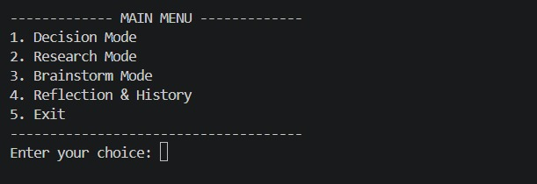

9.2 Decision Mode

The Decision Mode guides the user through a structured decision-making process and displays a summary of the completed session.

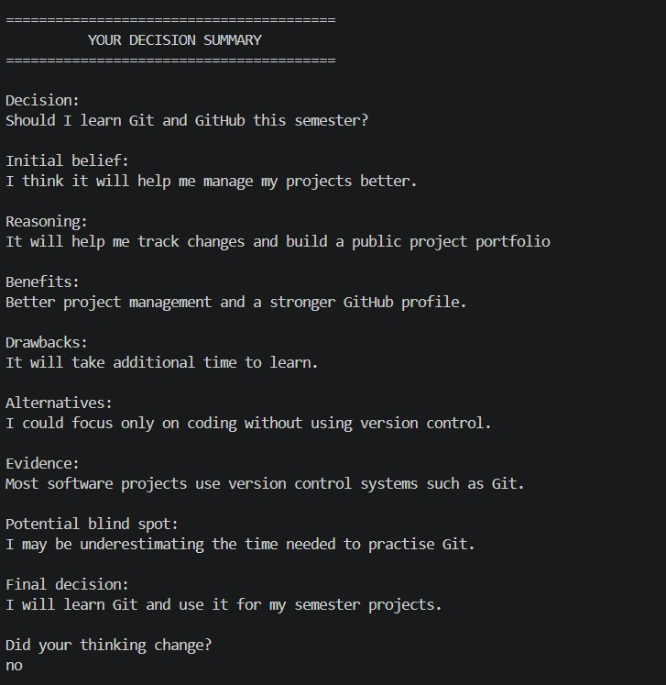
9.3 Research Mode

The Research Mode allows the user to record a research question, existing belief, sources, supporting and challenging evidence, and a conclusion.

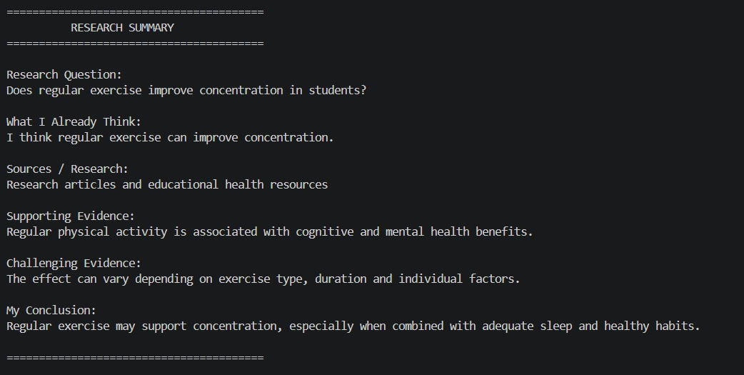
9.4 Brainstorm Mode

The Brainstorm Mode helps the user record ideas, identify constraints, evaluate feasible ideas, and select a direction.

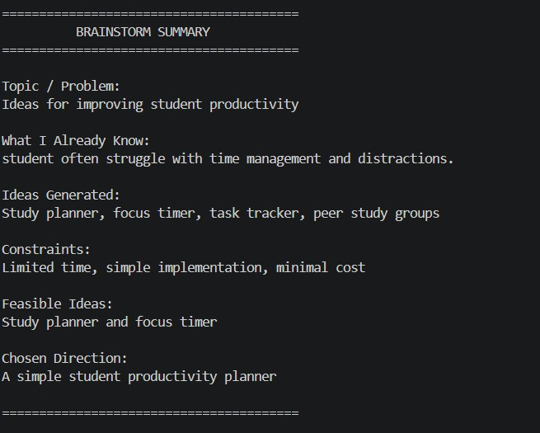
9.5 Reflection & Current History

The current history feature displays sessions created during the current program execution.

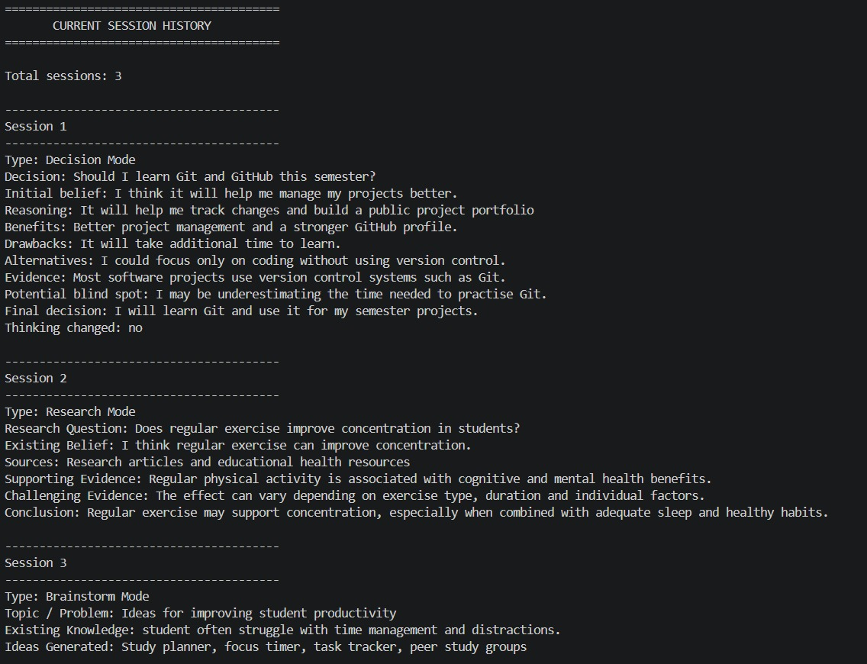
9.6 Persistent Saved History

The saved history feature reads previously stored sessions from the local text file, demonstrating persistent storage using Java File I/O.

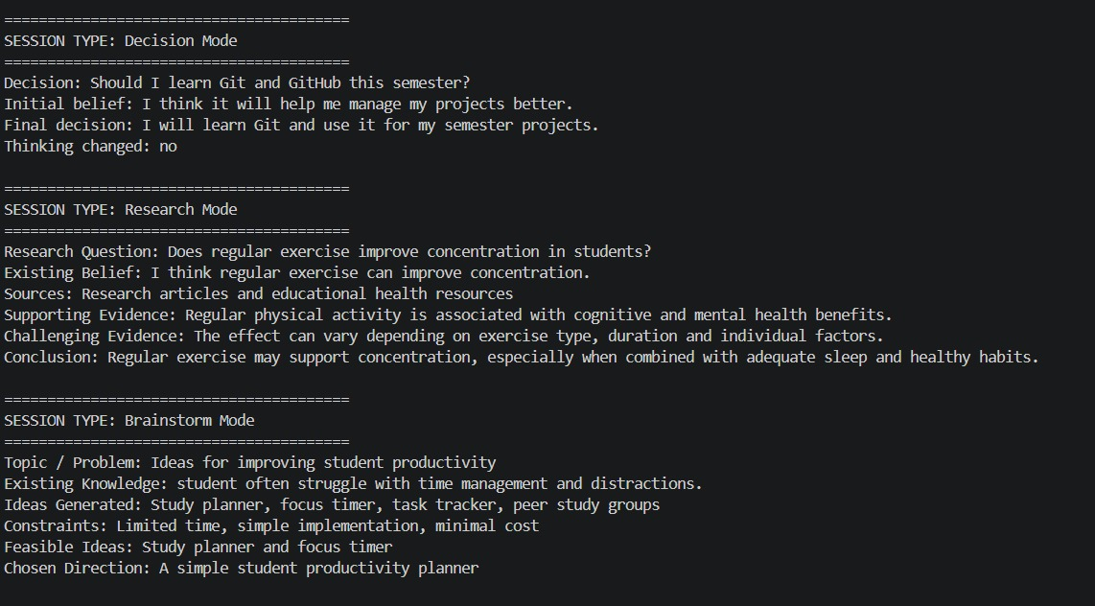
9.7 Results

The completed testing demonstrates that the three major functional modes, session history, input validation, and persistent local storage operate as intended.

10. Testing Approach

Testing was performed manually through the command-line interface to verify the major functional modules, input validation, history management, and persistent storage of the UseYourBrain application.

10.1 Functional Testing

Each major feature was executed with valid inputs to verify that the expected workflow and output were produced.

Test Case| Test Performed| Expected Result| Status
Main Menu| Selected each available menu option| Correct functionality was opened| Pass
Decision Mode| Entered valid decision details| Decision session was created and summary was displayed| Pass
Research Mode| Entered valid research details| Research session was created and summary was displayed| Pass
Brainstorm Mode| Entered valid brainstorming details| Brainstorm session was created and summary was displayed| Pass
Current History| Viewed current session history| Sessions created during the current run were displayed| Pass
Saved History| Viewed saved sessions| Previously stored sessions were displayed| Pass
Exit| Selected Exit option| Application terminated normally| Pass

10.2 Input Validation Testing

Invalid inputs were deliberately provided to verify that the application handled common input errors correctly.

Test Case| Input/Action| Expected Result| Status
Invalid Menu Input| Entered non-numeric input such as "abc"| Error message displayed and user was prompted again| Pass
Empty Input| Pressed Enter without entering required information| User was asked to provide a valid response| Pass
Invalid Yes/No Input| Entered a value other than Yes/No| User was prompted to enter a valid response| Pass

10.3 Persistence Testing

Persistence was tested by creating and saving sessions, closing the application, restarting it, and then accessing saved history.

The previously stored sessions were successfully retrieved from "useyourbrain_history.txt", confirming that local file-based persistence was functioning correctly.

10.4 Testing Result

The manual testing process confirmed that the major functional requirements of the application were working as expected. The application successfully handled normal user input, common invalid inputs, session history, and persistent local storage.

11. Challenges Faced

During the development of UseYourBrain, several challenges were encountered while designing, implementing, and testing the application.

11.1 Structuring the Application

One of the initial challenges was deciding how to divide the application into different classes. As the project grew beyond a single functionality, keeping all the code inside "Main.java" would have made the program difficult to manage. The application was therefore reorganized into separate model, service, and utility components.

11.2 Managing Different Session Types

Decision, Research, and Brainstorm modes collect different types of information but need to be handled as sessions within the same application. The "Session" interface was introduced to provide common behaviour while allowing each session class to maintain its own data.

11.3 Input Validation

Handling user input through the command line required additional validation. Empty responses, invalid menu choices, non-numeric input, and invalid Yes/No responses needed to be handled without causing the application to terminate unexpectedly.

11.4 Implementing Persistent Storage

Another challenge was ensuring that completed sessions remained available after the application was closed. Java File I/O was used to append session information to a local text file and read it again when requested.

11.5 Testing the Complete Workflow

Testing individual features was relatively straightforward, but testing the complete workflow required checking different modes, history, invalid inputs, and persistence across multiple program runs. Repeated testing helped identify and correct issues in input handling and session management.

12. Learnings & Key Takeaways

Developing UseYourBrain provided practical experience in applying Java programming concepts to a complete working application.

12.1 Applying Object-Oriented Programming

The project helped strengthen the understanding of classes, objects, interfaces, encapsulation, and separation of responsibilities. Creating separate session and service classes made these concepts more practical than using them only in individual programming exercises.

12.2 Understanding Modular Design

The project demonstrated the importance of dividing a program into smaller components. Separating the model, service, and utility layers made the code easier to understand, test, and modify.

12.3 Working with Java Collections

Using "ArrayList" in "HistoryService" provided practical experience in storing and managing multiple objects dynamically during program execution.

12.4 File Handling and Persistence

Implementing "FileManager" provided hands-on experience with Java File I/O and showed how information can be stored locally and retrieved after an application restart.

12.5 Exception Handling and Validation

The project reinforced the importance of handling invalid input and file-related errors. Proper validation helped prevent common user mistakes from interrupting the application.

12.6 Software Development Practices

The project also provided experience with Git and GitHub, maintaining a structured project repository, writing documentation, testing features, and making incremental changes through commits.

12.7 Independent Problem Solving

Beyond the technical concepts, the project provided practical experience in breaking a larger problem into smaller requirements, designing a workflow, implementing it step by step, and testing the complete system.

13. Future Enhancements

Although the current version of UseYourBrain provides the core functionality required for the project, several improvements could be considered for future versions.

13.1 Graphical User Interface

A graphical interface could be developed to make the application more visually interactive while keeping the existing core logic.

13.2 Database Integration

The current text-file storage could be replaced or extended with a database such as MySQL or SQLite for more structured and scalable storage of sessions.

13.3 User Accounts

User authentication and individual profiles could be introduced so that different users can maintain separate session histories.

13.4 Advanced Reflection and Analytics

Future versions could provide statistics about a user's sessions, such as the number of decisions made, research sessions completed, or how often their initial thinking changed.

13.5 Additional Thinking Modes

More guided activities could be added, such as problem-solving, argument analysis, study planning, and critical-thinking exercises.

13.6 Optional AI Assistance

An optional AI-assisted feature could be introduced in the future where AI is used only after the user's independent thinking process is completed. Such a feature could provide additional perspectives or questions without replacing the user's initial reasoning.

13.7 Cross-Platform Packaging

The application could be packaged more conveniently so that users can run it without manually compiling Java source files through the terminal.

14. References

1. Oracle. Java Documentation. Oracle Corporation.
https://docs.oracle.com/en/java/

2. Oracle. The Java Tutorials – Learning the Java Language. Oracle Corporation.
https://docs.oracle.com/javase/tutorial/

3. GitHub. GitHub Documentation.
https://docs.github.com/

4. Visual Studio Code. Visual Studio Code Documentation. Microsoft.
https://code.visualstudio.com/docs

5. VIT Bhopal University. Programming in Java / Build Your Own Project Course Requirements and Guidelines.

