SQL

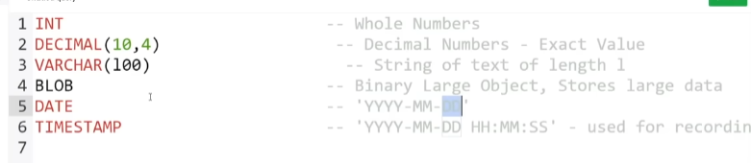

Int is the integer

Decimal –m is the total number of digits before the decimal and n is the number of digits after decimal

VARCHAR (1) :- it means it will store the string of length 1 if we have 100 there in the bracket it will store string upto length of 100

BLOB :- use to store large amount of binary data

DATE :- use to store date

TIMESTAMP :- use for recording

Create database db;

Create table student(

Student_id INT PRIMARY KEY,

Name VARCHAR(20),

Major VARCHAR(20),

);

**OR I can write it as**

Create table student(

Student_id INT,

Name VARCHAR(20),

Major VARCHAR(20),

PRIMARY KEY(student_id)

);

Describe table_name :- shows the structure of a table in sql (blueprint of the table not the data inside it )

Drop table table_name; :- deletes the table

alter table student ADD gpa decimal(2,2); :- add the new coloumn in table

alter table student drop column gpa; :- removes the mentioned column

**INSERTING DATA** :- Insert into table_name (valuestoBeInserted);

Ex:-

INSERT INTO student VALUES(

1,"Aadrika",'Photography'

2,”Apoorva”,’Drawing'

);

Select :- to retrive data from table (it shows the data of the table)

SELECT * FROM table_name;

Also its different from the describe command as describe only shows the structure of the table

**CONSTRAINTS :-**

EX :-

name VARCHAR(20) NOT NULL,

major VARCHAR(20) UNIQUE

UPDATE AND DELETE :-

UPDATE student

SET major='Dance'

WHERE major='Dancing';

SELECT * FROM student;

DELETE FROM STUDENT

WHERE student_id=4 AND name=”Aditi”; //with condition

DELETE FROM table_name //will delete all the rows from table

**BASIC QUERIES**