**REACT- Tutorial**

**Props and prop types:-**

**what does it imports , the component Navbar or the function defined inside the Navbar component?**

To determine what gets imported from a module (in this case, the Navbar component), you need to look at how the module is structured. Specifically, you should check what is being exported using the export statement.

Here's an example of a simple Navbar component:

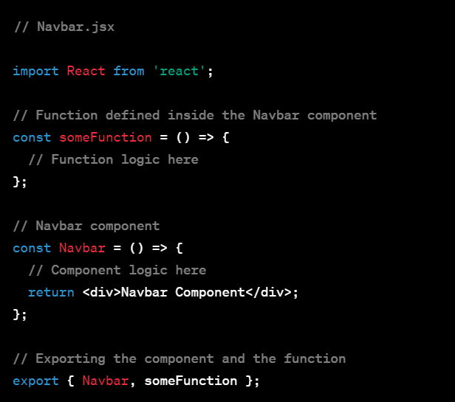

**In this example, both the Navbar component and the someFunction are exported from the module. When you import this module elsewhere, you can choose what to import.**

**For example:**

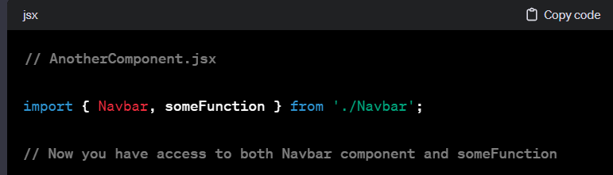

If you only want to import the Navbar component and not the someFunction, you can do:

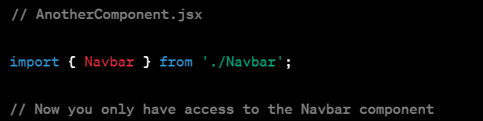

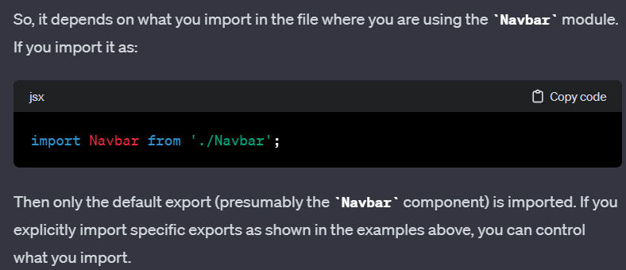

**Prop Type :-** prop ka type define krna

1st prop type use krne ke liye ek package install krna padta hai

🡨ye wala

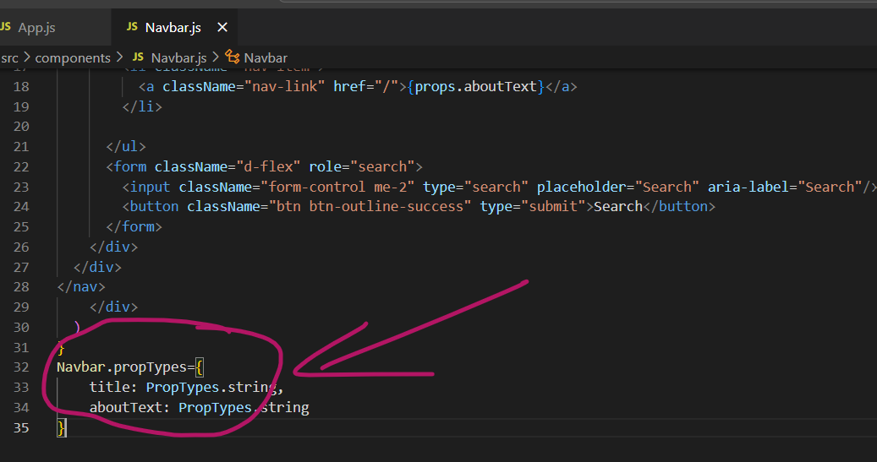

Yahaa isRequired likhne se agar in case tum prop ka value set krna bhul gye tph error show krega isse tumko samjh aa jayega ki tumne vaue assign nhi kiya hai

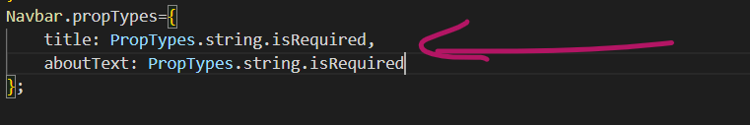

**React State :-**

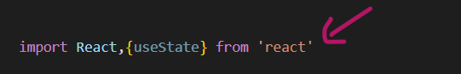

first u need to import this to use state , we call this {useState} a hook

, it lest u use state and other features of react without creating inshort you can use class’s feature in func based react component



Text is the state var, and setText is the function that we will use to update the text(var) value all over the page without reloading and eneter text here us the default value of the Text variable