


Bi-weekly assignment

Module Details
Module Code | UFCFK1-15-0
Module Title | Fundamentals of Data Science
Module Tutors | Kaushal Rimal
Year | 2025-2026
Component/Element Number | PSA/Bi-weekly assignment/Regular
Weighting | 10%

Dates
Submission Date | 17-April-2026
Submission Place | Backboard
Submission Time | 23:59
Submission Notes | Submit Gitlab URL

Submitted By:
Aadrit Thapa
L3 S2 (Section C)

- Create a simple flowchart or diagram to explain the working of Python. The diagram should clearly include input, processing, and output stages. Marks [10]
Output
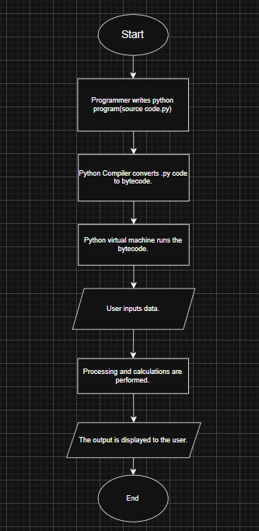
- Write a program to take two integer inputs from the user and display the results of the following operations in a clean format: Marks [2*5]
I. Addition
II. Multiplication
III. Division
IV. Modulus (remainder)
V. Exponentiation
Source Code
#docstring Question 2

'''This program takes two integer inputs from user and displays the results of addition, multiplication, division, modulus(remainder) and exponentiation in a respective order.'''
print(__doc__)
print()
num1 = int(input("Enter the first number :"))
num2 = int(input("Enter the second number:"))

print("\n------- Results -------\n")
print(f'I. Addition = {num1+num2}')
print(f'II. Multiplication = {num1*num2}')
print(f'III.Division = {num1/num2:.2f}')
print(f'IV. Modulus (remainder) = {num1%num2}')
print(f'V. Exponentiation = {num1**num2}')
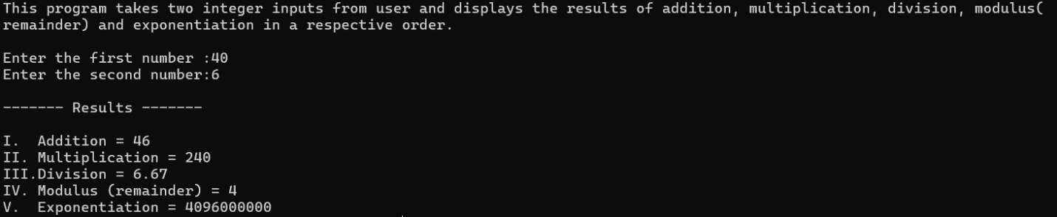
Output

- Write a program that prompts the user to enter a number and determines whether it is positive, even, positive odd, negative, or negative odd. Marks [2*5]
Source Code
#docstring Question 3
'''This program takes input from user and determines whether the number is positive, even, positive odd, negative, or negative odd.'''
print()
print(__doc__)
print()
num = int(input("Enter a number:"))

if num>0:
if num%2==0:
print(f'{num} is positive even.')
else:
print(f'{num} is positive odd.')
elif num<0:
if num%2!=0:
print(f'{num} is negative odd.')
else:
print(f'{num} is negative even.')
else:
print("Invalid input! Please Enter a valid input.")

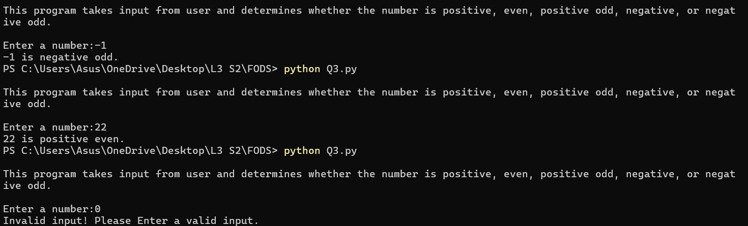
Output

- Write a program to take a single number as input and display: Marks [2*5]
I. Cube of the number
II. Cube root of the number
III. Natural logarithm of the number
IV. Base-2 logarithm of the number
V. The number raised to the power of 6
Source Code
#docstring Question 4
'''This program takes a single number as input and displays cube, cuberoot, natural log, base 2 log and number raised to power 6 of the input number'''
print()
print(__doc__)
print()

num = int(input("Enter a number:"))
n=1000000000
ln_num = n*(num**(1/n)-1)
ln_b2 = n*(2**(1/n)-1)
print("\n------ Results ------\n")
print(f'I. Cube of {num} = {num**3}')
print(f'II. Cube root of {num} = {num**(1/3):.2f}')
print(f'III.Natural logarithm of {num} = {ln_num:.2f}')
print(f'IV. Base-2 logarithm of {num} = {ln_num/ln_b2:.2f}')
print(f'V. {num} raised to the power of 6 = {num**6}')

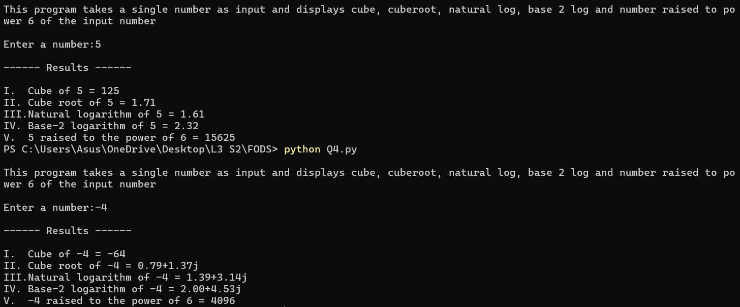
Output

- Write a program to input the marks of 6 subjects. Calculate total, average, percentage, and grade according to the rules below: Marks [2*5]
  - Distinction: 85% or above
  - First Division: 70% and above
  - Second Division: 55% and above
  - Third Division: 45% and above
  - Fail: Below 45%
Source Code
#docstring Question 5

'''This program takes the marks of 6 subjects and calculates total, average, percentage, and grade according to the mentioned rules.'''

print()
print(__doc__)
print()

total = 0
marks_dict = {}

for i in range(6):
sub = input("Enter subject name: ")
m = float(input(f"Enter marks for {sub}: "))
if 0>m>100:
print("Invalid marks! Enter 0-100.")
break
marks_dict[sub] = m
total += m

print("\n------ Marks Obtained ------\n")
for sub, m in marks_dict.items():
print(f"{sub} : {m}")

avg = total / 6
percentage = (total / 600) * 100
print(f"\nTotal = {total}")
print(f"Average = {avg:.2f}")
print(f"Percentage = {percentage:.2f}%")

if percentage >= 85:
print("Grade : Distinction")
elif percentage >= 70:
print("Grade : First Division")
elif percentage >= 55:
print("Grade : Second Division")
elif percentage >= 45:
print("Grade : Third Division")
else:
print("Grade : Fail")

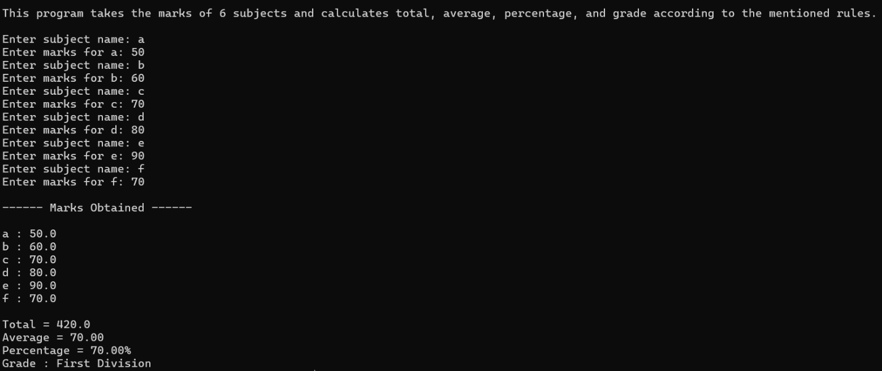
Output

- Write a program to display all prime numbers within a user-defined range. Additionally, print the count of prime numbers in that range along with their sum. Marks [10]
Source Code
#docstring Question 6
'''This program displays all prime numbers within a user-defined range and also keeps a count of the numbers along with their sum.'''

print()
print(__doc__)
print()

low_rng = int(input("Enter the lower range:"))
up_rng = int(input("Enter the upper range:"))
s = 0
p_count = 0
for n in range(low_rng,up_rng+1):
count = 0
i=1
while i<=n:
if n%i==0:
count +=1
i+=1
if count == 2:
print(n)
s += n
p_count+=1
print(f'Prime numbers between {low_rng} and {up_rng} = {p_count}')
print(f'Sum of prime numbers between {low_rng} and {up_rng} = {s}')
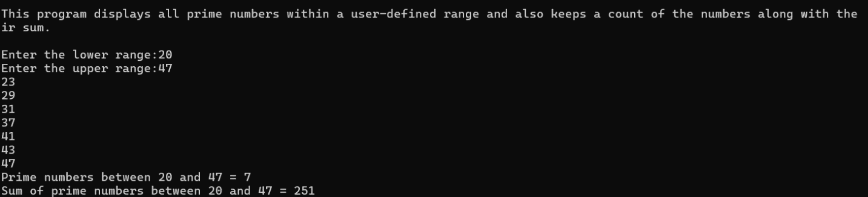
Output

- Write a program to find all numbers between 1000 and 2500 (inclusive) that are divisible by 9 but not by 6. Extend the program so that the range limits (1000 and 2500) can also be entered by the user. Marks [10]
Source Code
#docstring Question 7

'''This program finds all numbers between 1000 and 2500(inclusive) that are divisible by 9 but not by 6. Further the program has been extended such that the user can enter the boundary within which the numbers need to be calculated.'''

print()
print(__doc__)
print()

print("The numbers between 1000 and 2500(inclusive) that are divisible by 9 but not 6 are:")
r=1000
while 2500>=r>=1000:
if r%9 == 0 and r%6!=0:
print(r)
r+=1

while True:
ch= input(("\nDo you want to enter a boundary(y/n)? :")).lower()
if ch != 'y':
break

low_lim = int(input("Enter the starting boundary:"))
up_lim = int(input("Enter the ending boundary:"))

temp = low_lim
if low_lim>up_lim:
break
while(up_lim>=temp>=low_lim):
if temp%9==0 and temp%6!=0:
print(temp)
temp+=1

Output
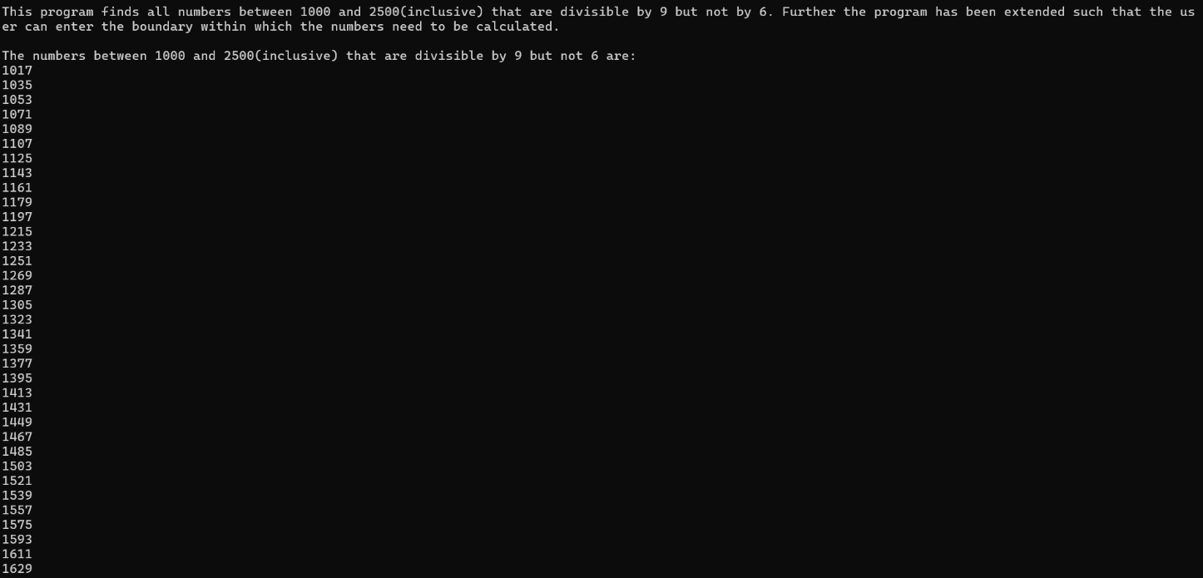
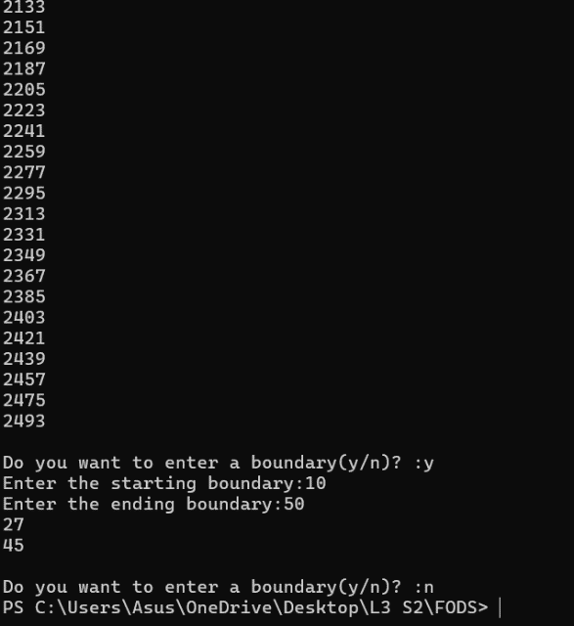
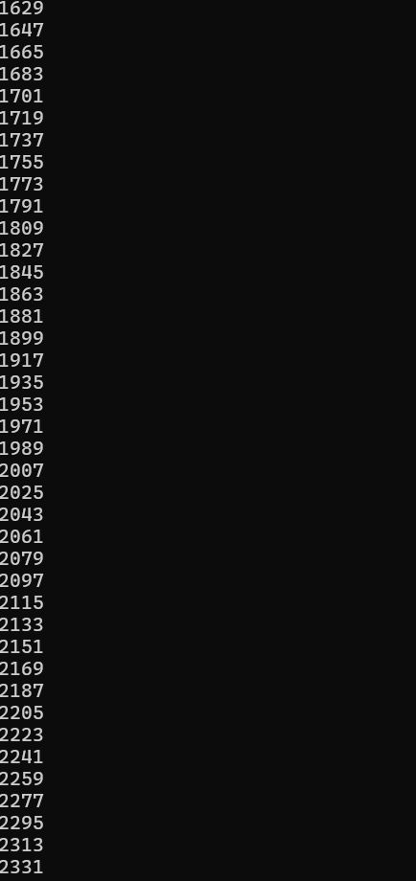
- Write a program to compute the factorial of a number entered by the user. Ensure the input is a valid positive integer. If the user enters anything else, display an error message such as “Invalid input! Please enter a positive integer.” Marks [10]
Source Code
#docstring Question 8

'''This program calculates the factorial of input number and strictly checks whether the number is a valid positive number or not before performing calculations.'''

print()
print(__doc__)
print()
fact = 1
num = int(input("Enter a positive integer to find its' factorial:"))

if num==0:
print(f'The factorial of {num} is {fact}.')
elif num>0:
for i in range(1,num+1):
fact = fact*i
print(f'The factorial of {num} is {fact}.')
else:
print("Invalid input! Please enter a positive integer.")
Output

- Write a menu-driven program that repeatedly asks the user for numbers and computes the separate sums of positive and negative numbers. Continue until the user chooses to exit the program. Marks [10]
Source Code
#docstring Question 9

'''This program asks user for numbers and finds separate sum of positive and negative numbers until user chooses to exit the program'''

print()
print(__doc__)
print()

p_sum = 0
n_sum = 0

while True:
print("\n1.Enter a number\n2.Exit")
opt = int(input("\nSelect an option:"))
if opt==1:
num=int(input("Enter a number:"))
if num>0:
p_sum+=num
elif num<0:
n_sum+=num

elif opt==2:
break
else:
print("Invalid Input!")
print(f'Sum of positive numbers = {p_sum}')
print(f'Sum of negative numbers = {n_sum}')

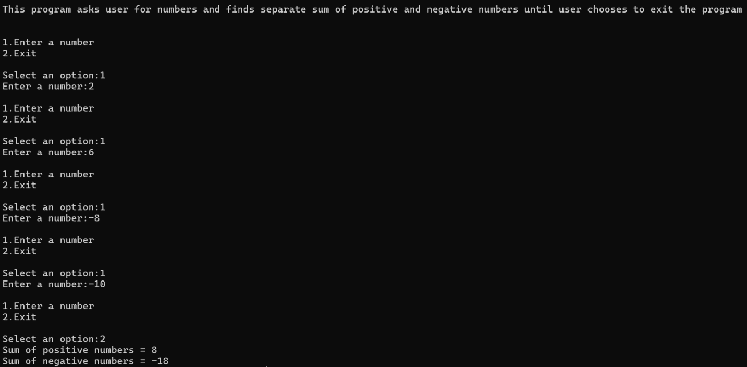
Output

- Write a number guessing game in Python with the following rules: Marks [ 2 * 5 = 10]
- The computer generates a random number between 1 and 50.
- The user must guess the number.
- After each guess, the program tells the user whether the guess is too high, too low, or correct.
- The user gets a maximum of 7 attempts.
- If the user does not guess correctly within the attempts, display “Better luck next time!” and end the game.
Source Code
#docstring Question 10
'''This program generates random number and is a guessing game sample'''

print()
print(__doc__)
print()

import random
while True:
r_num=random.randint(1,50)
guess=7
for attempt in range(1,8):
num = int(input("\nEnter your guess:"))
guess-=1
if num<r_num:
print("Too Low")
elif num>r_num:
print("Too High")
elif num==r_num:
print(f'Congratulations! You guessed the number. The number was {r_num}')
break
print(f'Remaining Guesses = {guess}')
if guess == 0:
print("Better luck next time!")

break

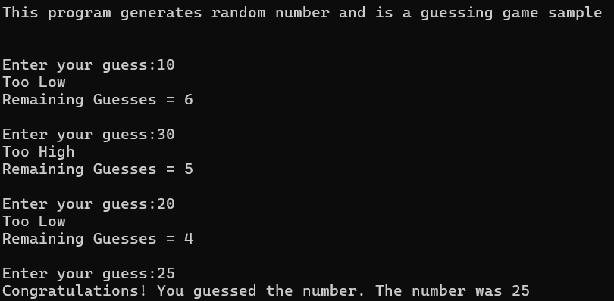
Output
