


Module Details
Module Code | UFCFK1-15-0
Module Title | Fundamentals of Data Science
Module Tutors | Kaushal Rimal
Year | 2025-2026
Component/Element Number | PSA/Bi-weekly assignment/Regular
Weighting | 10%

Dates
Submission Date | 17-April-2026
Submission Place | Backboard
Submission Time | 23:59
Submission Notes | Submit Gitlab URL

Submitted By:
Aadrit Thapa
L3 S2 (Section C)

Each question carries 10 marks.
- Write a program to create a function that accepts two integers and displays their sum, difference, product, quotient values. Marks [10 marks]
Description
This program defines a function that accepts two integer values as parameters. Inside the function, it calculates the sum, difference, product, and quotient of the two numbers. The results are then displayed clearly to the user. This demonstrates the use of functions, parameters, and basic arithmetic operations.
Source Code
#docstring Question 1
'''
Calculates and displays the sum, difference, product, and quotient of two numbers

Parameters:
num1 (int) : First number
num1 (int) : Second number
'''
print(__doc__)
print()
def calc(num1,num2):
print(f'Sum = {num1 + num2}')
print(f'Difference = {num1 - num2}')
print(f'Product = {num1*num2}')
if num2!=0:
print(f'Quotient = {num1/num2:.2f}')
else:
print(f'Quotient = undefined[division by zero]')

a= int(input("Enter the first number:"))
b = int(input("Enter the second number:"))

calc(a,b)

Output
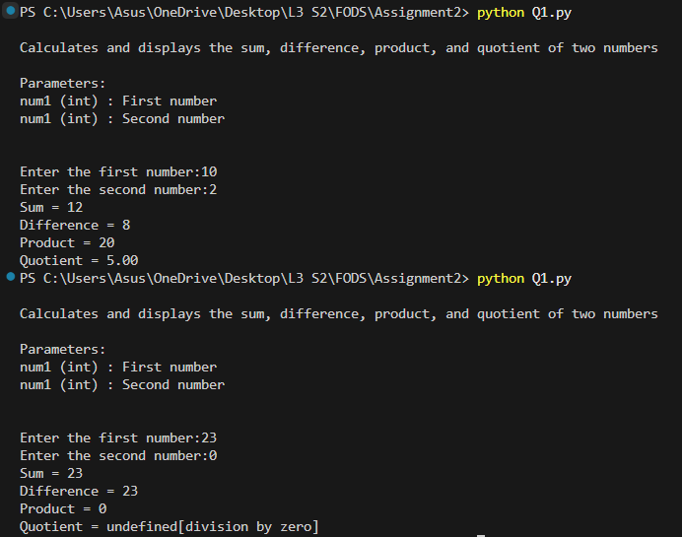

- Write a program to implement separate functions for the following mathematical operations. Each function should take two user inputs as parameters, operate, and return the result. Display the results clearly with proper formatting. Marks [2*5 = 10]
I. Addition
II. Multiplication
III. Division
IV. Floor Division
V. Exponentiation
Description
This program implements five different functions, each performing a specific mathematical operation: addition, multiplication, division, floor division, and exponentiation. Each function takes two user inputs as parameters, performs the required calculation, and returns the result. The outputs are displayed in a well-formatted manner, demonstrating modular programming and code reusability.
Source Code
#docstring Question 2
"""Perform addition, multiplication, division, floor division and exponentiation on two numbers"""
print(__doc__)
print()

def add(num1,num2):
return num1+num2
"""Returns the sum of two numbers"""
def product(num1,num2):
return num1*num2
"""Returns the product of two numbers"""
def div(num1,num2):
"""Returns the division of num1 by num2. Returns none if num2 is zero"""
if num2!=0:
return num1/num2
else:
return None
def floor_div(num1,num2):
"""Returns the floor division of num1 by num2. Returns none if num2 is zero"""
if num2!=0:
return num1//num2
else:
return None
def exponential(num1,num2):
"""Returns num1 raised to the power of num2"""
return num1**num2

a = float(input("Enter the first number:"))
b = float(input("Enter the second number:"))

r1 = div(a,b)
r2 = floor_div(a,b)
print("-----Results-----")
print(f'I. Addition : {add(a,b)}')
print(f'II. Multiplication : {product(a,b):.2f}')
if r1 is None:
print(f'III.Division : Undefined [Division by zero]')
else:
print(f'III.Division : {r1:.2f}')
if r2 is None:
print(f'IV. Floor Division : Undefined [Division by zero]')
else:
print(f'IV. Floor Division : {r2:.2f}')
print(f'V. Exponentiation : {exponential(a,b):.2f}')

Output
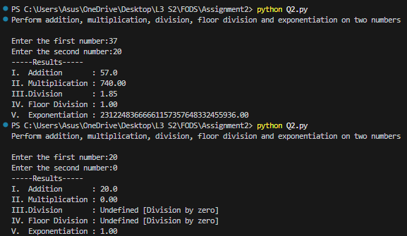
- Write a program to create a function that accepts one string as input and checks whether it is Armstrong or not. Display the output neatly. Marks [10]
Description
This program defines a function that takes a string input and checks whether it represents an Armstrong number. The function converts the string into a number and calculates the sum of its digits raised to the power of the number of digits. If the result equals the original number, it is an Armstrong number. The result is displayed neatly.
Source Code
#docstring Question 3
"""Check whether a given number is armstrong or not"""
print(__doc__)
print()

def armstrong(num_string):
if not num_string.isdigit():
return f'Invalid Input! Enter a numeric value.'
num = int(num_string)
power = len(num_string)
total = 0

for count in num_string:
total += int(count) ** power

if total == num:
return f'{num_string} is armstrong.'
else:
return f'{num_string} is not armstrong.'

num_s = input("Enter a numeric value:")
result = armstrong(num_s)
print(result)

Output
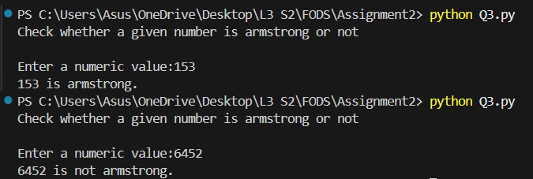

- Write a function that takes a list of numbers as input and returns a dictionary showing how many times each number occurs in the list. Test this function with at least three different lists. Marks [10]
Description
This program defines a function that accepts a list of numbers and returns a dictionary showing how many times each number appears in the list. The function iterates through the list and counts occurrences using a dictionary. It is tested with at least three different lists to verify correctness. This demonstrates dictionary usage and iteration.
Source Code
#docstring Question 4
"""Count how many times each number occurs in a list"""
print(__doc__)
print()

def counts(numbers):
dictionary = {}

for n in numbers:
if n in dictionary:
dictionary[n]+=1
else:
dictionary[n] = 1
return dictionary

li1 = [1,2,3,4,5]
li2 = [2,4,3,5,1,10]
li3 = [5,6,7,11,9]

for i, li in enumerate([li1,li2,li3],start = 1):
print(f'\nList {i} : {li}')
res = counts(li)
for k,v in res.items():
print(f'{k} occurs {v} times.')

Output
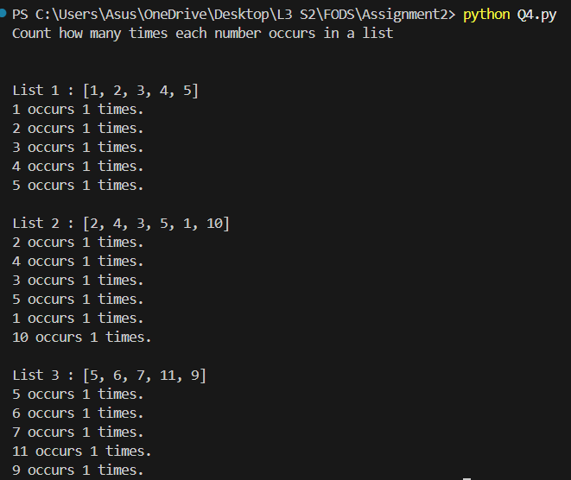

- Write a function that accepts a list of student names and returns the names sorted in reverse alphabetical order. Marks [10]
Description
This program defines a function that accepts a list of student names and returns the list sorted in reverse alphabetical order. It uses built-in sorting techniques to arrange the names from Z to A. This demonstrates list manipulation and sorting concepts.
Source Code
#docstring Question 5
"""Sort a list of student names in reverse alphabetical order."""
print(__doc__)
print()

def sort_li(names):
li1 = sorted(names, reverse=True)
return li1

details = []
rng = int(input("Enter the number of details you want to input:"))
for i in range(rng):
name = input("Enter student's name:")
details.append(name)

final_li = sort_li(details)

print("List in Reverse alphabetical order:")
for n in final_li:
print(n)
Output
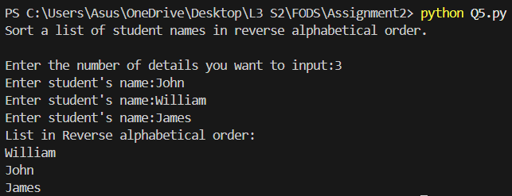
- Write a function that accepts two parameters: a list of countries and the country to be searched. The function should return the index of the country if found. Otherwise, it should return the message “Not Found in List”. Marks [10]
Description
This program defines a function that accepts a list of countries and a country name to search. The function checks whether the given country exists in the list. If found, it returns the index of that country; otherwise, it returns the message “Not Found in List”. This demonstrates searching and conditional statements.
Source Code
#docstring Question 6
"""Search for a country in a list and return its index if found"""
print(__doc__)
print()

def li(countries_list,country_to_find):
if country_to_find in countries_list:
return countries_list.index(country_to_find)
return f'Not found in list'

countries = []
rng = int(input("Enter the number of countries you want to input:"))
for i in range(rng):
name = input("Enter country's name:")
countries.append(name)

searched_name = input("Enter a country's name to search its' index:")
result = li(countries,searched_name)

print(f'Index of {searched_name} : {result}')

Output
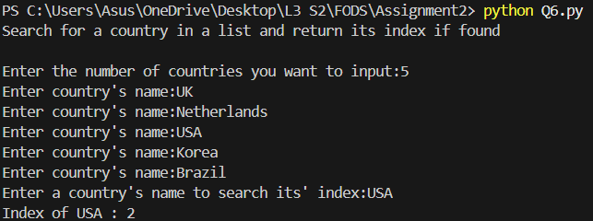

- Write a function key_value(sentence) that takes a sentence as input and returns a dictionary showing how many times each character (excluding spaces) occurs. Marks [10]
Description
This program defines a function key_value(sentence) that takes a sentence as input and returns a dictionary containing the frequency of each character, excluding spaces. The function iterates through each character and updates the dictionary accordingly. This demonstrates string handling and dictionary operations.
Source Code
#docstring Question 7
"""Count the occurrences of each character in a sentence (excluding spaces)."""
print(__doc__)
print()

def key_value(sentence):
dictionary = {}
for char in sentence:
if char!= ' ':
if char in dictionary:
dictionary[char] += 1
else:
dictionary[char]=1
return dictionary

sent = input("Enter a sentence:").lower()
result = key_value(sent)

print(f'Input Sentence : {sent}')
for k,v in result.items():
print(f'{k} occurs {v} times.')

Output
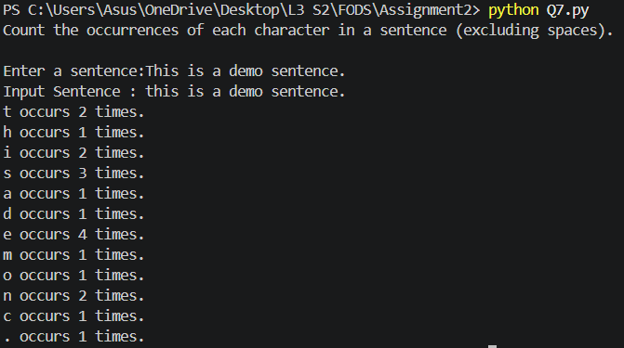

- Write a program to accept a list of numbers from the user and return a new list with all duplicates removed and the numbers sorted in ascending order. Marks [10]
Description
This program accepts a list of numbers from the user and removes duplicate values. It then sorts the resulting list in ascending order. The final list is displayed. This demonstrates list processing, use of sets (or logic), and sorting techniques.
Source Code
#docstring Question 8
"""Remove duplicates from a list of numbers and return it sorted in ascending order."""
print(__doc__)
print()

def function(numbers):
return sorted(set(numbers))
nums = []
rng = int(input("Enter the number of details you want to input: "))
for i in range(rng):
num = int(input("Enter a number:"))
nums.append(num)

sorted_li = function(nums)
print(f"Final List after removing duplicates and arranging data: {sorted_li}")
Output
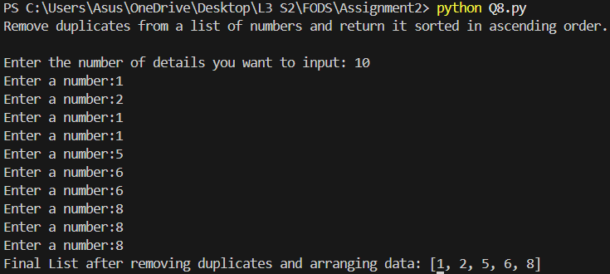
- Write a program to ask details of 3 movies (title, director, release year, rating). Store them in a dictionary and display the information in a well-formatted manner. Marks [10]
Description
This program collects details of three movies, including title, director, release year, and rating. Each movie is stored as a dictionary, and all movies are stored in a list. The program then displays the information in a well-formatted way. This demonstrates structured data storage using dictionaries and lists.
Source Code
#docstring Question 9
"""Accepts details of 3 movies (title, director, release year, rating),
store them in dictionaries, and display them in a well-formatted manner."""
print(__doc__)
print()
m = []
for i in range(3):
title = input("Enter the title of the movie: ")
direct_name = input("Enter the name of the director: ")
r_year = int(input("Enter the release year: "))
rate = float(input("Enter the ratings of the movie: "))

movies = {
"Title" : title,
"Director" : direct_name,
"Release year" : r_year,
"Rating" : rate
}

m.append(movies)

for i,movie in enumerate(m, start = 1):
print(f'\nMovie {i}:')
print(f"Title : {movie['Title']}")
print(f"Director : {movie['Director']}")
print(f"Release year : {movie['Release year']}")
print(f"Ratings : {movie['Rating']}")
print("-" *15)

Output
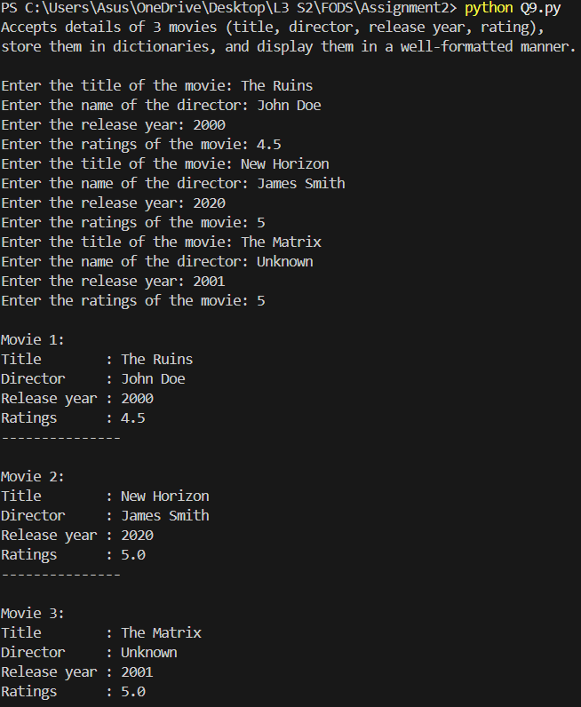

- Create a program to design a dice guessing game with the following specifications: Marks [10]
I. The dice has values from 1 to 6.
II. The program should generate a random value for the dice roll.
III. The player should guess the dice value.
IV. If the guess is correct, show a smiling face.
V. If the guess is off by 1 (e.g., dice = 5, guess = 4), show a neutral face.
Description
This program simulates a dice guessing game. The program randomly generates a number between 1 and 6 to represent the dice roll. The user is asked to guess the value. If the guess matches the dice value, a smiling face is displayed. If the guess is off by 1, a neutral face is shown; otherwise, the user loses. This demonstrates random number generation, conditional logic, and user interaction.
Source Code
#docstring Question 10
"""Dice Guessing Game:
- Dice calues range from 1 to 6.
- Player guesses the dice value.
- Show 😊 if guess is correct.
- Show 😐 if guess is off by 1.
- Show dice value if guess is incorrect."""

print(__doc__)
print()
import random
dice = random.randint(1,6)
guess = int(input("Enter your guess:"))

if 0<guess<7:
if guess == dice:
print("😊")
elif abs(guess- dice) == 1:
print("😐")
else:
print(f"GameOver! The value was {dice}")
else:
print("Invalid Input! Enter a valid guess")

Output
