


Module Details

Module Code | UFCFK1-15-0
Module Title | Fundamentals of Data Science
Module Tutors | Kaushal Rimal
Year | 2025-2026
Component/Element Number | PSA/Bi-weekly assignment/Regular
Weighting | 10%

Dates
Submission Date | 17-April-2026
Submission Place | Backboard
Submission Time | 23:59
Submission Notes | Submit Gitlab URL

Submitted By:
Aadrit Thapa
L3 S2 (Section C)

Questions
- Write a program to read a file “records.csv” and display its contents. The fields to read are: student_name, roll_no, program, year, and group. (10 marks)
Description:
This program reads data from a CSV file named “records.csv” and displays its contents in a structured format. It extracts fields such as student name, roll number, program, year, and group using Python’s CSV module. The program demonstrates how file reading operations are performed and how data can be presented clearly to the user.
Source Code
#docstring Question1
"""This program reads from a CSV file named 'records.csv' and displays its contents.
The fields include student_name, roll_no, program, year, and group.
Each record is read using csv.reader and printed in a formatted way.
"""
print(__doc__)
print()
import csv
with open("records.csv","r") as file:
line = csv.reader(file)
next(line)
for i in line:
print(f'Student Name : {i[0]}')
print(f'Roll Number : {i[1]}')
print(f'Program : {i[2]}')
print(f'Year : {i[3]}')
print(f'Group : {i[4]}\n')

Output
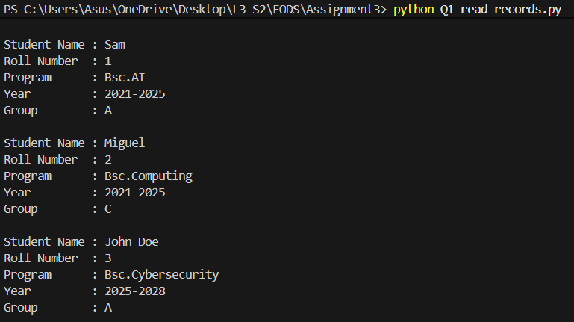

- Write a program to take user details as input and append them to the existing file “records.csv”. The fields to take input are: student_name, roll_no, program, year, and group. (10 marks)
Description
This program takes student details as input from the user, including student name, roll number, program, year, and group, and appends the information to an existing CSV file named “records.csv”. It ensures that new records are added without overwriting existing data, demonstrating the concept of file handling and data storage.
Source Code
#docstring Question2
"""This program takes student details as input from the user and appends them to an existing
csv file named 'records.csv'. The details include student_name, roll_no, program, year and group.
"""
print(__doc__)
print()
print("Enter the following information:\n")
student_name = input(f'Student Name : ')
roll_no = int(input(f'Roll Number : '))
program = (input(f'Program : '))
year = input(f'Year : ')
grp = input(f'Group : ')

import csv
with open("records.csv","a",newline="") as file:
data = csv.writer(file)
data.writerow([student_name, roll_no, program, year, grp])

print(f'{student_name} has been added successfully.')

Output
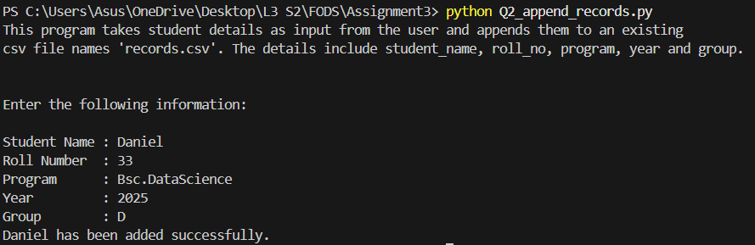

- Write a program to accept a list of integers from the user, perform addition, subtraction, multiplication, and division operations, and save the results into a file with the current date and time. The program should continue until the user decides to exit. When the user chooses to exit, the program should display the contents of the file in a neatly formatted way. (10 marks)
Description
This program accepts a list of integers from the user and performs arithmetic operations such as addition, subtraction, multiplication, and division. The results are saved into a file along with the current date and time. The program runs continuously until the user chooses to exit, after which all stored results are displayed in a well-formatted manner.
Source Code:
#docstring Question 3
"""This program accepts a list of integers from the user and performs arithmetic operations
such as addition, subtraction, multiplication, and division.
The results are stored in a file along woth the current date and time.
The program continues until the user chooses to exit, after which all stored
results are displayed in a formatted manner."""

print(__doc__)
print()

from datetime import datetime
while True:
num = input("Enter numbers separated by comma:")
numbers = [int(x) for x in num.split(",")]

add = sum(numbers)

sub = numbers[0]
for n in numbers[1:]:
sub -= n

product = 1
for n in numbers:
product *= n

div = numbers[0]
for n in numbers[1:]:
if n!= 0:
div /= n
else:
div = "Undefined: Division by zero"
break

dt = datetime.now()
timestamp = dt.strftime("%Y-%m-%d %H:%M:%S")

with open ("results.txt","a") as file:
file.write(f'Time :{timestamp}\n')
file.write(f'Numbers:{numbers}\n')
file.write(f'Sum :{add}\n')
file.write(f"Subtraction:{sub}\n")
file.write(f'Multiplication :{product}\n')
file.write(f'Division :{div}\n')
file.write("-"*20)

choice = input("Do you want to continue(y/n)? : ").lower()
if choice!='y':
break

print("Saved Results successfully")
with open('results.txt','r') as file:
for line in file:
print(line,end="")

Output
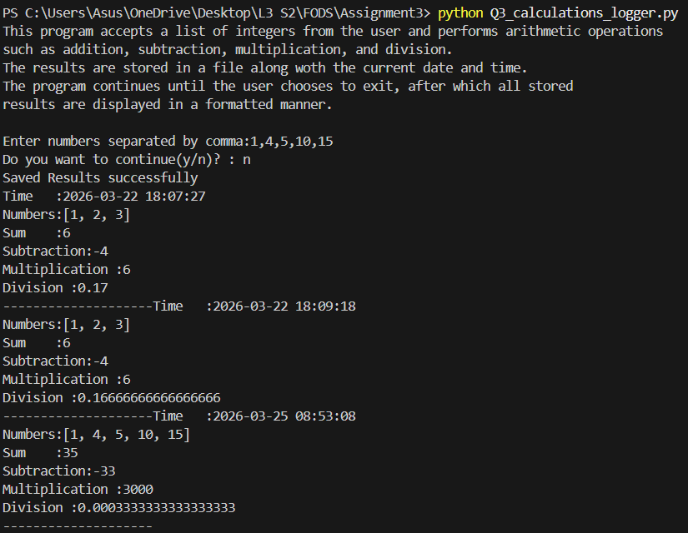

- Write a program that reads from one file and copies the content into another file. The input and output file names should be entered by the user. Use try/except to handle exceptions. Display an error message if the input file does not exist, and also if the output file already exists. (10 marks)
Description
This program reads data from one file and copies it into another file based on user input. It takes the input and output file names from the user and uses exception handling to ensure proper execution. It displays an error message if the input file does not exist or if the output file already exists, demonstrating both file handling and error handling techniques.
Source Code
#docstring Question 4
"""This program reads content from one file and copies it into another file.
The user provides input and output file names. It uses exception handling to
display an error if the input file does not exist or if the output file already exists."""

print(__doc__)
print()

import os
input_file_name = input("Enter the file name to copy its contents:")
output_file_name = input("Enter a new file name to copy the contents into:")

if os.path.exists(output_file_name):
print("Output file already exists")

else:
try:
with open(input_file_name,"r") as file:
data = file.read()

with open(output_file_name,"w") as file:
file.write(data)
print("\nContents copid successfully.")
except FileNotFoundError:
print("Input file doesn't exist")
Output
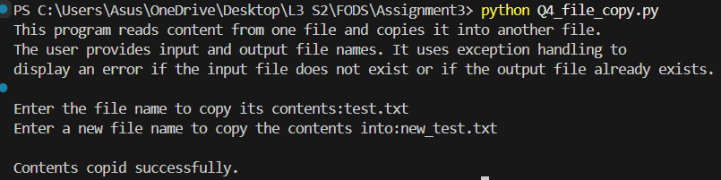

- Create a class Learner with the attributes: roll_no, full_name, address, enrollment_year, program, and group. Instantiate an object of the class to take input for all attributes and display the details. (10 marks)
Description
This program defines a class named “Learner” with attributes such as roll number, full name, address, enrollment year, program, and group. An object of the class is created using user input, and the details are displayed in a structured format. The program demonstrates the basic concepts of object-oriented programming including class creation and object instantiation.
Source Code
#docstring Question 5
"""This program defines a class 'Learner' with attributes such as roll number,
full name, address, enrollment year, program, and group. An object of the class
is created using user input, and the details are displayed."""
print(__doc__)
print()

class Learner:
def __init__(self, roll_no, full_name, address, enrollment_year, program, group):
self.roll_no = roll_no
self.full_name = full_name
self.address = address
self.enrollment_year = enrollment_year
self.program = program
self.group = group

def display(self):
print("\nDetails:")
print(f"Roll Number : {self.roll_no}")
print(f"Full Name : {self.full_name}")
print(f"Address : {self.address}")
print(f"Enrollment year : {self.enrollment_year}")
print(f"Program : {self.program}")
print(f"Group : {self.group}")

print("Enter Details:")
roll_no = int(input("Enter roll number:"))
full_name = input("Enter full name:")
address = input("Enter address :")
enrollment_year = int(input("Enter enrollment year:"))
program = input("Enter program :")
group = input("Enter group :")

val = Learner(roll_no, full_name, address, enrollment_year, program, group)

val.display()

Output
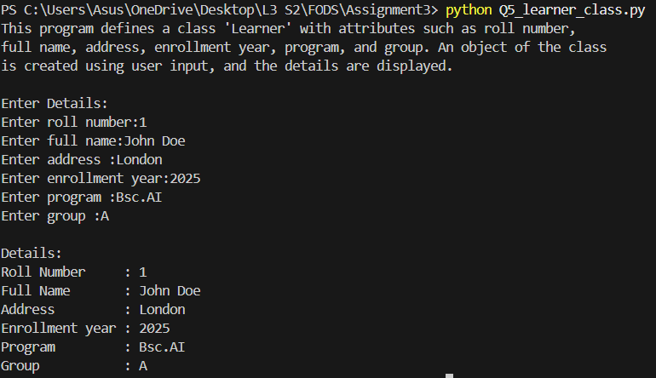

- Write a program to create a class called Dish with attributes such as: dish_id, dish_name, ingredients, and instructions. Create another class called Cookbook to manage a collection of dishes. (10 marks)
Description
This program defines a class called “Dish” to represent individual dishes and a class called “Cookbook” to manage a collection of dishes. It provides functionality to add, view, search, update, and remove dishes through a menu-driven interface. The program demonstrates the use of classes, objects, and list operations in managing data.
Source Code
#docstring Question 6
"""This program defines a class 'Dish' and a class 'Cookbook' to manage a collection
of dishes. It allows adding, viewing, searching, updating, and removing dishes
using a menu-driven approach."""

print(__doc__)
print()

class Dish:
def __init__(self, dish_id, dish_name, ingredients, instructions):
self.dish_id = dish_id
self.dish_name = dish_name
self.ingredients = ingredients
self.instructions = instructions

class Cookbook:
def __init__(self):
self.dishes = []

def add_dishes(self,dish):
self.dishes.append(dish)
print("Dish added successfully")

def show_dishes(self):
if not self.dishes:
print("No dishes available,")
for num in self.dishes:
print(f"ID : {num.dish_id}")
print(f"Name : {num.dish_name}")
print(f"Ingredients : {num.ingredients}")
print(f"Instructions: {num.instructions}")

def search_dishes(self, name):
found = False
for num in self.dishes:
if num.dish_name == name:
print(f"Dish Found : {num.dish_name}")
found = True
if not found:
print("Dish not found!")

def remove_dishes(self, dish_id):
for num in self.dishes:
if num.dish_id == dish_id:
self.dishes.remove(num)
print("Dish removed successfully.")
return
print("Invalid dish ID.")

def update_dishes(self, dish_id):
for num in self.dishes:
if num.dish_id == dish_id:
num.dish_name = input("Enter new name: ")
num.ingredients = input("Enter new ingredients: ")
num.instructions = input("Enter new instructions: ")
print("Dish updated successfully.")
return
print("Invalid dish ID.")

cookbook = Cookbook()
while True:
print("\nSelect an option: ")
print(f"1. Add dishes")
print(f"2. Show all dishes")
print(f"3. Remove a dish")
print(f"4. Update a dish")
print(f"5. Search a dish")
print("6. Exit")
opt = int(input("Enter your choice(1-5): "))

if opt == 1:
rng = int(input("Enter the no.of dishes you want to input:"))
for i in range(rng):
id= int(input("Enter dish id:"))
name = input("Enter dish name:")
ingredients = input("Enter ingredients :")
instructions = input("Enter instructions:")
dish = Dish(id, name, ingredients, instructions)
cookbook.add_dishes(dish)

elif opt == 2:
cookbook.show_dishes()

elif opt == 3:
dish_id = int(input("Enter dish ID to remove: "))
cookbook.remove_dishes(dish_id)

elif opt == 4:
dish_id = int(input("Enter dish ID to update: "))
cookbook.update_dishes(dish_id)

elif opt == 5:
name = input("Enter dish name to search: ")
cookbook.search_dishes(name)

elif opt == 6:
break
else:
print(f"Invalid input!")
break

Output
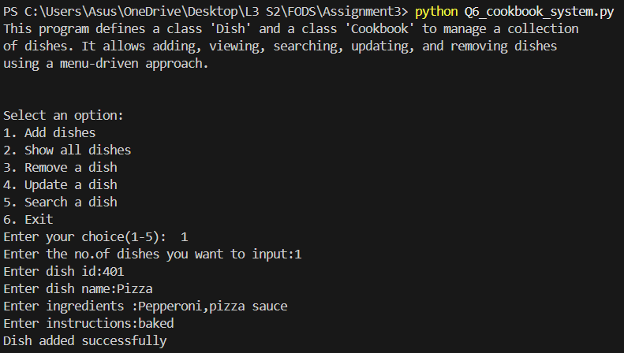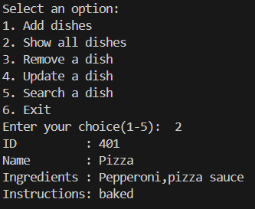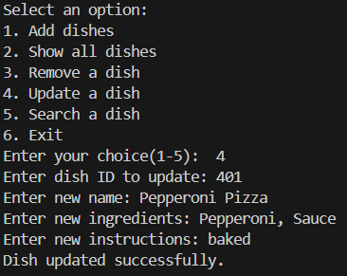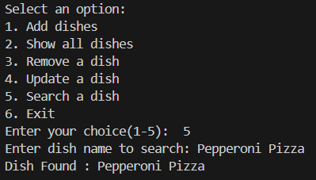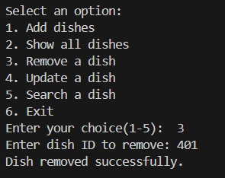

- Write a program to create a class called Staff with attributes such as: emp_id, full_name, address, phone_number, marital_status, dependents, and salary. Instantiate this class for multiple staff members and write the data into a file “staff.csv”. The program should also allow the user to view the list of staff and their details. Use the concept of try/except in the program. (20 marks)
Description
This program creates a class named “Staff” to manage employee details such as employee ID, full name, address, phone number, marital status, dependents, and salary. It allows the user to input multiple staff records and stores them in a CSV file named “staff.csv”. The program also provides functionality to view stored records and uses exception handling to handle file-related errors.
Source Code
#docstring Question 7
"""This program defines a class 'Staff' to manage employee details such as emp_id, full_name,
address, phone_number, marital_status, dependents, and salary.
Multiple staff records are writeen to a CSV file 'staff.csv', and
the user can view the stored data. Exception handling is used for file operations."""

print(__doc__)
print()

import csv
class Staff:
def __init__(self,emp_id,full_name,address,phone_number,marital_status,dependents,salary):
self.emp_id = emp_id
self.full_name = full_name
self.address = address
self.phone_number = phone_number
self.marital_status = marital_status
self.dependents = dependents
self.salary = salary

def add_details(self):
rng = int(input("Enter the number of details you want to input:"))
for i in range(rng):
id = int(input("\nEnter employee ID : "))
fN = input("Enter full name of the employee : ")
add = input("Enter the address : ")
pN = int(input("Enter the phone number : "))
mS = input("Enter the marital status : ")
dS = int(input("Enter the no. of dependents : "))
Sal = float(input("Enter the salary : "))

with open("staff.csv","a",newline = "") as file:
line = csv.writer(file)
line.writerow([id,fN,add,pN,mS,dS,Sal])
print("Details added successfully.")

def show_details(self):
try:
with open("staff.csv","r") as file:
data = csv.reader(file)
for l in data:
print(f"Employee ID : {l[0]}")
print(f"Name : {l[1]}")
print(f"Address : {l[2]}")
print(f"Phone Number : {l[3]}")
print(f"Marital status: {l[4]}")
print(f"Dependents : {l[5]}")
print(f"Salary : £{l[6]}\n")
except Exception as a:
print("Error: File not found!")

obj = Staff(0, "", "", "", "", 0, 0) #constructor
while True:
print("\n---- Menu -----\n")
print("1. Add Details")
print("2. View Details")
print("3. Exit")

ch = int(input("Select an option (1-3): "))
if ch == 1:
obj.add_details()
elif ch == 2:
obj.show_details()
elif ch == 3:
break
else:
print("Invalid input!")

Output
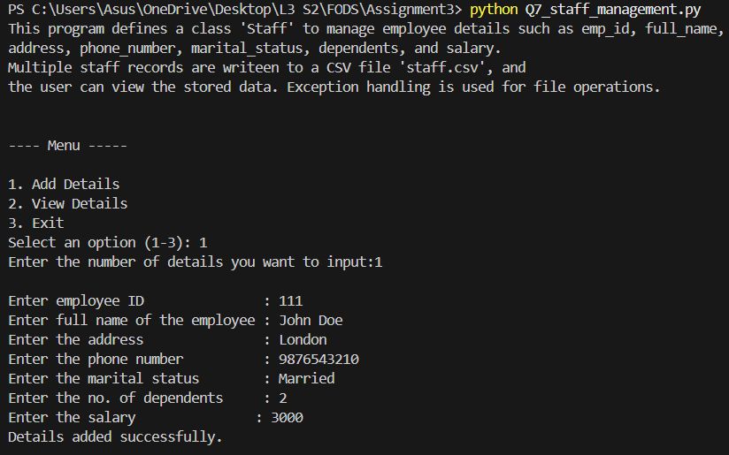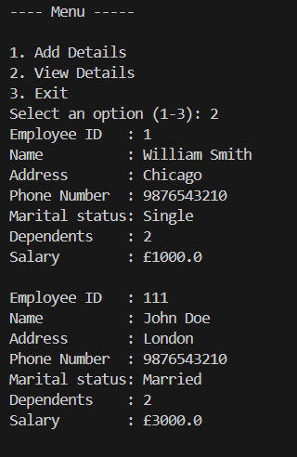

- Write a program to design a basic library management system with functionalities such as: borrow a book, return a book, and search for a book. Use OOP concepts to create necessary classes and apply OOP features (like encapsulation/inheritance if applicable). For storing book details, use file handling along with exception handling. (20 marks)
Description
This program implements a basic library management system using object-oriented programming concepts. It allows users to view available books, add new books, borrow books, return books, and search for books. The program uses file handling to store book details in a CSV file and applies exception handling to ensure smooth operation and data reliability.
Source Code
#docstring Question 8
"""This program implements a basic Library Management system using OOP.
It allows users to add, view, borrow, return, and search for books.
Book details are stored in a CSV file, and file handling along with exception
handling is used to manage data persistence."""

print(__doc__)
print()

import csv
class Book:
def __init__(self,book_id,title,author,year,available = True):
self.book_id = book_id
self.title = title
self.author = author
self.year = year
self.available = available
class Library:
def __init__(self):
self.books = []
self.load()

def add(self):
rng = int(input("Enter the no. of books you want to add: "))
for i in range(rng):
book_id = int(input("Enter the book id : "))
title = input("Enter the title of the book : ")
author = input("Enetr the author of the book : ")
year = int(input("Enter the year of publication : "))

new_book = Book(book_id,title,author,year,True)
self.books.append(new_book)
self.save()
print("New book(s) added successfully.")

def load(self):
try:
with open("books.csv","r") as file:
line = csv.reader(file)
next(line)
for l in line:
book_id = int(l[0])
title = l[1]
author = l[2]
year = int(l[3])
available = l[4] == "True"
self.books.append(Book(book_id,title,author,year,available))
except FileNotFoundError:
print("books.csv not found. ")
def save(self):
with open("books.csv","w", newline ="") as file:
write = csv.writer(file)
write.writerow(["Book ID","Title","Author","Year","Available"])
for book in self.books:
write.writerow([book.book_id, book.title, book.author, book.year, book.available])

def borrow(self,book_id):
for book in self.books:
if book.book_id == book_id:
if book.available:
book.available = False
self.save()
print(f'{book.title} borrowed successfully.')
else:
print("Book already borrowed")
return
print("Book not found.")

def search(self,title):
found = False
for book in self.books:
if book.title.lower() == title.lower():
print(f"Book found : {book.title}")
print(f"Author : {book.author}")
found = True
break
if not found:
print(f"No books with the title {title} found.")

def retrn(self,book_id):
for book in self.books:
if book.book_id == book_id:
if not book.available:
book.available = True
self.save()
print(f'{book.title} returned successfully.')
else:
print("Book already returned")
return
print("Book not found.")

def show(self):
if not self.books:
print("No books available in the library.")
return
print("\n----- List of Books -----\n")
for book in self.books:
status = "Available" if book.available else "Borrowed"
print(f'ID : {book.book_id}')
print(f'Title : {book.title}')
print(f'Author : {book.author}')
print(f'Year : {book.year}')
print(f'Status : {status}\n')
library = Library()
while True:

print("\n----- Library Management System -----\n")
print("1. Add new books")
print("2. View all books")
print("3. Borrow a book")
print("4. Return a book")
print("5. Search a book")
print("6. Exit")

ch = int(input("Select an action:"))

if ch == 1:
library.add()
elif ch == 2:
library.show()
elif ch == 3:
book_id = int(input("Enter book id to borrow : "))
library.borrow(book_id)

elif ch == 4:
book_id = int(input("Enter book id to return : "))
library.retrn(book_id)

elif ch == 5:
title = input("Enter book title to find: ")
library.search(title)

elif ch == 6:
print("Thank you for trying this library management system.")
break
else:
print("Invalid input!")
Output
