


Assessment Brief

Module Details

Module Code | UFCFK1-15-0
Module Title | Fundamentals of Data Science
Module Tutors | Kaushal Rimal
Year | 2025-2026
Component/Element Number | PSA/Bi-weekly assignment/Regular
Weighting | 10%

Dates
Submission Date | 17-April-2026
Submission Place | Backboard
Submission Time | 23:59
Submission Notes | Submit Gitlab URL

Submitted By:
Aadrit Thapa
L3 S2 (Section C)
Questions
- Write a program to generate a NumPy array of numbers (e.g. [10, 20, 30, 40, 50]). Perform the following array operations: (5*3 = 15 marks)
a) Find the total sum of elements.
b) Calculate the mean value of the array.
c) Identify the largest and smallest values in the array.
Description
This program generates a NumPy array of numerical values and performs basic operations like sum, mean value, largest and smallest values in the array using NumPy.
Source Code
#docstring Question1
"""This program generates a Numpy array of
numbers and performs calculations like sum,
mean, maximum and minimum"""

print(__doc__)
print()

import numpy as np

array = np.arange(10,60,10)

total = np.sum(array)

mean = np.mean(array)

largest = np.max(array)
smallest = np.min(array)

print("---- Results ----")
print(f'Total = {total}')
print(f'Mean = {mean}')
print(f'Largest value = {largest}')
print(f'Smallest value = {smallest}')

Output
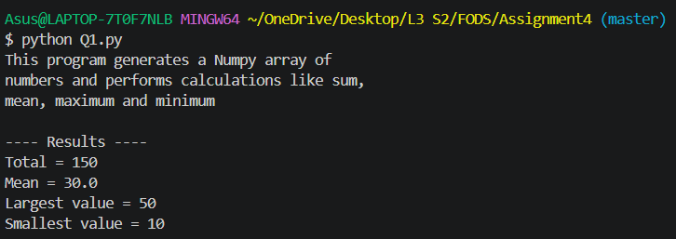

- Write a program to take a list of numbers as input from the user (at least 12 elements). Sort the list and perform slicing operations to extract elements between index ranges such as 3–6, 6–9, 4–10. (15 marks)
Description
This program takes a list of at least 12 numbers as input from the user and sorts the list in both ascending and descending order. It then performs slicing operations to extract specific portions of the list based on given index ranges such as 3-6, 6-9, and 4-10.
Source Code
#docstring Question 2
"""This program takes a list of at least 12 numbers from user,
sort the list, and perform slicing operations to extract
elements from specified index ranges"""

print(__doc__)
print()

import numpy as np

try:
n = int(input("How many numbers do you want to enter?:\n"))
if (n>=12):
li = []
for i in range(n):
val = int(input(f"Enter element {i+1} : "))
li.append(val)

li.sort()
print(f"Ordered list in ascending order : {li}")

print(f"Elements from index 3 to 6 : {li[3:6]}")
print(f"Elements from index 6 to 9 : {li[6:9]}")
print(f"Elements from index 4 to 10 : {li[4:10]}\n")

li.sort(reverse=True)
print(f"Ordered list in descending order: {li}")
print(f"Elements from index 3 to 6 : {li[3:6]}")
print(f"Elements from index 6 to 9 : {li[6:9]}")
print(f"Elements from index 4 to 10 : {li[4:10]}\n")
else:
print("There must be at least 12 inputs.")
except:
print("Invalid input(s)")
Output
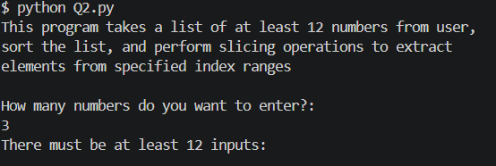
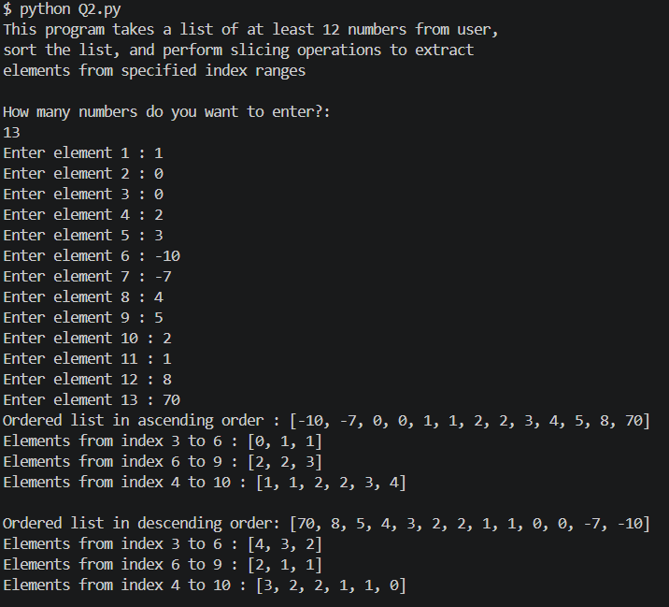
- Create an array of random integers using NumPy, sort it, and reshape it into a matrix of valid dimensions. (For example, if you have an array of size 1 × 12, reshape it into 3 × 4 or 4 × 3.)
[Hint: Use the reshape (row, column) method in NumPy.] (15 marks)
Description
This program creates a NumPy array of random integers, sorts the array, and reshapes it into a two-dimensional matrix with valid dimensions. The reshape operation ensures that the total number of elements remain unchanged while converting the array into a structured format.

Source Code
#docstring Question 3

"""This program generates a NumPy array of random integers,
sort the array, and reshape it into a matrix of valid dimensions using reshape() method"""

print(__doc__)
print()

import numpy as np

try:
li = np.random.randint(1,20,12)
print(f"Unsorted List : {li}")
li.sort()
print(f"Sorted List : {li}")

li = li.reshape(3,4)
print(li)

except ValueError:
print("Invalid dimensions!")
Output
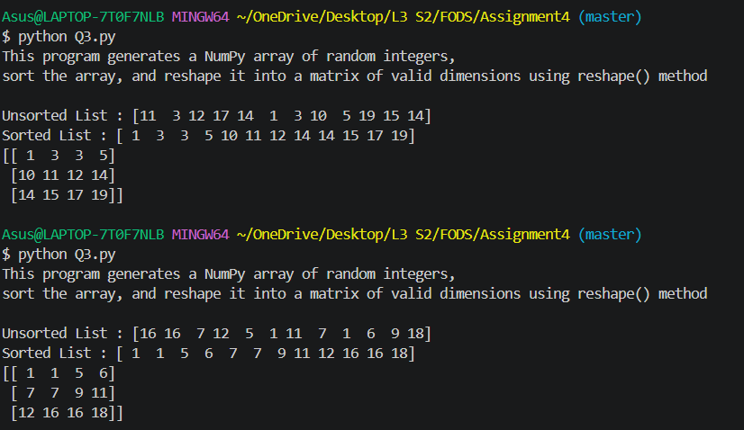

- Write a program to input two matrices of compatible dimensions and perform operations such as addition, subtraction, and multiplication using NumPy. Ensure that dimension compatibility is validated before performing the operations. If the matrix sizes are mismatched, raise a proper exception. (15 marks)
Description
This program accepts two matrices from the user and performs matrix operations such as addition, subtraction, and multiplication after checking dimension compatibility using NumPy.
Source Code
#docstring Question 4
"""This program takes two matrices as input and performs
matrix operations such as addition, subtraction, and multiplication
using Numpy.

It also checks for dimension compatibility before performing operations."""

print(__doc__)
print()

import numpy as np

try:
print("For matrix A :")
row1 = int(input("Enter the number of rows : "))
col1 = int(input("Enter the number of columns : "))

total1 = row1*col1

matA = []
for i in range(total1):
valA = int(input(f"Enter element {i+1} : "))
matA.append(valA)
matA = np.array(matA)
matA = matA.reshape(row1, col1)

print("For matrix B:")
row2 = int(input("Enter the number of rows : "))
col2 = int(input("Enter the number of columns : "))

total2 = row2*col2

matB = []
for i in range(total2):
valB = int(input(f"Enter element {i+1} : "))
matB.append(valB)
matB = np.array(matB)
matB = matB.reshape(row2, col2)

if row1 == row2 and col1 == col2 :
matC = matA + matB
matD = matA - matB
print("Matrix A:")
for row in matA:
for val in row:
print(val, end=" ")
print()
print("Matrix B:")
for row in matB:
for val in row:
print(val, end=" ")
print()
print("Sum:")
for row in matC:
for val in row:
print(val, end=" ")
print()
print("Difference:")
for row in matD:
for val in row:
print(val, end=" ")
print()

if col1 == row2:
print("Multiplication:")
matE = np.dot(matA,matB)
for row in matE:
for val in row:
print(val, end=" ")
print()
else:
print("Conditions not valid to perform multiplication")
except ValueError:
print("Invalid input or dimensions!")

Output
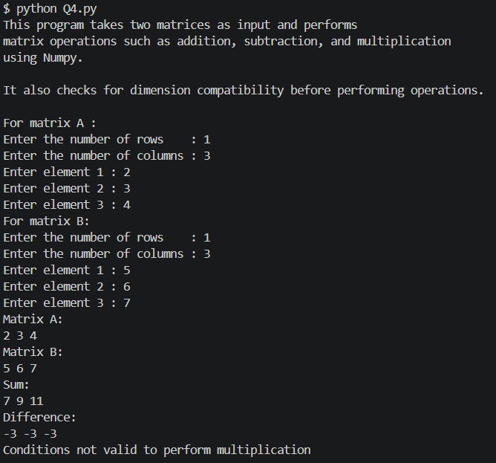
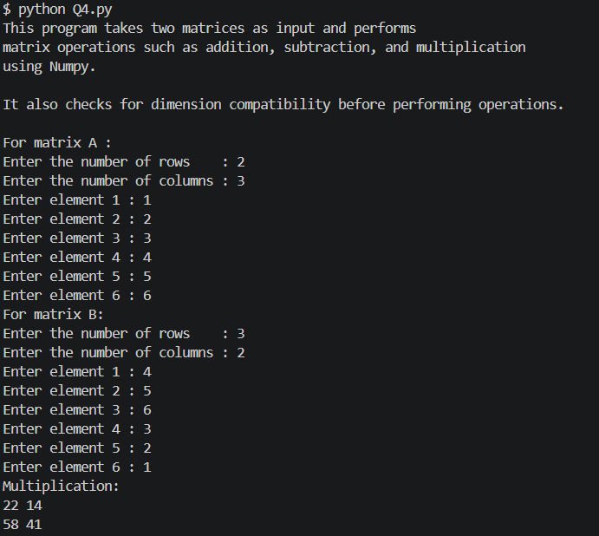

- Write a program to read the CSV file “health_data.csv” using Pandas and plot the data using Matplotlib. Create scatter plots for the following relationships: ( 20 marks)
  - weight vs height
  - age vs weight
  - height vs age
  - gender vs height
  - gender vs weight
Description
This program reads data from a CSV file using Pandas and visualizes the relationships between different variables using Matplotlib scatter plots. It generates plots for weight vs height, age vs weight, height vs age, gender vs height, and gender vs weight to analyze patterns in the dataset.
Since gender is a categorical variable, it is converted into numerical form (Male = 0 and female = 1) so that it can be used in scatter plots, as Matplotlib requires numerical data for plotting.
Source Code
#docstring Question 5

"""This program reads health data from a CSV file using Pandas
and creates a scattered plot using matplotlib.
It includes plots for weight, height, age, and gender relationships."""

print(__doc__)
print()

import pandas as pd
import matplotlib.pyplot as plt

r = pd.read_csv("health_data.csv")

r['Gender'] = r["Gender"].map({'Male':0, 'Female' :1})
plt.figure()
plt.scatter(r['Weight'],r['Height'])
plt.xlabel("Weight")
plt.ylabel("Height")
plt.title("Weight Vs Height")
plt.show()

plt.figure()
plt.scatter(r['Age'],r['Height'])
plt.xlabel("Age")
plt.ylabel("Height")
plt.title("Age Vs Height")
plt.show()

plt.figure()
plt.scatter(r['Height'],r['Age'])
plt.xlabel("Height")
plt.ylabel("Age")
plt.title("Height Vs Age")
plt.show()

plt.figure()
plt.scatter(r['Gender'],r['Height'])
plt.xlabel("Gender")
plt.ylabel("Height")
plt.title("Gender Vs Height")
plt.show()

plt.figure()
plt.scatter(r['Gender'],r['Weight'])
plt.xlabel("Gender")
plt.ylabel("Weight")
plt.title("Gender Vs Weight")
plt.show()

Output
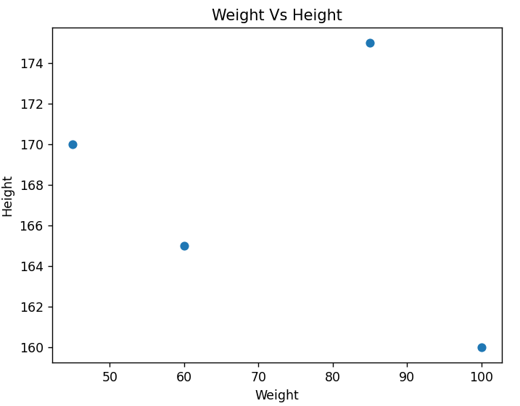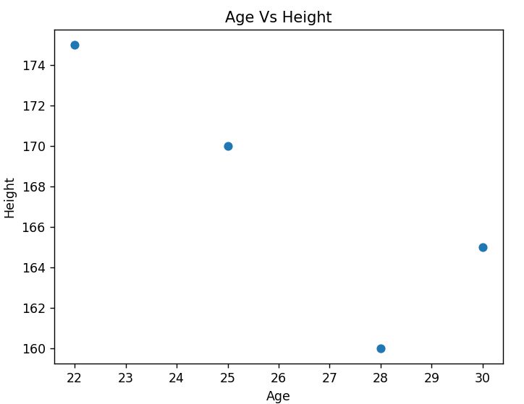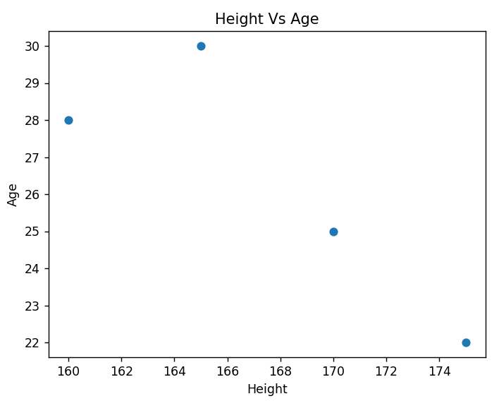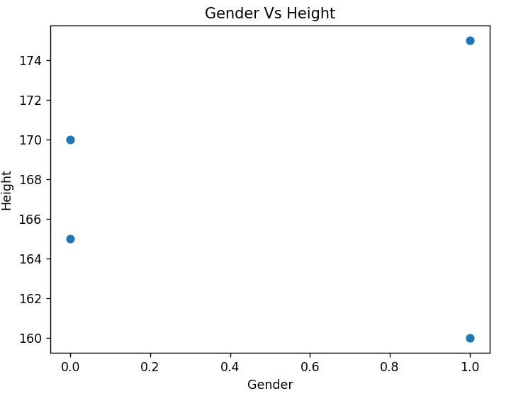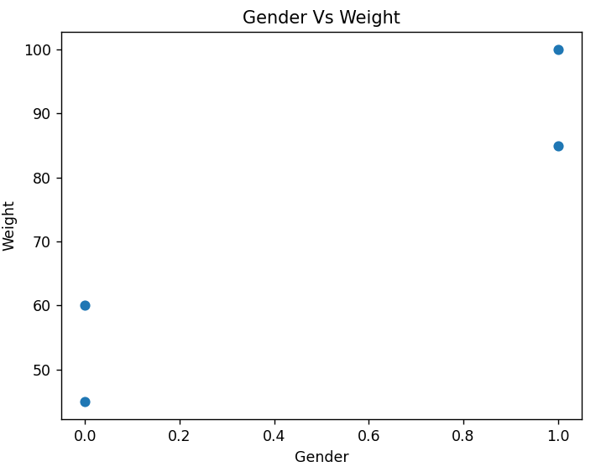

- Read the data from the file “health_data.csv” into a Pandas DataFrame. Add 2 new columns: BMI and Health_Status. Populate these columns using the following conditions-
(20 marks)
  - BMI = Weight / Height
  - Health_Status is based on BMI values:
    - BMI < 18.5 : Underweight
    - 18.5 ≤ BMI ≤ 24.9 : Healthy range
    - 25 ≤ BMI ≤ 29.9 : Overweight risk
    - 30 ≤ BMI ≤ 34.9 : High risk of diabetes/heart disease
    - BMI ≥ 40 : Critical health condition
Description
This program is an extension to previous question. It reads health-related data from a CSV file and calculates the Body Mass Index (BMI) for each individual. Based on this calculation, it categorizes individuals into different health status groups such as underweight, healthy, overweight, and high risk, providing a basic health analysis.

Source Code
#docstring Question 6
"""This program reads health data from a CSV file and computes
BMI for each record. It also categorizes individuals into different
health status groups based on BMI values."""

print(__doc__)
print()

import pandas as pd

r = pd.read_csv("health_data.csv")

r["Height"] = r["Height"]/100
r["BMI"] = r["Weight"]/r["Height"]

def status(bmi):
if bmi < 18.5:
return "Underweight"
elif 18.5 <= bmi <=24.9:
return "Healthy"
elif 25<= bmi <= 29.9:
return "Overweight risk"
elif 30<= bmi <=34.9:
return "High risk of diabetes/ heart disease"
elif bmi >= 40:
return "Critical health condition"
else:
return "Very high risk"

r["Health_Status"] = r["BMI"].apply(status)

print(r)

Output
