**Support plus Document**

1. Login to “Admin Panel”, Admin URL is shown below….

[**http://104.238.126.23:8080/PMJSKV/wp-admin**](http://104.238.126.23:8080/PMJSKV/wp-admin) **Admin Credential**

**Username:** admin

**Password:** admin@2017

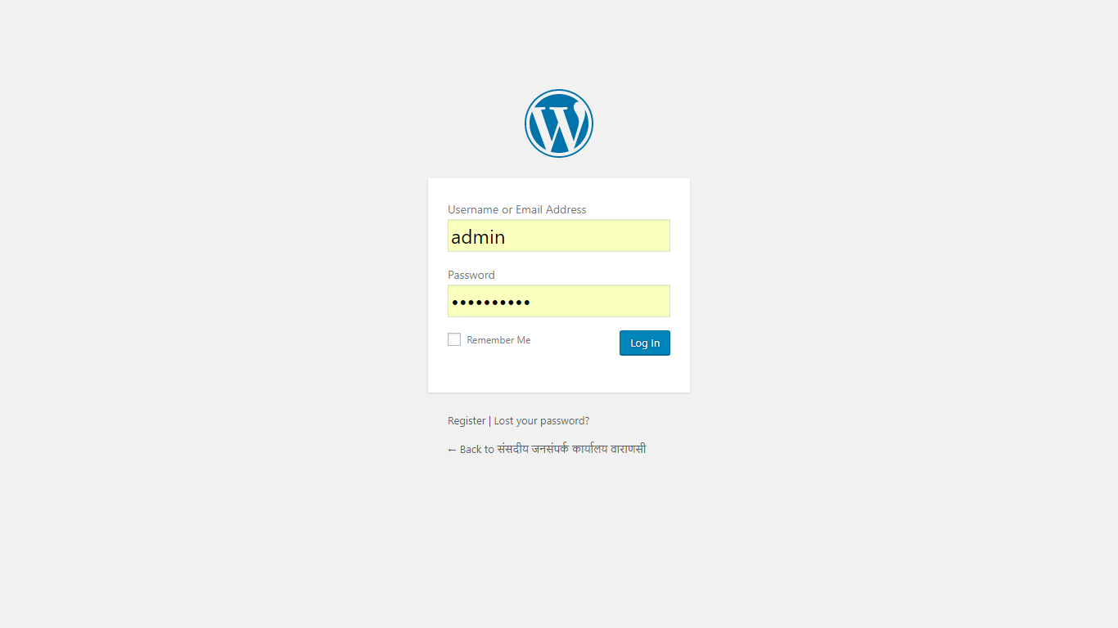

**Create new department or user for assign the ticket.**

Go to Users => Add new => Add new user with information and correct **Email id** and assign the role to user.

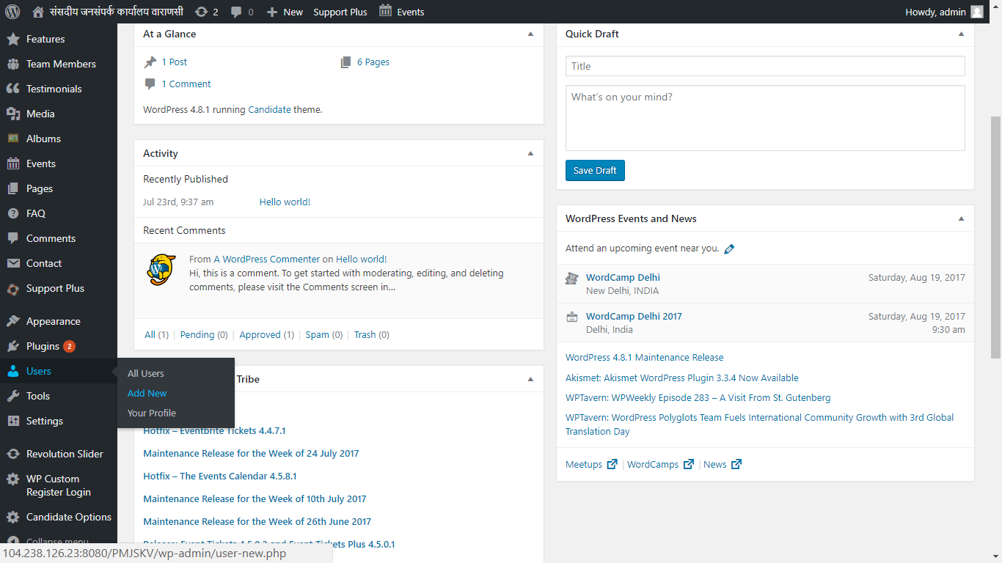

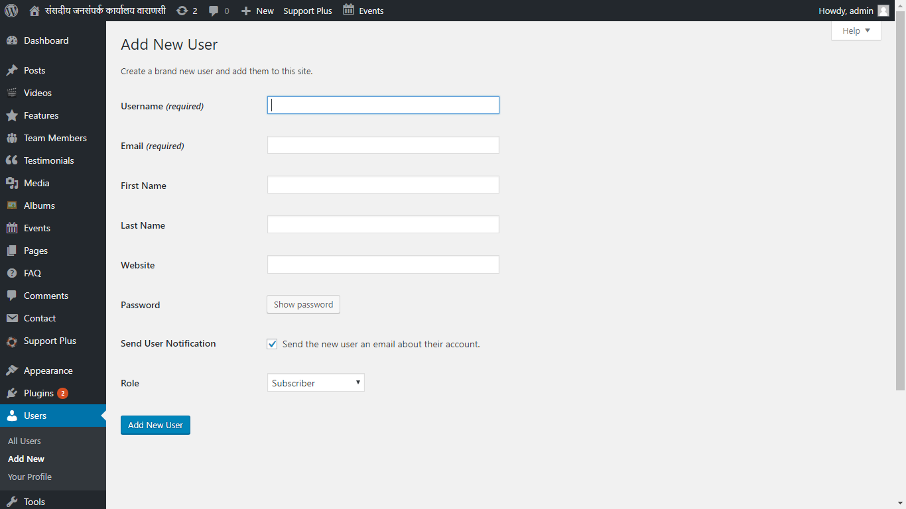

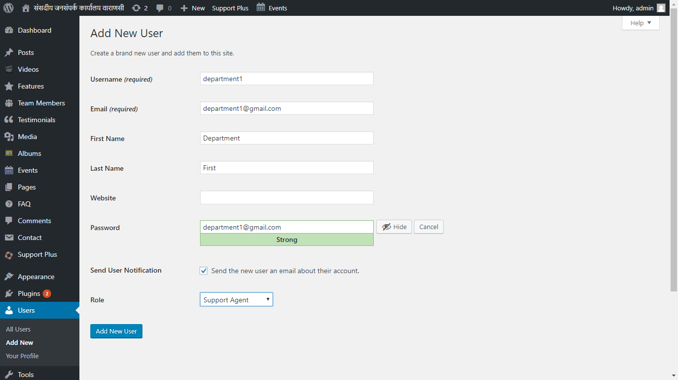

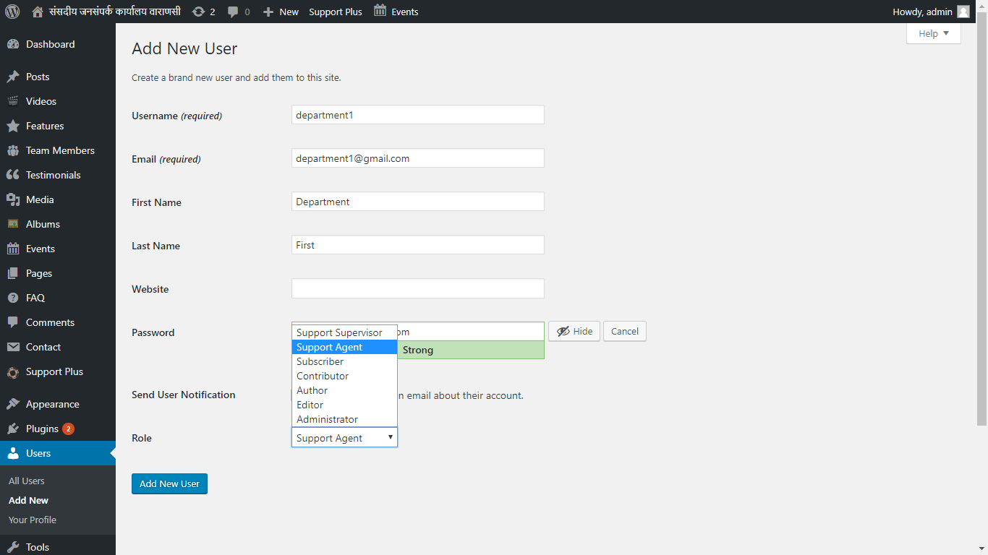

**Assign new ticket to department.**

Go to Support plus   
 Click on Support plus and shown all the tickets.

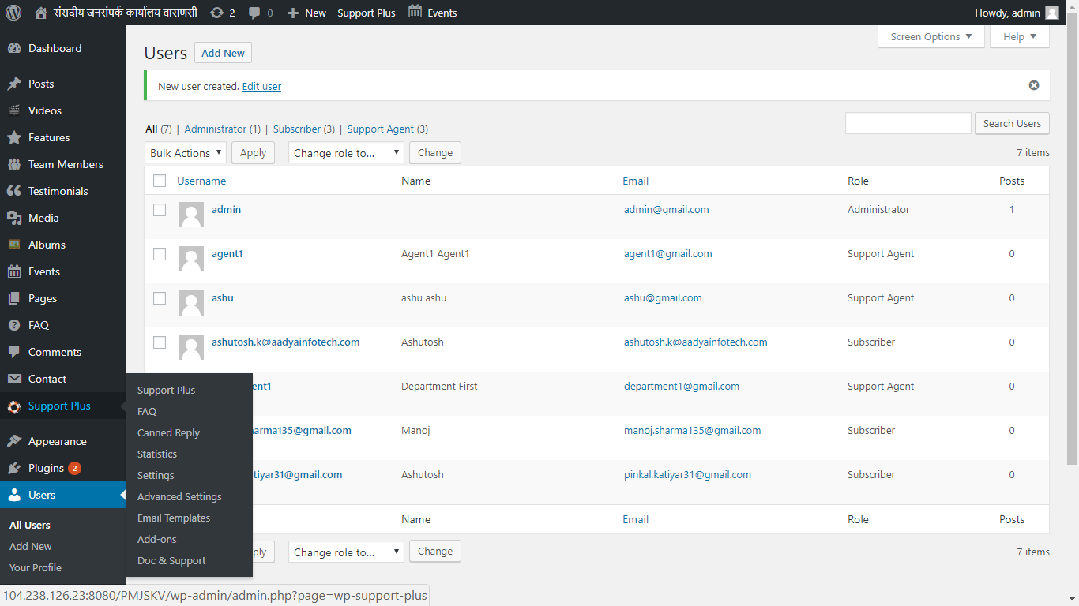

**Click on one ticket and assign the role.**

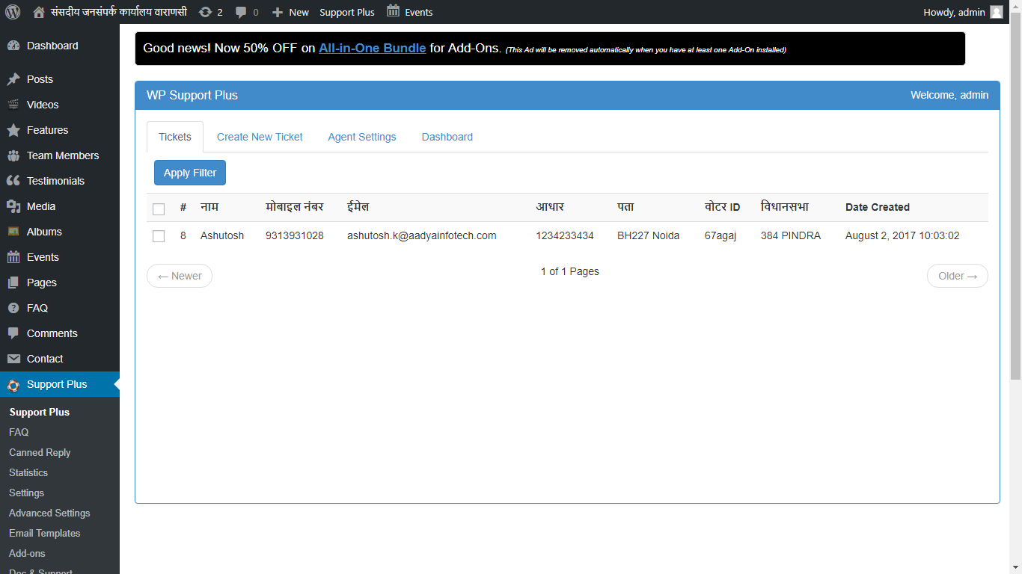

Click on **Assign Agent Button.**

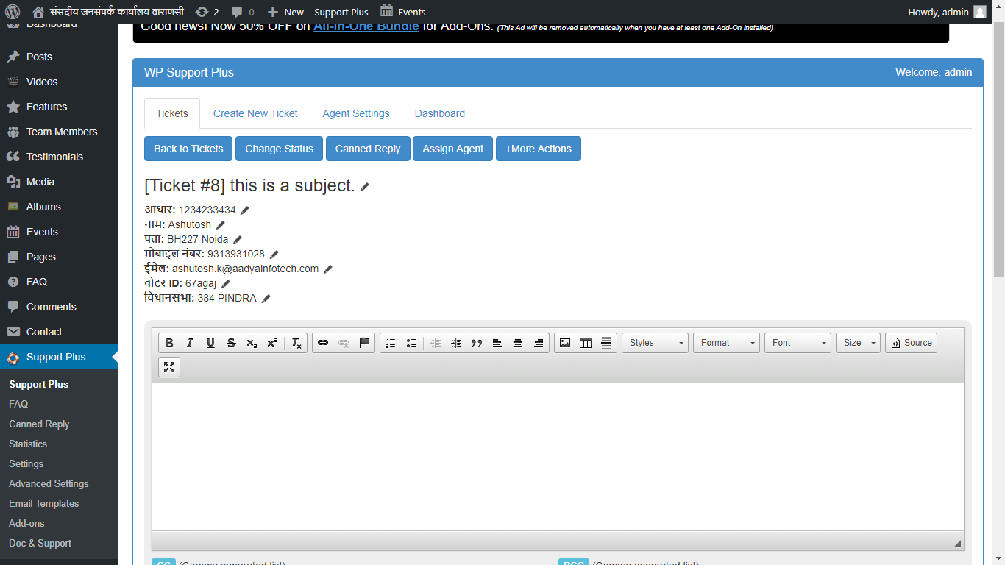

Show all the Agent / Department and select the Agent / Department for ticket.

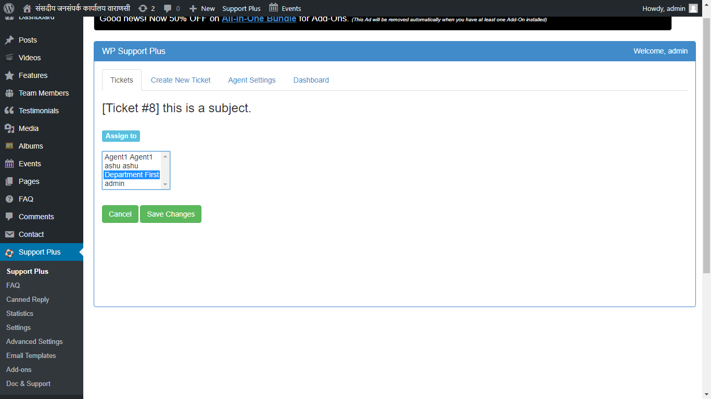

Create a **New User** for creating a **new ticket**.

For Login User  
<http://104.238.126.23:8080/PMJSKV/>   
  
  
  
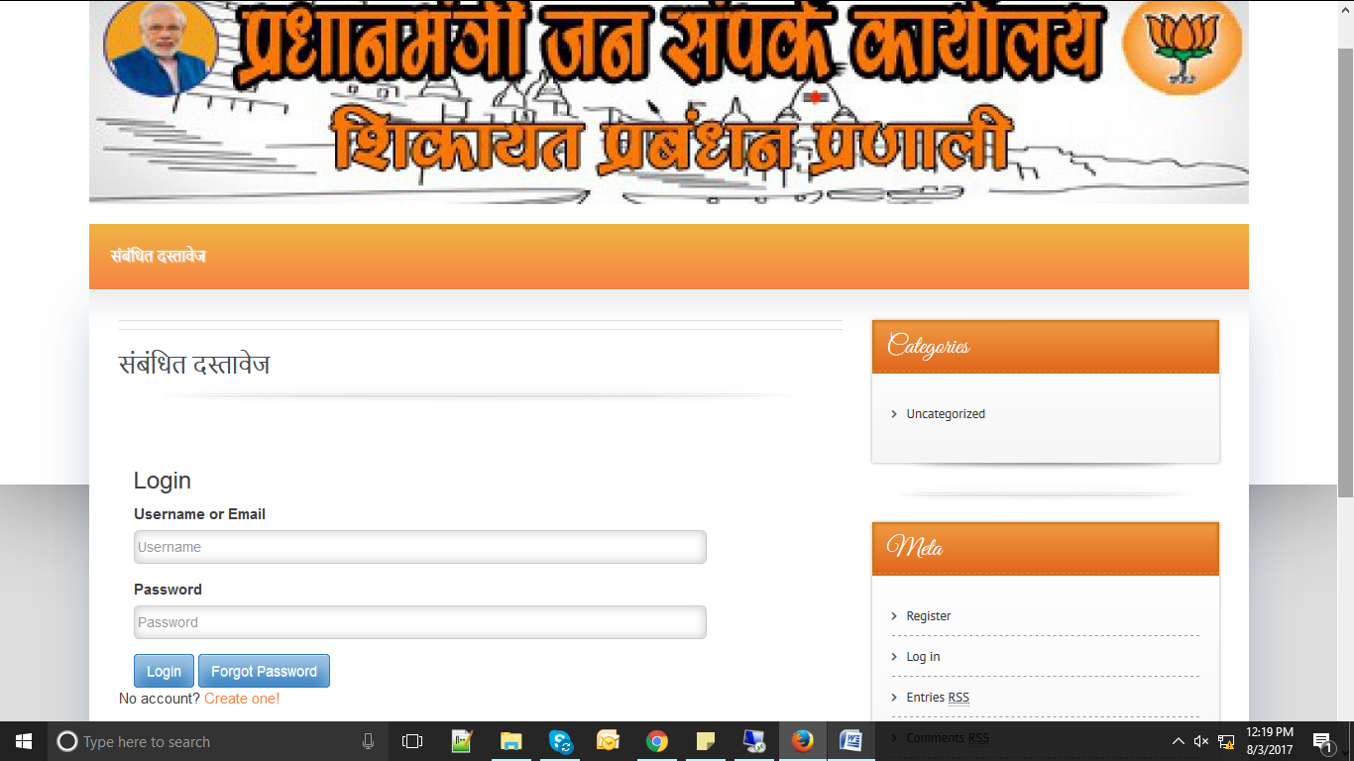

For **Register new user**

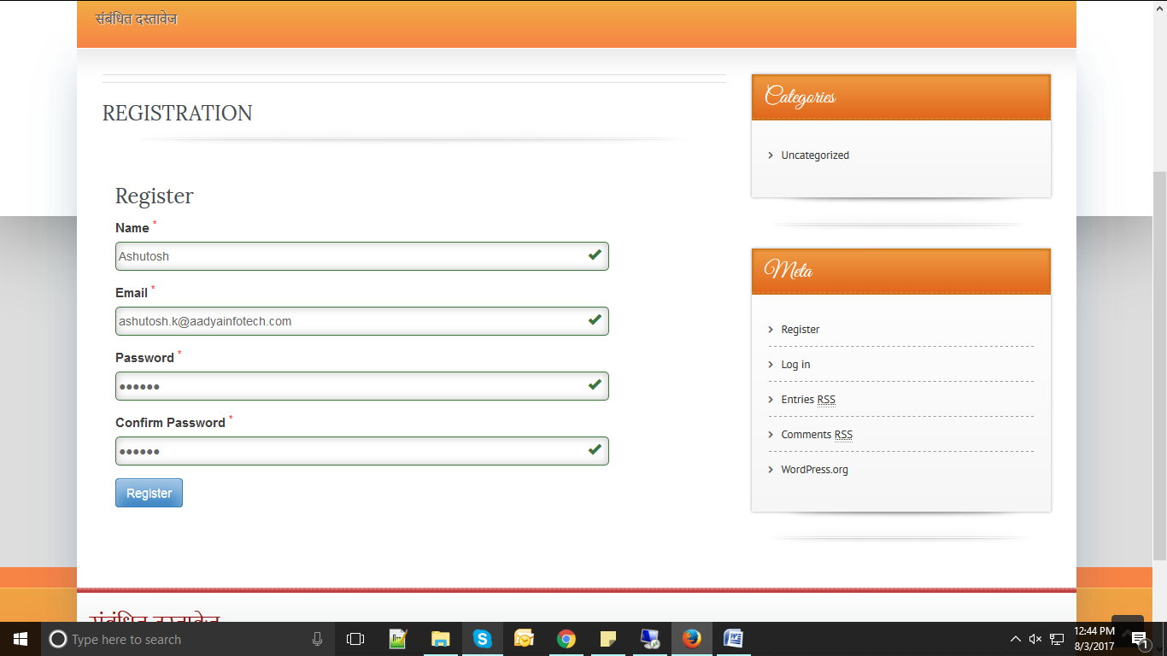

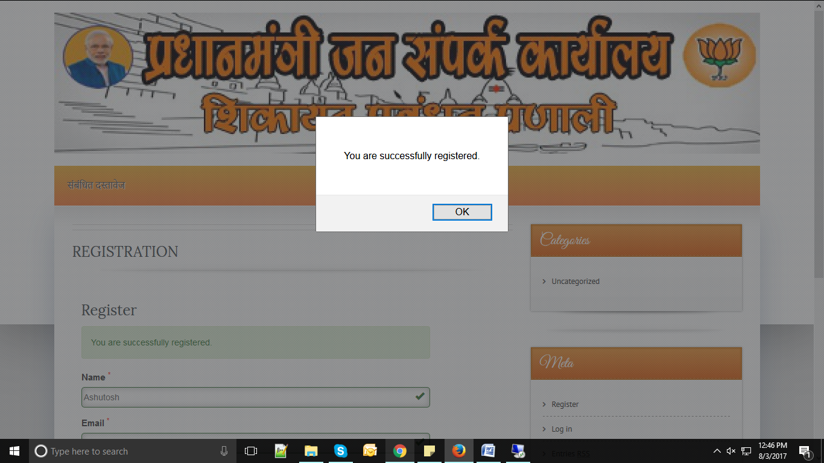

With **Login Credential.**

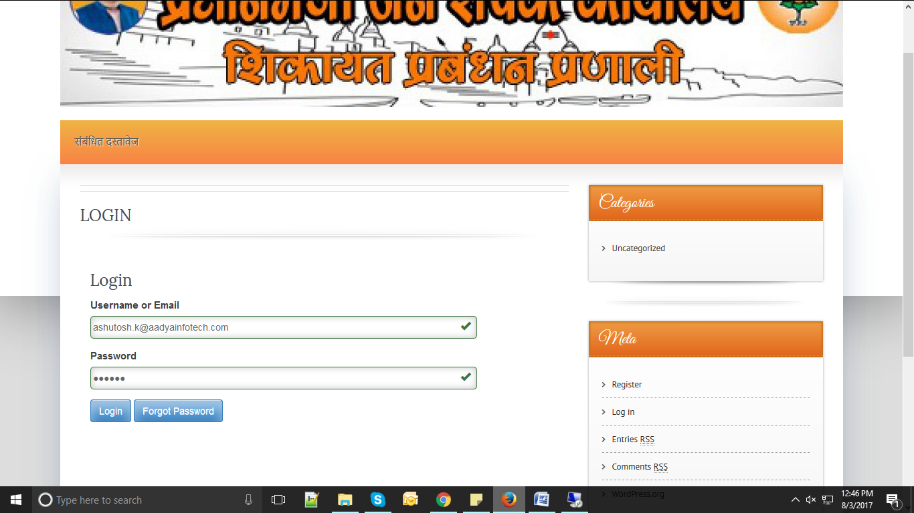

Create a **New Ticket** **(User side)**

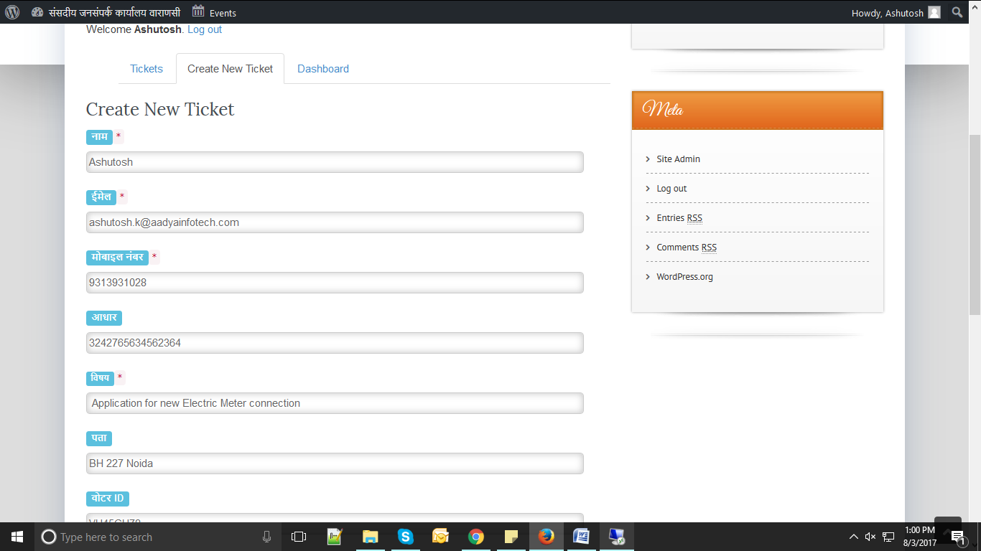

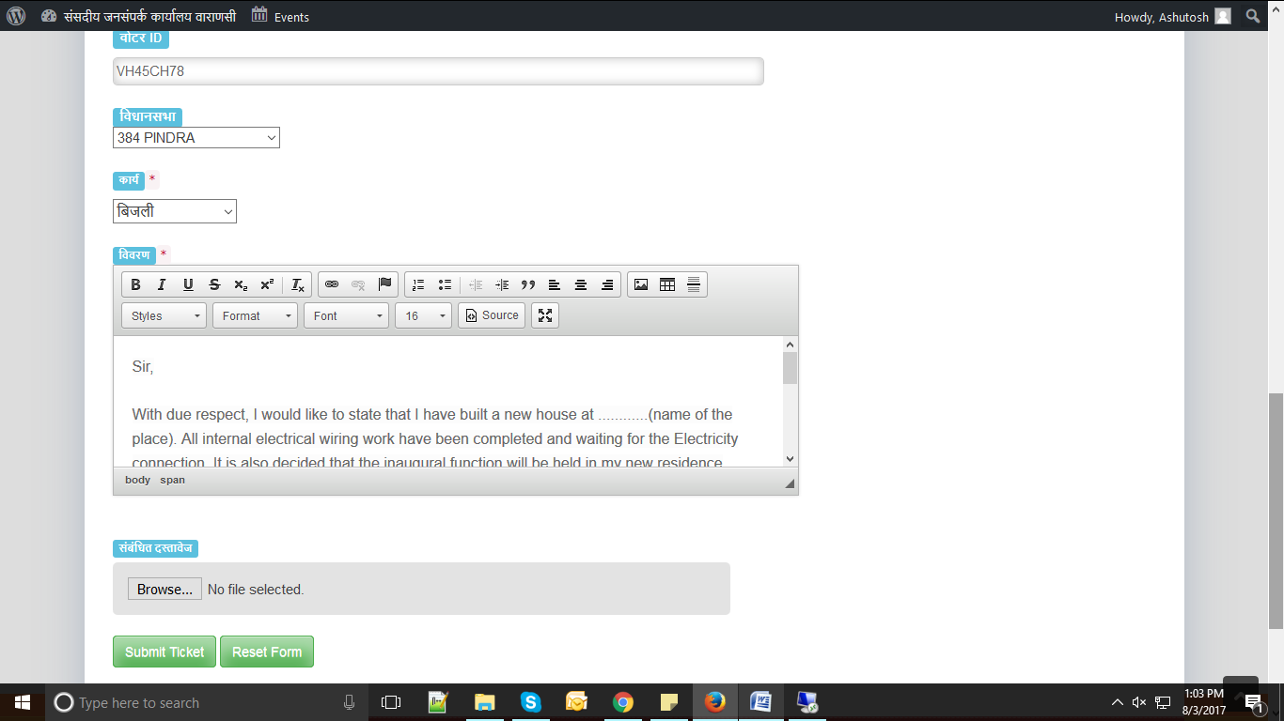

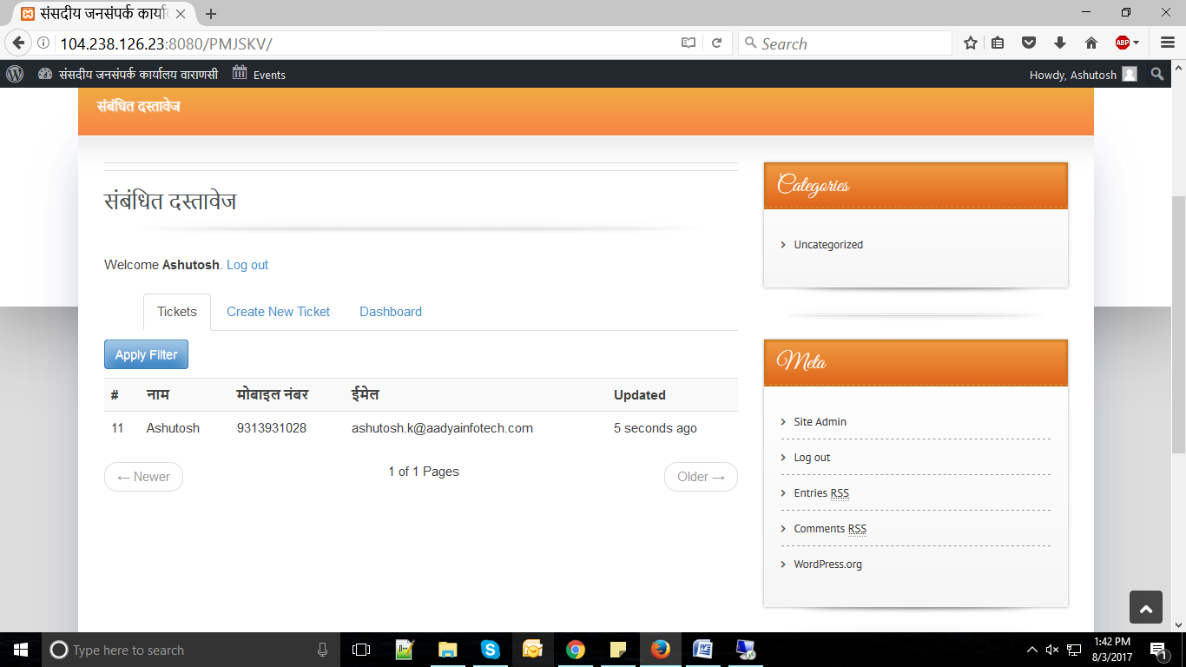

In **admin side** show all ticket send by User.

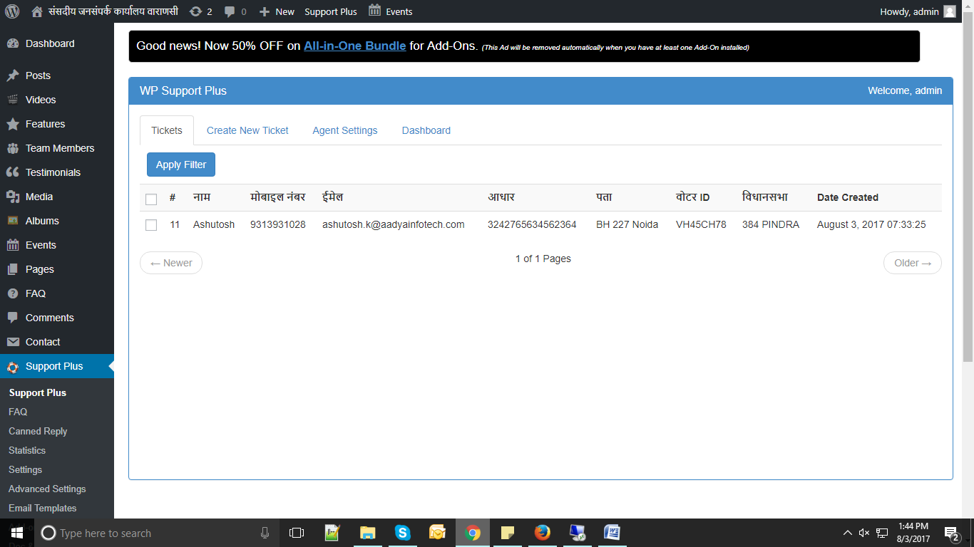

Assign the **Department** by the Admin

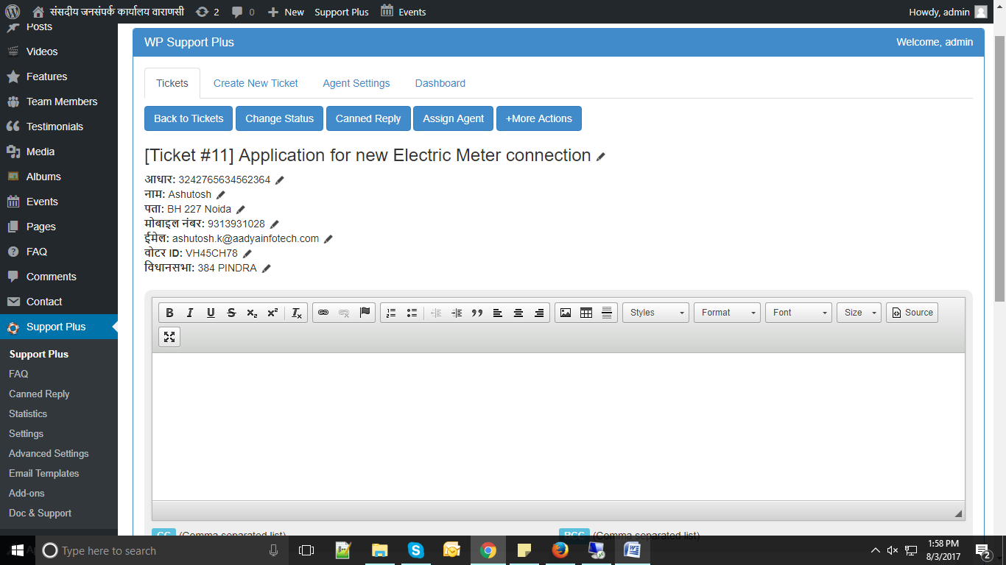

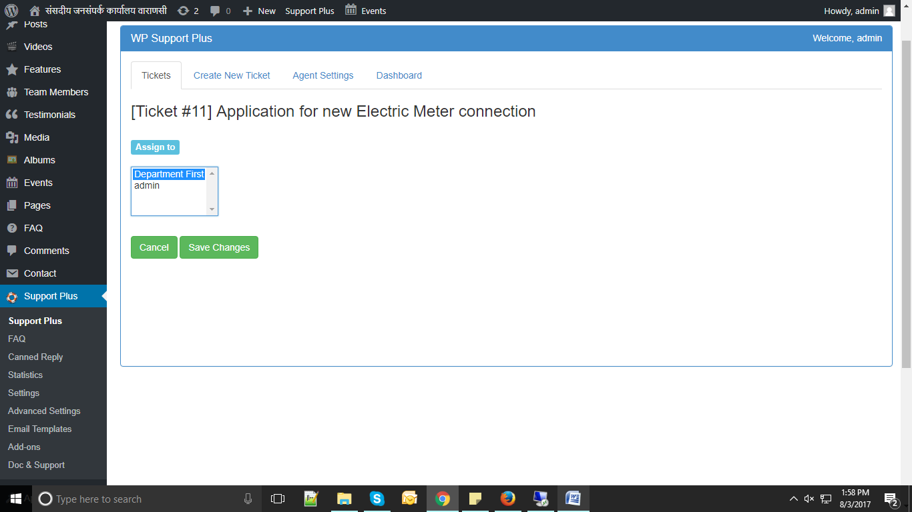

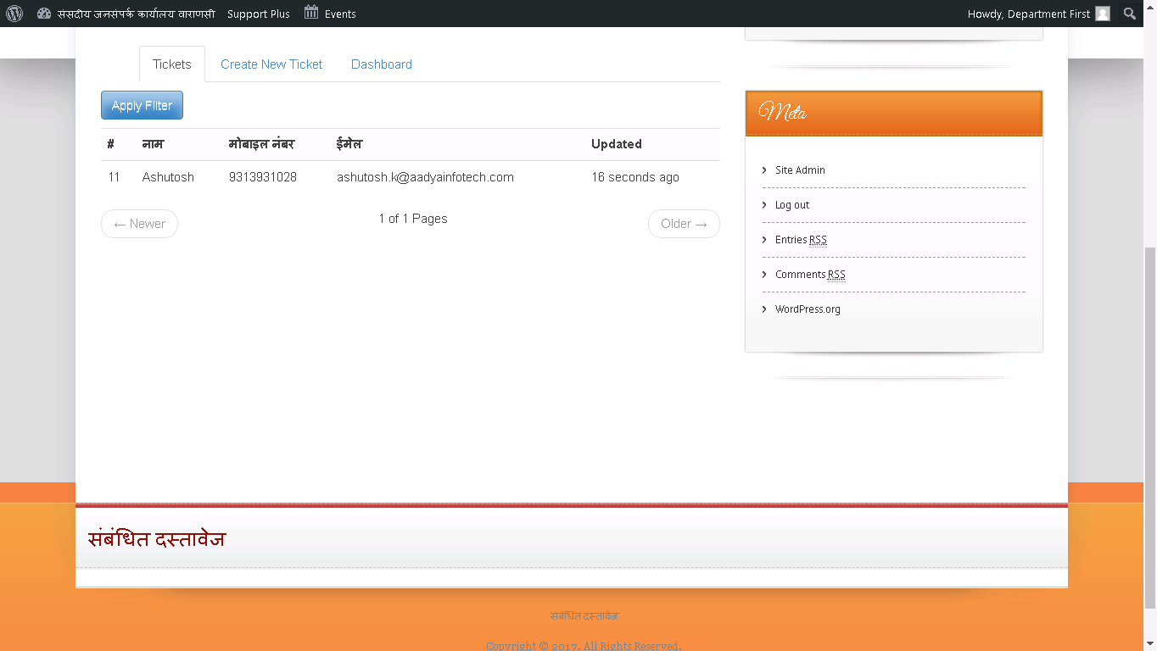**In Department side**

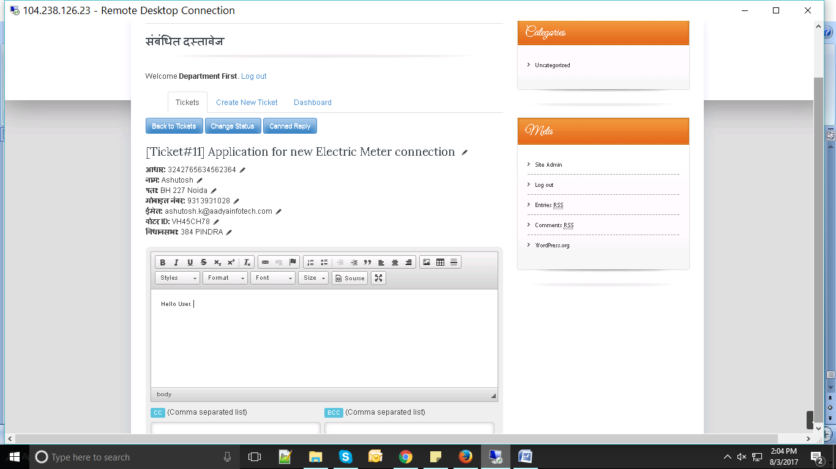

**Reply to user or admin by the department.**

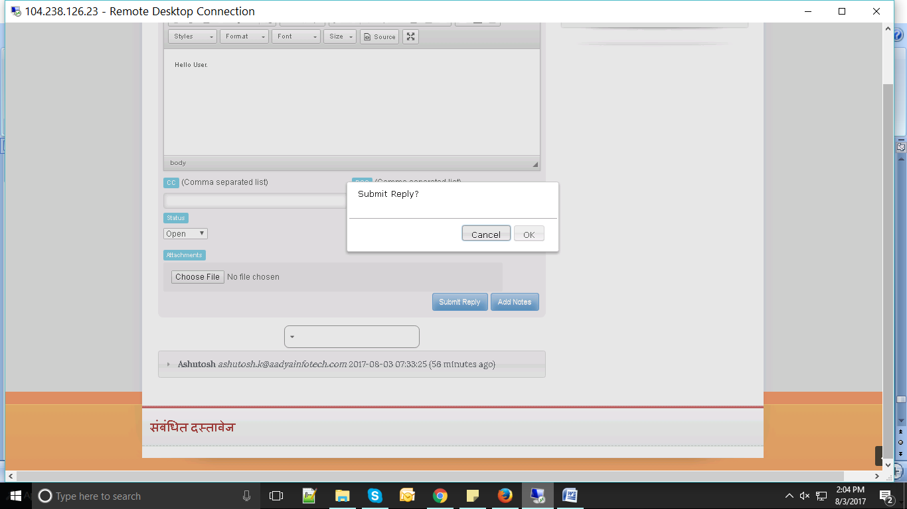

**Show reply content in User side.**

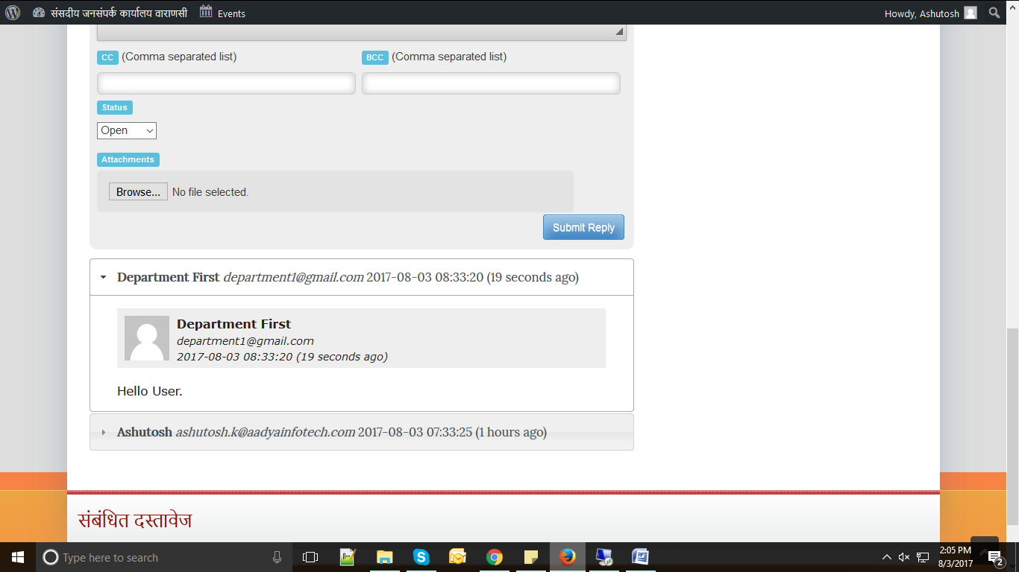

**Show in admin Side.**

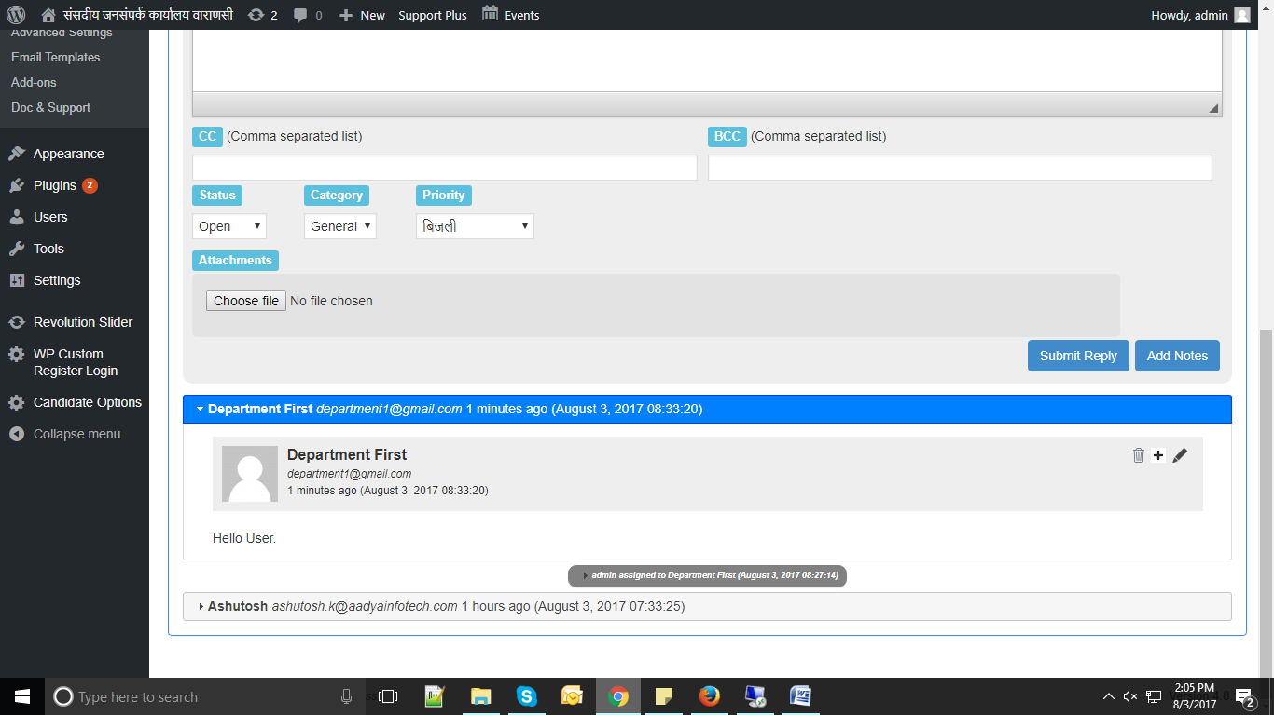

**Reply to user or department by the admin.**

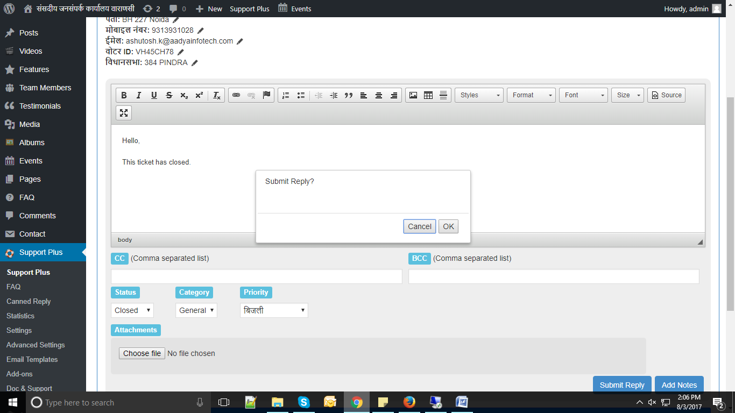

**Show in department Side.**

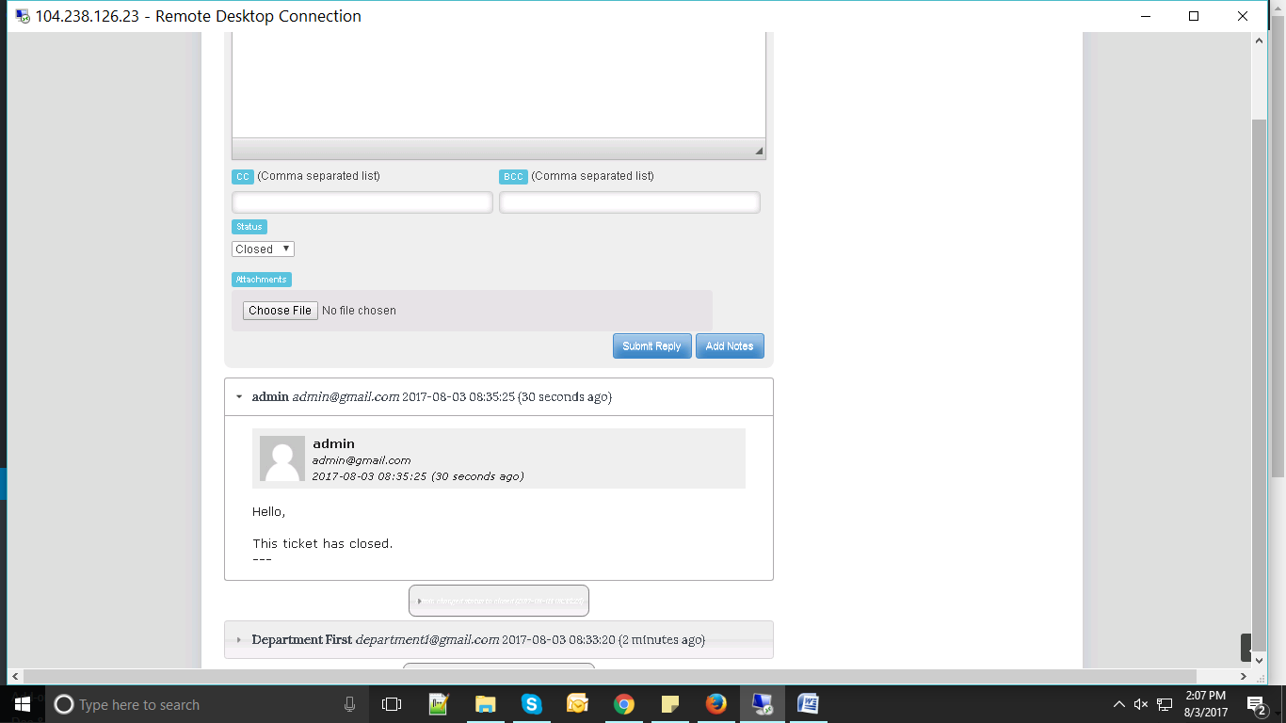

**Show reply in user side.**

