Name: Aadya Shukla
Roll No: 202401100200001
Sem/Sec- V-A
Subject- Software Engineering Lab

UNIVERSITY ERP MANAGEMENT SYSTEM

LAB-3: Identify the classes. draw the class diagram.

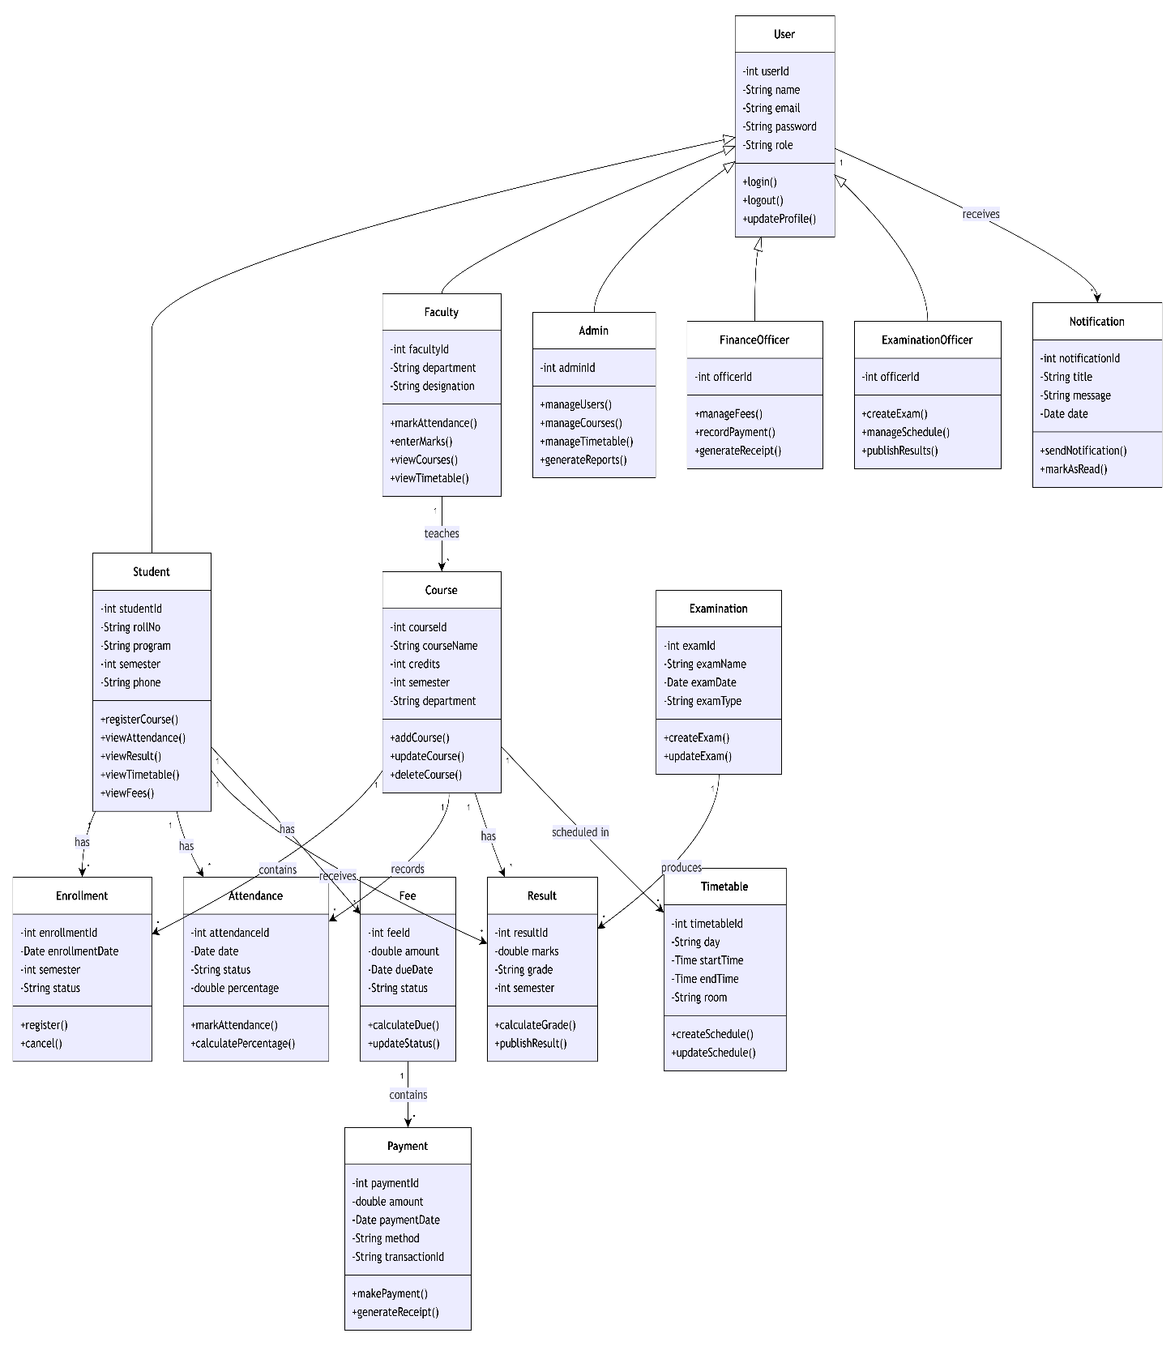

1. User
The User class is the parent class for all users of the University ERP System. It contains common information such as user ID, name, email, password, and role.
Attributes: userId, name, email, password, role
Methods: login(), logout(), updateProfile()
The User class is inherited by Student, Faculty, Admin, Finance Officer, and Examination Officer.

2. Student
The Student class represents students registered in the university. It stores student-specific information such as roll number, program, semester, and phone number.
Methods: registerCourse(), viewAttendance(), viewResult(), viewTimetable(), and viewFees().
A student can enroll in multiple courses, view attendance, examination results, timetable, and fee information.

3. Faculty
The Faculty class represents teaching staff. It contains information such as faculty ID, department, and designation.
Methods: markAttendance(), enterMarks(), viewCourses(), and viewTimetable().
Faculty members can teach courses, record student attendance, and enter marks.

4. Admin
The Admin class represents the system administrator who manages major ERP operations.
Methods: manageUsers(), manageCourses(), manageTimetable(), and generateReports().
The administrator is responsible for managing users, courses, timetables, and generating system reports.

5. Finance Officer
The FinanceOfficer class handles financial operations of the University ERP.
Methods: manageFees(), recordPayment(), and generateReceipt().
The Finance Officer manages student fee records, records payments, and generates payment receipts.

6. Examination Officer
The ExaminationOfficer class manages examination-related activities.
Methods: createExam(), manageSchedule(), and publishResults().
The Examination Officer creates examinations, manages examination schedules, and publishes results.

7. Course
The Course class represents courses offered by the university. It contains course ID, course name, credits, semester, and department.
Methods: addCourse(), updateCourse(), and deleteCourse().
Courses are associated with enrollments, attendance, results, and timetable information.

8. Enrollment
The Enrollment class represents a student's registration for a particular course.
It stores information such as enrollment ID, enrollment date, semester, and enrollment status.
Methods: register() and cancel().
A student can have multiple enrollment records, while each enrollment is associated with a course.

9. Attendance
The Attendance class stores attendance information for students in different courses.
Attributes: attendanceId, date, status, and percentage
Methods: markAttendance() and calculatePercentage().
Faculty members use attendance records to record and calculate student attendance.

10. Timetable
The Timetable class represents the schedule of courses.
It contains information such as day, start time, end time, and room.
Methods: createSchedule() and updateSchedule().
The timetable is associated with courses and allows students and faculty to view their schedules.

11. Examination
The Examination class represents examinations conducted by the university.
It contains examination ID, examination name, examination date, and examination type.
Methods: createExam() and updateExam().
An examination can produce multiple result records.

12. Result
The Result class stores the academic results of students.
It contains marks, grade, and semester information.
Methods: calculateGrade() and publishResult().
Results are associated with students, courses, and examinations.

13. Fee
The Fee class represents the fee information of a student.
It contains fee ID, amount, due date, and payment status.
Methods: calculateDue() and updateStatus().
A student can have multiple fee records, and each fee record can have associated payment records.

14. Payment
The Payment class stores details of fee payments made by students.
It contains payment ID, amount, payment date, payment method, and transaction ID.
Methods: makePayment() and generateReceipt().
Payment records are associated with fee records.

15. Notification
The Notification class represents messages or alerts sent to users.
It contains notification ID, title, message, and date.
Methods: sendNotification() and markAsRead().
Notifications are associated with users and can be used to communicate important academic, examination, fee, or administrative information.

