SOFTWARE DESIGN ANALYSIS REPORT
University ERP
(Enterprise Resource Planning) System

A. Project Details
Field | Details
Project title | University ERP (Enterprise Resource Planning) System
Project objective | Design a centralized university system for student records, course registration, faculty activities, attendance, timetables, examinations, results, fee payments, notifications and reports. It aims to improve accuracy, reduce paperwork and provide role-based access to academic and administrative information.
Technology stack | Proposed: web interface using HTML/CSS/JavaScript; backend using Java, Python or Node.js; relational database such as MySQL or PostgreSQL. Replace this with the actual approved/implemented stack.

B. Module Identification and Modularization
The system is divided by business responsibility so that each module can be developed, tested and maintained independently. Shared services support authentication, data persistence and notifications.
ID | Module | Main responsibility | Inputs / outputs | Depends on
M1 | Authentication & Roles | Authenticate users, manage sessions and enforce permissions. | Credentials → session, role | User records / database
M2 | Student & Course Management | Maintain student profiles, course catalogue and enrollment. | Student/course data → records and enrollment status | M1, database
M3 | Faculty & Attendance | Maintain faculty assignments and attendance. | Course/student/attendance data → attendance summaries | M1, M2, database
M4 | Timetable Management | Create and publish class schedules and room allocations. | Course/faculty/room/time → timetable | M2, M3, database
M5 | Examination & Results | Manage exams, schedules, marks, grades and publication. | Exam/marks → schedules and results | M1, M2, M3, database
M6 | Finance & Fees | Track dues, record payments and issue receipts. | Fee/payment data → status and receipts | M1, M2, database/payment service
M7 | Notifications & Reports | Send alerts and generate academic/administrative reports. | Events/filters → notifications and reports | M1–M6, database

Module hierarchy / decomposition diagram

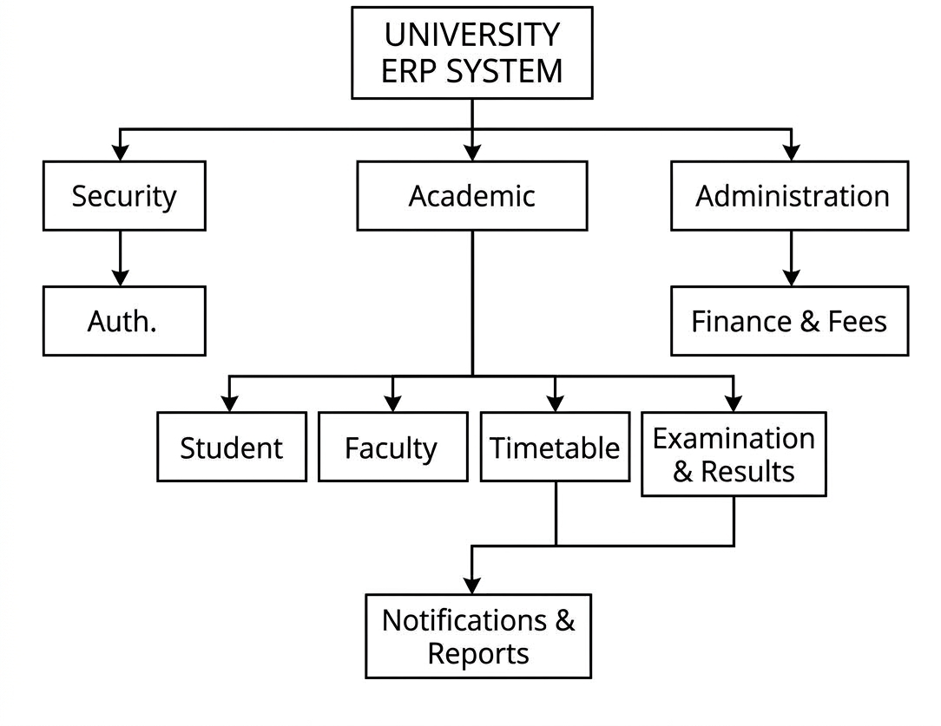

C. Design Strategy
Selected strategy: HYBRID (Top-Down decomposition with Bottom-Up integration)
- The design starts from the complete ERP system and decomposes it into major business modules, following a top-down approach.
- Each module is then designed and tested around one responsibility, such as attendance, fees or examinations.
- Reusable components such as authentication, validation, database access and notifications are integrated across modules.
- The hybrid strategy provides an overall architecture while allowing parallel development and reuse of common components.
- Integration tests verify that modules exchange consistent data and respect access permissions.
Evidence – decomposition/build-up sketch:
Whole ERP → Identify roles/workflows → Define modules → Define interfaces/data → Build shared services → Integrate → System test

D. Design Approach
Selected approach: OBJECT-ORIENTED
- The system has identifiable entities with state and behaviour: User, Student, Faculty, Course, Enrollment, Attendance, Examination, Result, Fee, Payment and Notification.
- Role types can share common identity and authentication behaviour through a base User class.
- Encapsulation groups data with related operations; associations model relationships such as Student–Enrollment–Course and Fee–Payment.
- Object-oriented design supports maintenance and extension when new roles or modules are added.
- The design maps naturally to classes and relational database records.

Evidence – class/object structure sketch

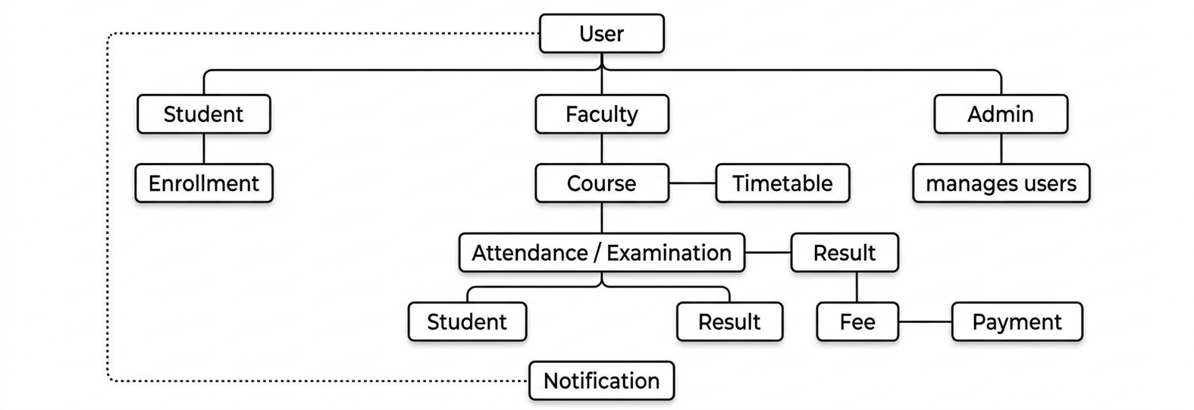
A traditional structure chart is primarily used for function-oriented design. Since this project selects object-oriented design, the class/object structure is provided as the matching evidence.

E. Coupling Analysis
The design aims for low coupling by exchanging defined data and service requests instead of allowing modules to modify each other's internal state.
Module pair | Interaction / shared data | Coupling type / level | How to reduce dependency
Authentication ↔ Student/Course | User ID, role, session/token | Data coupling; low | Pass only identity/role; centralize authorization.
Student/Course ↔ Attendance | Enrollment ID, course ID, student ID, attendance entries | Data coupling; low–moderate | Use stable IDs and defined attendance service methods.
Examination/Results ↔ Student/Course | Student ID, course ID, exam ID, marks, result status | Data coupling; moderate | Use documented interfaces and validate referenced IDs.
Finance/Fees ↔ Student Management | Student ID, fee amount, due date, payment status | Data coupling; low–moderate | Exchange IDs; keep payment rules inside Finance module.
Notifications/Reports ↔ Other modules | Event type, recipient ID, report filters | Message/data coupling; low | Use small events and approved reporting interfaces.

F. Cohesion Analysis
Each module should group tasks that contribute to one clear responsibility.
Module | Main responsibility | Cohesion type / level | Improvement, if needed
Authentication & Roles | Validate identity, manage sessions, check permissions | Functional; high | Keep academic and payment logic outside this module.
Student & Course Management | Maintain profiles/catalogue and process enrollment | Functional; high | Split catalogue and enrollment if complexity grows.
Faculty & Attendance | Record and retrieve attendance | Functional; high | Keep attendance calculations and persistence together.
Examination & Results | Schedule exams, record marks, calculate grades, publish results | Functional; high | Separate publication approval if workflow becomes complex.
Finance & Fees | Track dues, record payment and issue receipts | Functional; high | Place gateway-specific code behind a payment interface.

G. Module Interaction and Design Quality
This sequence shows a representative course-registration workflow. The same layered interaction can be applied to attendance, examinations, fees and reporting.
# | Sender → receiver | Message / information
1 | Student → ERP Interface | Submit login credentials
2 | ERP Interface → Authentication | validateCredentials(username, password)
3 | Authentication → Database | Fetch user record and role
4 | Database → Authentication | Return user record (response)
5 | Authentication → ERP Interface | Authentication result and role
6 | Student → Course Management | Request course registration
7 | Course Management → Database | Check eligibility and availability
8 | Database → Course Management | Return validation data
9 | Course Management → Database | Save enrollment
10 | Database → Course Management | Confirm saved enrollment
11 | Course Management → Notification Service | Send registration event asynchronously where supported
12 | Course Management → Student | Display registration status

Sequence diagram

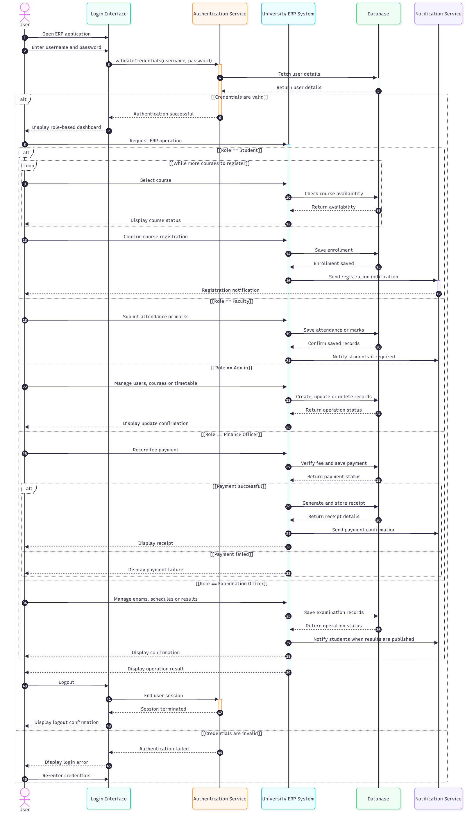

Design quality summary
- Modularity: seven modules separate the main business responsibilities.
- Low coupling: modules exchange IDs, structured data and service requests through defined interfaces.
- High cohesion: each module focuses on one business capability.
- Security: role-based authorization is applied before protected operations.
- Maintainability: clear module boundaries help isolate changes.
- Testability: modules can be unit-tested before integration and end-to-end testing.

Assumptions and items to finalize
- Replace placeholders with team members, roll numbers, institution and submission date.
- Update the proposed technology stack to match the actual implementation.
- Payment gateway, notification provider, attendance threshold, grading rules and production-scale requirements need confirmation.
- This report describes a proposed design and does not claim that every module has already been implemented.

