SOFTWARE METRICS &
COMPLEXITY ANALYSIS
University ERP (Enterprise Resource Planning) System

Document Control
Field | Value
Project | University ERP System
Report | Software Metrics & Complexity Analysis
Version | 1.0
Analysis basis | Design-stage model and requirements available in the project conversation
Source code reviewed | No - code repository/source files were not supplied
Metric status | Design-based estimates are marked as estimates; implementation metrics are marked not yet measurable

Executive Summary
This report evaluates the planned University ERP System using software-size, functional-size, control-flow complexity, coupling/cohesion, and test-quality metrics. The proposed design contains seven functional modules and a 15-class UML model. A provisional Function Point count and representative Cyclomatic Complexity values are calculated from the current requirements and diagrams. These numbers are planning estimates, not measured implementation results. Lines of Code (LOC), Halstead metrics, Maintainability Index, defect density, code coverage, and measured performance cannot be reported honestly until source code and test results are available.
Headline metric | Current value | Interpretation
Functional modules | 7 | Design inventory from the project model
Classes in proposed UML model | 15 | Design inventory; count should be updated if the class diagram changes
Actor roles | 5 | Student, Faculty, Admin, Finance Officer, Examination Officer
Preliminary Unadjusted Function Points | 216 core; 226 including two optional external interfaces | Provisional estimation based on assumed transaction/data complexity
Course-registration Cyclomatic Complexity | V(G) = 5 | Moderate branching in the modeled workflow; design estimate
Source-code metrics | Not measured | No implementation files were provided

1. Purpose, Scope and Method
The purpose is to quantify the approximate size and structural complexity of the University ERP design, identify areas requiring careful implementation/testing, and define metrics that can be measured after coding. The scope follows the seven modules in the design analysis: Authentication & Roles; Student & Course Management; Faculty & Attendance; Timetable Management; Examination & Results; Finance & Fees; Notifications & Reporting.

1.1 Measurement principles
- Observed design counts (for example, seven modules) are reported as design inventory values.
- Function Point Analysis (FPA) and Cyclomatic Complexity (CC) values are provisional estimates because detailed data-element counts and source code are unavailable.
- No source-code values such as LOC, Halstead Volume, Maintainability Index, or actual test coverage are invented.
- Targets in this report are recommendations for the project, not claims about current achievement.

2. System Inventory and Size Metrics
Metric | Current design value | How interpreted / measured
Functional modules | 7 | Count modules in the project decomposition.
UML classes | 15 | Count class boxes in the current class model: User, five role classes, and domain classes.
Actor roles | 5 | Student, Faculty, Admin, Finance Officer, Examination Officer.
Use cases | Freeze after final diagram revision | Count each distinct use-case oval once; avoid counting repeated labels twice.
Source Lines of Code (SLOC) | Not yet measurable | Run a source-code counter on the finished repository; exclude generated/dependency code.
Database entities/data groups | 12 core candidate groups | A design inventory of user/student/faculty/course/enrollment/attendance/timetable/exam/result/fee/payment/notification groups; actual schema may differ.

2.1 Why LOC is not estimated here
LOC depends on the actual language, coding style, generated code, comments, and implementation decisions. The design diagram does not determine the final line count. Once code exists, record physical LOC and source LOC separately, and document the counting tool and exclusions.

3. Functional Size Estimation (Function Point Analysis)
Function Point Analysis estimates user-visible functionality independent of a specific programming language. The preliminary count below uses standard low/average/high weighting as a planning approximation. It is not a certified IFPUG count because the required Data Element Types (DETs), File Types Referenced (FTRs), and Record Element Types (RETs) have not been enumerated from detailed screens and data definitions.

3.1 Standard weights used
Function type | Low | Average | High | Meaning in this project
External Input (EI) | 3 | 4 | 6 | Data entering the application, such as course registration or payment entry
External Output (EO) | 4 | 5 | 7 | Calculated/derived output, such as reports or receipts
External Inquiry (EQ) | 3 | 4 | 6 | Query with input and response, such as viewing attendance/fee details
Internal Logical File (ILF) | 7 | 10 | 15 | Logical data group maintained by the ERP
External Interface File (EIF) | 5 | 7 | 10 | Data group maintained by another system and referenced by ERP

3.2 Provisional count
Function type | Low count | Average count | High count | Weighted subtotal
EI | 6 | 4 | 1 | 6×3 + 4×4 + 1×6 = 40
EO | 1 | 3 | 1 | 1×4 + 3×5 + 1×7 = 26
EQ | 4 | 3 | 1 | 4×3 + 3×4 + 1×6 = 30
ILF | 0 | 12 | 0 | 12×10 = 120
EIF (optional integrations) | 2 | 0 | 0 | 2×5 = 10
Total UFP incl. optional EIFs |  |  |  | 226
Core UFP excluding optional EIFs |  |  |  | 216

Calculation: UFP = Σ(count at each complexity level × assigned weight). The optional EIF assumption represents a payment gateway and a notification provider, only if these are external systems actually integrated. Without those two interfaces, the provisional core value is 216 UFP. Refine every count after finalizing UI transactions, logical data groups, and external interfaces.

3.3 Interpretation
- The result is a preliminary sizing baseline useful for planning, not a final effort or cost estimate.
- Function Points cannot be converted into person-hours without a calibrated productivity rate from the team or organization.
- Do not use the provisional UFP as evidence of delivered functionality; re-count after the scope and data model are finalized.

4. Cyclomatic Complexity Analysis
Cyclomatic Complexity, introduced by McCabe, measures the number of linearly independent paths through a control-flow graph. It is useful for identifying functions that require more branch-oriented testing. Here it is applied to representative workflows inferred from the ERP diagrams; values are design-level estimates and will change if implementation logic differs.

4.1 Formula
V(G) = E − N + 2P or, for a single connected routine, V(G) = D + 1
Where E = number of control-flow edges; N = number of nodes; P = number of connected components (normally 1 for one routine); D = number of binary decision points. For multiway branches, count the independent outcomes according to the chosen control-flow graph representation.

4.2 Control-flow graph: course registration
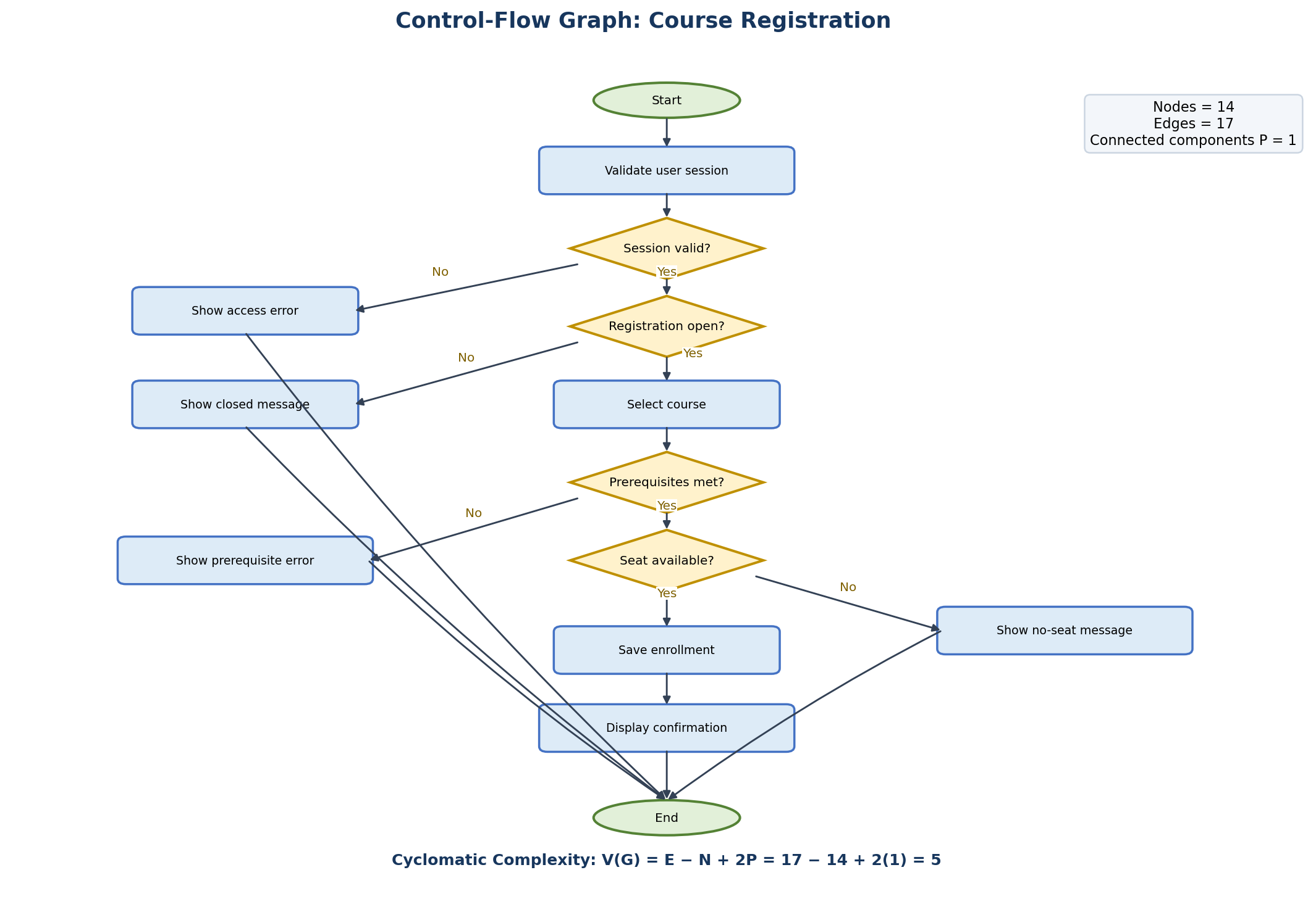
Figure 1. Representative control-flow graph for registering one course. The four decision nodes represent session validity, registration window, prerequisite eligibility, and seat availability.
Worked calculation: Nodes N = 14; edges E = 17; connected components P = 1. Therefore, V(G) = 17 − 14 + 2(1) = 5. The same result follows from four independent decision points plus one: V(G) = 4 + 1 = 5. This suggests at least five independent test paths for the modeled routine, with additional tests needed for boundary values, errors, and data integrity.

4.3 Workflow complexity comparison
Workflow | Assumed independent decisions (D) | Estimated V(G)=D+1 | Interpretation
Login / Authentication | 1 | 2 | Low: valid vs invalid credentials
Course Registration | 4 | 5 | Moderate: session, registration window, prerequisites, capacity
Attendance Submission | 2 | 3 | Low: authorization and input/date validation
Fee Payment | 1 | 2 | Low: payment success vs failure; idempotency needs separate tests
Result Publication | 3 | 4 | Low-to-moderate: completeness, approval, publication permission

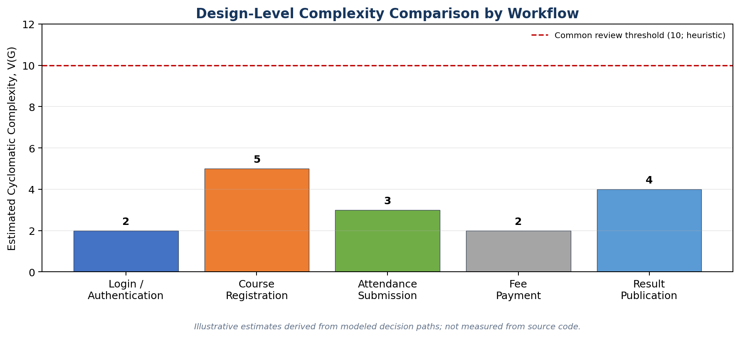
Figure 2. Design-level complexity comparison; the dashed threshold at 10 is a practical review heuristic, not a universal standard.

4.4 Complexity interpretation and actions
- V(G) from 1–10 is commonly treated as relatively simple; 11–20 as more complex; greater values deserve closer review. These bands are rules of thumb, not formal acceptance criteria.
- Course registration is the highest estimated workflow in this sample and should receive branch tests for each validation decision and failure path.
- Keep guard/validation logic separate and explicit; avoid deeply nested conditions by extracting focused helper functions.
- Recalculate CC directly from functions/methods after implementation rather than assuming these design estimates are exact.

5. Coupling and Cohesion Metrics
Coupling describes the degree of dependency between modules; cohesion describes how strongly the responsibilities within a module belong together. The following are qualitative design assessments, not measured values obtained from code dependency analysis.

5.1 Module interaction / coupling matrix
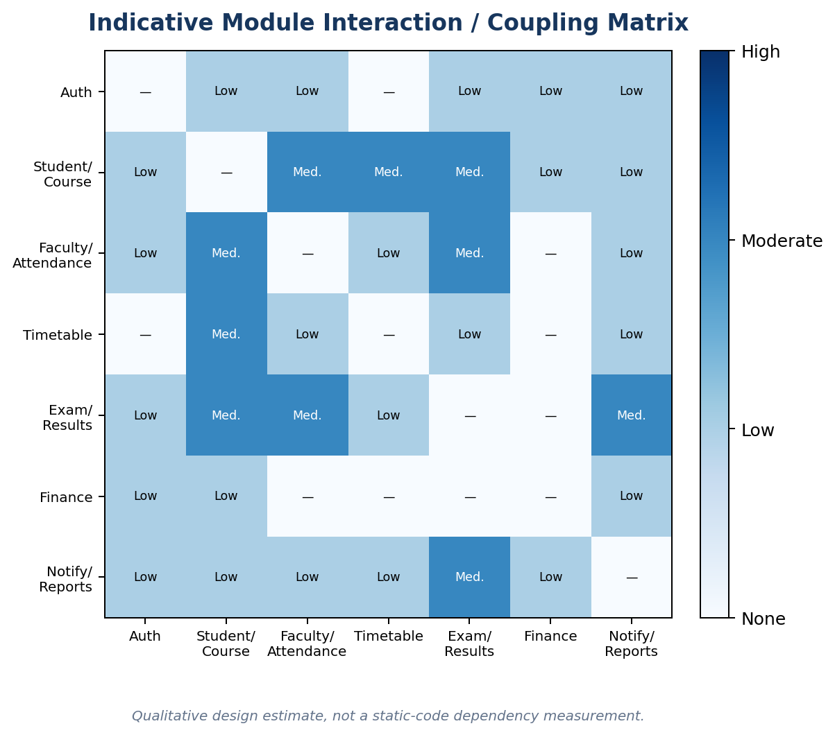
Figure 3. Indicative module interaction intensity: none, low, moderate, high. Interactions are inferred from the current module design.
Module | Target coupling | Target cohesion | Design reason
Authentication & Roles | Low | High / functional | Identity and permission checks are centralized.
Student & Course Management | Low–moderate | High / functional | Student records, course catalogue and enrollment are related but should use stable service boundaries.
Faculty & Attendance | Low–moderate | High / functional | Attendance actions are limited to assigned courses and authorized staff.
Timetable Management | Moderate | High / functional | Needs course/faculty/room availability but should not own those modules’ records.
Examination & Results | Moderate | High / functional | Uses student/course references and owns exam/result workflow.
Finance & Fees | Low–moderate | High / functional | Uses student identity but owns fee/payment rules and receipts.
Notifications & Reporting | Low | High / functional | Consumes events/filters rather than embedding business rules from other modules.

5.2 Improvement recommendations
- Use service interfaces and identifiers rather than direct access to another module’s internal objects or tables.
- Keep one clear responsibility per module. If a module becomes difficult to describe in one sentence, review its cohesion.
- Use a notification/event interface to avoid making academic/finance transactions depend on notification delivery.
- Add automated architecture/dependency checks after implementation if supported by the selected toolchain.

6. Additional Source-Code Metrics (Measure After Implementation)
Metric | Definition / formula | Required data | Status now
LOC / SLOC | Count of physical/source lines under a documented counting convention | Repository and language-aware counter | Not measurable
Halstead vocabulary | n = n1 + n2; n1 unique operators, n2 unique operands | Tokenized source code | Not measurable
Halstead length | N = N1 + N2; N1 total operators, N2 total operands | Tokenized source code | Not measurable
Halstead Volume | V = N × log2(n) | n and N from source | Not measurable
Halstead Difficulty | D = (n1/2) × (N2/n2) | Operator/operand counts | Not measurable
Halstead Effort | E = D × V | Difficulty and volume | Not measurable
Maintainability Index | Tool-dependent composite using source metrics (commonly includes volume, complexity and LOC) | Source code plus a specified analyzer/formula | Not measurable
Defect density | Confirmed defects / KLOC or per function point | Issue tracker and measured size | Not measurable
Test coverage | Executed statements/branches / total measured statements/branches | Automated test suite and coverage tool | Not measured
Requirement test coverage | Requirements with linked passing tests / total testable requirements × 100% | Traceability matrix and test results | Not measured

Halstead and Maintainability Index results vary with the counting tool and language rules. When reporting them, record the tool, version, exclusions, and exact formula. Do not compare metrics produced by different methods without qualification.

7. Testing and Quality Metrics Plan
Metric / target | Suggested academic-project target | How to verify
Functional requirement coverage | 100% of mandatory requirements linked to test cases | Requirement-to-test traceability matrix
Critical role authorization tests | 100% of identified critical role/action combinations tested | Test matrix for Student, Faculty, Admin, Finance and Examination roles
Unit test statement coverage | Aim for ≥70% where meaningful and achievable | Coverage tool report; this is a target, not a current result
Critical branch coverage | Exercise both outcomes of every critical decision | Branch coverage report and manual test paths
Severity-1 defects at submission | 0 known unresolved severity-1 defects | Defect log and release checklist
Normal response time | Specification target ≤2 seconds for typical operations | Load/response-time tests under documented conditions
Login response time | Specification target ≤3 seconds under normal load | Timed tests with representative data
Report generation | Specification target ≤10 seconds for normal report sizes | Report performance test
Backup/restore | At least one successful restore drill | Backup/restore record and validation

The response-time figures above come from the project’s stated SRS targets; they are not performance-test results. Concurrent-user targets must be validated through load testing on an identified deployment environment.

8. Risk Assessment from the Metrics
Risk / indicator | Impact | Recommended mitigation
Course registration has highest sampled CC (5) | More independent branch paths; invalid enrollment could occur if a path is missed | Test each guard and error path; add duplicate-registration, capacity-boundary and prerequisite tests.
Function Point baseline is provisional | Effort/schedule estimates may change when details are known | Finalize screen/data definitions and repeat the count using DET/FTR/RET rules.
No source-code metrics yet | Maintainability or implementation complexity cannot be objectively assessed | Run LOC, CC, Halstead and coverage tools on the actual repository before final report.
Cross-module dependencies | Changes can propagate to attendance, examination, fee and reporting modules | Use explicit interfaces, stable IDs and integration tests.
Notification or external payment services may fail | Users might not receive alerts or payment status may be uncertain | Make notifications non-blocking; verify transactions and implement idempotent payment handling.

9. Conclusion
The University ERP design has seven functional modules and a proposed 15-class object model. A preliminary Function Point Analysis gives 216 UFP for the core system and 226 UFP if two optional external interfaces are counted. The representative course-registration control-flow graph has Cyclomatic Complexity V(G)=5, and the sampled workflows range from 2 to 5 based on explicit design assumptions. Coupling is intended to remain low-to-moderate and cohesion high through focused modules and defined interfaces. These values provide a transparent design-stage baseline; source-derived metrics and actual quality outcomes must be measured once code and tests are available.

Appendix A. Metric Formula Reference
Metric | Formula / rule | Use
Function Points | UFP = sum(count × complexity weight) | Estimate user-visible functional size independent of language.
Cyclomatic Complexity | V(G)=E−N+2P; for a connected routine, often V(G)=D+1 | Estimate independent control-flow paths and guide tests.
Defect Density | Defects / KLOC (or function points) | Compare defect counts against a size measure.
Test Coverage | Covered items / total measurable items × 100% | Measure how much code or requirement set has been exercised.
Requirement Coverage | Requirements with linked tests / total testable requirements × 100% | Check that requirements are verified.

Appendix B. Assumptions and items to finalize
- Replace cover placeholders with actual student/team, roll numbers, college, faculty guide and date.
- Update the technology stack and seven-module inventory if your implemented design differs.
- Confirm whether payment gateway and notification service are included; these change the provisional EIF count.
- Finalize the use-case diagram and count unique use cases after the diagram is no longer changing.
- After implementation, rerun source-code and test metrics and replace every “not measurable” value with a dated tool report.

