UNIVERSITY ERP SYSTEM
SYSTEM ARCHITECTURE REPORT

1. Introduction
The University ERP System is a centralized application designed to support academic and administrative activities, including student records, course registration, faculty and attendance management, timetables, examinations, results, fees, and administration.

2. System Architecture Diagram
The diagram uses a layered architecture. Users access the system through a common interface; business modules handle university workflows; shared services provide reusable security, notification, and reporting functions; and the data layer stores records and documents. Arrows are intentionally limited to the spaces between layers to avoid crossing module labels.
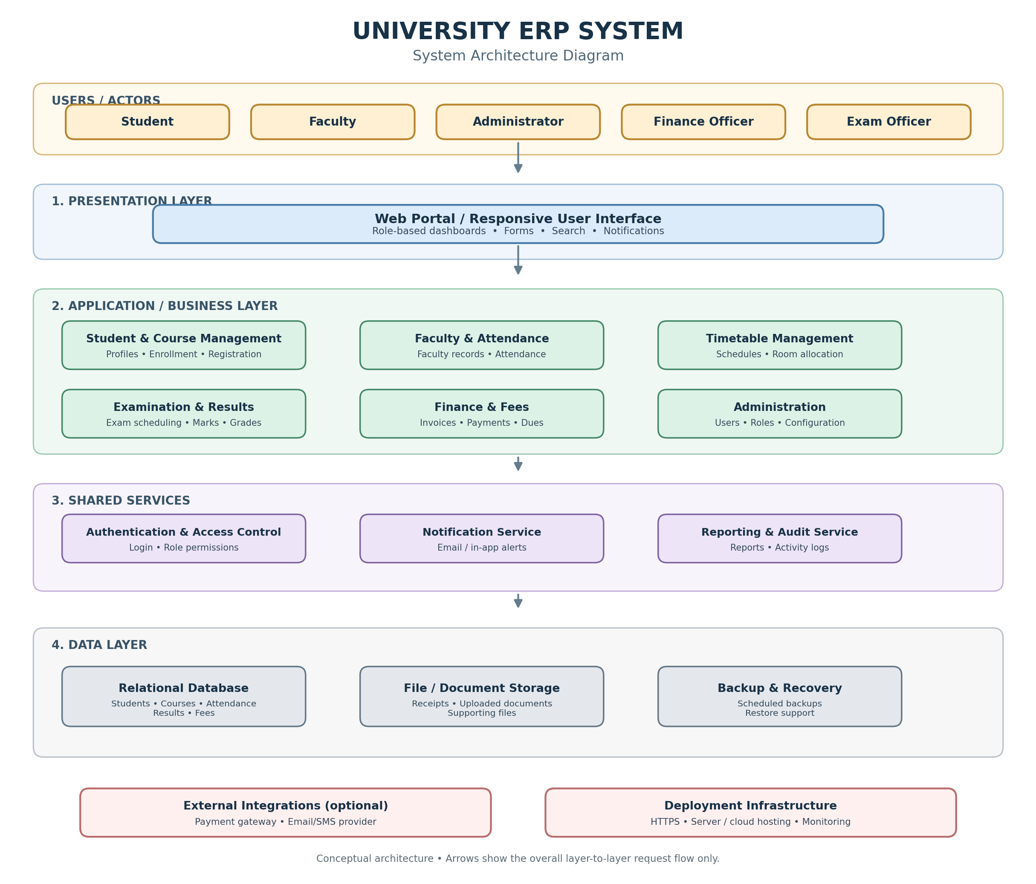
Figure 1. University ERP System architecture with simplified, non-overlapping flow arrows.

3. Architecture Layers
Layer | Components | Purpose
Presentation | Web portal / responsive UI | Provides dashboards, forms, search, and user interaction.
Application / Business | Student & Course; Faculty & Attendance; Timetable; Examination & Results; Finance & Fees; Administration | Implements business rules and coordinates ERP workflows.
Shared Services | Authentication & Access Control; Notification; Reporting & Audit | Provides reusable security, communication, reporting, and traceability functions.
Data | Relational database; File/document storage; Backup & recovery | Stores structured records, uploaded files, and recoverable copies.
External / Infrastructure | Payment gateway and email/SMS provider (optional); HTTPS, hosting, monitoring | Supports integrations and reliable deployment.

4. Main User Roles
- Student: Views profile and timetable, registers for courses, checks attendance and results, and reviews fee status.
- Faculty: Views assigned courses, records attendance, and submits assessment marks.
- Administrator: Manages users, permissions, academic setup, and system configuration.
- Finance Officer: Manages fee records, invoices, payments, and outstanding dues.
- Exam Officer: Coordinates examinations, grade processing, and result publication.

5. Typical Request Flow
- A user signs in through the presentation layer.
- Authentication and access control validate the account and role permissions.
- The relevant business module validates the request and applies university rules.
- The module reads or updates required records in the data layer.
- Notification or reporting services are invoked when required.
- The result is returned to the user interface.

6. Security and Quality Considerations
- Use authentication and role-based access control to restrict users to authorized functions.
- Protect data in transit with HTTPS and protect sensitive stored data where appropriate.
- Apply input validation and server-side authorization to important operations.
- Record important administrative, finance, and examination actions in audit logs.
- Maintain regular backups and test restoration procedures.
- Use monitoring, error handling, and modular separation to improve reliability and maintainability.

7. Deployment Assumptions
This conceptual architecture does not prescribe a particular programming language, framework, database vendor, or hosting platform. Deployment may use a university-managed server or cloud infrastructure.

8. Conclusion
The architecture separates user interaction, business functionality, shared services, and data storage. This separation supports clarity, maintainability, security, and future extension.

