**Table of Contents**

**Data Types:** **2**

**Object Oriented Programming Basic Vocab** **3**

**Java:** When you write code in java. Then, there are two parts to the compiler: the first part turns the code into bytecode. Then, the second part makes the code suitable for any type of processor/computer.

# Data Types:

* Primitives and Non-primitive (Wrapper Classes): built in data types, and do not need to declare a class to use them
* Wrapper classes are non-primitive data types
  + For college board, String is a primitive data type
  + In regular Java, Strings are Non-primitive data type.
  + Wrapper classes are capitalized, and primitives are not.
* Wrapper classes have method, since you are declaring them
* Python is a weak programming language

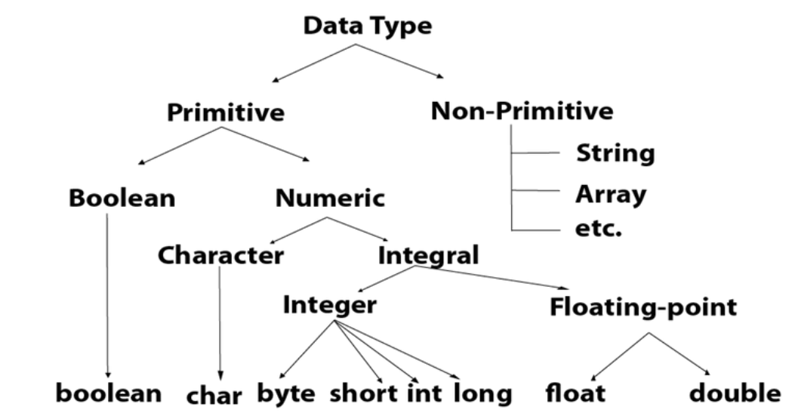

# Object Oriented Programming Basic Vocab

* **attribute -** a characteristic of an object
* **behavior -** an action that an object can perform
* **class -** a programmer-defined blueprint from which objects are created
* **constructor -** a block of code that has the same name as the class and tells the computer how to create a new object
* **debugging -** finding and fixing problems in an algorithm or program
* **instantiate -** to call the constructor to create an object
* **object -** an instance of a class
* **object-oriented programming -** an approach to creating and using models of physical or imagined objects
* **state -** the attributes of an object that are represented by its instance variables
* **constructor signature** - the first line of the constructor which includes the public keyword, the constructor name, and the values to specify when an object is created
* **inheritance** - an object-oriented programming principle where a subclass inherits the attributes and behaviors of a superclass
* **subclass** - a class that extends a superclass and inherits its attributes and behaviors
* **superclass** - a class that can be extended to create subclasses