**Practical 6 Part 2**

**Exercise-** Create an express application to send user information from form using GET and POST methods.

**Program 1: Form with GET() method**

**register.html**

<h1>Register</h1>

<form action="formSubmit" method="get">

<table>

<tr>

<td>Roll No</td>

<td><input type="text" name="rno" placeholder="Enter Roll No"></td>

</tr>

<tr>

<td>Name</td>

<td><input type="text" name="name" placeholder="Enter name"></td>

</tr>

<tr>

<td>Address</td>

<td><input type="text" name="address" placeholder="Enter address"></td>

</tr>

<tr>

<td>Email</td>

<td><input type="email" name="email" placeholder="Enter Email"></td>

</tr>

<tr>

<td>Mobile</td>

<td><input type="text" name="mobile" placeholder="Enter Mobile No"></td>

</tr>

<tr>

<td><input type="submit"></td>

</tr>

</table>

</form>

**get.js**

const express=require('express');

var app=express();

app.get('/register',function(req,res){

res.sendFile(__dirname + '/register.html');

});

app.get('/formSubmit',function(req,res){

// res.send(req.query.name);

const rno = req.query.rno;

const name = req.query.name;

const address = req.query.address;

const email = req.query.email;

const mobile = req.query.mobile;

res.send(`Roll Number: ${rno}<br> Name: ${name}<br> Address: ${address}<br> Email: ${email}<br> Mobile No: ${mobile}`);

});

app.listen(7000);

**Output:**



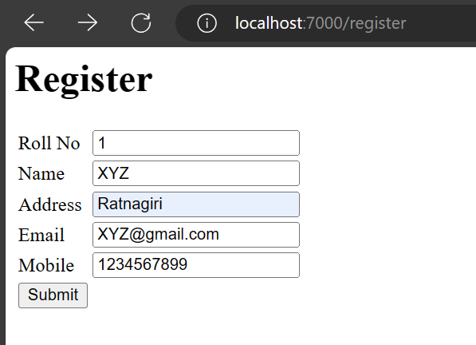

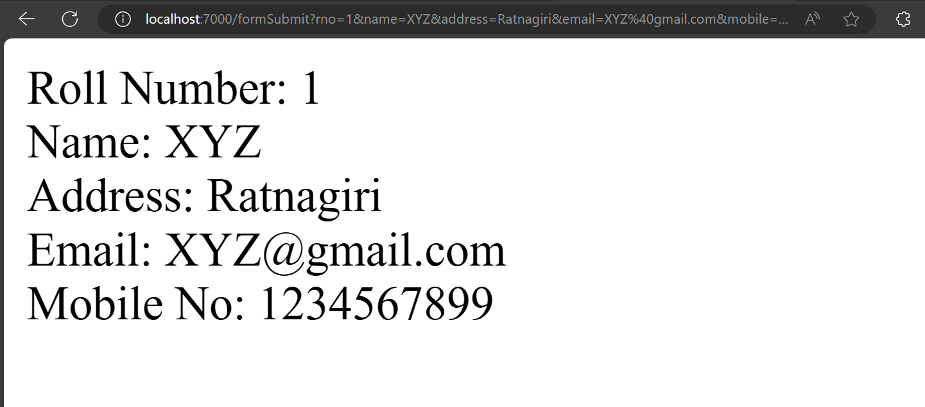

**Program 2: Form with POST() method**

**register.html**

<h1>Register</h1>

<form action="formSubmit" method="post">

<table>

<tr>

<td>Roll No</td>

<td><input type="text" name="rno" placeholder="Enter Roll No"></td>

</tr>

<tr>

<td>Name</td>

<td><input type="text" name="name" placeholder="Enter name"></td>

</tr>

<tr>

<td>Address</td>

<td><input type="text" name="address" placeholder="Enter address"></td>

</tr>

<tr>

<td>Email</td>

<td><input type="email" name="email" placeholder="Enter Email"></td>

</tr>

<tr>

<td>Mobile</td>

<td><input type="text" name="mobile" placeholder="Enter Mobile No"></td>

</tr>

<tr>

<td><input type="submit"></td>

</tr>

</table>

</form>

**post.js**

const express=require('express');

var app=express();

var bp=require('body-parser');

app.use(bp.json());

app.use(bp.urlencoded({extended:true}))

app.get('/register',function(req,res){

res.sendFile(__dirname + '/register.html');

});

app.post('/formSubmit',function(req,res){

//res.send(req.body.name);

const rno = req.body.rno;

const name = req.body.name;

const address = req.body.address;

const email = req.body.email;

const mobile = req.body.mobile;

res.send(`Roll Number: ${rno}<br> Name: ${name}<br> Address: ${address}<br> Email: ${email}<br> Mobile No: ${mobile}`);

});

app.listen(7000);

**Output:**



