Batch: A1 Roll No.: 1811007

Experiment No. 07

Grade: AA / AB / BB / BC / CC / CD /DD

Signature of the Staff In-charge with date

TITLE: Simulate Bankers Algorithm for Deadlock Avoidance
_____________________________________________________________________

AIM: Implementation of Banker’s Algorithm for Deadlock Avoidance
______________________________________________________________________
Expected Outcome of Experiment:

CO 4. Describe the problems related to process concurrency and the different synchronization mechanisms available to solve them.
________________________________________________________________
Books/ Journals/ Websites referred:

1.Silberschatz A., Galvin P., Gagne G. “Operating Systems Principles”, Willey Eight edition.
2.Achyut S. Godbole , Atul Kahate “Operating Systems” McGraw Hill Third
Edition.
3.William Stallings, “Operating System Internal & Design Principles”, Pearson.
4.Andrew S. Tanenbaum, “Modern Operating System”, Prentice Hall.
_____________________________________________________________________
Pre Lab/ Prior Concepts:

Knowledge of deadlocks and all deadlock avoidance methods.
Description of the application to be implemented:
The Banker's algorithm is a resource allocation and deadlock avoidance algorithm developed by Edsger Dijkstra.

DATA STRUCTURES
(where n is the number of processes in the system and m is the number of resource types)

Implementation details:
def main():
processes = int(input("number of processes : "))
resources = int(input("number of resources : "))
max_resources = [int(i) for i in input("maximum resources : ").split()]
print("\n-- allocated resources for each process --")
currently_allocated = [[int(i) for i in input(f"process {j + 1} : ").split()] for j in range(processes)]
print("\n-- maximum resources for each process --")
max_need = [[int(i) for i in input(f"process {j + 1} : ").split()] for j in range(processes)]

allocated = [0] * resources
for i in range(processes):
for j in range(resources):
allocated[j] += currently_allocated[i][j]
print(f"\ntotal allocated resources : {allocated}")

available = [max_resources[i] - allocated[i] for i in range(resources)]
print(f"total available resources : {available}\n")

running = [True] * processes
count = processes
while count != 0:
safe = False
for i in range(processes):
if running[i]:
executing = True
for j in range(resources):
if max_need[i][j] - currently_allocated[i][j] > available[j]:
executing = False
break
if executing:
print(f"process {i + 1} is executing")
running[i] = False
count -= 1
safe = True
for j in range(resources):
available[j] += currently_allocated[i][j]
break
if not safe:
print("the processes are in an unsafe state.")
break
print(f"the process is in a safe state.\navailable resources : {available}\n")

if __name__ == '__main__':
main()

Output:

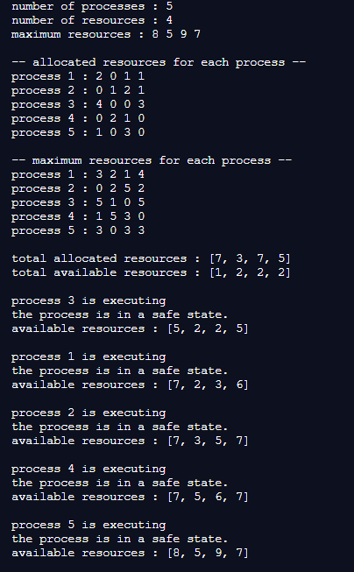

Conclusion: Thus we successfully implemented Banker’s Algorithm.
Post Lab Descriptive Questions (Add questions from examination point view)

- The wait-for graph is a deadlock detection algorithm that is applicable when:
  - All resources have a single instance
  - All resources have multiple instances
  - Both a and b
  - None of the above
A

- Resources are allocated to the process on non-sharable basis is _
  - Hold and Wait
  - Mutual Exclusion
  - No pre-emption
  - Circular Wait
B
- Which of the following approaches require knowledge of the system state?
  - Deadlock Detection
  - Deadlock Prevention
  - Deadlock Avoidance
  - All of the above
D
- Consider a system having ‘m’ resources of the same type. These resources are shared by 3 processes A, B, C which have peak time demands of 3, 4, 6 respectively. The minimum value of ‘m’ that ensures that deadlock will never occur is
a) | 11
b) | 12
c) | 13
d) | 14
C
5.Consider a system with total of 150 units of memory allocated to three processes as shown:

Process | Max | Hold
P1 | 70 | 45
P2 | 60 | 40
P3 | 60 | 15
Apply Banker’s algorithm to determine whether it would be safe to grant each of the following request. If yes, indicate sequence of termination that could be possible.

- The P4 process arrives with max need of 60 and initial need of 25 units

If process 4 needs 25 units, that means it holds 35 units. The table becomes:
Process | Max | Hold | Need
1 | 70 | 45 | 25
2 | 60 | 40 | 20
3 | 60 | 15 | 45
4 | 60 | 35 | 25

Total: 150 Units. Available: 150-45-40-15-35=15 units which are not enough to meet the requirements of any process.

- The P4 process arrives with max need of 60 and initial need of 35 units.
No Deadlock.
Available resources are: 150-(45+40+15+35) = 25. Initially, we begin with process 1. Now, process 1 releases 45 resources. Then, we add holded resources, which is total 45 now. Now we go for the second process, which leads to releasing of 70 resources. Then, we release second process which adds a total of 40 resources to our current resources. Now we have 110 resources out of which 25 will be used for the last process. Hence, there is not dead lock in this sequence.
Sequence: 1,2,3,4

Date: 17/11/20 Signature of faculty in-charge

