**Name:Aafreen khan**

**Enrollment:1810DMBCSE03275**

**Branch:B.tech+m.b.a Year:2nd CSE “I”**

**Objective/ Vision**

It maintains the information about the user login in a transport company with sufficient detail of vehicle.ID,Name, contact no. and and all the available transport sevices provided by the company.

**Tools and Technologies to be used**

1. Use Netbeanse IDE to develop the project
2. MYSQL for the database.
3. Apache Tomcat for the server.
4. Jsp and javascript

**How Project Works:**

**Page 1:-Login page**

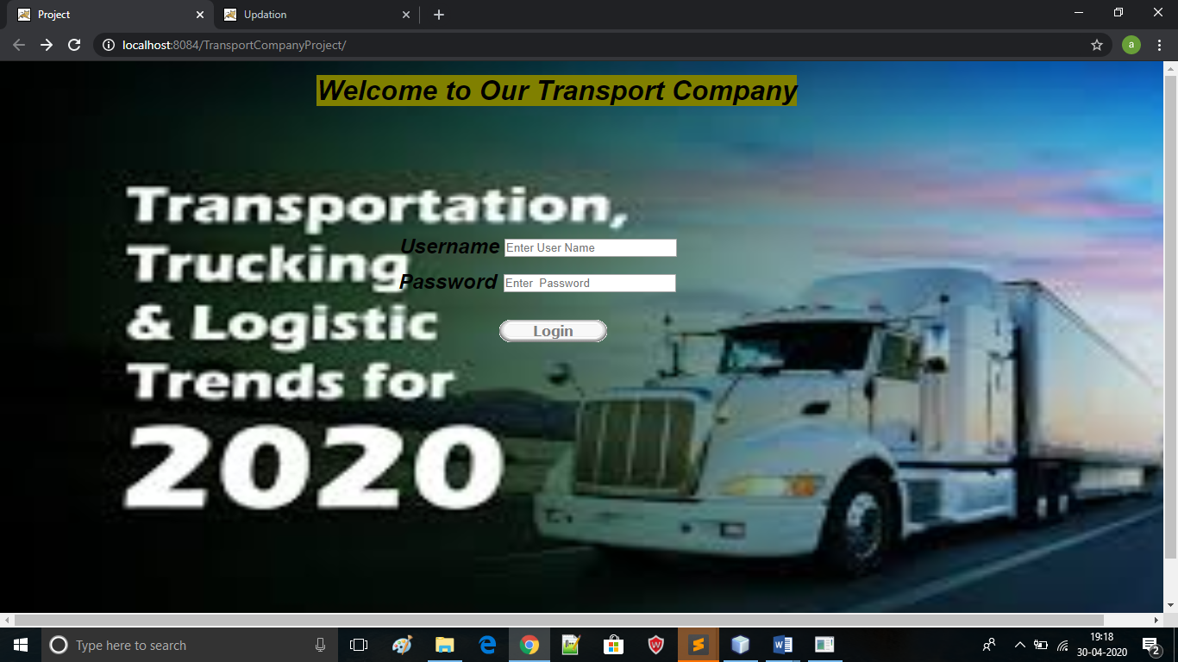

1. **After it redirect to home page:-**

There are 5 button on this page which do following activity:-

* 1. Insert detail of new login user
  2. View all user data
  3. Insert detail of vehicle
  4. View all vehicle detail
  5. Update user information

Page 2:-Home page after login successfully

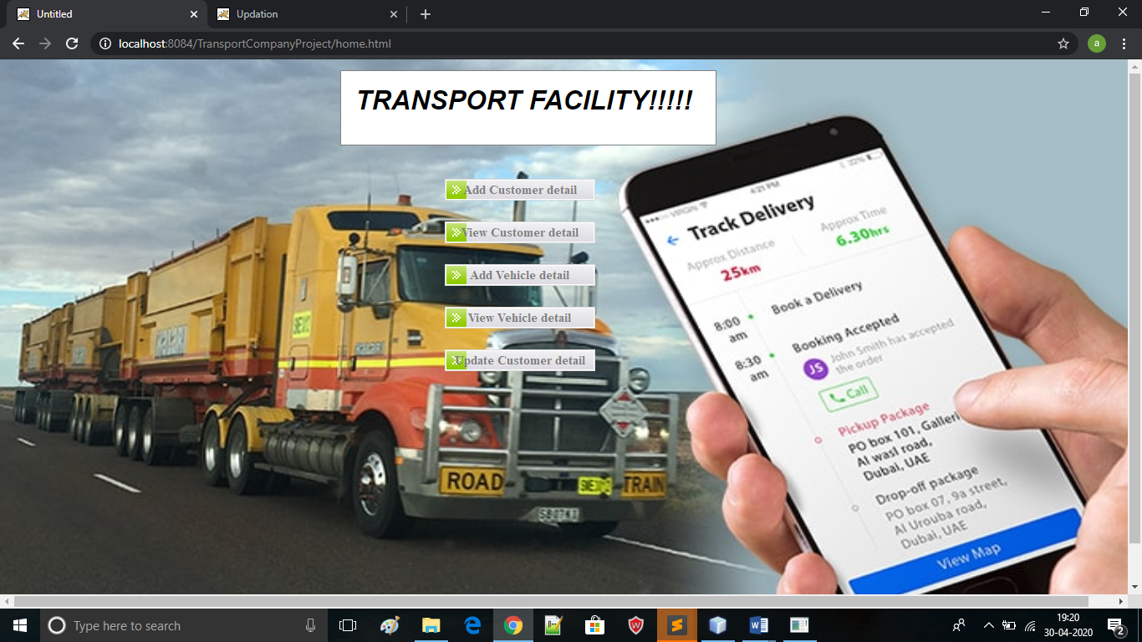

**Page 3:- Add user detail:**

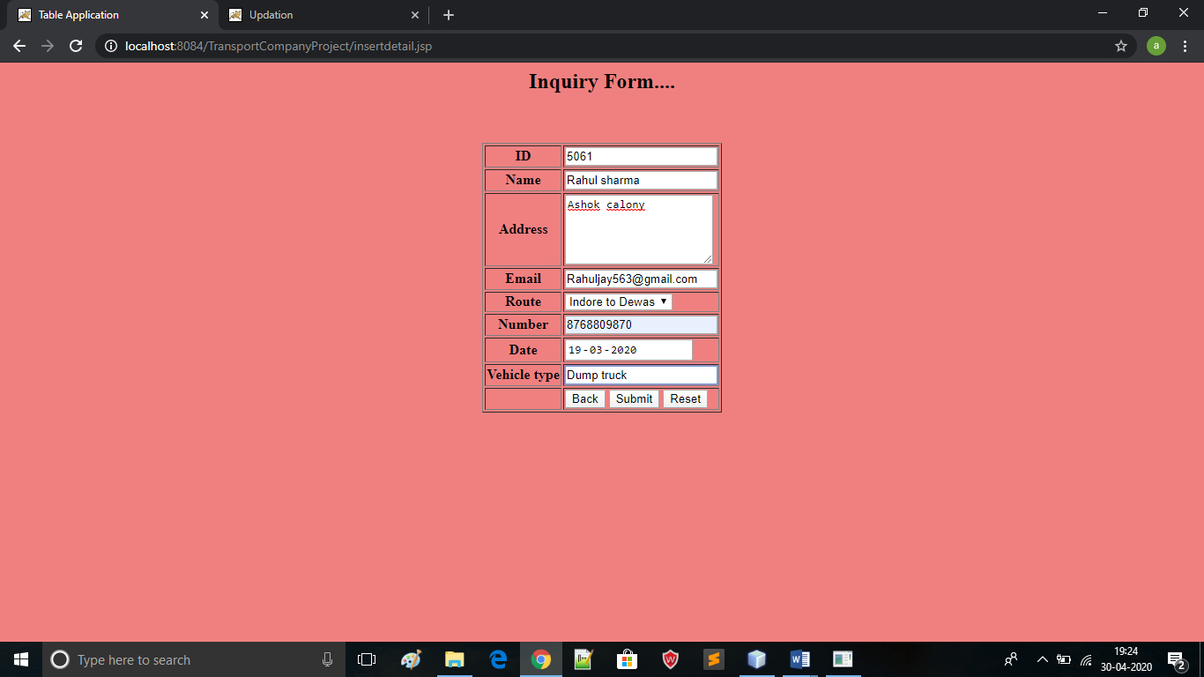

Record Inserted message-

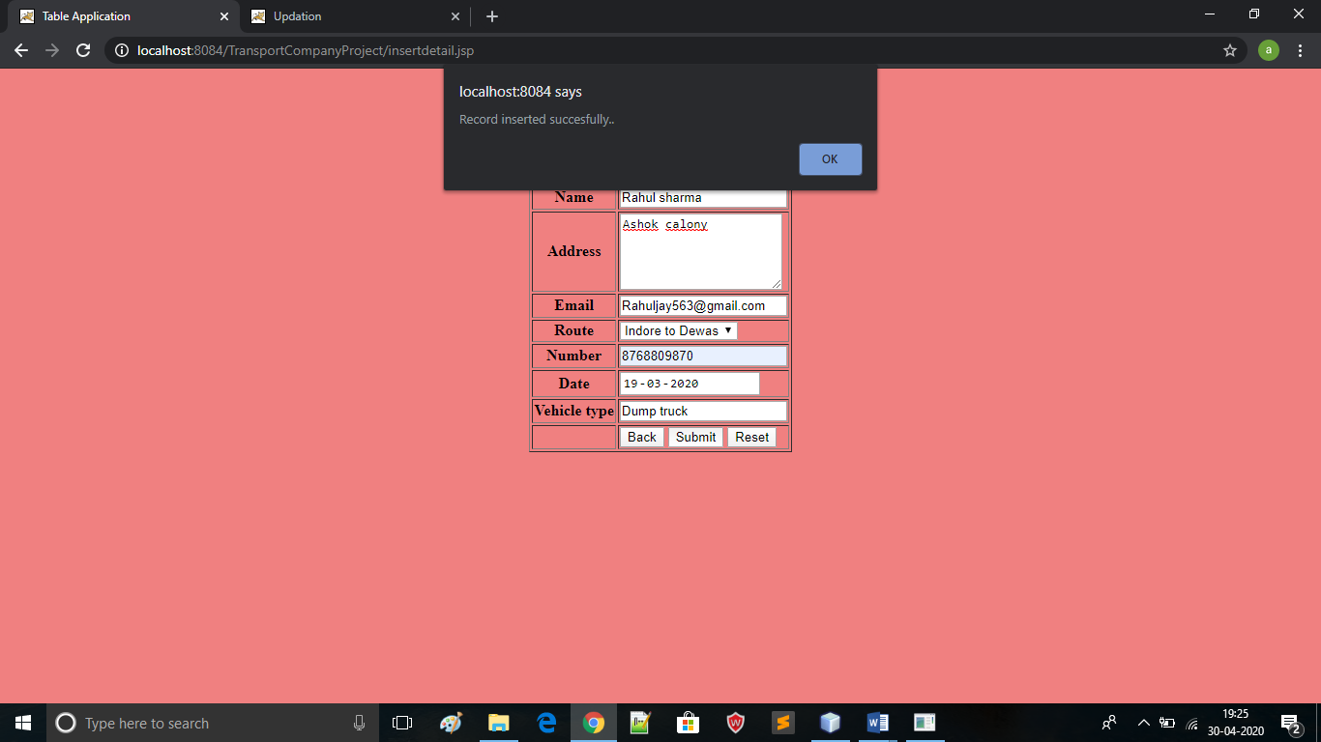

**Page 4:- View Data of all User who login successfully:**

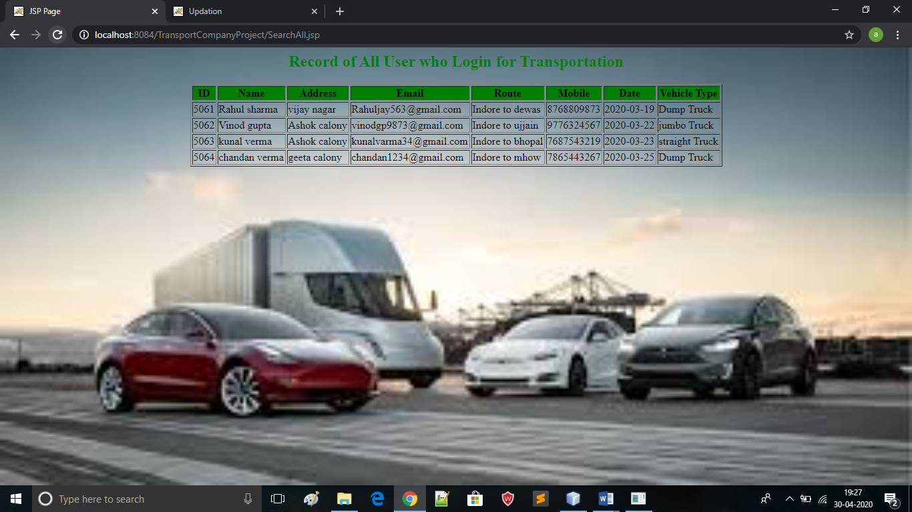

**Page 5:- Insert vehicle detail:-**

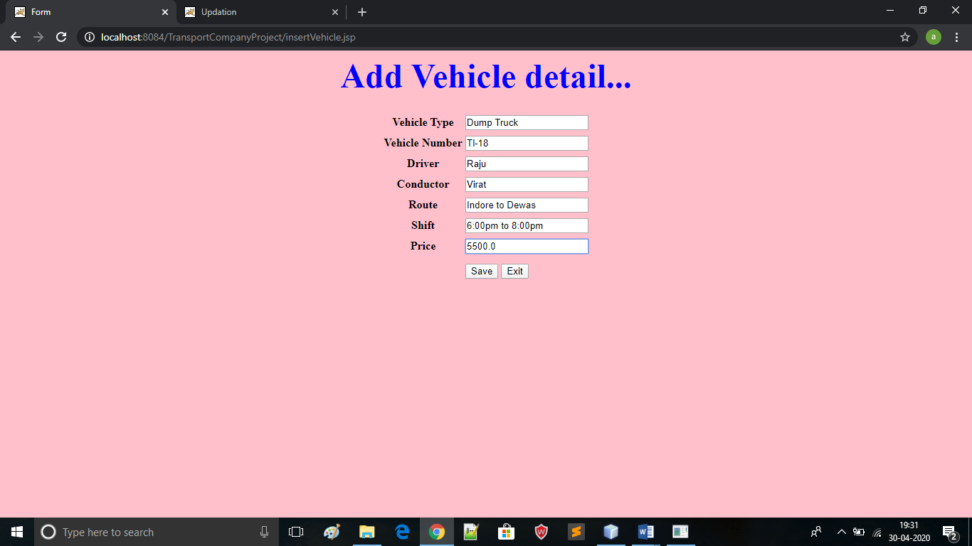

**On Click save data stored in databae:**

**Record inserted message**

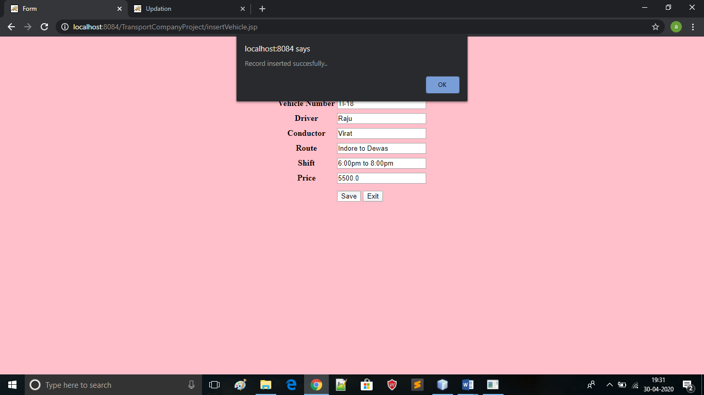

**Page 6:-show data of all vehicle:**

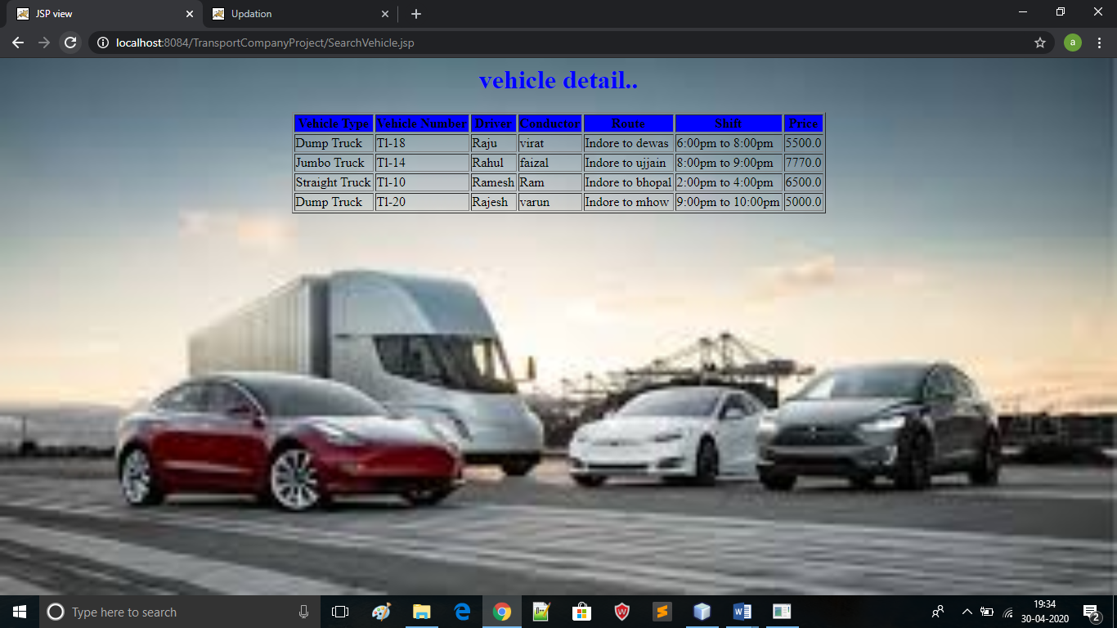

**Page 7:- updated the information :**

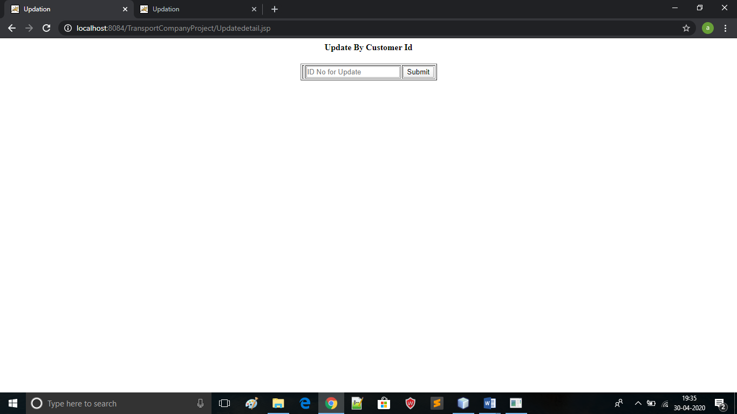

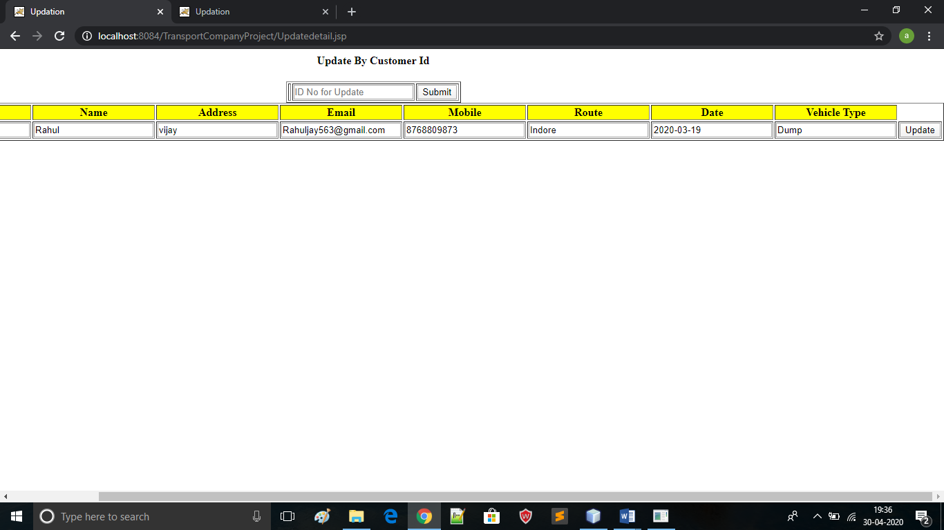

Updated successfully message:-

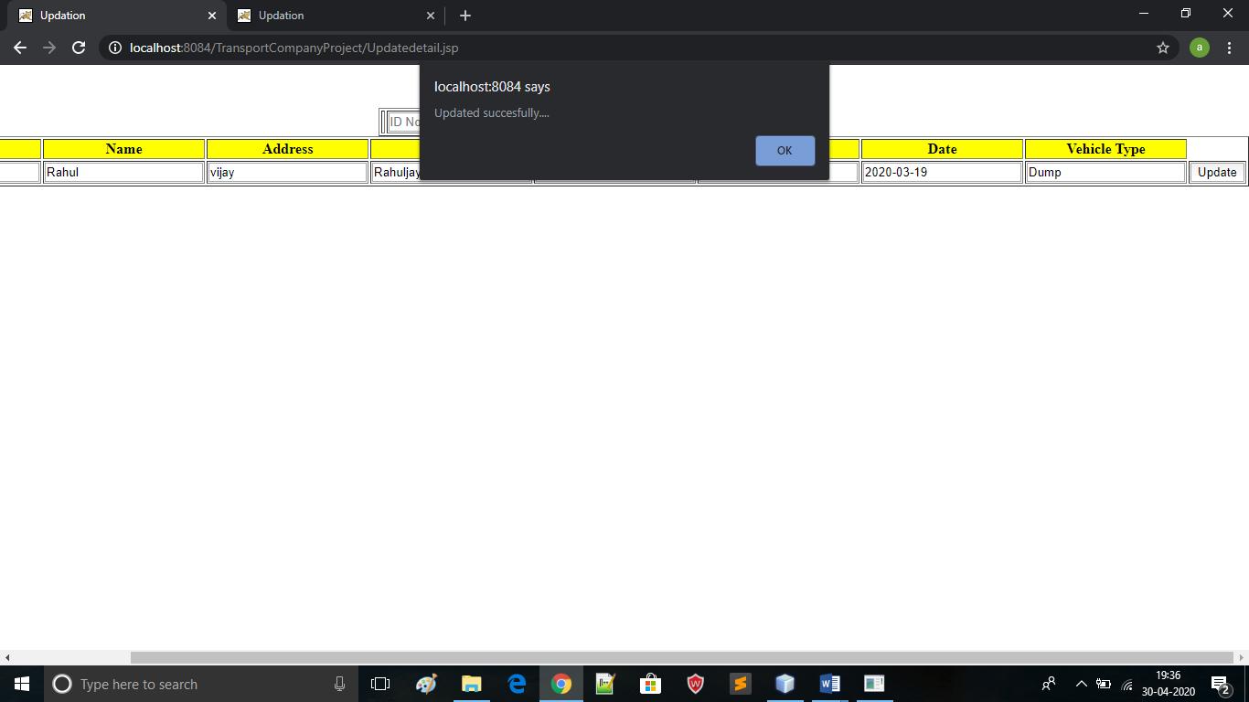

**Class diagram:**

Show user detail:name,email,no,address:

Show vehicle detail:vehicletype,Vno,Route,shift :

Add vehicle detail:

Add user detail :

Login:

Username

Password

User: