**Inventory Data Warehouse Project**

This project is about using **Pentaho Data Integration** to perform data cleaning and transform operations on two data sources: 1>Excel Spreadsheet and 2> Access Table. Data is then loaded into newly created fact table of the inventory data warehouse.

**Part 1: Using Excel Spreadsheet data source**

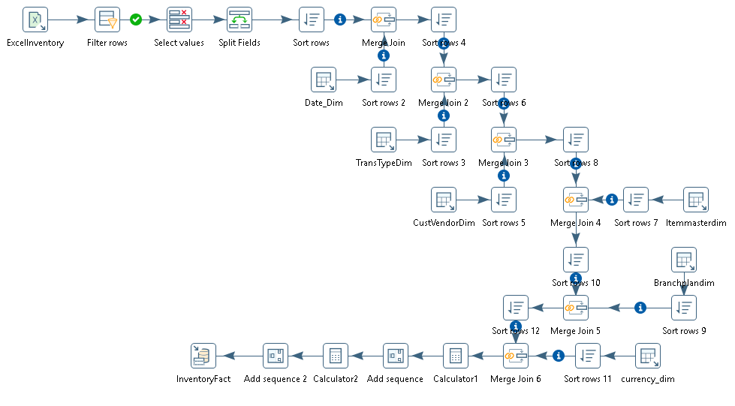

**Part 2: Using Access table data source**

