EXPERIMENT 4
EXPLORATORY DATA ANALYSIS (EDA) – DATA INSPECTION, FILTERING, STATISTICAL ANALYSIS AND CORRELATION

Aim
To perform data inspection, filtering, grouping, aggregation, descriptive statistical analysis, and correlation analysis using Pandas and visualize the results using Matplotlib.
Algorithm 1
Dataset Inspection
Step 1
Import dataset
Step 2
Display dataset
Step 3
Check dimensions
Step 4
Display data types
Step 5
Generate summary
Program 1
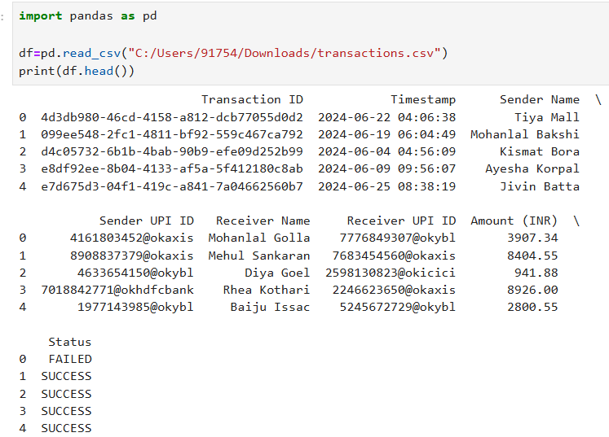
Program 2
Shape of Dataset
print(df.shape)
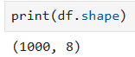
Program 3
Data Types
print(df.dtypes)
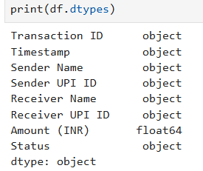
Algorithm 2
Filtering Data
Step 1
Specify condition
Step 2
Apply filter
Step 3
Display records
Program 4 - Filter Transactions Greater Than ₹5000
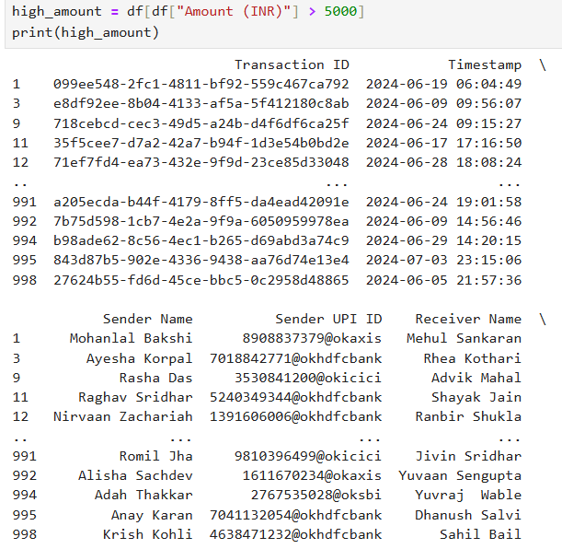
Program 5 - Filter Successful Transactions
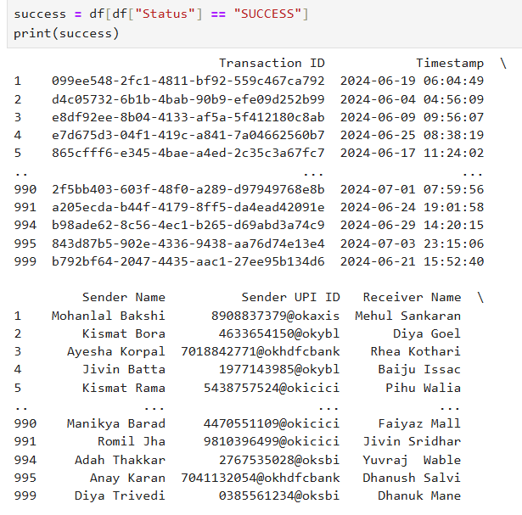

Algorithm 3
Sorting Data
Step 1
Select column
Step 2
Apply sort_values()
Step 3
Display sorted result
Program 6
Sort transaction by amount-descending
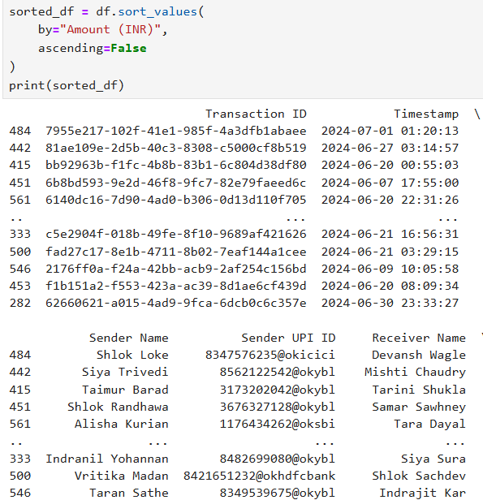
Visualization - Transaction Ranking
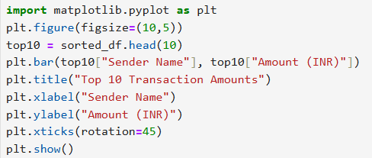
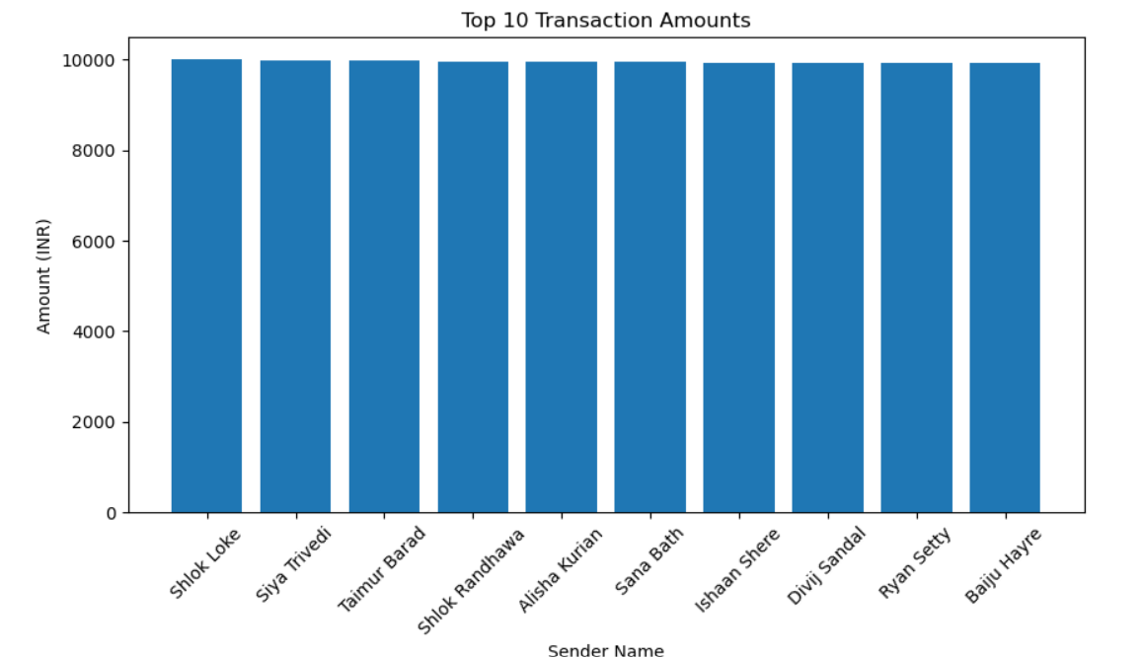
Algorithm 4
Statistical Analysis
Step 1
Select numerical column
Step 2
Calculate Mean
Step 3
Calculate Median
Step 4
Calculate Mode
Step 5
Calculate Standard Deviation
Program 7
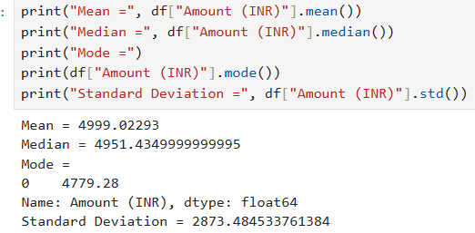

Program 8- Descriptive Statistics
print(df.describe())
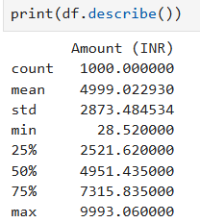
Algorithm 5
Grouping and Aggregation
Step 1
Select Status Column
Step 2
Apply groupby()
Step 3
Calculate Average Amount
Step 4
Display Result
Program 9
Average Transaction Amount By Status
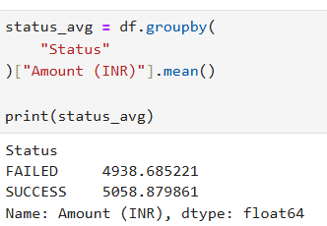
Visualization
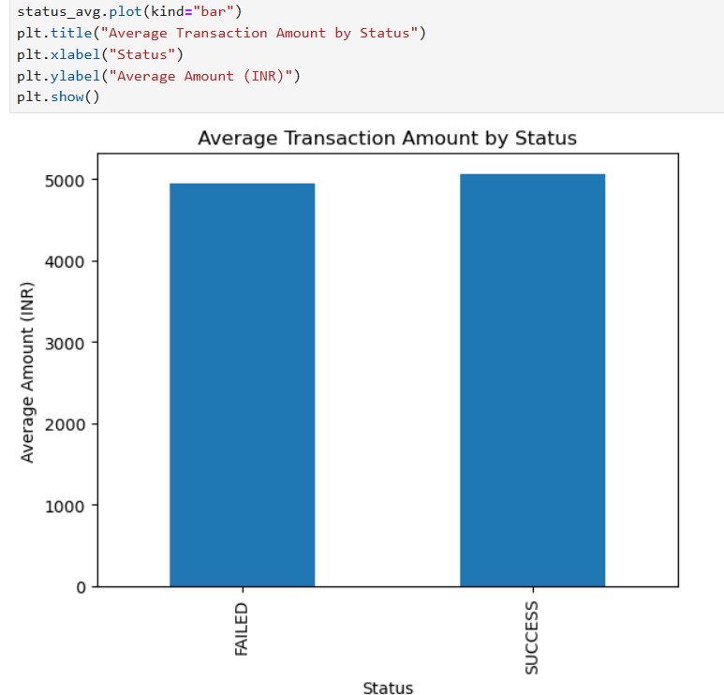

Algorithm 6
Correlation Analysis
Step 1
Select numerical columns
Step 2
Apply corr()
Step 3
Interpret correlation coefficient
Program 10
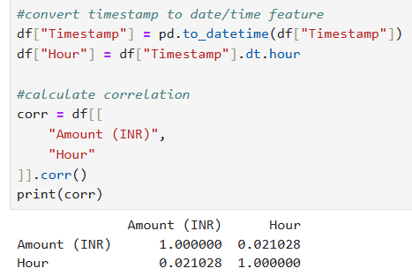

Result
Thus, data inspection, filtering, sorting, descriptive statistical analysis, grouping, aggregation, and correlation analysis were successfully performed using Pandas. The analytical results were visualized and interpreted successfully.

