*#importing libraries used in the prediction*

**import** **pandas** **as** **pd**

**import** **numpy** **as** **np**

**import** **matplotlib.pyplot** **as** **plt**

%matplotlib inline

df = pd.read_csv("http://bit.ly/w-data")

print("Data Succesfully loaded to dataframe df")

df.head(5)

Data Succesfully loaded to dataframe df

Out[2]:

|  | **Hours** | **Scores** |
| --- | --- | --- |
| **0** | 2.5 | 21 |
| **1** | 5.1 | 47 |
| **2** | 3.2 | 27 |
| **3** | 8.5 | 75 |
| **4** | 3.5 | 30 |

df.describe()

Out[3]:

|  | **Hours** | **Scores** |
| --- | --- | --- |
| **count** | 25.000000 | 25.000000 |
| **mean** | 5.012000 | 51.480000 |
| **std** | 2.525094 | 25.286887 |
| **min** | 1.100000 | 17.000000 |
| **25%** | 2.700000 | 30.000000 |
| **50%** | 4.800000 | 47.000000 |
| **75%** | 7.400000 | 75.000000 |
| **max** | 9.200000 | 95.000000 |

Lets plot a histogram for the dataframe df

In [4]:

gym = df['Hours']

gym.hist()

plt.xlabel('Hours')

plt.ylabel('Frequency')

plt.show()

gym = df['Scores']

gym.hist(color="black")

plt.xlabel('Sores')

plt.ylabel('Frequency')

plt.show()

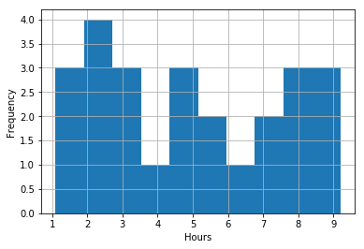

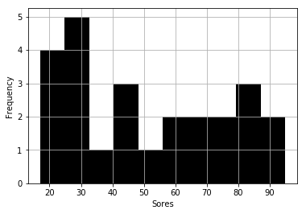

Now lets plot the dataframe points on a graph (2D plane) and try to analyse the dataset

In [6]:

df.plot(x='Hours', y='Scores', kind='scatter')

plt.title('Hours and Scores Relationship')

plt.xlabel('Hours')

plt.ylabel('Scores')

plt.show()

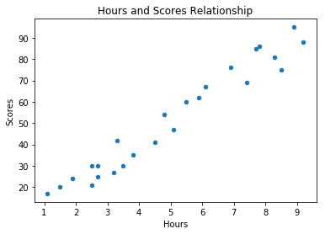

By looking at the above plotted graph, there appears to be positive linear relationship between no of hours studied and the score obtained

**Begining our predictive analysis**

Lets take Hours as the inputs ('attributes') and Scores as the outputs ('labels')

In [32]:

df.head(5)

Out[32]:

|  | **Hours** | **Scores** |
| --- | --- | --- |
| **0** | 2.5 | 21 |
| **1** | 5.1 | 47 |
| **2** | 3.2 | 27 |
| **3** | 8.5 | 75 |
| **4** | 3.5 | 30 |

In [33]:

X = df.iloc[:, :-1].values

y = df.iloc[:, 1].values

In [42]:

*# X.reshape(1,25)*

X

Out[42]:

array([[2.5],

[5.1],

[3.2],

[8.5],

[3.5],

[1.5],

[9.2],

[5.5],

[8.3],

[2.7],

[7.7],

[5.9],

[4.5],

[3.3],

[1.1],

[8.9],

[2.5], [1.9],

[6.1],

[7.4],

[2.7],

[4.8],

[3.8],

[6.9],

[7.8]])

In [43]:

y

Out[43]:

array([21, 47, 27, 75, 30, 20, 88, 60, 81, 25, 85, 62, 41, 42, 17, 95, 30,

24, 67, 69, 30, 54, 35, 76, 86])

Now lets split split this data into training and test sets.

In [41]:

*#importing the module*

**from** **sklearn.model_selection** **import** train_test_split

X_train, X_test, y_train, y_test = train_test_split(X, y, test_size=0.2, random_state=0)

Lets plot the training and the training sets and observe

In [46]:

plt.scatter(X_train, y_train, label='Training Data', color='blue')

plt.scatter(X_test, y_test, label='Testing Data', color='green')

plt.legend()

plt.title('Train Test Split')

plt.show()

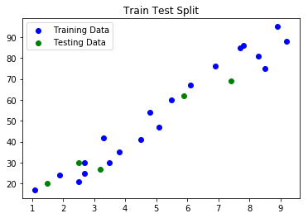

We have now split our data into training and test sets, now lets train our algoirthm

**Training the Algorithm**

In [50]:

*#importing the module*

**from** **sklearn.linear_model** **import** LinearRegression

LR = LinearRegression()

LR.fit(X_train, y_train) *#input of X_train needs to be 2D*

Out[50]:

LinearRegression(copy_X=True, fit_intercept=True, n_jobs=None, normalize=False)

**Making Predictions**

In [60]:

*#Use the model to make predictions on TEST data*

prediction = LR.predict(X_test)

*#Prediction line*

line = LR.coef_*X + LR.intercept_

*#Plot prediction line against actual test data*

plt.plot(X_test, prediction, label='Linear Regression', color='blue')

plt.scatter(X_test, y_test, label='Actual Test data', color='green')

plt.legend()

plt.title('Linear Regression line vs Actual Test Data')

plt.show()

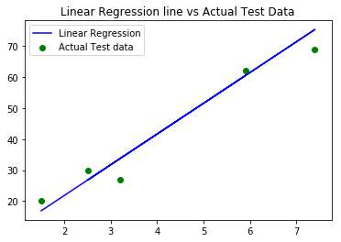

df2 = pd.DataFrame({'Actual': y_test, 'Predicted': prediction})

df2

Out[64]:

|  | **Actual** | **Predicted** |
| --- | --- | --- |
| **0** | 20 | 16.884145 |
| **1** | 27 | 33.732261 |
| **2** | 69 | 75.357018 |
| **3** | 30 | 26.794801 |
| **4** | 62 | 60.491033 |

**Score of the student if he studies for 9.25 hrs/day**

In [79]:

score = LR.predict([[9.25]]) *#Input needs to be 2D array*

print("No of hours the student studies per day: 9.25")

print('His predicted score: **{}**'.format(score[0]))

No of hours the student studies per day: 9.25

His predicted score: 93.69173248737539

**Evaluating/Scoring our model**

In [83]:

**from** **sklearn** **import** metrics

print('Mean Absolute Error:', metrics.mean_absolute_error(y_test, prediction))

Mean Absolute Error: 4.183859899002982

In [84]:

LR.score(X_test, y_test)

Out[84]:

0.9454906892105354