SmartCare v0.3 - Domain Model Workbook
Week 6 student resource

Requirement-to-Concept Trace
Requirement | Concept | State/behaviour | Decision
FR-01 | Appointment | attribute: patient, practitioner, time | Confirmed class -- central entity
FR-02 | Appointment | behaviour: list all appointments | Supports display; no new concept needed
FR-03/04/05 | Appointment | behaviour: reject blank required fields | Confirmed responsibility of Appointment
FR-06 | Patient | behaviour: search appointment history | Confirmed responsibility of Patient
FR-07 | Appointment | behaviour: detect exact duplicate | Confirmed responsibility of Appointment
FR-08 | Practitioner | behaviour: view own scheduled appointments | Confirmed responsibility of Practitioner
FR-09 | Appointment | attribute: creation timestamp | Confirmed attribute of Appointment
FR-10/FR-11 | Appointment | attribute: status; behaviour: cancel, retain record | Confirmed -- status attribute, not a Cancellation class
FR-12 | Appointment | behaviour: confirm booking | Supports interaction; no new concept needed
NFR-02 | Appointment | design constraint: logic independently testable | Influences design -- core logic kept separate from any display code

CRC Cards

Patient
Responsibilities | Collaborators
Know its own name | Appointment
Be associated with its appointment history | Appointment

Practitioner
Responsibilities | Collaborators
Know its own name | Appointment
Be associated with its scheduled appointments; support checking for double-booking conflicts (FR-07) | Appointment

Appointment
Responsibilities | Collaborators
Know the patient, practitioner, time and status it links; validate required fields (FR-03/04/05); detect duplicates (FR-07) | Patient, Practitioner
Record its creation timestamp (FR-09); retain its record after cancellation (FR-11) | N/A

Optional class
Responsibilities | Collaborators
Not applicable -- no additional class required beyond Patient, Practitioner, and Appointment | N/A
See Candidate Concepts analysis: Clinic, Database, Cancellation, and Status were all considered and rejected as standalone classes | N/A

UML Class Diagram
Insert/draw UML here. Include defensible relationships and multiplicities.
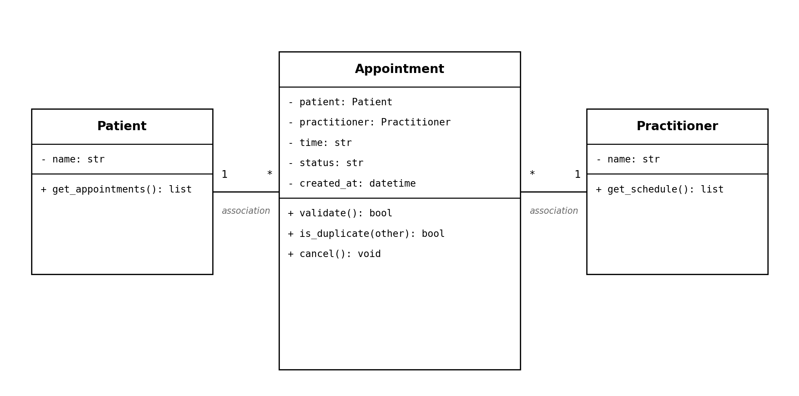

Design Rationale
Explain class selection, responsibility allocation and key relationships.
Three classes were selected: Patient, Practitioner and Appointment. Each candidate concept from the requirements was tested against two questions: does it have its own identity/data, and would the system ever need more than one instance with separate data? Patient and Practitioner passed both tests -- they are distinct real-world entities referenced by many Appointments. Name, Clinic, Database, Cancellation and Status all failed at least one test: Name is just a text attribute, Clinic is not multi-instance and stores no data of its own, Database is an infrastructure concern rather than a domain concept and Cancellation/Status are states an Appointment can be in, not separate entities.

Responsibility allocation followed the CRC analysis: Patient and Practitioner are deliberately simple, mostly holding identifying data and a reference to their appointments. Appointment carries almost all of the real logic -- validation (FR-03/04/05), duplicate detection (FR-07), status tracking (FR-10/FR-11), and timestamping (FR-09) -- because Appointment is the central entity that the case study's actual problems (duplicate bookings, inconsistent status, limited history) all revolve around.

Both relationships (Patient-Appointment and Practitioner-Appointment) are associations, not inheritance or composition. Neither Patient nor Practitioner is a type of Appointment and an Appointment is not owned/destroyed alongside its Patient or Practitioner -- it references them. Multiplicity is 1-to-many in both cases: one Patient or Practitioner can have many Appointments, but each Appointment links to exactly one Patient and one Practitioner.

AI Design Review Record
AI suggestion | Evidence | Decision | Reason | Model change
Patient, Practitioner, and Appointment should be the core classes | Yes -- matches independent Candidate Concepts analysis (identity, data, referenced by other concepts) | Accepted | Correctly identified based on confirmed requirements | None -- confirms the existing model
Add PatientManager, PractitionerManager, AppointmentManager classes | No -- no requirement asks for a separate manager layer | Rejected | Redundant wrappers that duplicate existing class/function responsibilities | None added
Add a ClinicController class | No -- no FR needs a central controller object | Rejected | Speculative architecture not evidenced by any requirement | None added
Add a NotificationManager class | No -- SMS reminders were only ever an unconfirmed assumption in Stage 2 | Rejected | Invents a feature never confirmed by the client | None added
Add a dedicated ScheduleEngine class | Partial -- FR-07/FR-08 relate to scheduling, but no requirement asks for a separate engine | Modified | Scheduling is a real concept, but too small-scale here to justify its own class | Scheduling responsibility kept inside Appointment.is_duplicate() and Practitioner.get_schedule() instead

