1. **ANSWER 1**

***ER DIAGRAM***

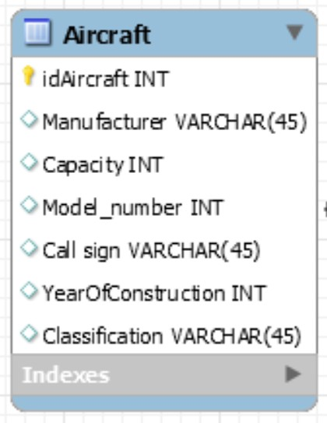

**DATA 1:**

***AIRCRAFT TABLE***

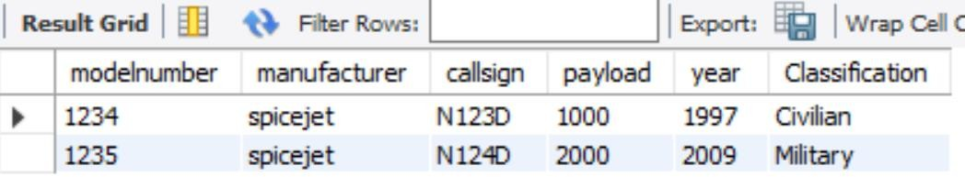

1. **ANSWER 2**

***ER DIAGRAM***



**DATA 2:**

***RESTAURANT TABLE***

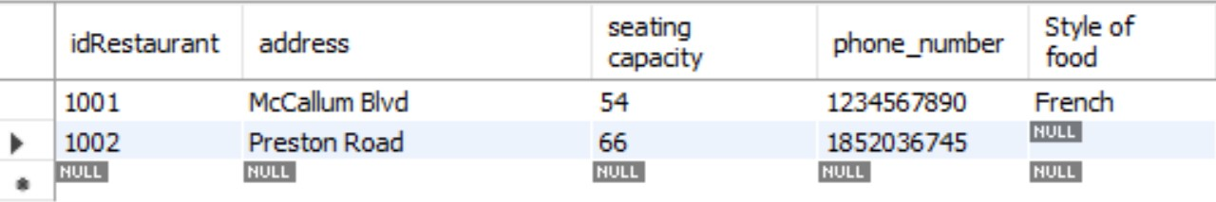

1. **ANSWER 3**

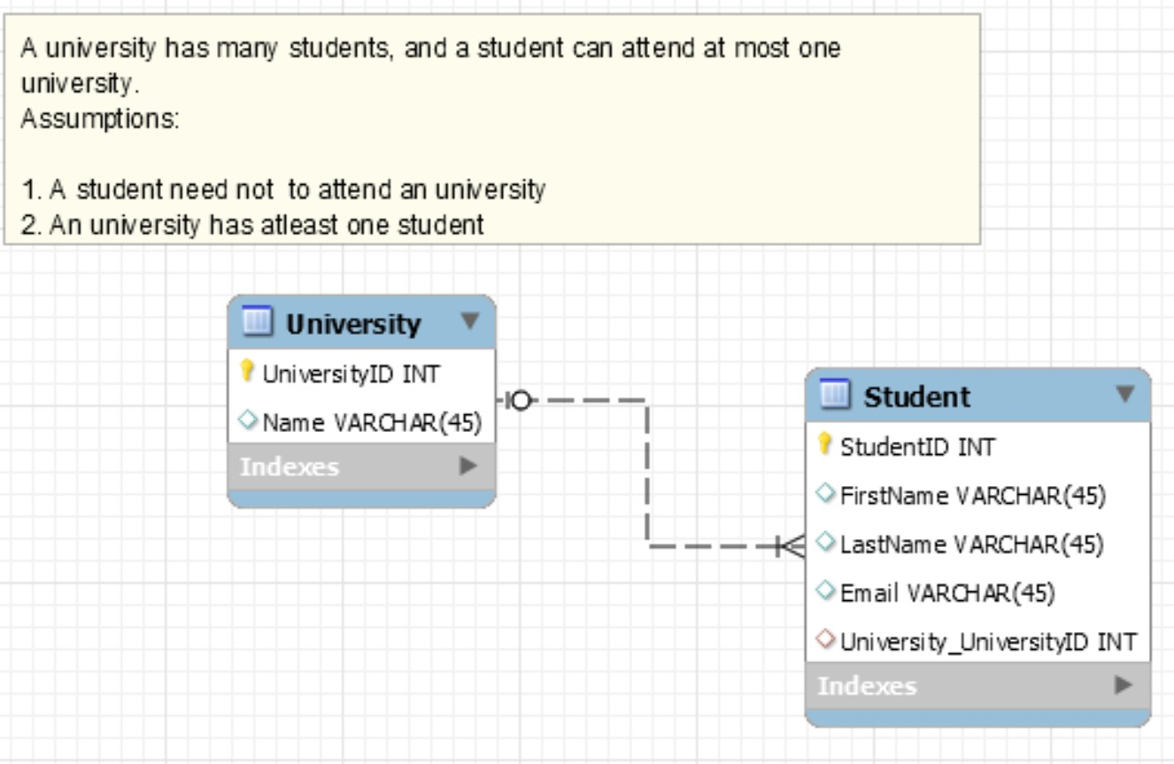***ER DIAGRAM***

**DATA 3:**

***STUDENT TABLE***

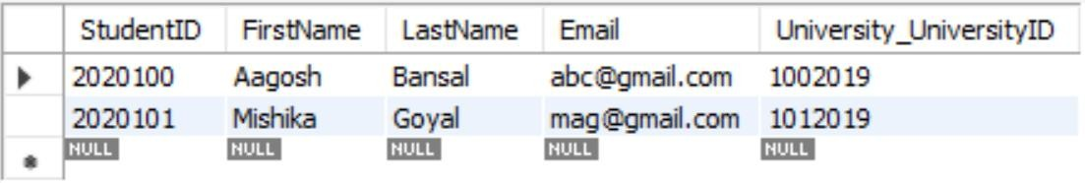

***UNIVERSITY TABLE***

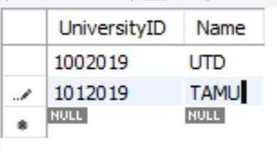

1. **ANSWER 4**

***ER DIAGRAM***

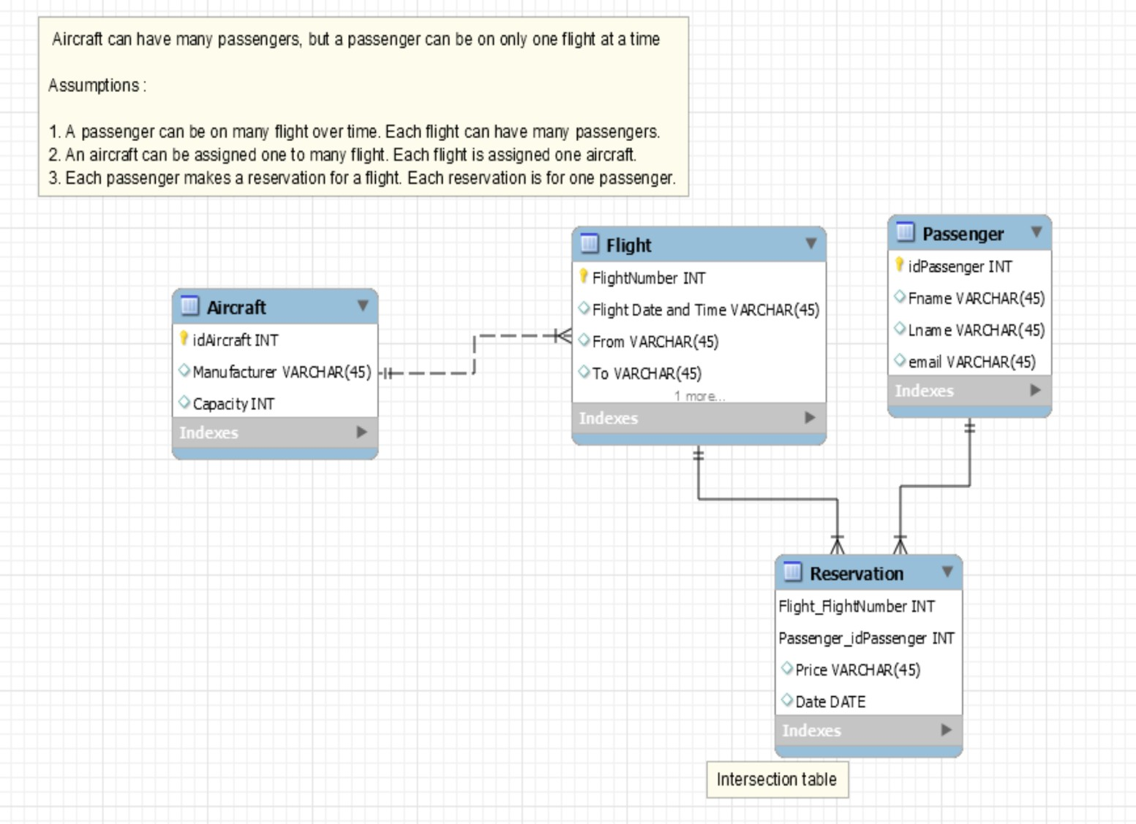

**DATA 4:**

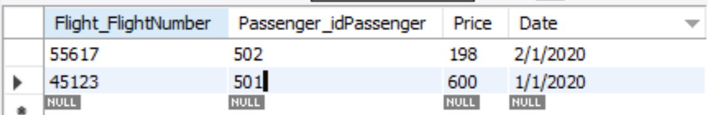***RESERVATION TABLE***

***FLIGHT TABLE***

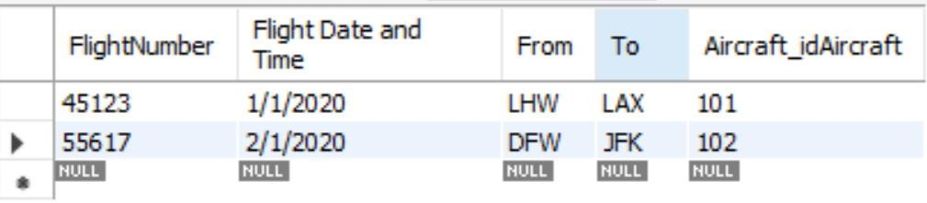

***AIRCRAFT TABLE***

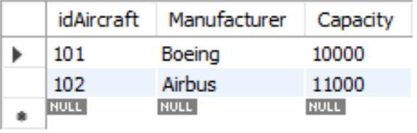

***PASSENGER TABLE***

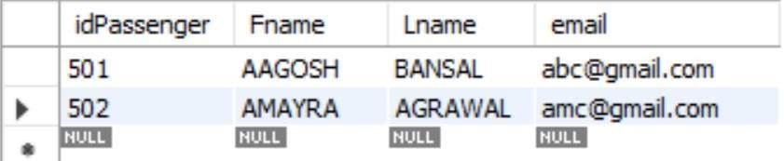

1. **SECOND PART**

**K-DATA**

# 1NF

1. No column in any table will contain multipart or multivalued values - 1 Normal form.
2. every table will have a good primary key (consisting of columns that contain non changing non null values that are unique across all rows in the table 1 Normal form.

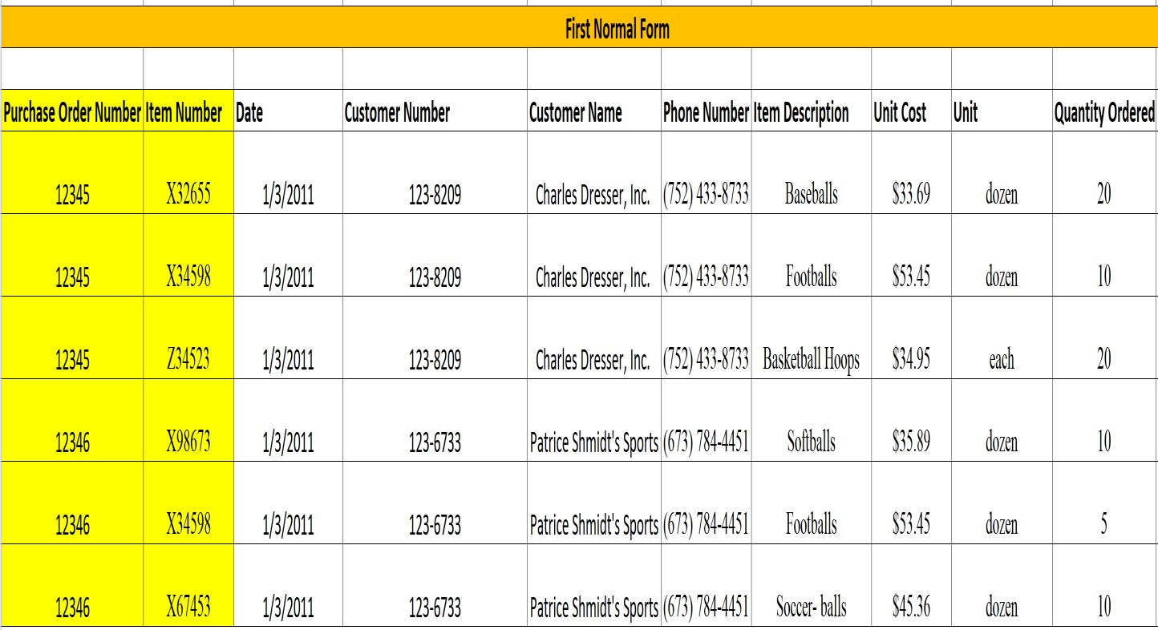

# 2NF and 3NF

No partial functional dependency. All non-key columns in each table will rely on the entire primary key for its existence (i.e. functionally dependent on the entire primary key) - 2 Normal form

No transitive functional dependency. All non-key column in each table will rely ONLY on the entire primary key for its existence (i.e. functionally dependent only on entire primary key). No non key column will be functionally dependent on another non key column in the database - Third Normal Form

