1.

/\****"Provide a list of students whose first name starts with ‘B’ or who live in Seattle."***

***Translation:*** Select student's first name, student's last name where the student has "B" as

first letter or where the student lives is Seattle

***Cleanup:*** SELECT student first name, student last name, student city FROM students WHERE student first name LIKE'B_%'

or student city Seattle*/

use schoolschedulingexample;

SELECT StudFirstName, StudLastName, StudCity FROM students WHERE StudFirstName LIKE 'B_%' OR StudCity = 'Seattle';

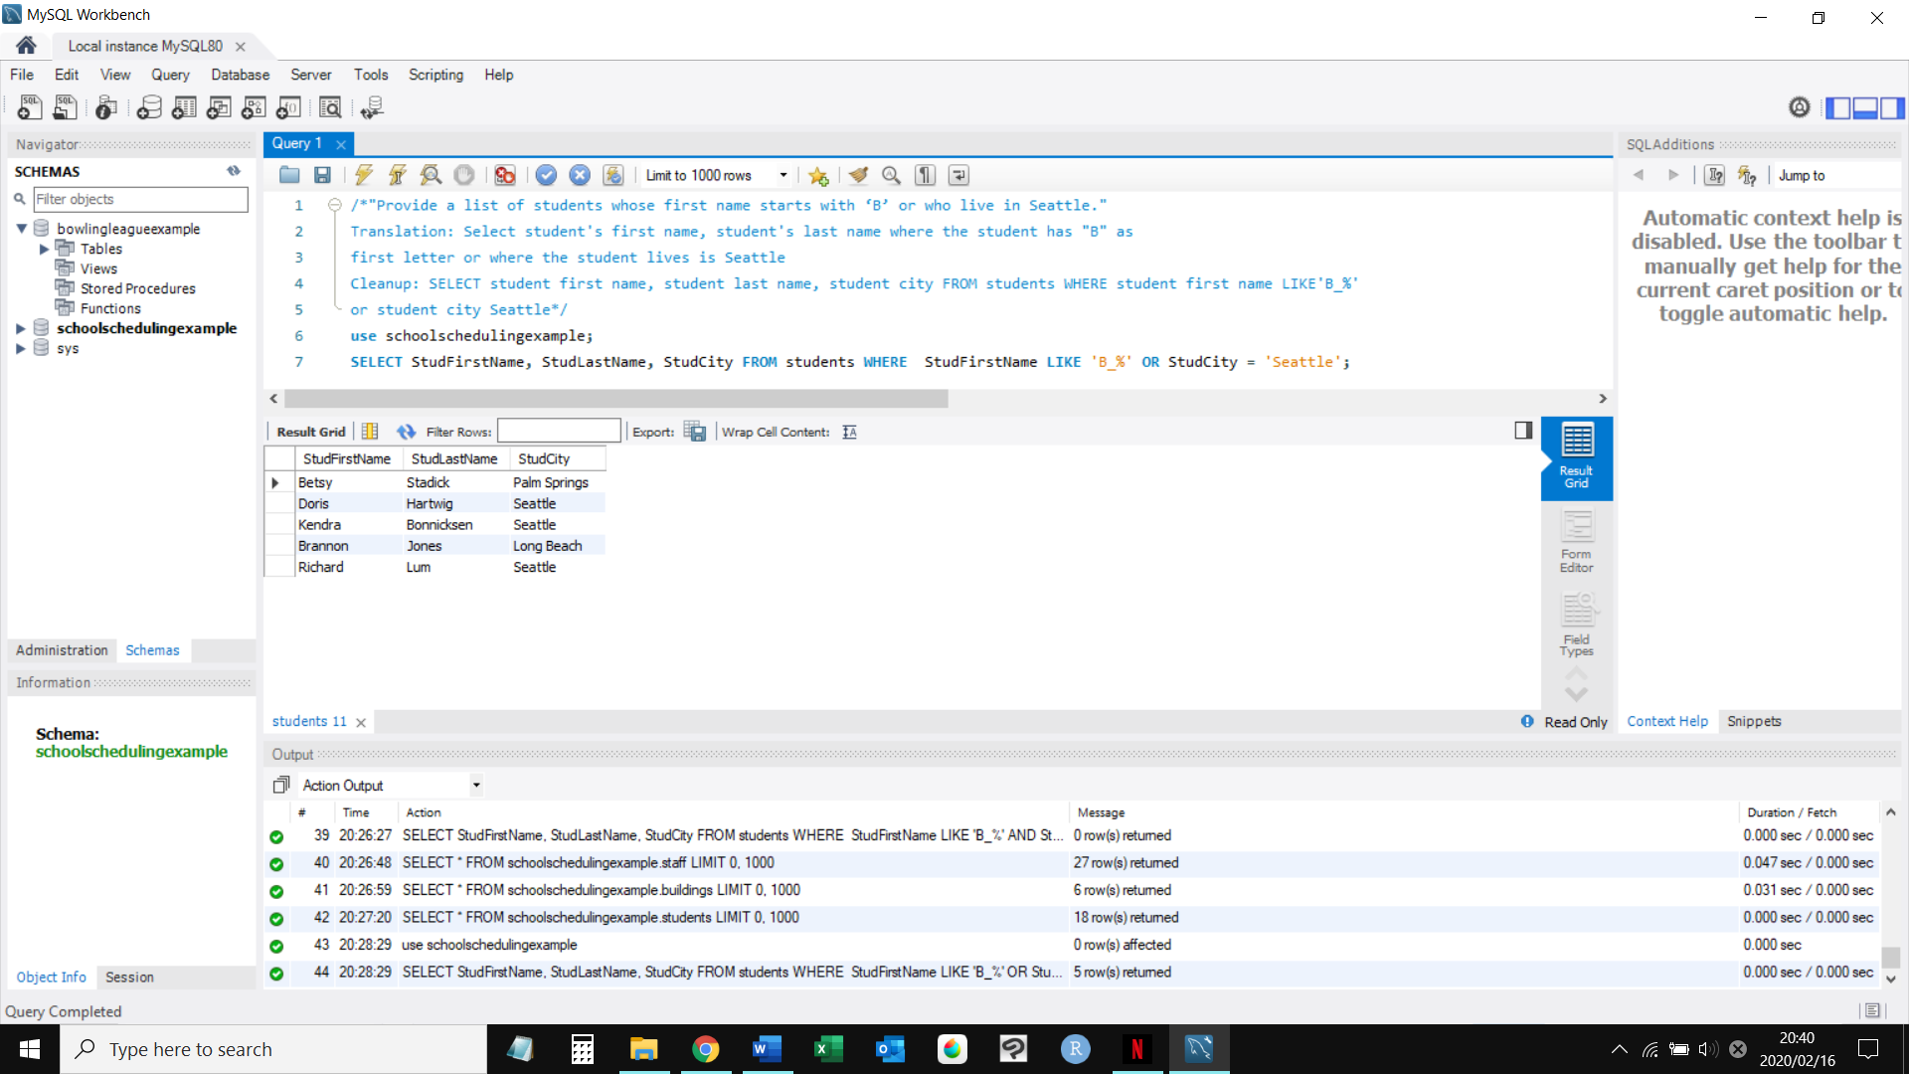

2.

/\****"Show me an alphabetical list of all the staff members and their salaries if they make between $40,000 and $50,000 a year."***

***Translation:*** Select employees whose earn between $40K and $50K a year and list them alphabetically

***Cleanup:*** SELECT Stffirstname, Stflastname, Salary From Staff Where Salary BETWEEN “40000” AND “50000” ORDERBY Stffirstname, Staflastname; */

SELECT

Stfirstname, Stlastname, Salary

FROM

Staff

WHERE

Salary BETWEEN ‘40000’ AND ‘50000’

ORDER BY Stffirstname, Stflastname;

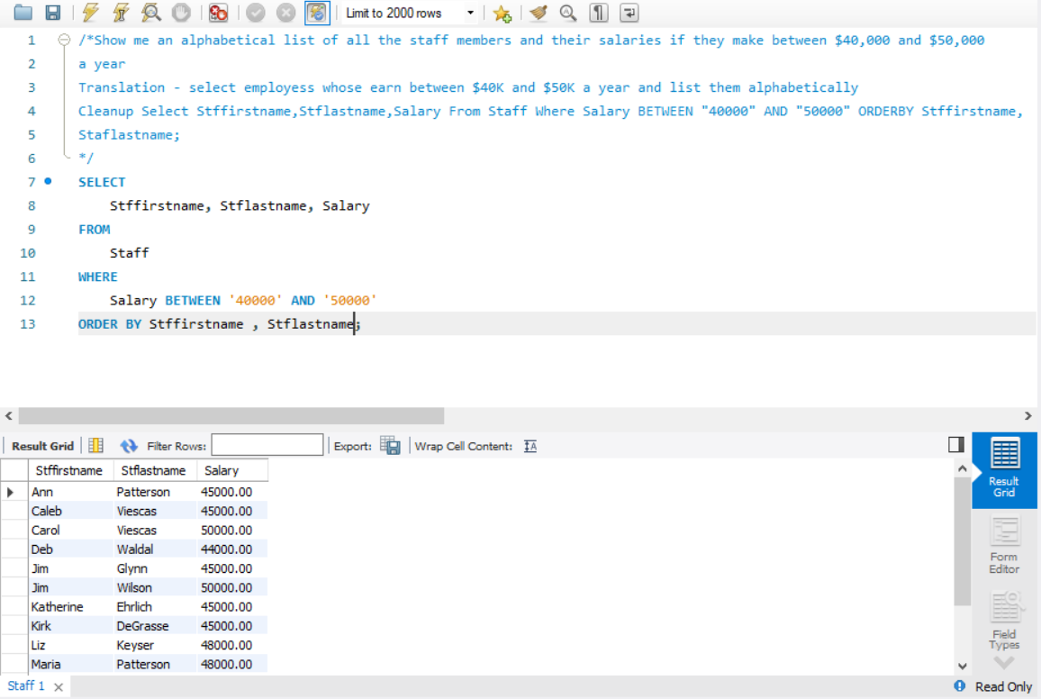

3.

/\****"Show me the engagements that run for at least 3 days."***

***Translation:*** Select from engagements where end date is at least three days after the start date

***Cleanup:*** SELECT engagements WHERE EndDate, StartDate bigger or equal than 3*/

use entertainmentagencyexample;

select * from engagements where datediff( EndDate,StartDate) >= 3;

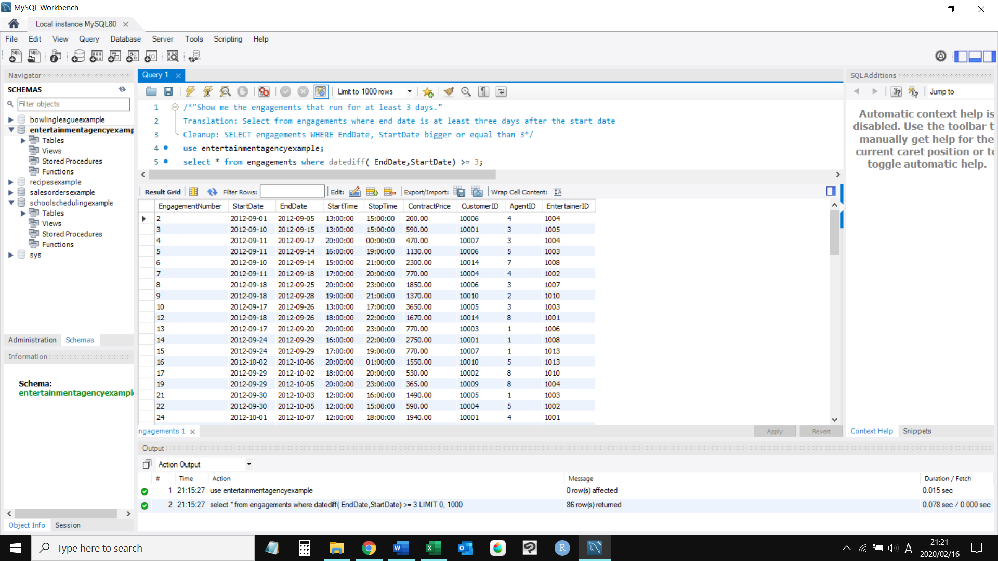

4.

/\****"Provide a list of staff members and their salaries if they make at least $35000 a year."***

***Translation:*** Select staff members name, salary if the salary is at least 35000

***Cleanup:*** SELECT staff first name, staff last name, salary FROM staff WHERE salary bigger or equal to 35000*/

USE SCHOOLSCHEDULINGEXAMPLE;

SELECT STFFIRSTNAME, STFLASTNAME, SALARY FROM STAFF WHERE SALARY >= '35000';

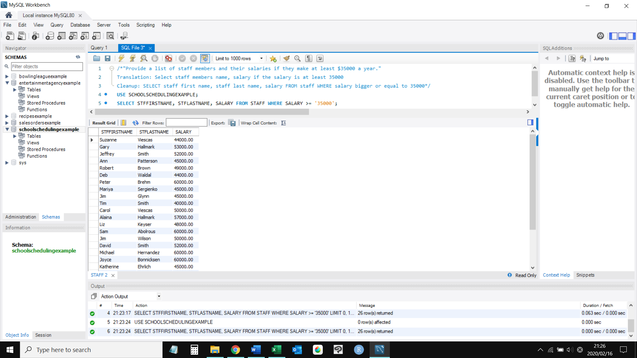

5.

/\****"Provide a list of recipes that contain eggs in their preparation"***

***Translation:*** Select recipes which have eggs in the preparation column

***Cleanup:*** SELECT recipetitle form recipes WHERE Preparation LIKE "%eggs%" */

SELECT

recipetitle

FROM

recipes

WHERE

Preparation LIKE '%eggs%';

