1.

/\****"Show me an alphabetical list of all the staff members and their salaries if they make between $40,000 and $50,000 a year."***

***Translation:*** Select staff members who earns between $40k and $50k a year and list them alphabetically

***Cleanup:*** SELECT StfFirstName, StfLastName, Salary FROM Staff WHERE Salary between "40000" and "50000" order by StfFirstName and StfLastName; */

SELECT StfFirstName, StfLastName, Salary

FROM staff

WHERE Salary between '40000' and '50000'

order by StfFirstName, StfLastname;

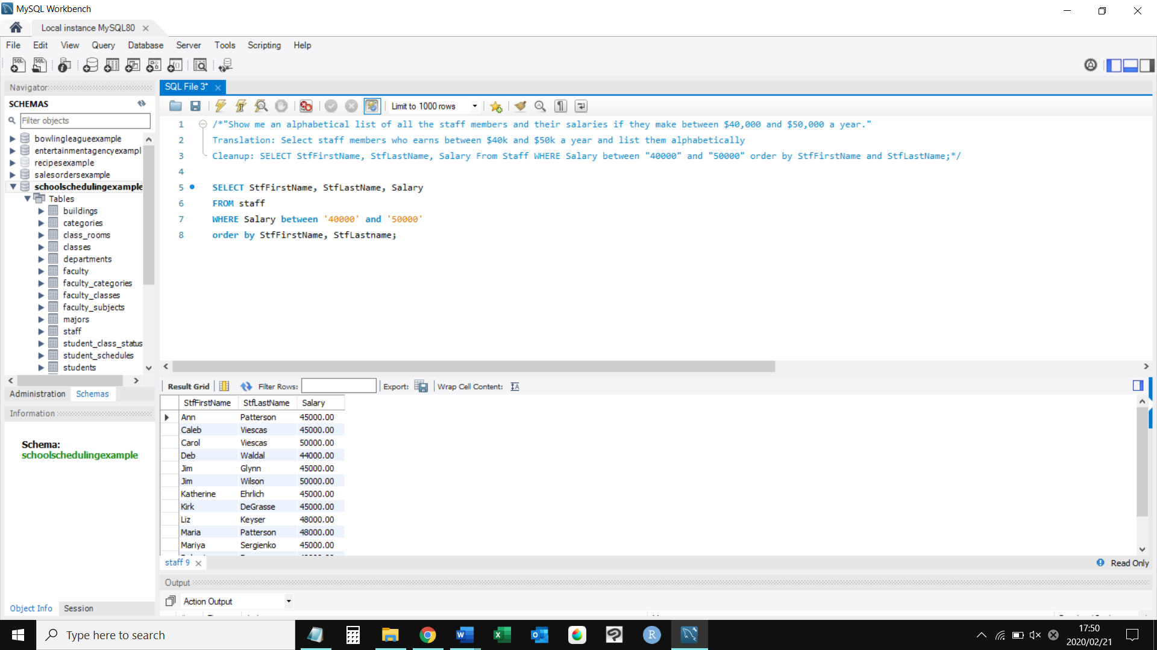

2.

/\***List the recipes that have no notes**

**Translation**: Select recipes name which doesn't have any notes

**Cleanup:** SELECT RecipeTitle from Recipes where notes is NULL */

select RecipeTitle

from recipes

where notes is null;

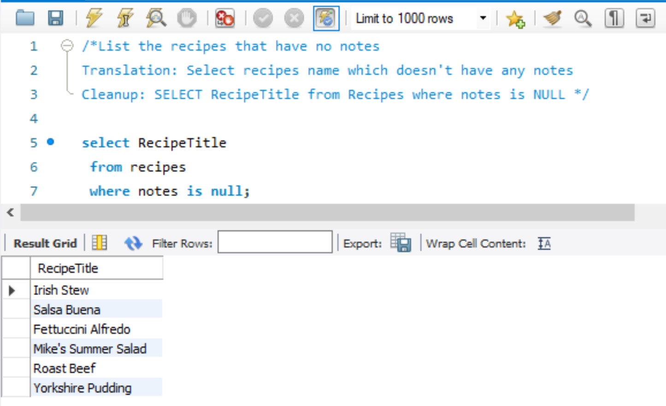

3.

/\***List the bowlers in teams 3, 4, and 5 whose last names begin with the letter ‘H’**

**Translation:** Select the bowlers whose last name starts with H

**Cleanup:** SELECT FirstName, Last Name , TeamId FROM BOWLERS where TeamId in 3,4,5

and last name like H */

SELECT BowlerFirstName, BowlerLastName, TeamID

from bowlers

where TeamID IN (3,4,5)

AND BowlerLastName like 'H%';

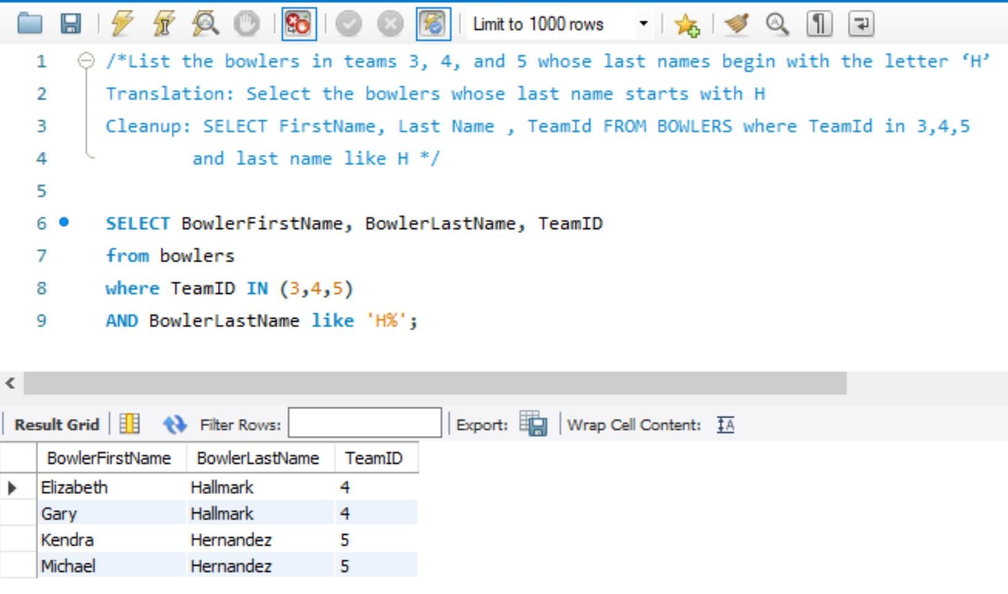

4. /\***Show me a list of students whose last name is ‘Kennedy’ or who live in Seattle**

**Translation** - Students whose last name is Kennedy or whose live in Seatle

**Clean up** - Select STUDFIRSTNAME, STUDLASTNAME, STUDCITY FROM STUDENTS

WHERE STUDLASTNAME LIKE 'Kennedy'OR STUDCITY LIKE 'Seatle' */

SELECT

STUDFIRSTNAME, STUDLASTNAME, STUDCITY

FROM

STUDENTS

WHERE

STUDLASTNAME LIKE 'Kennedy'

OR STUDCITY LIKE 'Seatle';

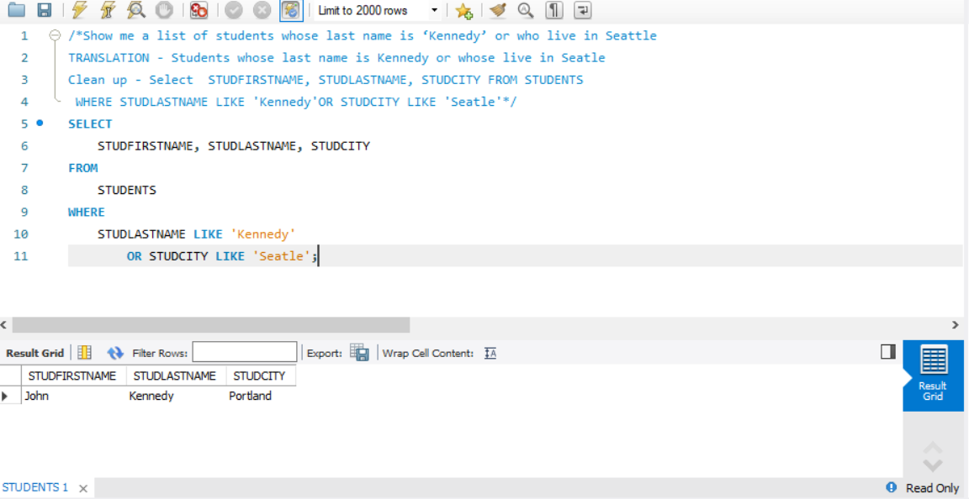

5.

/\***Show the ingredients that are meats (ingredient class is 2) but that aren’t chicken**

**Translation**: Select the ingredients that are meats but doesnt have chicken

**Cleanup**: SELECT IngrdientName from Ingredients where InggredientClassId is 2 and Ingredient name not like "%chicken%" */

SELECT IngredientName

from ingredients

where IngredientClassID = 2

AND IngredientName not like '%chicken%';

