**Question 2**

/* **Show me the vendors and the products they supply to us for products that cost less than $100**

**TRANSLATION** - List of vendor name from vendors table and productname from products table if the wholesaleprice is less than $100

**CLEAN UP** -SELECT VendName,ProductName,WholesalePrice

FROM Vendors,Products,product_vendors

WHERE Vendors.VendorID=Product_Vendors.VendorID

AND Products.productnumber=Product_Vendors.Productnumber

AND Wholesaleprice < 100; */

SELECT VendName,ProductName,WholesalePrice

FROM Vendors,Products,product_vendors

WHERE Vendors.VendorID=Product_Vendors.VendorID

AND Products.productnumber=Product_Vendors.Productnumber

AND Wholesaleprice < 100;

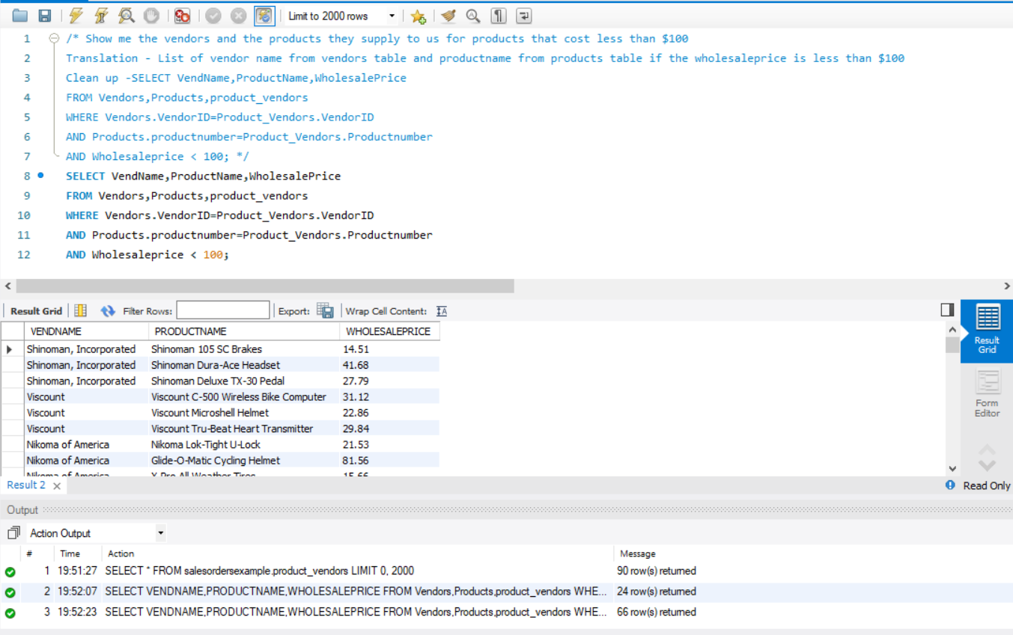

**Question 3**

**/* Find the agents and entertainers who live in the same postal code.**

**TRANSLATION :** Select set of agenst and entertainers that are form same postal code

**CLEANUP :** Select distinct AgtFirstName,AgtLastName form agents and CustFirstName, CustLastName from customers inner join on Zipcode*/

select distinct agents.AgtFirstName, agents.AgtLastName, customers.CustFirstName, customers.CustLastName

from agents

inner join customers

on agents.AgtZipCode = customers.CustZipCode;

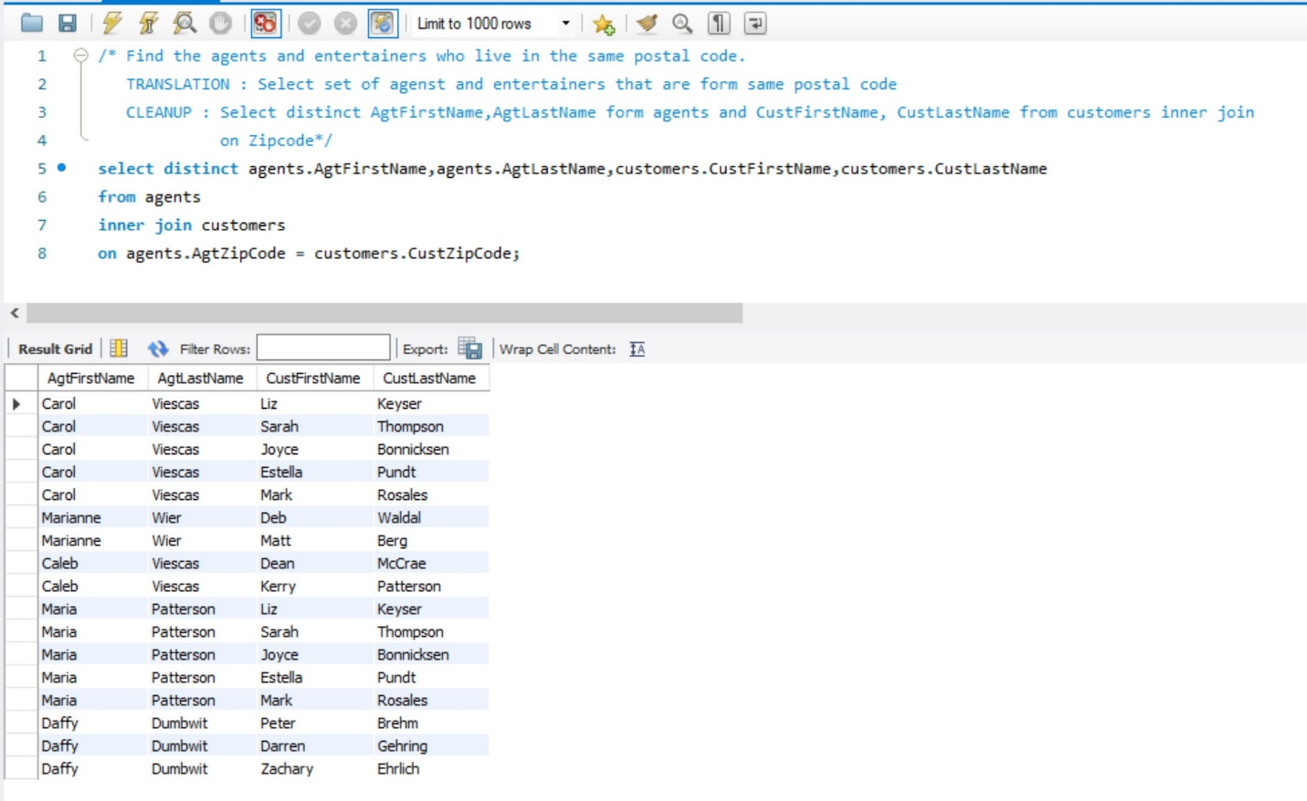

**Question 4**

**/* Display all recipe classes and any recipes that might be associated with them.**

**TRANSLATION :** List all recipe class along with the set of its all associative recipes if any.

**CLEANUP** : Select RecipeClassDescription from recipe_classes table and RecipeTitle from recipes table left join them on RecipeClassID. */

select distinct rc.RecipeClassDescription , r.RecipeTitle

from recipe_classes as rc

left join recipes as r

on rc.RecipeClassID = r.RecipeClassID;

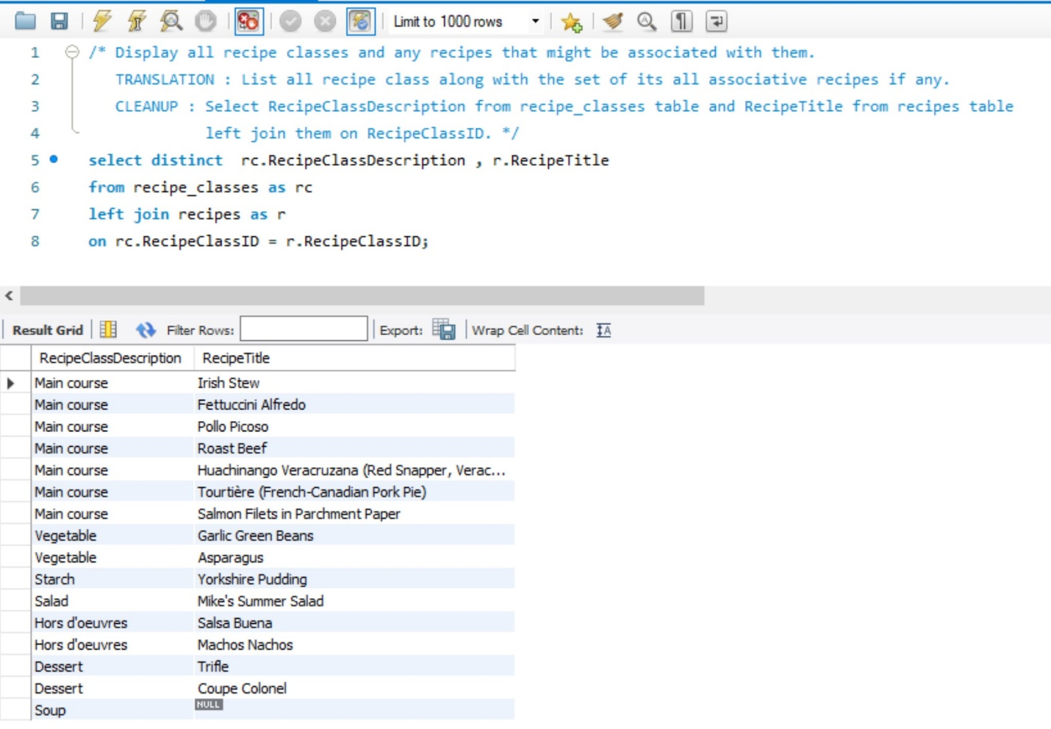

**Question 5**

/*

**What products have never been ordered?**

**TRANSLATION**: Select only those product Number and Prodct Name from product

table which are not available in order details table.

**CLEAN UP** - use salesordersexample;

select concat( "Product Name : ",ProductName ," with Product Number # ", ProductNumber, " was never ordered. ") as 'Result'

from products where ProductNumber not in (Select ProductNumber from order_details); */

use salesordersexample;

select concat( "Product Name : ",ProductName ," with Product Number # ", ProductNumber, " was never ordered. ") as 'Result'

from products where ProductNumber not in (Select ProductNumber from order_details);

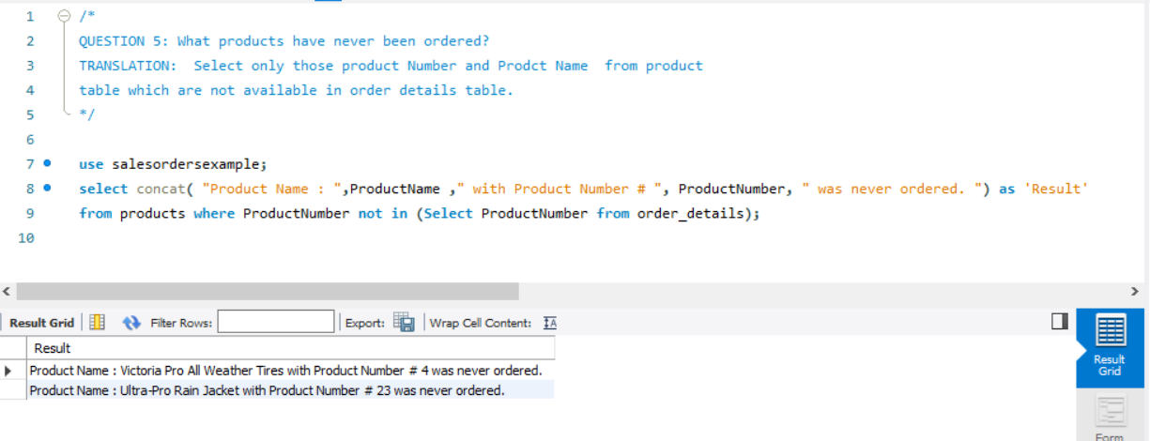

**Question 6**

/\***List the subjects taught on Wednesday**.

**TRANSLATION**: Select subject id from classes record where wednesday schedule is 1. Join classes table with subject table

on subject id to select corresponding subject name from subject table.*/

**CLEAN UP** : use schoolschedulingexample;

select distinct concat( "Subject '", s.subjectname,"'"," is taught on Wednesday") as Result

from classes c left join subjects s

on c.subjectid = s.subjectid

where c.WednesdaySchedule = 1

order by 1*/

use schoolschedulingexample;

select distinct concat( "Subject '", s.subjectname,"'"," is taught on Wednesday") as Result

from classes c left join subjects s

on c.subjectid = s.subjectid

where c.WednesdaySchedule = 1

order by 1;

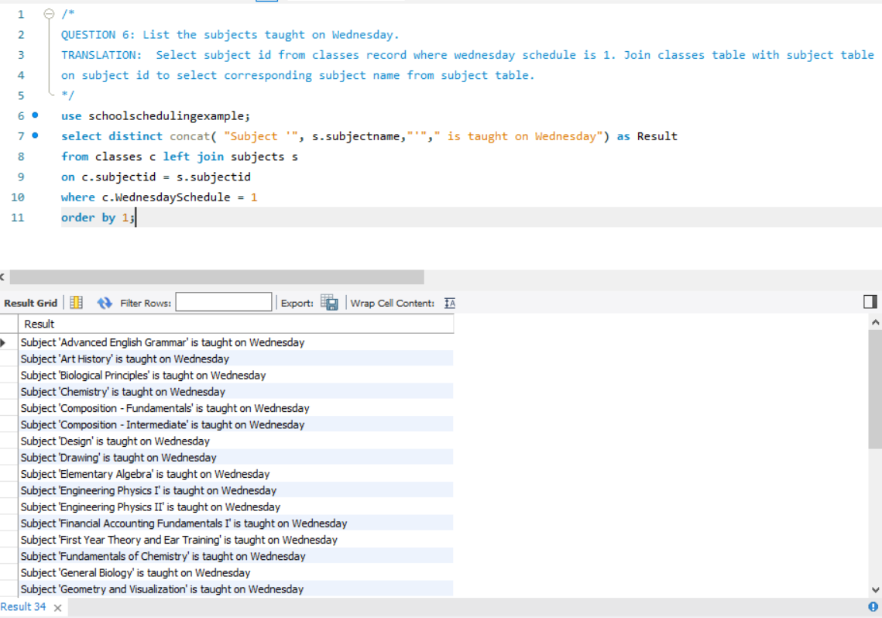

**Question 9**

/\***List the entertainers who played engagements for both customers Berg and Hallmark.**

**TRANSLATION :** Select entertainer stage name from those common to the set of entertainers who played for Berg or the set of entertainers who played for Hallmark.

**CLEANUP :** Select unique distinct entertainer stage name from the entertainers table inner joined with the engagements table on entertainers.entertainer ID in the entertainers table = engagements.entertainer ID in the engagements table, then inner joined with the customers table on customers.customer ID in the customers table matching = engagements.customer ID in the engagements table where the customer last name is = 'Berg' or the customer last name is = 'Hallmark' */

SELECT DISTINCT Entertainers.EntStageName

FROM (Entertainers

INNER JOIN Engagements

ON Entertainers.EntertainerID =

Engagements.EntertainerID)

INNER JOIN Customers

ON Customers.CustomerID =

Engagements.CustomerID

WHERE Customers.CustLastName = 'Berg'

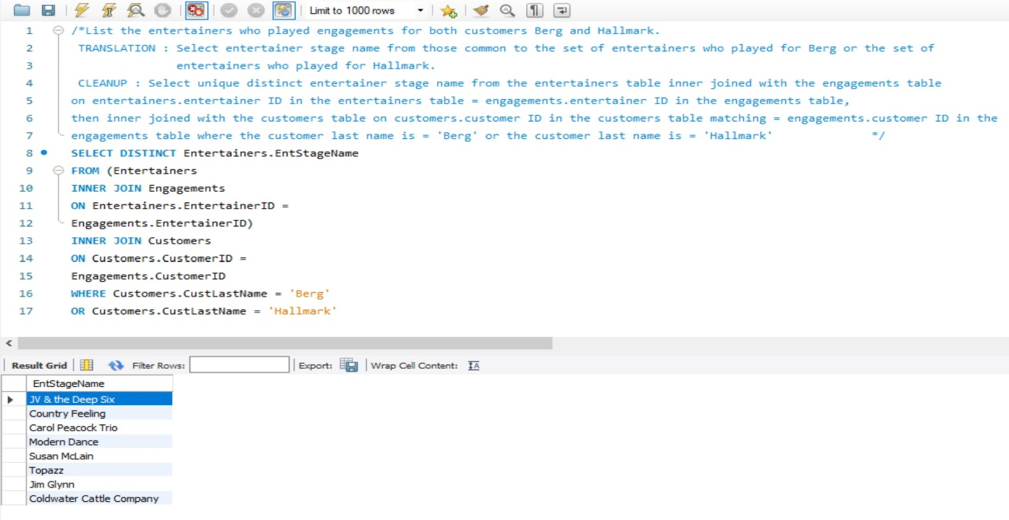OR Customers.CustLastName = 'Hallmark'