QUESTION 1

/* How many classes are held in room 3346?

TRANSLATION - Count the number of classes held in classroom ID 3346

Cleanup - SELECT count(CLASSID) FROM CLASSES WHERE CLASSROOMID="3346"*/

SELECT count(CLASSID) FROM CLASSES WHERE CLASSROOMID="3346";

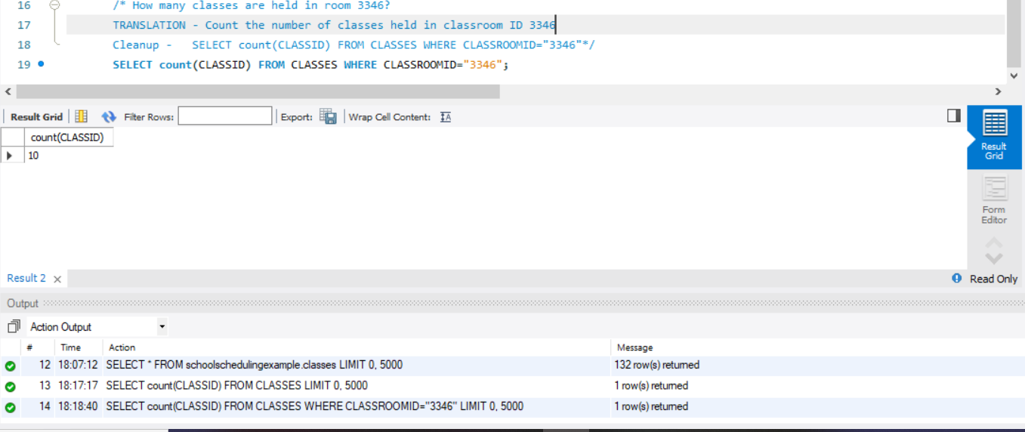

QUESTION 2

/* Calculate the current average raw score and handicap for each bowler

Translation - average of raw score and handicap score form bowler_scores table

Clean up - Select avg (rawscore),avg(HANDICAPSCORE), BOWLERFIRSTNAME,BowlerLastName

FROM bowler_scores,bowlers

GROUP BY BOWLERFIRSTNAME;*/

Select B.BowlerFirstName,avg(rawscore),avg(HandiCapScore),COUNT(B.BowlerID)

FROM bowler_scores BW JOIN bowlers B ON B.BowlerID = BW.BowlerID

GROUP BY B.BowlerFirstName ORDER BY 1;

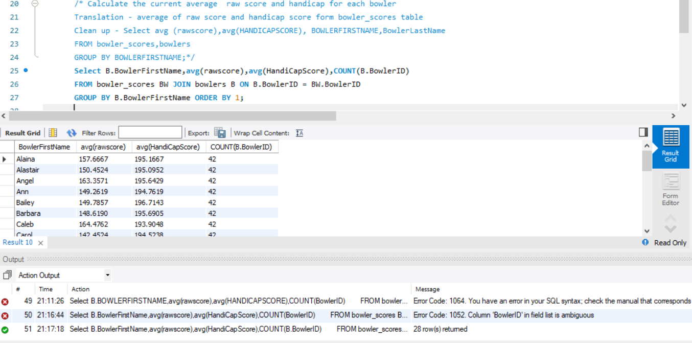

Q4

/* **Show me the subject categories that have fewer than three full professors teaching that subject.**

**Translation :** Select set of subject categories from categories that have less than 3 professor teaching that subject

**Clean Up:** SELECT CategoryDescription, COUNT(FC.StaffID) FROM (Categories C INNER JOIN Faculty_Categories FC ON C.CategoryID = FC.CategoryID) INNER JOIN Faculty F ON F.StaffID = FC.StaffID WHERE F.Title = 'Professor' GROUP BY C.CategoryDescription HAVING COUNT(FC.StaffID) < 3; */

SELECT C.CategoryDescription, COUNT(FC.StaffID) AS ProfCount

FROM (Categories C

INNER JOIN Faculty_Categories FC

ON C.CategoryID = FC.CategoryID)

INNER JOIN Faculty F

ON F.StaffID = FC.StaffID

WHERE F.Title = 'Professor'

GROUP BY C.CategoryDescription

HAVING COUNT(FC.StaffID) < 3;

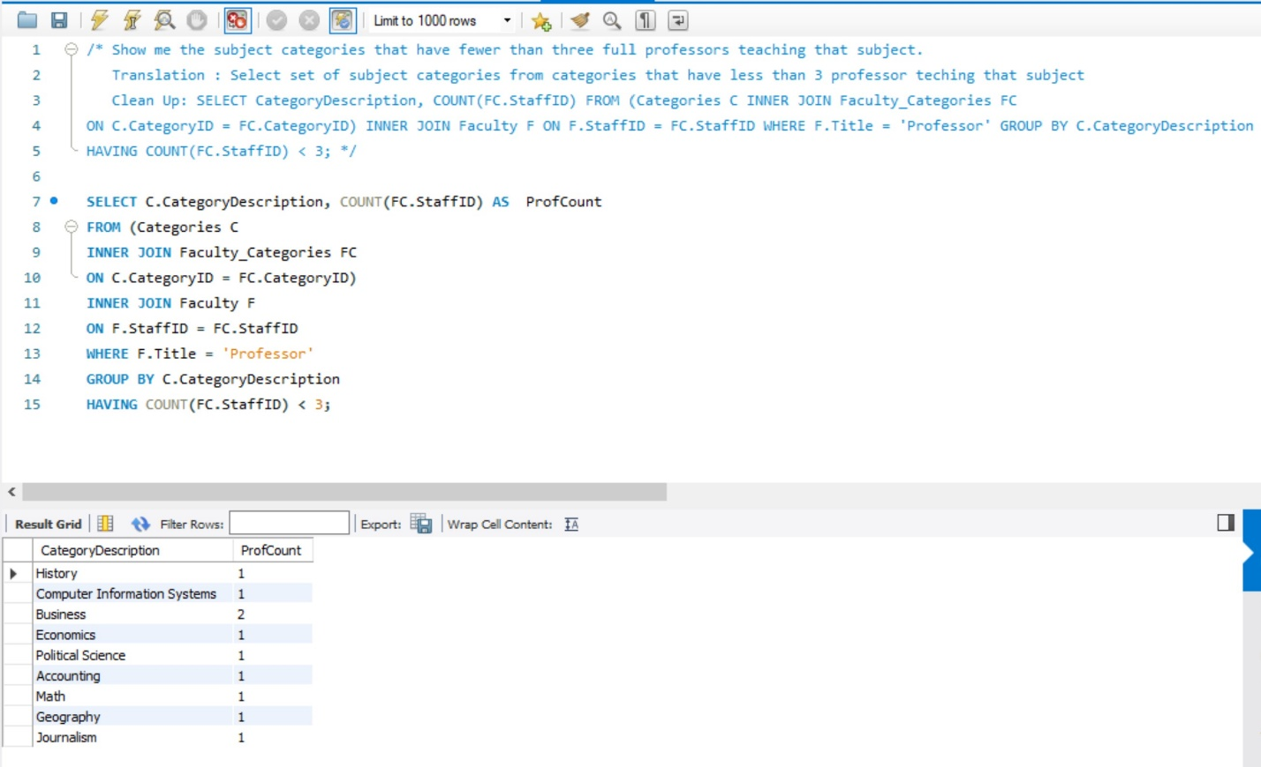

Q 3

/* **List all meat ingredients and the count of recipes that include each one.**

**Translation :** Select set of ingredient description and unique count of recipes belonging to that set

**Clean Up:** SELECT IngredientClassDescription, IngredientName, (SELECT COUNT(*) FROM Recipe_Ingredients RI WHERE RI.IngredientID = I.IngredientID) FROM Ingredient_Classes IC INNER JOIN Ingredients I ON IC.IngredientClassID = I.IngredientClassID WHERE IC.IngredientClassDescription = 'Meat' */

SELECT IC.IngredientClassDescription, I.IngredientName,

(SELECT COUNT(*)

FROM Recipe_Ingredients RI

WHERE RI.IngredientID = I.IngredientID) AS RecipeCount

FROM Ingredient_Classes IC

INNER JOIN Ingredients I

ON IC.IngredientClassID = I.IngredientClassID

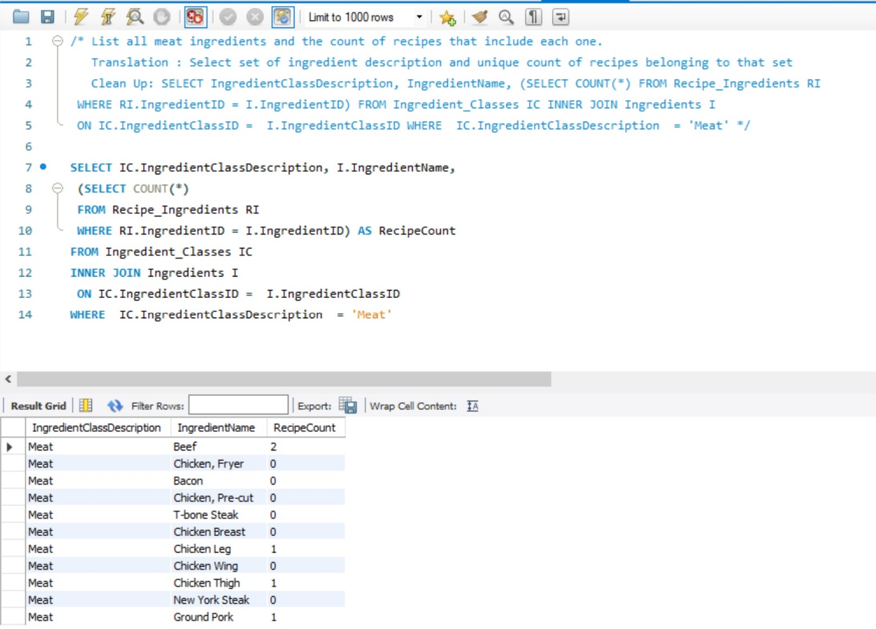WHERE IC.IngredientClassDescription = 'Meat'

QUESTION 5

/*Show me the subject categories that have fewer than three full professors teaching that subject

SELECT faculty from faculty table with status of "full time" ,select subject from categories table are included in subject table

and faculty-subjects table,get count of fulltime faculty for each category and remove those with count < 3 */

SELECT CAT.Categorydescription, count(F.StaffID)

FROM Categories CAT JOIN subjects SUB on CAT.CategoryID = SUB.CategoryID

JOIN Faculty_subjects FS ON SUB.SubjectID = FS.SubjectID

JOIN Faculty F ON F.Staffid = FS.StaffID

WHERE F.Status ='Full Time'

GROUP BY CAT.CategoryDescription

having 'teacher count' < 3 order by 2;

