Question 1

**/\***

**Add 0.5 percent to the commission rate of agents who have sold more than $20,000 in engagements.**

**Translation: from engagement table sum contract price where sum is greater than 20000**

**update Agents a**

**inner join engagements e**

**on a.agentid = e.agentid**

**SET a.CommissionRate = a.CommissionRate + .05**

**where e.contractprice > 20000**

**in ( select sum(ContractPrice) from engagements**

**group by agentid)**

Q2.

/* **For all staff in ZIP Codes 98270 and 98271, change the area code to 360.**

**Translation:** Update the students table by setting the area code to 360 where the student ZIP Code is 98270 and 98271.

**Cleanup:** UPDATE Staff and SET StfAreaCode to '360' WHERE StfZipCode = '98270' and '98271' */

UPDATE Staff

SET Staff.StfAreaCode = '360'

WHERE Staff.StfZipCode IN ('98270', '98271')

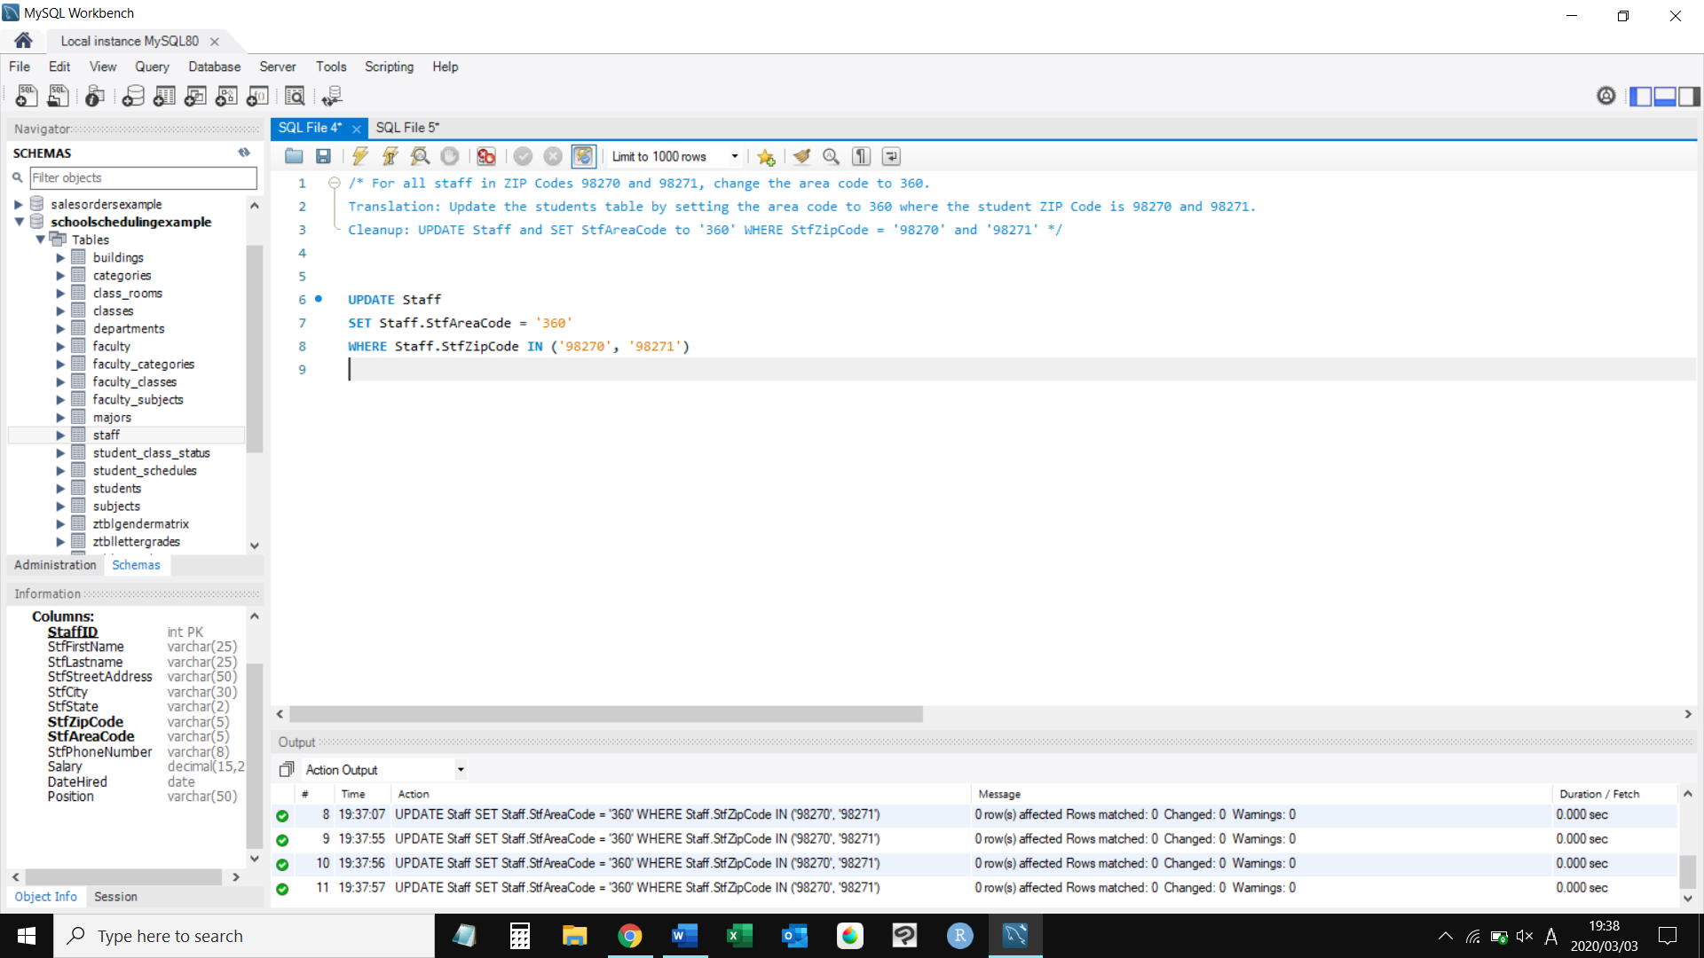

Question 3

insert into students (StudentID,StudFirstName,StudLastName,StudStreetAddress,StudCity,StudState,StudZipCode,StudAreaCode,StudPhoneNumber)

select StaffID,StfFirstName,StfLastname,StfStreetAddress,StfCity,StfState,StfZipCode,StfAreaCode,StfPhoneNumber from staff

where StfFirstName = "tim" and StfLastname = "smith";

Q4

/* **Delete products that have never been ordered**

**TRANSLATION** : Delete all data of products that have never been ordered from product_vendors(foreign key constraint) then from products table

**CLEAN UP :** delete from product_vendors where productnumber not in (select productnumber from order_details);

delete from products where productnumber not in (select productnumber from order_details); */

delete from product_vendors

where productnumber not in

(select productnumber from order_details);

delete from products

where productnumber not in

(select productnumber from order_details);

