

INDORE

IOT BASED SMART HOME AUTOMATION

WITH INTEGRATED VOICE CONTROL

A Project Report Submitted at
Rajiv Gandhi Proudyogiki Vishwavidyalaya, Bhopal
In partial fulfillment of the degree
Of

Bachelor of Engineering
In
Computer Science & Engineering

Computer Science and Engineering Department
Medi-Caps Institute of Science and Technology
Indore-453331
2018-19

INDORE

IOT BASED SMART HOME AUTOMATION

WITH INTEGRATED VOICE CONTROL

A Project Report Submitted at
Rajiv Gandhi Proudyogiki Vishwavidyalaya, Bhopal
In partial fulfillment of the degree
Of

Bachelor of Engineering
In
Computer Science & Engineering

Project Co-ordinator: Submitted By:
Mr. Sourabh Dave Aagosh Bansal (0876CS151002)
Amay Phansalkar (0876CS151017)
Abhijeet Soni (0876CS151008)

Computer Science and Engineering Department
Medi-Caps Institute of Science and Technology
Indore-453331
2018-19
I N D O R E |  | Medi-Caps Institute of Science and Technology  A. B. Road, Pigdambar, Rau, Indore – 453331

CERTIFICATE

This is to certify that Aagosh Bansal (0876CS151002), Amay Phansalkar (0876CS151017) and Abhijeet Soni (0876CS151008) have completed their major project work titled “IOT BASED SAMRT HOME AUTOMATION WITH INTEGRATED VOICE CONTROL” as per the syllabus and submitted a satisfactory report on this project as a part of fulfillment towards the degree of Bachelor of Engineering (Computer Science) from Rajiv Gandhi Proudyogiki Vishwavidyalaya, Bhopal.

Signature:______________
Name:_________________
(Project Guide)

Signature:_______________ Signature:________________
Name: __________________ Name: ___________________
(Internal Examiner) (External Examiner)

ACKNOWLEDGEMENT

The successful completion of a project is generally not an individual effort. It is an outcome of cumulative efforts of a number of persons, each having its own importance to the objective. This section is a value of thanks and gratitude towards all those persons who have directly or indirectly contributed in their own special way towards the completion of the project. For their invaluable comments and suggestions, we wish to thank them all.

No word will suffice to thank our project co-coordinator Mr. Sourabh Dave for their cooperation, invaluable guidance and encouragement which extended us for completion of our project, both in knowledge and morale.

We also acknowledge all of our team members who dedicated their time and energy for their development efforts.

Table of Contents

1. Introduction
1.1 Purpose/Aim of Project/Objective
1.2 Scope
1.3 Problems Domain
1.4 Solution Domain
1.5 Platform Specification
1.5.1 Hardware
1.5.2 Software

2. System Requirement Analysis
2.1 Information Gathering
2.1.1 Functional Requirement
2.1.1 Non Functional Requirement
2.2 System Feasibility
2.2.1 Operational
2.2.2 Technical
2.2.3 Economical

3. System Analysis
3.1 Use Case Diagram
3.2 Sequence Diagram
3.3 Activity Diagram
3.4 Swim lane Diagram

4. Design
4.1 Architectural Design
4.1.2 Architectural Style Used
4.1.3 System Architecture

5. Implementation
5.1 Implementation of Modules
5.2 Graphical User Interface

6. Testing
6.1 Testability
6.1.1 Observability
6.1.2 Decomposability
6.1.3 Stability
6.2 Testing Method Used

7. Conclusion and Future Work
8. References

Figure No. | Figure Name | Page No.
1 | Usecase Diagram
2 | Sequence Diagram
3 | Activity Diagram
LIST OF FIGURES

ABSTRACT
ABSTRACT
The home automation system plays an important role in maintaining living standards and provide secure and flexible environment. The aim of this project is to design a IOT based home automation system which makes operating of electrical appliances in home through android applications from anywhere in world using internet. The home automation system allows controlling of home appliances by using voice commands by recognizing input speech. The speech recognition is done by support vector machine. The home automation system is implemented wirelessly. The electrical appliances such as fans , light , switches , light sensors , current sensors are integrated in a system which then connected to microcontroller which act as within the home to control and perform the user commands.

INTRODUCTION

1. INTRODUCTION
A smart home is one that incorporates advanced sensing and automation systems to provide the inhabitants with monitoring and control regardless of whether they are inside or outside the home. For example, a smart home may have controls for lighting, temperature, multi-media, security, window and door operations, as well as many other functions.

1.1 Objective
A smart home is one that incorporates advanced sensing and automation systems to provide the inhabitants with monitoring and control regardless of whether they are inside or outside the home. For example, a smart home may have controls for lighting, temperature, multimedia, security, window and door operations, as well as many other functions.
In this project, we discuss design and development of activation and controlling of home automation system via the web or android application using microcontroller. It predominantly concentrates on the control of home appliances remotely when the person is far from the home. This project is primarily concerned with the programmed control of light or whatever other home machines, control of door and home security through android mobiles or web application using the internet as communication protocol interfaces and Arduino as processing unit. This project intends to control the system with the web by either turning device on or off so that the entrance control that system can be controlled from anyplace on the planet.

1.2 Scope
Our project finds humongous application in day to day life. It gives ease to everyone and especially the people who are away from their home and want to monitor and control it remotely. But here are some of the target audience we have focused on and hope so that our project will reduce the problems they are facing currently and provide them with the best, cost saving and time efficient solution. Those people are: -
For physically challenged
- For old members of the family
- For Job working Parents

1.3 Problem Domain
Here are some of the major problems which motivate us to bring the project to reality.
- In the metropolitan cities where the home has become a place to just dine and bed, hence increases the concern of the homeowners about the safety and security of their homes when they are away.
- In this corporate world it is quite difficult to monitor our dear ones such as infants or the aged members of the family.
- In today’s busy lifestyle of people many a times they forget to switch off the various appliances which leads to unnecessary consumption of electrical energy along with the increase in electrical bills, ultimately resulting into climatic changes.
- People who are disabled, handicapped or deaf can’t operate the appliances in the home or they can’t reach those things. So Home Automation is not done by the efficient way. It becomes difficult and insecure. To minimize these above-mentioned problems a simple home automation system designed in which the modem of Wi-Fi interfaced.

1.4 Solution Domain
In today’s high tech world, we have got the solution for all the problems in a very efficient and compact way. For the above problems stated we have found out the best solution and that is an IOT based home automation system integrated with voice recognition.
Following solution guidelines has been constructed and planned for the implementation purpose: -
- A dedicated and fully customizable android app which would be used by the user to monitor and control the appliances of home from anywhere and also getting the notifications for the same.
Following features are planned for user: -
- Addition and updating of home appliances
- Monitor home appliances
- Control home appliances
- Get notification
- Create automated instructions for home appliances
- Submission of feedback

1.5 Platform Specification
    - Hardware Specification
- Arduino Mega AT2560
- ESP8266 node MCU 12E
- Jumper wires
- 8 Channel relay board
- Android OR IOS phone with google Assistant
- Soldering wire and machine
- Bread Board
- LED
- Motor
- DHT11 Sensor
- Water Detector sensor
- LDR
- PIR Sensor
- Weight Sensor
- Soil Moisture Sensor
- Gas Sensor
- Bluetooth Module
- GPS Tracker
- Distance Sensor
- Buzzer
- USB OTG
- Battery 12V
- 5V Circuit

    - Software Specification
- Development tool: Arduino IDE
- Operating system: Android or IOS
- Controlling Software: Google Assistant and Blynk

SYSTEM REQUIREMENTS ANALYSIS

2. SYSTEM REQUIREMENTS ANALYSIS
There are a number of requirements for this project design.
The system should be as easy to use as possible and should allow the user to control all appliances remotely via a web-based interface or mobile based application. The system is also based on automated sensors that will respond according to the activity
The system should be designed in a modular fashion. A modular system allows for easier implementation and well as easier modification at a later stage.

2.1 Information Gathering
    - Functional Requirements
- The ability to control a device – This is simply the ability to turn On or Off a device, e.g. a lamp, from the Home Automation interface.
- The ability to authenticate users – This authenticates user connections to the Home Automation System to prevent unauthorized access.
- The ability to assign devices to a logical group – This simply means that a collection of devices is abstracted to logical groups of devices for ease of operation and organization of devices. These logical groups in this project will be referred to as ‘Rooms’ in the Home Automation System, which can hold any number of devices.
- The ability to sense the activities- the sensors used in the system sense the activities and respond according to it.

2.1.2 Non-functional Requirements
This section will further expand on the overview of requirements listed in Section 2.2.
Security Requirements
There are security risks associated with using the Home Automation System as it is designed to operate on a network like the Internet. When accessing the system, the user needs to be assured that intruders, such as hacker attempts and third party invasions, cannot have access to the Home Automation System. The user therefore needs to be confident that the Home Automation System is secure. The ability to authenticate user connections to the system is required.
To prevent unauthorized access the user has to log on to a website or mobile application in order to have access to the Home Automation System. A secure system to validate the username and password information is required. The system will accept this information as proof of the identity and allow the user to access the Home Automation System.
Performance Requirements
- Speed of the Internet connection from the remote computer and the speed of the connection to the server will affect performance. The Home Automation System will be designed to be capable of operating even with slow Internet connections e.g. a standard 56K modem dial up connection to the network.
- The Home Automation System will be designed to operate on a standard personal computer with a standard web browser installed. Response times to commands should be minimal from the browser.
- The system will also be able to get operated using a user friendly mobile application
- Mobile application used to control devices is a light weight application that is easy to integrate, support device to device communication using bridge widget, direct pin manipulation
- Efficiency of the software code will have an effect on how quickly commands to the system are given. Every effort will be made to design the code with performance in mind.
- Hardware connected to the system may suffer from a latency factor between issuing of a command and when that command is carried out. This will be taken into account and may influence how fast the commands are processed within the system.

User Requirements
- The user interface of the Home Automation System should be intuitive and easy to use. We plan to provide a web-based interface for users to access the Home Automation System. This will enable users to use the system more easily, since it will be accessible through a common web browser from any computer connected to the Internet. This eliminates the need for installation and configuration of proprietary software.
- We also plan to provide a mobile app interface for users to access the home automation system, with the help of this app users will be able to control home appliances with one touch
- The user interface will feature the use of meaningful graphics and icons, which will allow the user to easily identify options available. The number and size of these graphics, however, should be kept to a minimum to improve performance on computers with slow connections to the Internet.
- User interface of mobile app is designed with one touch user friendly buttons; it has all the appliances button with their respective names on it.
- The user will be able to access the status of all devices that are currently installed and running on the Home Automation System.
- The Administrator will be able to add/remove devices to the system. The administrator will also be view all users and their devices.

Hardware Requirements
The hardware requirements for the Home Automation System consist of a computer controlled switching mechanism that will control the device to be automated.
- Arduino Mega 2560-

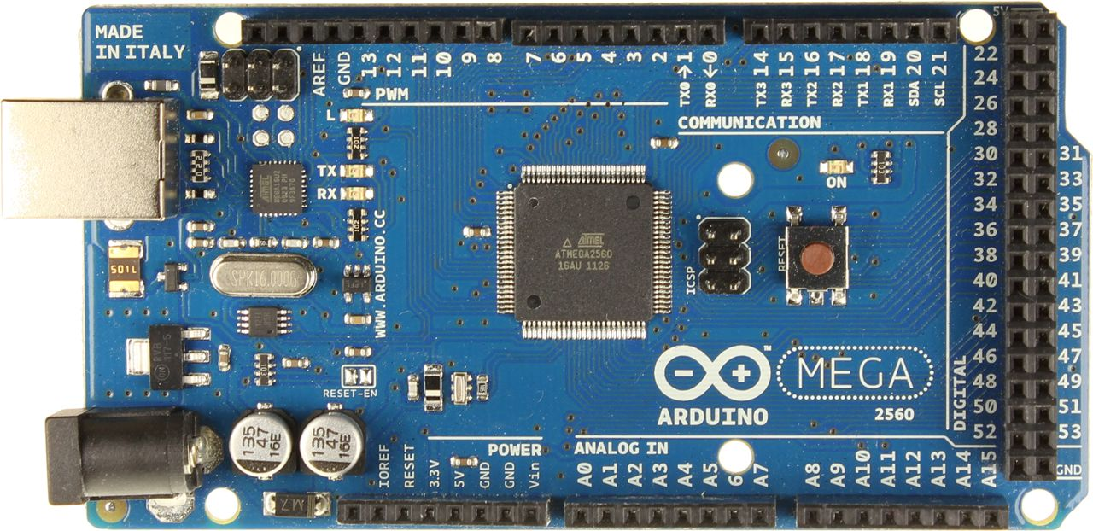
Figno. 1.1 Arduino Mega Microcontroller board

- Arduino is the microcontroller which is integrated with digital devices and interactive objects that can sense and control objects in the physical and real world.
- Application:a) Act as a master controller. b) Monitoring various devices and sensors.

- ESP8266-

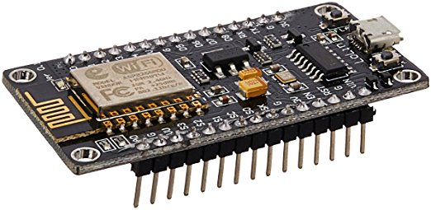
Figno. 1.2 ESP8266 Wi-Fi Microchip

- The ESP8266 is a low-cost Wi-Fi microchip with full TCP/IP stack and microcontroller capability.
- Application:a) Act as Wi-Fi shield for Arduino.

- 8 Channel Relay-
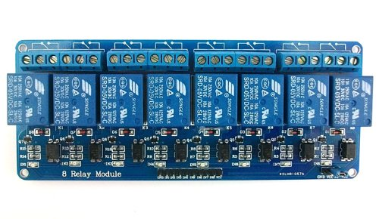
Figure 1.3: 8- Channel Relay Board

8 Channel Relay Board is a simple and convenient way to interface 8 relays for switching application in your project. Input voltage level support TTL as well as CMOS. Easy interface with Microcontrollers based projects and analog circuits
- Input supply 12 VDC @ 336 mA
- Output eight SPDT relay
- Relay specification 5 A @ 230 VAC
- Trigger level 2 ~ 15 VDC
- Header connector for connecting power and trigger voltage
- LED on each channel indicates relay status
- Screw terminal connector for easy relay output and aux power connection
- Four mounting holes of 3.2 mm each
- PCB dimensions 152 mm x 60 mm

- Sensors
- LDR Sensor
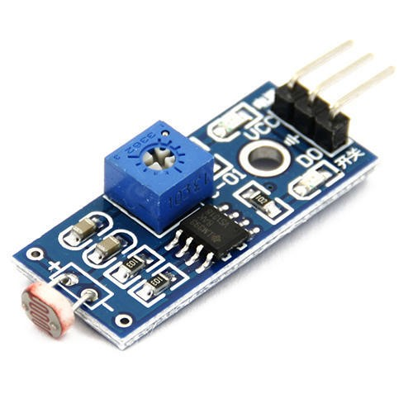
- A light dependent resistor works on the principle of variation of resistance with variation in light intensity.
- Application: Automatic control of outdoor garden lights.
- Water Sensor
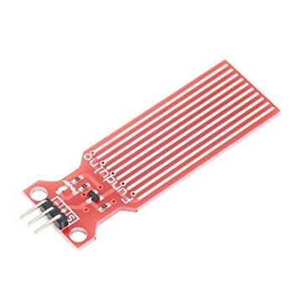
- Water sensor is used to detect water leakage as well as water level.
- MQ6
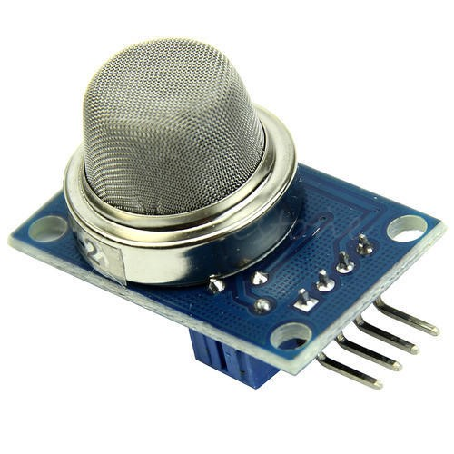
- The gas sensor module consists of a steel exoskeleton under which a sensing element is housed.
- Application: Detect gas leakage in the kitchen as well as smoke, Detection of alcohol.
- DHT 11
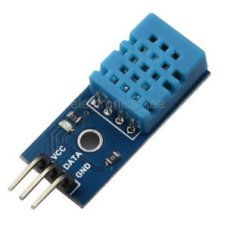
- DHT 11 is a temperature and humidity sensor which is capable of recording temperature and humidity of the area in which it is present.
- PIR Sensor
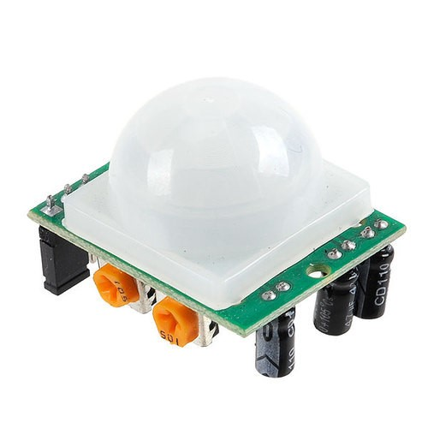
- A passive infrared sensor (PIR sensor) is an electronic sensor that measures infrared (IR) light radiating from objects in its field of view.
- Application: a) Automatic light control on motion detection.
b) Trigger alarm on motion detection.

- Distance Sensor
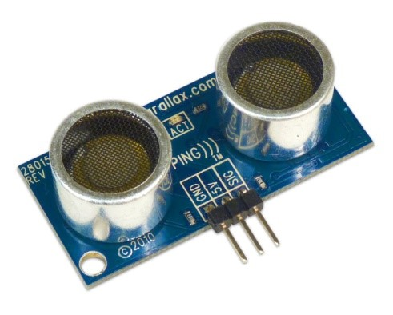
- An ultrasonic sensor which records the distance by tracing sound wave reflected back by an obstacle.
- Application: Trigger alarm on intrusion detection
- Soil Moisture Sensor
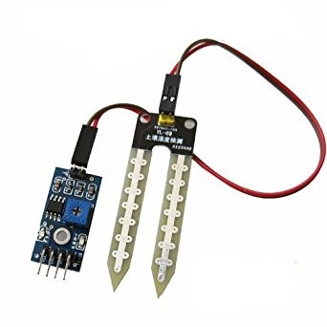
- The Soil Moisture Sensor uses capacitance to measure dielectric permittivity of the surrounding medium.
- Application: To depict the amount of moisture present in the medium, Automatic irrigation system.
- Weight Sensor
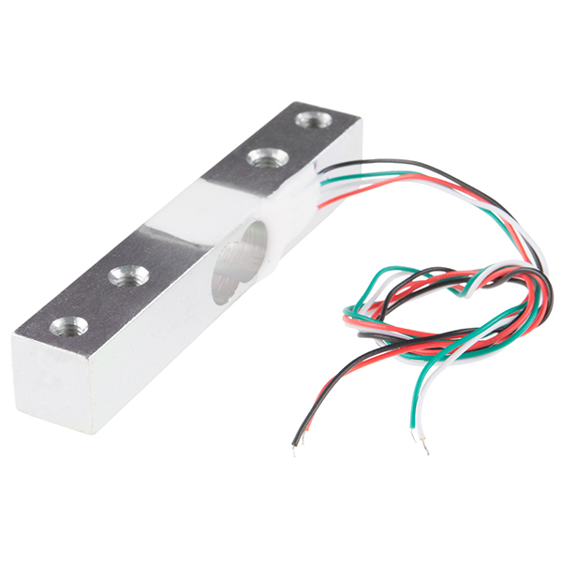
- A load cell is a sensor or a transducer that converts a load or force acting on it into an electronic signal.
- Application: To detect the weight of an object, Notify user whenever LPG cylinder is emptied.
- HC-05
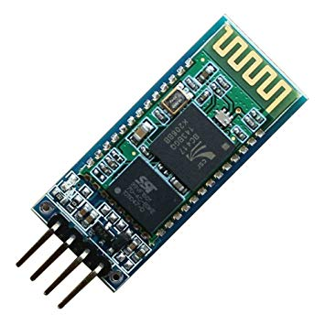
- The HC‐05 module is an easy to use Bluetooth SPP (Serial Port Protocol) module,designed for transparent wireless serial connection setup.
- Application: Provide Bluetooth connectivity, Useful in case Wi-Fi connectivity fails.
10) NEO-6m
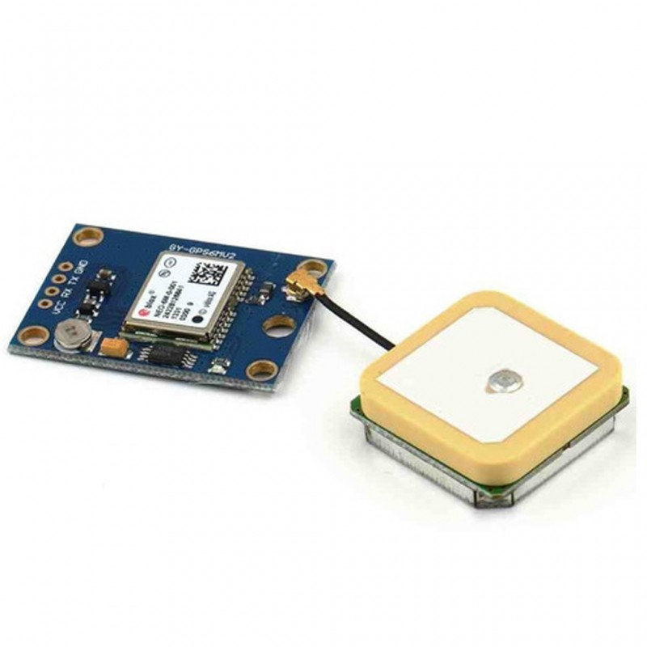
- Neo-6m is a GPS tracker module which can be used to track the location of an object with which it's integrated.
- Application: Helps in tracking an object precisely, Ensure vehicle safety.
11) LCD Screen
- An LCD touchscreen provides a user interface which can be used to perform various functions on a single touch.
- Application:a) Serve as output display unit. b) Can be integrated with a smart chair. c) Replicate the functionality of the Android app.
There are various sensors we will use in this project to make it smart and automated such as:
Beside this hardware we will use some simple elements in circuit such as LEDs, Motor, buzzers., We will use jumper wires breadboard 5V battery for basic circuit.

  - System Feasibility
This project will be challenging in many ways. The development of the communication with the automated devices and user interface is a new combination of technologies.
However, we are working in software/hardware environment and feel the resulting software would be benefit in Home Automation.
The home automation system is beneficial for its users as it will reduce the human efforts and make the control on appliances easy , we examined that in the world of smart houses different levels and technologies are used, as mentioned before there are different stages of complexity that can be used in designing a smart home, those different levels certainly come with customer needs technological aspects different prices which will change the economical technical operational point of view of the customer, as he will decide their choice upon the allowed, needed, and the affordability of their home. As we all know the performance varies with the kind of level and complexity so the very famous and well known saying is applied “the more you pay, the more you get”. The difference in the price could be due to different reasons, for example the quality of components used which will differ in the lifetime of system and its reliability. The price would also differ due to the different options available in the smart home.
This project can be implemented using affordable electronic and software technology making it economically, technically and operationally feasible.

    - Operational
In order to perform a well-designed and established smart house the quality of the equipment used must be superior quality that can handle a tough and around the clock usage of different members of the family. As for the software used in the implementation it should be updated with the latest hardware in order to perform in the best way possible. The quantity of equipment depends on the home size and the person’s need, in our design we choose limited quantity but with a good type because our idea is to achieve the goal with a reasonable but of course with great performance. In the field of software our equipment will be connected with the Internet all the time to update the software of the components. The software is easy, simple and can be used by each person and with different ages.
Operations of our smart home:
- Ability to control various electrical appliances such as light, fan, AC, etc.
- Ability to sense temperature and moisture of the home.
- Ability to detect water leakage and notify the user.
- Ability to control lights with variation in light intensity.
Everything in life has an end and every product has a lifetime period, by estimating the lifetime of smart homes it can be said that the life time period of a smart home is around 5 years., as its clear the smart home is full of electronic devices and even it is always updated and efficient it must have an end so considering this period it must be changed by the newest devices according to the latest technologies. According to our smart integrated wiring system the mission of changing devices and updating is so easy and simple so it will not take much time.

    - Technical
There are different criteria which are necessary to be discussed among the technical performance measures (TPM). There is no doubt that the reliability, availability, affordability, and maintainability are these main aspects to be dealt with as the better they are the better the
product is in the eyes of the customer. For the reliability our product’s probability of failure must be as low as possible in order to tolerance the tough work. The availability of our system is high means that its available whenever you are, also the components choose to be used in the smart home must be available everywhere so we must choose our components from the market in order to compare the different type and measure their degree of availability. Another point of view in the field of the technical performance is the affordability and the difference between the availability and this point. Affordability is the ability to buy a product while availability is finding the product everywhere. In our system the affordability must be high in order to buy any missing product whenever is needed. Time processing is a very sensitive point because every person cares about time and needs his job to be done in the very little time. We tried as mentioned before to make this system the simplest way ever in order to save time also if we looked inside the system itself we will find that the components perform the tasks in a fast way. The final point to be discussed in this part is the maintainability or the ability of the products to be maintained, we are trying to reach the most maintained products ever in order to give a chance for the smart home to last for the longest time.

    - Economical
In the world of smart houses different levels and technologies are used, as mentioned before there are different stages of complexity that can be used in designing a smart home, those different levels certainly come with different prices which will change the economical point of view of the customer, as he will decide their choice upon the allowed, needed, and the affordability of their home. As we all know the performance varies with the kind of level and complexity so the very famous and well known saying is applied “the more you pay, the more you get”. The difference in the price could be due to different reasons, for example the quality of components used which will differ in the lifetime of system and its reliability. The price would also differ due to the different options available in the smart home. The design is chosen to be simple but effective, full of features but not expensive, the reason for this choice is to provide a good smart home with a low price. Although it’s clear that our design if full of components but actually it is not highly priced, the economical view is taken in consideration to help in finding the most flexible and efficient home. A lot of smart homes are more complex than this design but we choose the most important and needed issues to solve. From the view of maintainability, our design is very easy to be maintained, there is no need to bring an expert each time a problem is found, any issue can be fixed in an easy and fast way, in other words people living in this smart home can fix any bug by themselves with no need to professional persons.

SYSTEM ANALYSIS

3. SYSTEM ANALYSIS
3.1 Use case Diagram
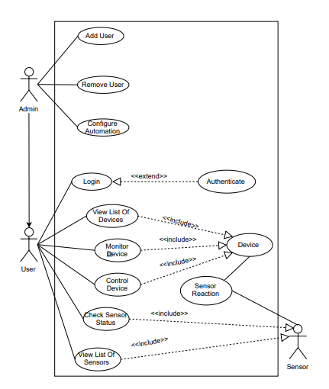
Use case diagrams are usually referred to as behavior diagrams used to describe a set of actions (use cases) that some system or systems (subject) should or can perform in collaboration with one or more external users of the system (actors). Each use case should provide some observable and valuable result to the actors or other stakeholders of the system.

Figno.1 Use case Diagram

3.2 Sequence Diagram
A sequence diagram is a type of interaction diagram because it describes how—and in what order—a group of objects works together. These diagrams are used by software developers and business professionals to understand requirements for a new system or to document an existing process. Sequence diagrams are sometimes known as event diagrams or event scenarios.

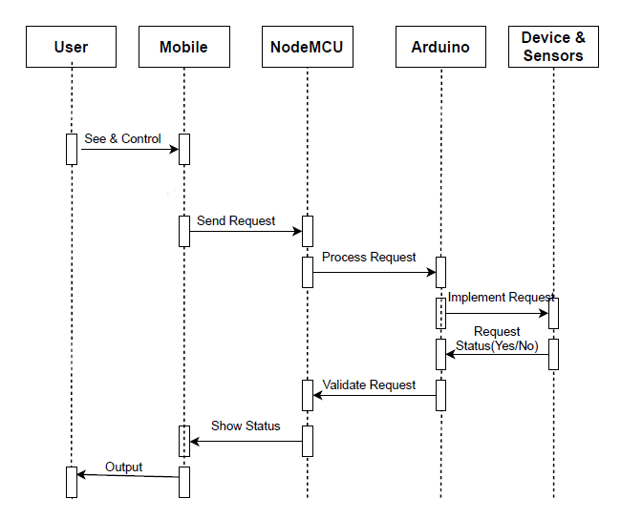

Figno.2 Sequence Diagram

  - Activity Diagram
Activity diagram is basically a flowchart to represent the flow from one activity to another activity. The activity can be described as an operation of the system. The control flow is drawn from one operation to another. This flow can be sequential, branched, or concurrent. Activity diagrams deal with all type of flow control by using different elements such as fork, join, etc
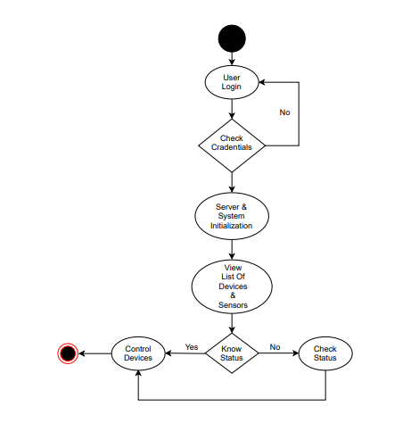
Figno.3 Activity Diagram

DESIGN

4. DESIGN
4.1 Architecture Design
Based on the discussions of related technologies and smart home systems, a smart home technology is the integration of technology and services through home networking for a provision of a better quality of living. The architectural design for Smart Homes is based on the integration of the emerging technologies of Wireless Sensor Networks and Hierarchical Mobile IP. The traditional setup for Smart Homes is enhanced by providing mobility using Blynk server. The scenario is shown on Figure 3, wherein the home user can control the home appliances or equipments connected to a home network even if he moves into a foreign network.

4.1.1 Architectural Style Used
3 Tier Architecture:
A three-tier architecture is a client-server architecture in which the functional process logic, data access, computer data storage and user interface are developed and maintained as independent modules on separate platforms. Three-tier architecture is a software design pattern and a well-established software architecture.
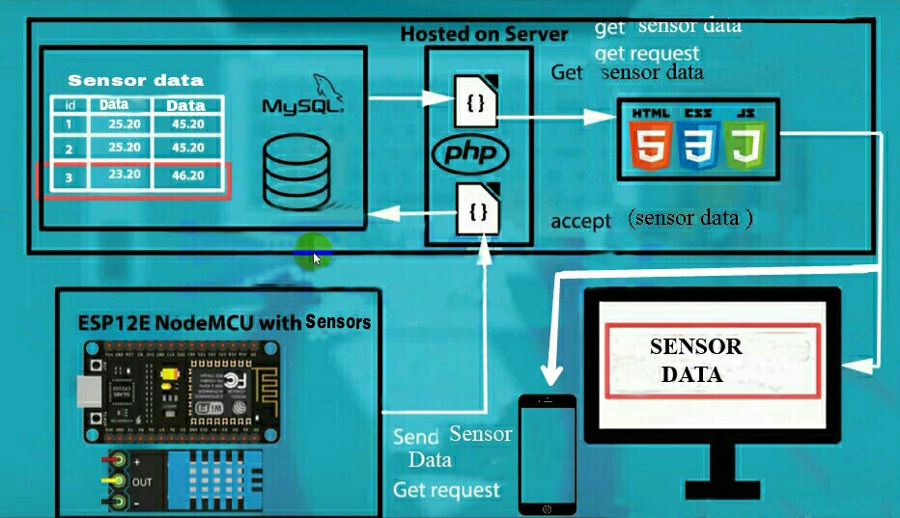
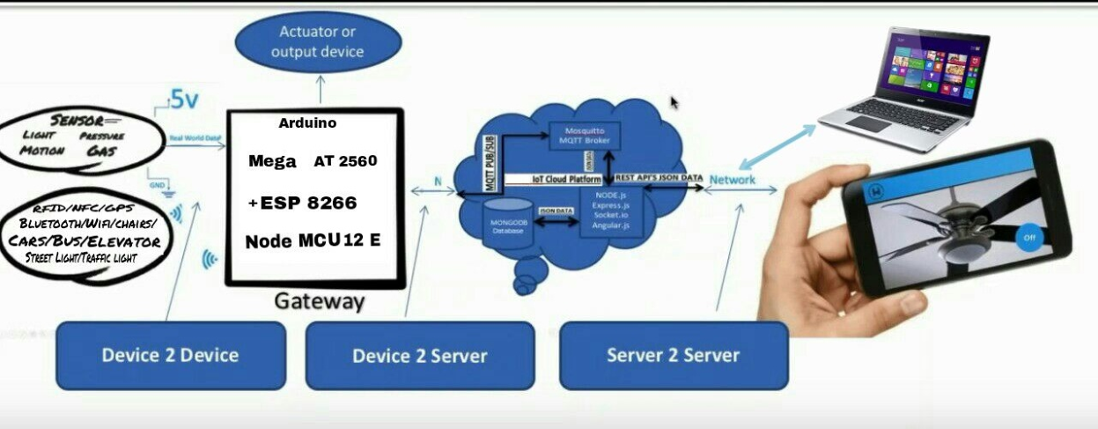
4.1.2 System Architecture

IMPLEMENTATION

5 IMPLEMENTATION
5.1 Graphical User Interface

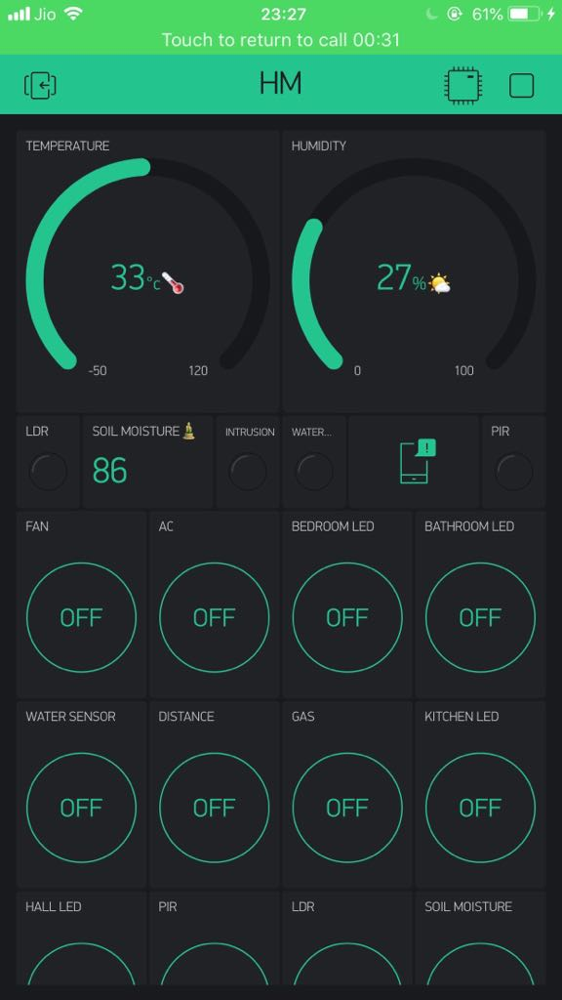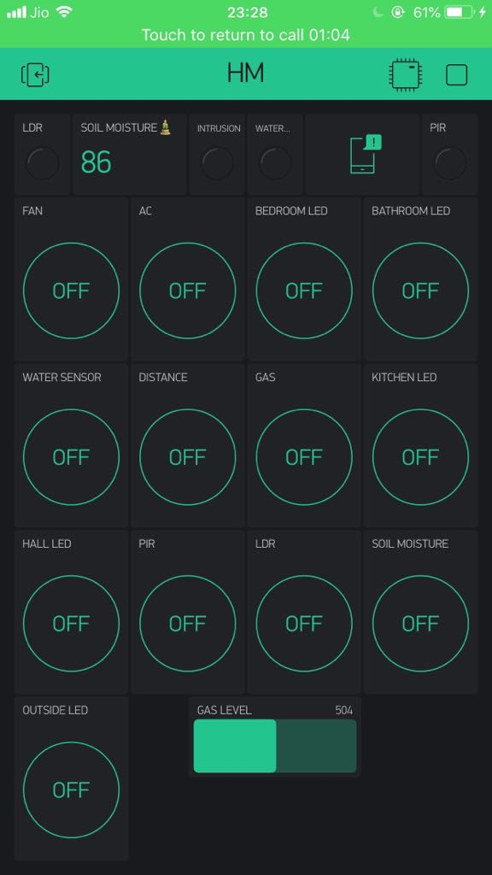

5.2IMPLEMENTATION OF MODULES

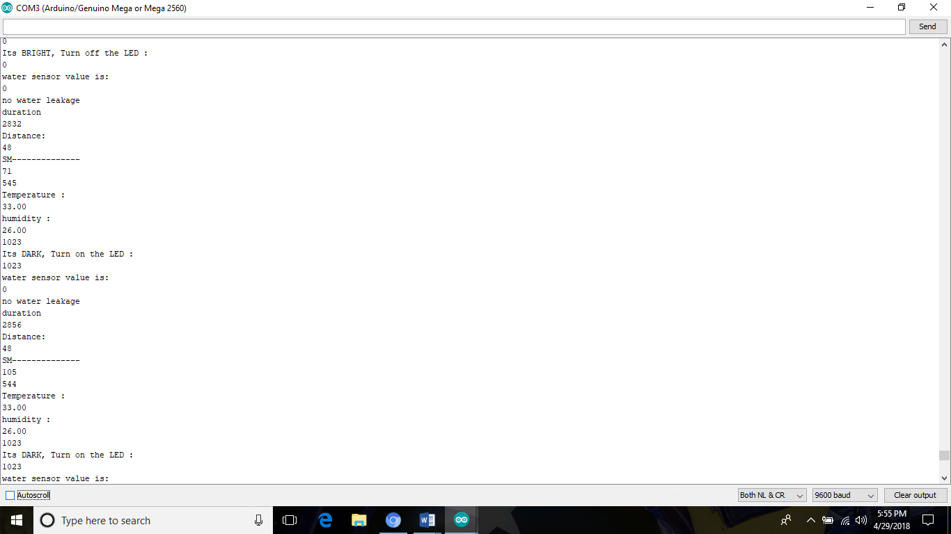

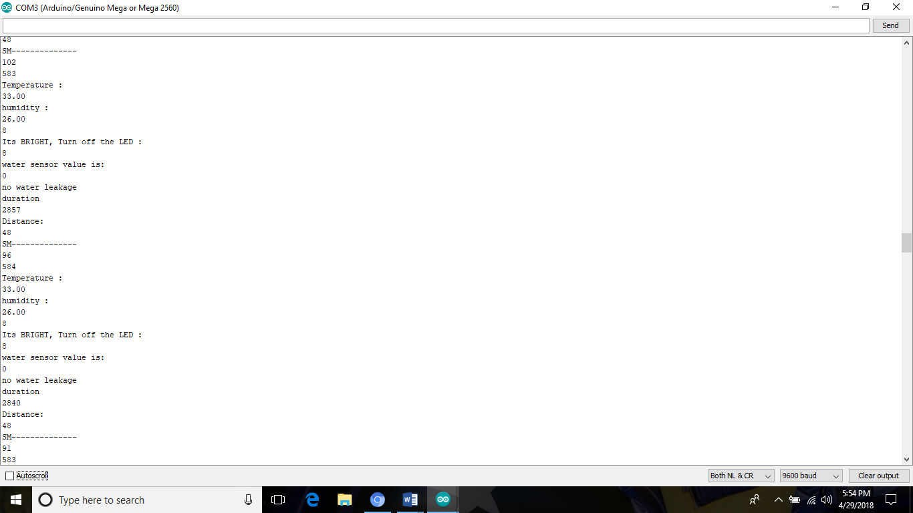

TESTING

6. TESTING
Test Characteristics
1. A good test has a high probability of finding an error. Tester must understand the system and develop a mental picture of how it might fail.
2. A good test is not redundant; every test should have a different purpose.
3. A good test should be “best of breed”; the test that has the highest likelihood of uncovering a whole class of errors should be used.
4. A good test should be neither too simple nor too complex.

6.1 Testability
6.1.1 Observability
The results of each test case are readily observed. Variables are visible during execution. Source code is available.

6.1.2 Decomposability
Testing can be targeted; independent modules can be tested independently.

6.1.3 Stability
Few changes are requested during testing, the application recovers well from failures.

6.2 Testing Method Used
A rich variety of test case design methods have evolved for software. These methods provide the developer with a systematic approach to testing. These methods provide a mechanism that can help to ensure the completeness of tests and provide the highest likelihood for uncovering errors in software.
1. Unit testing Different units of the systems are tested separately. Certain set of inputs are given to the different modules of the system, and output from each module is verified.
2. System testing Entire system is tested as a whole unit. Selected set of inputs are given to the system .Some feedback forms are filled by entering in to the system in user login, then the feedbacks are verified, by analyzing them, by login in to system as administrator.
3. Black box testing Various inputs are given and the outputs are verified. Here the functionality of the system is verified, by giving certain feedback as input, and verifying the retrieved feedback, which is the output. The functionality of the system is tested with out referring to the source code of the system.
4. White box testing Different sections of the code is analyzed and tested, that it will work correctly, without any errors and bugs.
Results: The results are verified by observing the input and output.

CONCLUSION

7. CONCLUSIONS
The project in general has been very successful. The software produced for the project is functionally correct, reasonably robust, and usable. The project has met the entire General and Non-Functional Requirements stated in Section 2, and in addition, has been implemented in a modular fashion, which can be easily modified or rewritten at a later stage.
The user interface is easy to use, and works in all web browsers. It does not require any propriety interfaces, applets or plug-ins to operate. This means that the Home Automation System is accessible from any web browser and that the system could be usable from anywhere on the Internet and therefore from anywhere on the planet.
The software is robust. The design of the software means that most errors are caught in a non-fatal manner, meaning that the software can continue executing even after a bad request.

7.1 Possible Future Software Changes
As the software was being developed, a number of major shortcomings in the system were found. There are a number of changes to the design that could be considered in future additions to the software:
- Due to the nature of the type of PIC module used in this project, the module did not have the ability to respond to a request for status, so it is not possible to query devices for status when the Home Automation System is first started. Therefore, when the system starts, the status of devices is at first unknown, and so is assumed to be ‘Off’ for each device.
- The performance of the software is something that could also be improved by optimizing the code if given more time. The performance gains to do this however would only be noticeable on very slow connections to the Internet (<28.0 kbps).
- There are a number of classes such as the Check class that could have been used so that the overall system would be faster and more memory efficient.
The changes mentioned here would not be too complex to implement. The modular design of the system would allow for changes to be made without significant changes to the existing code.

7.2 Final Thoughts
There is plenty of potential for expansion and commercial development for this project. The areas that were selected for implementation in the Home Automation System provided enough complexity to make the software useful and provide a good proof of concept.

REFERENCES

8. REFERENCES
- www.arduino.cc
- www.github.com
- www.adafruit.com
- www.electronicshub.org
- http://www.edgefxkits.com

