

Department of Computer Science & Engineering

Lab :01

Course title: Digital Image Processing

Course Code: CSE-438

Student Information

Name: Aahadul Islam Fardin

ID: 2019-1-60-224

Section: 02

Date of Submission: 19 February 2023

Problem 1:

Code:

img1=imread('img1.png');

img1=im2bw(img1);

img1_4_perem=bwperim(img1,4);

img1_8_perem=bwperim(img1,8);

figure,imshow(img1_4_perem)

figure,imshow(img1_8_perem)

Output:

Problem 2:

Code:

img2=imread('img2.png');

binaryImage=imbinarize(rgb2gray(img2),'adaptive','Sensitivity',0.5);

figure,imshow(img2,'InitialMagnification', 'fit')

figure,imshow(binaryImage,'InitialMagnification', 'fit')

Output:

Problem 3:

Code:

cc = bwconncomp(binaryImage,8);

numberOfObjectFourConnectivity=cc.NumObjects

cc = bwconncomp(binaryImage,4);

numberOfObjectEightConnectivity=cc.NumObjects

Output:

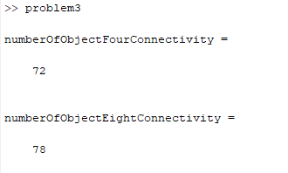

Problem 4:

Code:

x=1;

y=1;

s=1024;

t=1022;

distance=((x-s).^2+(y-t).^2).^0.5

Output:

distance = 1.4453e+03

Problem5:

Addition, Subtraction, Multiplication and Division

(1)

a= imread('img1.png');

b= imread('img2.png');

imfinfo('img1.png')

imfinfo('img2.png')

c= imadd(a,b);

subplot(221);imshow(a);title=('1st image')

subplot(222);imshow(b);title=('2nd image')

subplot(223);imshow(c);title=('Addition image')

d= imsubtract(a,b);

subplot(224);imshow(d);title=('Substract image')

(2)

a= imread('img1.png');

b= imread('img2.png');

imfinfo('img1.png')

imfinfo('img2.png')

c= immultiply(a,b);

subplot(221);imshow(a);title=('1st image')

subplot(222);imshow(b);title=('2nd image')

subplot(223);imshow(c);title=('Multiply image')

d= imdivide(a,b);

subplot(224);imshow(d);title=('divide image')

Output:

Problem 6:  
AND

W1=imread('img1.png');

W2=imread('img2.png');

AND= bitand(W1,W2);

figure

subplot(131)

imshow(W1)

subplot(132)

imshow(W2)

subplot(133)

imshow(AND)

Output

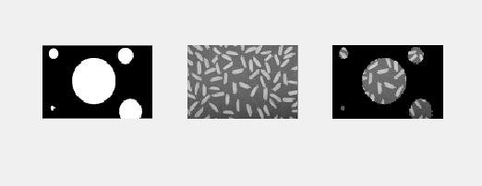

OR

W1=imread('img1.png');

W2=imread('img2.png');

OR= bitor(W1,W2);

figure

subplot(131)

imshow(W1)

subplot(132)

imshow(W2)

subplot(133)

imshow(OR)

Output

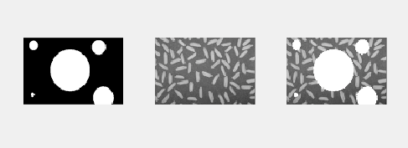

Problem 7:

W=imread('img3.png');

NotW= bitcmp(W);

figure

subplot(121)

imshow(W)

subplot(122)

imshow(NotW)

Output:

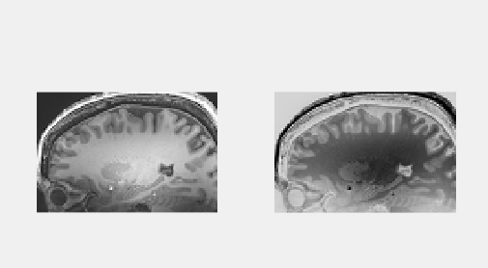

Problem 8:

A = imread('img4.jpg');

A = double(A);

B= bitget(A,1);

subplot(2,2,1);imshow(B);title('Plane 1');

B= bitget(A,2);

subplot(2,2,2);imshow(B);title('Plane 2');

B= bitget(A,3);

subplot(2,2,3);imshow(B);title('Plane 3');

B= bitget(A,4);

subplot(2,2,4);imshow(B);title('Plane 4');

Output:

Problem 9:

I4=imread('img4.jpg');

I4_Stect=imadjust(I4,stretchlim(I4,[0.05,0.95]),[]);

subplot(2,2,1),imshow(I4);title('Original');

subplot(2,2,2),imshow(I4_Stect);title('Stretched');

subplot(2,2,3),imhist(I4);title('Original');

subplot(2,2,4),imhist(I4_Stect);title('Stretched');

Output:

