

Lab 02

Submitted By:

Md. Aahadul Islam Fardin

ID: 2019-1-60-224

Section: 02

Course Code: CSE438(Image Processing)

Submitted To:

**Dr. Ahmed Wasif Reza**

Professor  
Department of Computer Science & Engineering

Date: 28-02-2023

**Problem No:1**

Code:

inputImg = imread('tree.jpg');

refImg = imread("tree_reference.png");

if size(refImg, 3) == 3

refImg = rgb2gray(refImg);

end

inputHist = imhist(inputImg);

refHist = imhist(refImg);

inputCDF = cumsum(inputHist) / numel(inputImg);

refCDF = cumsum(refHist) / numel(refImg);

transFunc = interp1(refCDF, 0:255, inputCDF, 'linear');

outputImg = uint8(transFunc(double(inputImg) + 1));

subplot(1,2,1); imshow(inputImg); title('Input Image');

subplot(1,2,2); imshow(outputImg); title('Output Image');

Output:

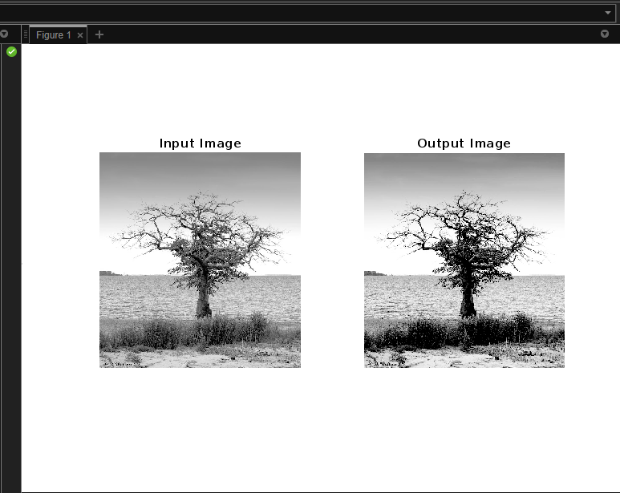

Problem No: 2

Code:

inputImg = imread('CT.jpg')

outputImg = histeq(inputImg);

subplot(2,2,1); imshow(inputImg); title('Input Image');

subplot(2,2,2); imshow(outputImg); title('Output Image');

inputHist = imhist(inputImg);

outputHist = imhist(outputImg);

subplot(2,2,3); stem(inputHist); title('Input Histogram');

subplot(2,2,4); stem(outputHist); title('Output Histogram');

Output:

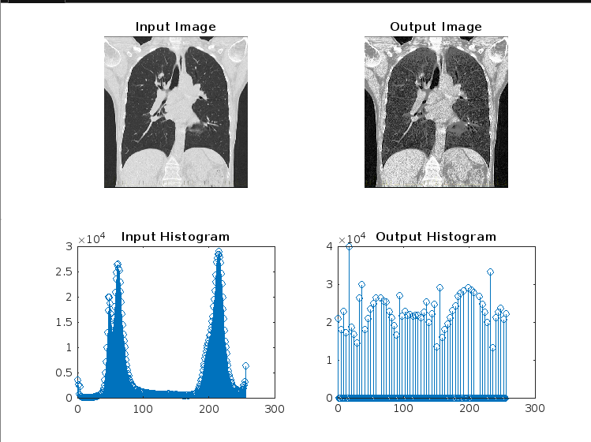

Problem No: 3

Code:

inputImg = imread('MRI.jpg');

noisyImg = imnoise(inputImg, 'salt & pepper', 0.05);

minFilteredImg = ordfilt2(noisyImg, 1, true(3,3));

maxFilteredImg = ordfilt2(noisyImg, 9, true(3,3));

subplot(2,2,1); imshow(inputImg); title('Input Image');

subplot(2,2,2); imshow(noisyImg); title('Noisy Image');

subplot(2,2,3); imshow(minFilteredImg); title('Min Filtered Image');

subplot(2,2,4); imshow(maxFilteredImg); title('Max Filtered Image');

Output:

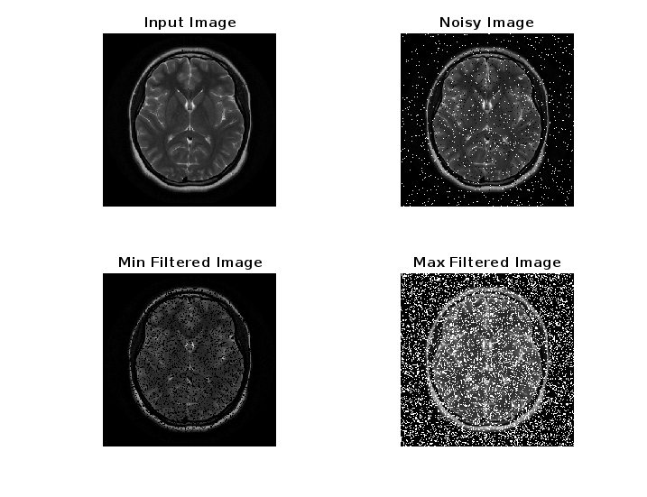

Problem No: 4

Code:

inputImg = imread('MRI.jpg');

noisyImg = imnoise(inputImg, 'gaussian', 0, 0.01);

minFilteredImg = ordfilt2(noisyImg, 1, true(3,3));

maxFilteredImg = ordfilt2(noisyImg, 9, true(3,3));

subplot(2,2,1); imshow(inputImg); title('Input Image');

subplot(2,2,2); imshow(noisyImg); title('Noisy Image');

subplot(2,2,3); imshow(minFilteredImg); title('Min Filtered Image');

subplot(2,2,4); imshow(maxFilteredImg); title('Max Filtered Image');

Output:

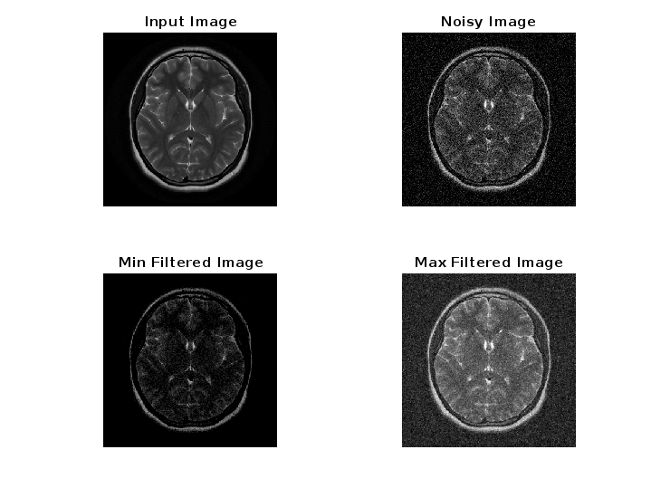

Problem No: 5

Code:

inputImg = imread('MRI_2.jpg');

if size(inputImg, 3) == 3

inputImg = rgb2gray(inputImg);

end

noisyImg = imnoise(inputImg, 'gaussian', 0, 0.01);

boxFilteredImg = imboxfilt(noisyImg, 3);

averageFilteredImg = imfilter(noisyImg, fspecial('average', 3));

medianFilteredImg = medfilt2(noisyImg, [3, 3]);

figure;

subplot(2, 4, 1); imshow(inputImg); title('Input Image');

subplot(2, 4, 2); imshow(noisyImg); title('Noisy Image');

subplot(2, 4, 3); imshow(boxFilteredImg); title('Box Filtered Image');

subplot(2, 4, 4); imshow(averageFilteredImg); title('Average Filtered Image');

subplot(2, 4, 5); imshow(medianFilteredImg); title('Median Filtered Image');

boxPSNR = psnr(inputImg, boxFilteredImg);

averagePSNR = psnr(inputImg, averageFilteredImg);

medianPSNR = psnr(inputImg, medianFilteredImg);

disp(['Box Filtered PSNR: ' num2str(boxPSNR) ' dB']);

disp(['Average Filtered PSNR: ' num2str(averagePSNR) ' dB']);

disp(['Median Filtered PSNR: ' num2str(medianPSNR) ' dB']);

figure;

bar([boxPSNR, averagePSNR, medianPSNR]);

title('PSNR Comparison');

ylabel('PSNR (dB)');

xticklabels({'Box Filtered','Average Filtered','Median Filtered'});

Output:

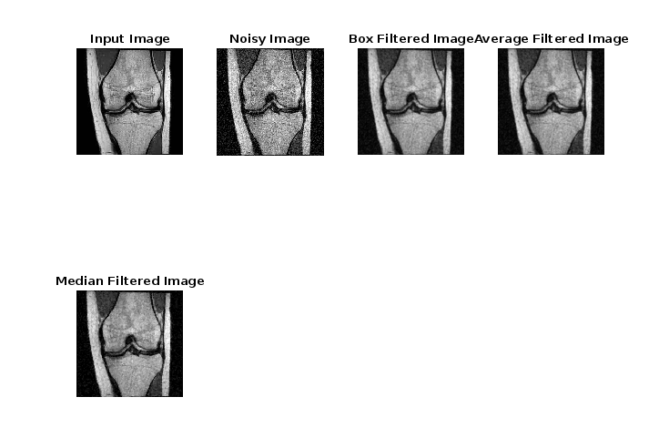

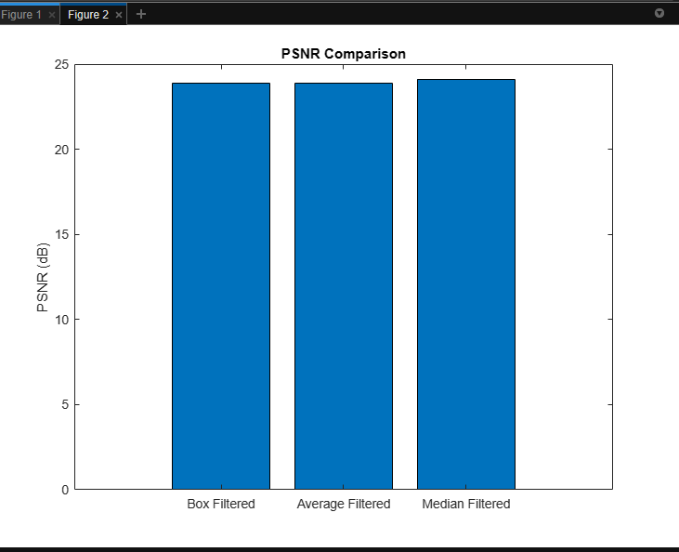

Problem No: 6

Code:   
input_img = imread('contrast.png');

output_img = histeq(input_img);

figure;

subplot(1, 2, 1);

imshow(input_img);

title('Input Image');

subplot(1, 2, 2);

imshow(output_img);

title('Output Image');

figure;

subplot(2, 1, 1);

imhist(input_img);

title('Input Image Histogram');

subplot(2, 1, 2);

imhist(output_img);

title('Output Image Histogram');

Output:

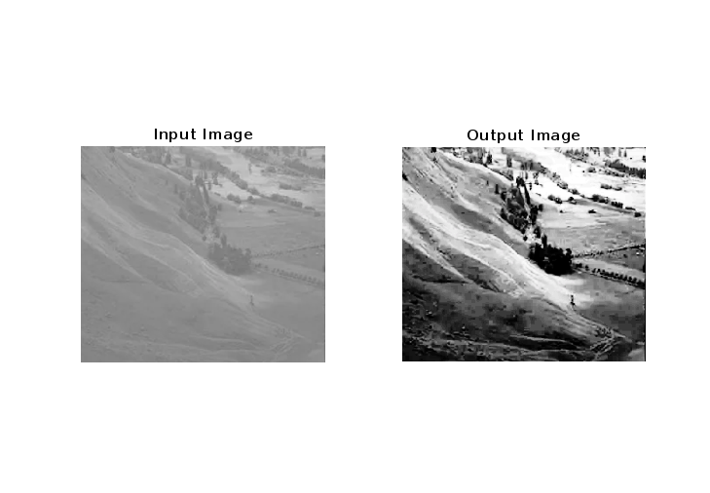

Problem No: 7

Code:

input_img = imread('Brightness.png');

brightness_adj = 120;

output_img = imadjust(input_img, [], [], brightness_adj/255);

figure;

subplot(1, 2, 1);

imshow(input_img);

title('Input Image');

subplot(1, 2, 2);

imshow(output_img);

title('Output Image');

Output:

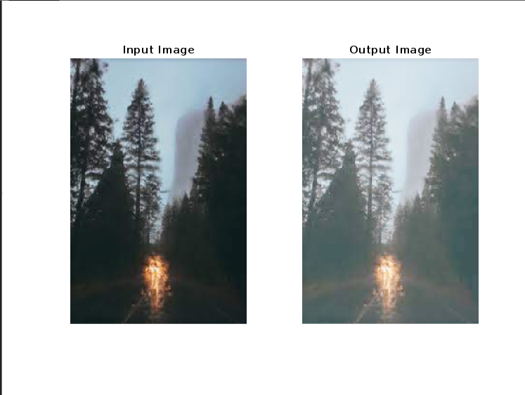

Problem No: 8

Code:

input_img = imread('coins.png');

output_img = uint8(floor(double(input_img)/32) * 32);

figure;

subplot(1, 2, 1);

imshow(input_img);

title('Input Image');

subplot(1, 2, 2);

imshow(output_img);

title('Output Image');

Output:

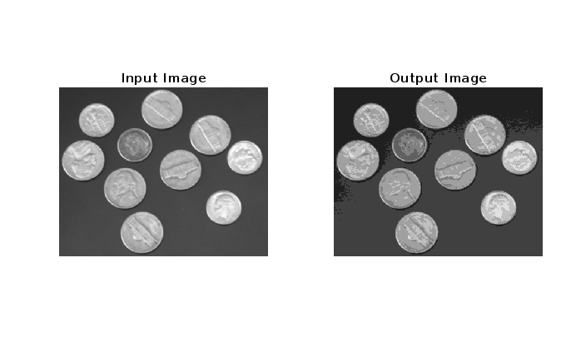

Problem No: 9

Code:

input_img = imread('Galaxy.png');

% show the input image

figure;

imshow(input_img);

title('Input Image');

% show the matrix form of the image

disp('Image matrix:');

disp(input_img);

% display pixel information by hovering cursor over image

imtool(input_img);

% find the value of pixel (10,78)

pixel_value = input_img(10,78);

fprintf('Pixel value at (10,78): %d\n', pixel_value);

% show the size of the image

img_size = size(input_img);

fprintf('Image size: %d x %d\n', img_size(1), img_size(2));

% show all image information

imfinfo('input_image.jpg')

Output:

Pixel value at (10,78): 45

Image size: 433 x 425

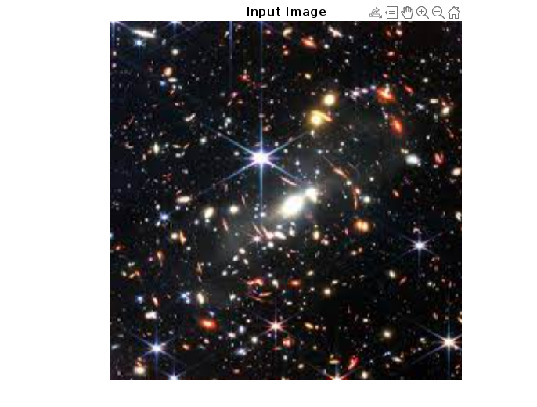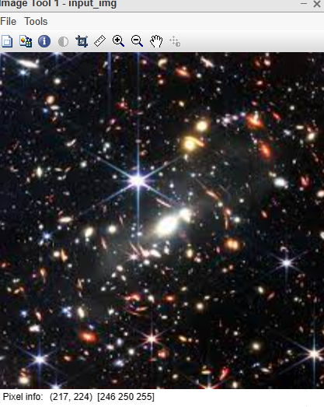

Problem No:10

Code:

rgb_img = imread('rgb_image.png');

gray_img = imread('grayscale__image.png');

indexed_img = imread('indexed__image.png');

subplot(1,3,1);

imshow(rgb_img);

title('RGB Image');

subplot(1,3,2);

imshow(gray_img);

title('Grayscale Image');

subplot(1,3,3);

imshow(indexed_img);

title('Indexed Image');

gray_rgb_img = rgb2gray(rgb_img);

gray_indexed_img = ind2gray(indexed_img, gray(256));

binary_img = imbinarize(gray_img);

inverted_binary_img = imcomplement(binary_img);

figure;

imhist(gray_img);

title('Histogram of Grayscale Image');

inverted_rgb_img = imcomplement(rgb_img);

blurred_rgb_img = imgaussfilt(rgb_img, 5);

Output:

