
Department of Electrical Engineering & Computing Sciences
Academic Year | 2025-2026
Semester |  | - Fall Spring | Summer
Course Code - Name | CSEC-201 Programming for Information Security – All Sections (600,601,602)
Instructor | Ebram Kamal William Aziz
Exam | Quiz/Test | Assignment Mid  Project | Final | Other
Start Date | Fri., Sep. 11, 2026
Due Date | Sun., Oct. 4, 2026
- Read Instructions under each section.
- Exam scheme: open book group-based activity.
- Class activity report must be submitted to MyCourses by the team leader of each team
- Each Student must attend presentation and discussion of code otherwise he will get 0 grade in this project
Student ID | Student Name
745009592 | Aahil Riyaz Beekay (Team Leader)
434000569 | Zoheb Bamban
748004800 | Saquib Gudme
434002906 | Anay Nayak

CLOs:
- Design and implement a protocol programming using sockets in multiple languages.
- Classify sections and explain how memory can and should be managed programmatically.
- Describe the compilation process and how high-level code is translated into low-level code.
- Implement basic programs in a low-level programming language such as x86 assembly.
- Explain how memory corruption vulnerabilities can be exploited and be able to implement basic memory corruption exploits.

If the assessment maps to a single CLO, state the CLO below:
CLO | Max Score | Students Average Score
CLO1 | 20

Project [20 Points] Spring2026
Instructions: This project is Group-based, each group may consist of (3-4 students). The group is expected to write python and C code to develop the following explained protocol using socket programming. Each team leader submits this version the instructions sheet with the code copied at the end, in addition to the client, server programs. Due date of submission is on Sunday 22 Feb. 2026.

Files should be named as follow: teamleaderName_client.py, teamleaderName_server.py, teamleaderName_client.c, teamleaderName_projectDocument.docx

You need to keep your work on Github and show the continus work on the project.

Rubric: (Each student might have different grade based on the presentation/ discussions and explanation of code)
This is group work which means each student is responsible for all the code parts.
Your project will not be evaluated (your grade will be 0/20 in project) if you did not attend the presentation/ discussions.
CRITERIA | Max Grade | Std. Grade | Feedback
Setup Phase | 3
Closing Phase | 4
Start-Packet | 2
Encryption-Packet | 2
Confirm-Connection-Packet | 2
Using RSA including session key encryption | 5
Using AES | 5
Using Caesar | 5
Prompt packets | 5
openRead includes reading from files | 6
openWrite incudes writing on files | 6
Data Packet | 2
Exception packets | 6
Server Multithreads | 4
Comments | 3
Running code | 5
Integrating C client part | 5
Discussions | 10
GenAI | 10
Github | 10
Total | 100 | /100 | /20

Project Problem:
Remote controlling protocols such as Telnet and SSH are used to remotely run commands on other devices without the need to physical direct interaction with these devices. In this project you will design and develop a simple application layer protocol that help folders and files management on servers.
You have to write Python3 code to implement the Remote File Management Protocol (RFMP) which is designed to serve a remote controlling application.
RFMP has three phases: setup phase, operation phase, and closing phase.
1. Setup-Phase:
Once the client opens the application, the application sends a series of packets to the server device in the following order:
- Start-Packet (from client to server): contains the packet type, protocol name, protocol version, secured-communication example:
  - (SS,RFMP,v1.0,0), where SS is the packet type (start), RFMP is the protocol name, v1.0 is the version, 0 means no secured communication is required, in this case no encryption for the packet is required.
  - (SS, RFMP,v1.0,1), where SS is the packet type (start), RFMP is the protocol name, v1.0 is the version, 1 means secured communication is required, in this case the server expects to receive an encryption-packet (EC) immediately after the start-packet (SS).

- Confirm-Connection-Packet (from server to client): this packet is sent with one field if security is not required which is the packet-type (CC) from the server to inform the client to start sending information packets or with two fields if security is required (CC, Server_public_key).

- Encryption-Packet (from client to server): contains information about encryption algorithm, and credentials used to secure communication. This packet is sent in case the Start-Packet contains 1 in the secure-communication field. This packet type contains the following fields (packet-type, Algorithm, credentials): (EC, ALgorithm, session_key, username:Client_public_key).
- These encryption algorithms can be generated using AI tools such as Claud or Gemini, this part weight is 15% of project grade and students must explain any generated code and learn how the code functions.
The following table shows the options of the algorithms and credentials sent with each:
Fields | Credentials
AES Cipher | Both will use AES to encrypt files contents
Caesar Cipher | Both will use Caesar to encrypt files contents
Session_key | Either AES or Caesar key encrypted using RSA private key
Public_Key | Public key generated by RSA algorithm, used to decrypt session key
In the Start-up phase the client prepares three keys:
1. Session Key that will be used later to encrypt data either by using Caesar or AES algorithms.
2. Public and Private Keys using RSA algorithm. That will be used later to encrypt and decrypt session key
The server in the setup phase will generate both private key and public key using the RSA algorithm and send his public key to client in the confirmation packet (CC, Server_publik_Key).
The Client program will use the Server_public_ key to encrypt the session_key and send it to server. The server will use his private_key to decrypt the session_key, then later in the operation phase the server will use the session_key to decrypt data before saving the data into a file on server.
Client
Server
(SS, RFMP, 1.0, 0)
Not Secured

(CC)

(SS, RFMP, 1.0, 1)

(CC, PubKeyser)
Secured

(EC,Alg,Encrypted(sessionKey),PubKeycln )

- Operation-Phase:
This phase is started once the client starts typing commands and send them to the server. This packet has type filed (CM). The packet has three fields the pcket_type, the command_type, arguments.
Ex. (CM, prompt, ls), (CM, prompt, mkdir directoryName). See the below table for all commands.

You can send any system command to the server. Such as processor or memory status enquiry, or folder management commands. In this project you have to include the following commands for file and folder management:

mkdir | Create new folder
cd | Change directory path command
rmdir or rd | To delete folders
del | To delete files
ren | To rename a folder
openRead | This command is not a prompt command; it is a keyword for the server program to use open file in read mode to retrieve its contents to the client
openWrite | This command is not a prompt command; it is a keyword for the server program to use python file open command to create new file in write mode
Choose any 5 other system prompt commands you want to execute on the server

- Each of the prompt commands requires argument which you should send in the packet (write full command text such as (CM,prompt,mkdir folder1), (CM,prompt,ren homework1 homework2). For these types of prompt commands you can use many python libraries to implement them:
os.system()
subprocess.run()

- The openRead and openWrite commands requires to send in the same packet file names you want to open in read mode or write mode for example: (CM, openRead, data.txt) or (CM, openWrite, data.txt)

- Data Packets are used to send data to be saved in the file created using openWrite command. This packet has the following format: (DP, text) where the text is any data you want the server to save.
If the communications are secured according to the setup phase then you have to encrypt the text field before sending. And the server will decrypt the text before saving it to the file.

- In the openRead, the server should open a file and send its contents to the client. Make sure if encryption is chosen in the setup phase then the server should use the session key to encrypt the text before sending it.

- After each command execution on the server, the server should returns either successful (SC) packet or Error packet(EE).

- Closing-Phase:
Packet (End) is used in closing phase. In this phase a Close-Packet is sent to the server to confirm that the client has finished from using the application. And the server will expect no more messages from the client.
4. Exception-Packets: Your client should check each response from the server if the server sends an Exception Event (EE) packet-type message this means that there has an error occurred while processing client’s requests. Each EE packet contains the following fields: (EE, Error Code, Description). Error Code values are left to your implementation, you can suggest set of error codes (maximum 4 error codes).

Note: You have to implement a client side with proper options that the user can choose from and remotely control the server and displays server responses.

5. Integrating with C client program:
You have to integrate your project with a C client version in addition to the Python client version and Python server version. This C client part is simple version of the python client part, where you have to implement a nonsecured communication client in the C-part, (no encryption) and the C client program sends only one type command which is the openRead to return file contents from a server file.

Implementation Summary
Prerequisites:

1. pip install pycryptodome (library for RSA and AES)
2. python AahilRiyazbeekay_server.py (server runs on port 5000)
3. python AahilRiyazbeekay_client.py (pick y for secure or n for not secure)
4. C client: gcc AahilRiyazbeekay_client.c -o client_c.exe -lws2_32 then run client_c.exe

How packets are sent:
Every packet is text inside sent in the format of the brackets like (CM,prompt,mkdir folder1). The client sends a packet and waits for the reply from the server, so the messages never get mixed. TCP can still cut a big message into parts, so receive_packet() keeps calling recv() until the message ends with ). Keys and encrypted data are base64 so they are one line with no commas.

Packets we used:

(SS,RFMP,v1.0,0) or (SS,RFMP,v1.0,1) start packet, 1 = secure

(CC) or (CC, Server_public_key) Server confirms

(EC, AES or Caesar ,session_key,username:Client_public_key)

(CM, prompt, command) (CM, openRead, file) (CM, openWrite, file)

(DP, text) Saves data in the file from openWrite

(SC,message) Success, for openRead the file text is inside the SC

(EE,code,description) Error description

(END) closing

Security (Encryption and Decryption) :
When the server starts,it makes its RSA keys. If the client picks secure, the server sends its public key in the CC packet. The client makes the session key (16 random bytes for AES or a number from 1 to 25 for Caesar) and its own RSA keys. It encrypts the session key with the server public key and sends it in the EC packet with the username and client public key. The server decrypts the session key with its private key. After that the text in openWrite (DP packet) and openRead is encrypted with AES or Caesar. We used the server public key because then only the server can open it.

Error codes:
100 - bad packet (wrong format or wrong order like DP before openWrite)
200 - file or folder not found
300 - command failed or not allowed
400 - encryption error

Commands:
mkdir, cd, rmdir/rd, del and ren are done with the os module. Our 5 extra commands are ls, pwd, whoami, hostname and cat and they run with subprocess.run() (on windows the server uses dir, cd, whoami, hostname and type instead). Any other command gets error 300 so nobody can run any harmful commands on the server.

Multithreading:
Every time a client connects the server starts a new thread with threading.Thread(target=handle_client). Each thread has its own variables (folder, algorithm, key) so one client doing the cd command does not move the others.

C client:
The C client is not secure. It sends (SS,RFMP,v1.0,0), waits for (CC), asks for a file name, sends (CM,openRead,filename), prints the file text from the SC reply, then sends (END).
GitHub repository: https://github.com/Aahil-Riyaz/RFMP-Socket-Project

Test Screenshots:
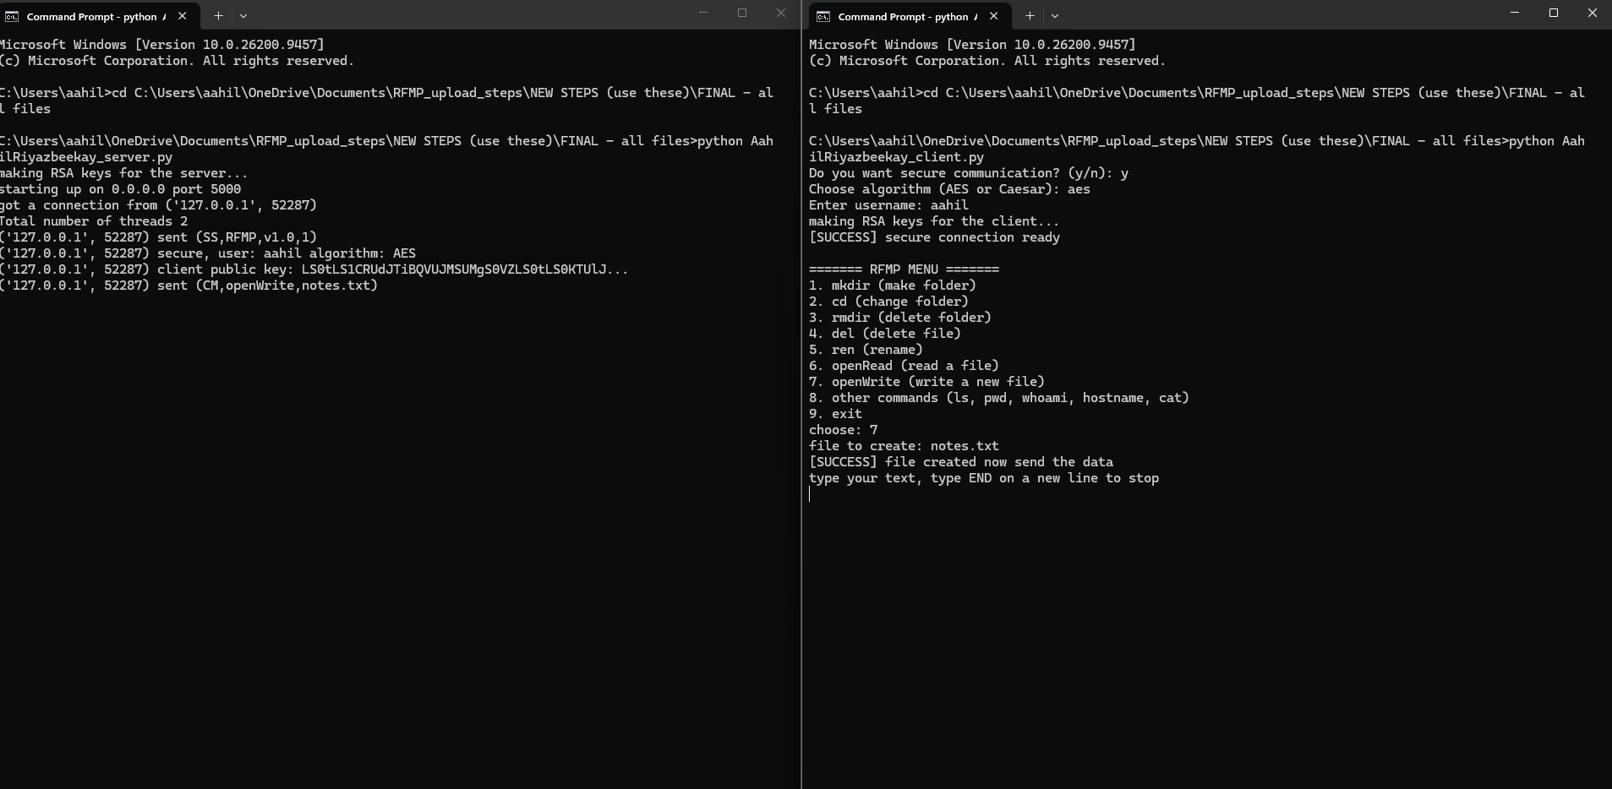
Figure 1: Secure mode with AES. The client gets the server key, sends the EC packet and makes a new file with openWrite.
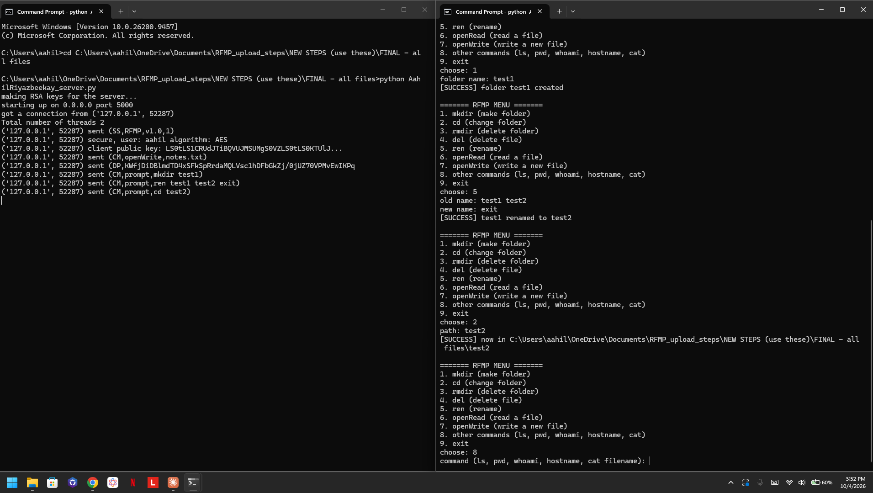
Figure 2: Prompt commands mkdir, ren and cd working. The server log shows the DP text is scrambled by AES.
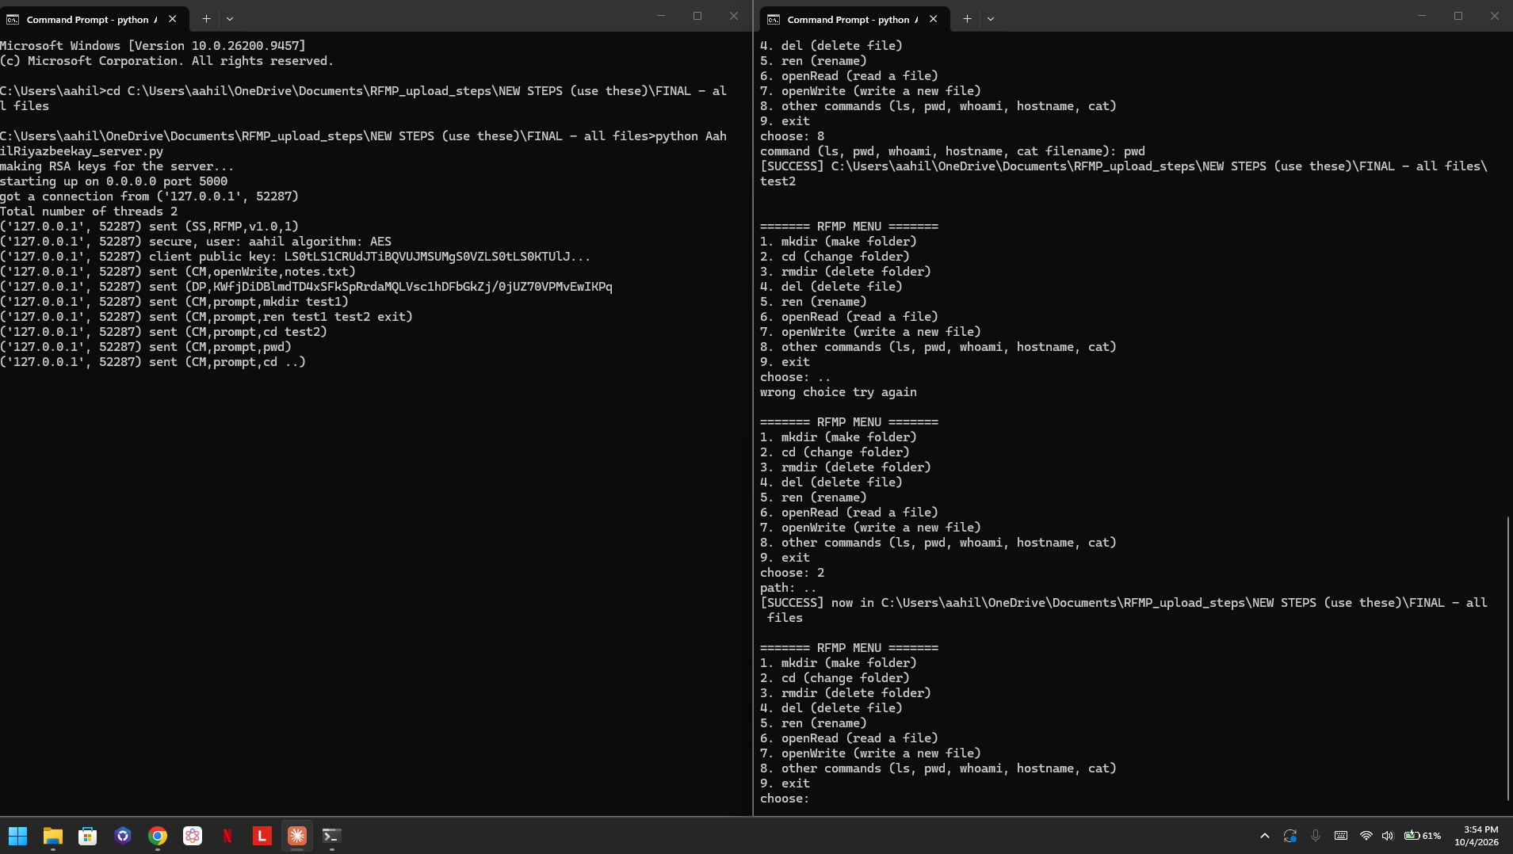
Figure 3: pwd shows the folder we are in, then cd .. goes back.
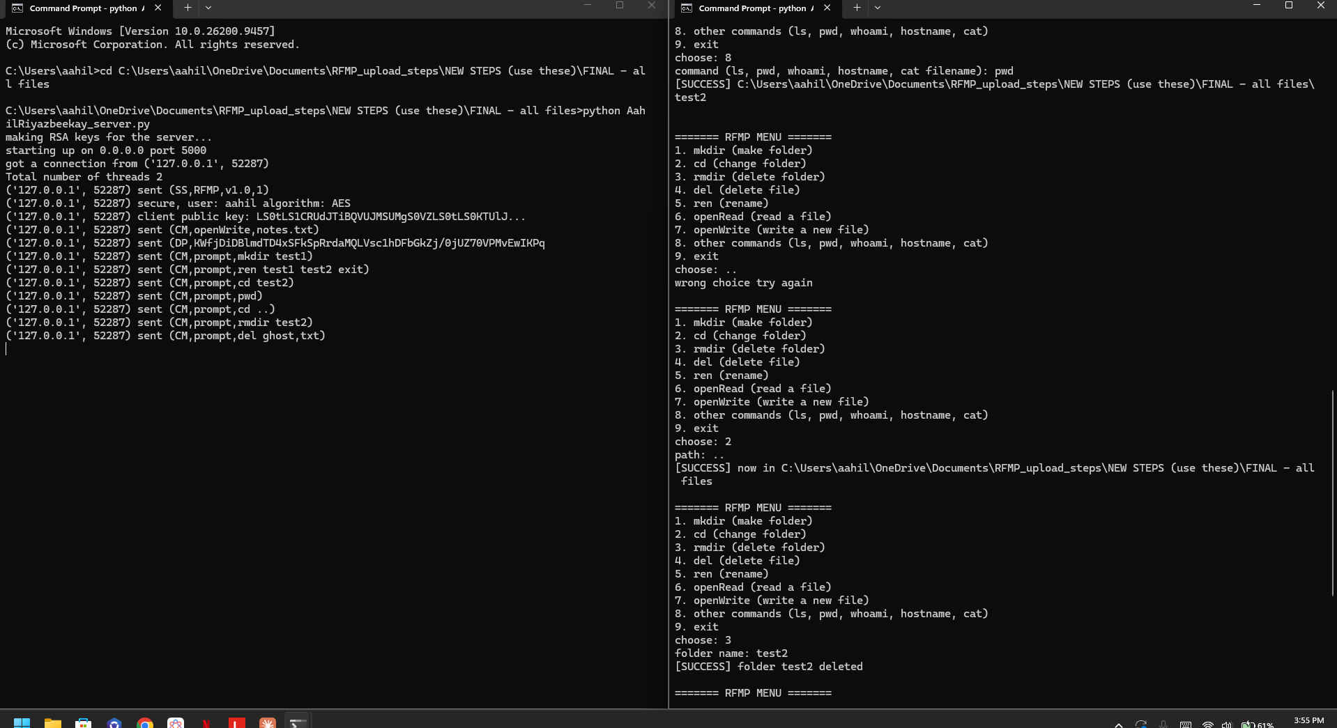
Figure 4: rmdir deletes the test2 folder.
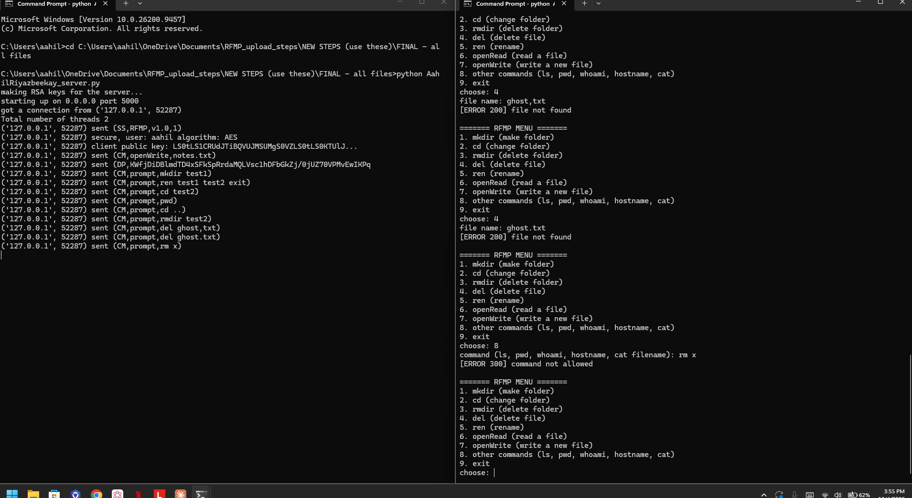
Figure 5: Error packets. 200 = file not found and 300 = command not allowed.
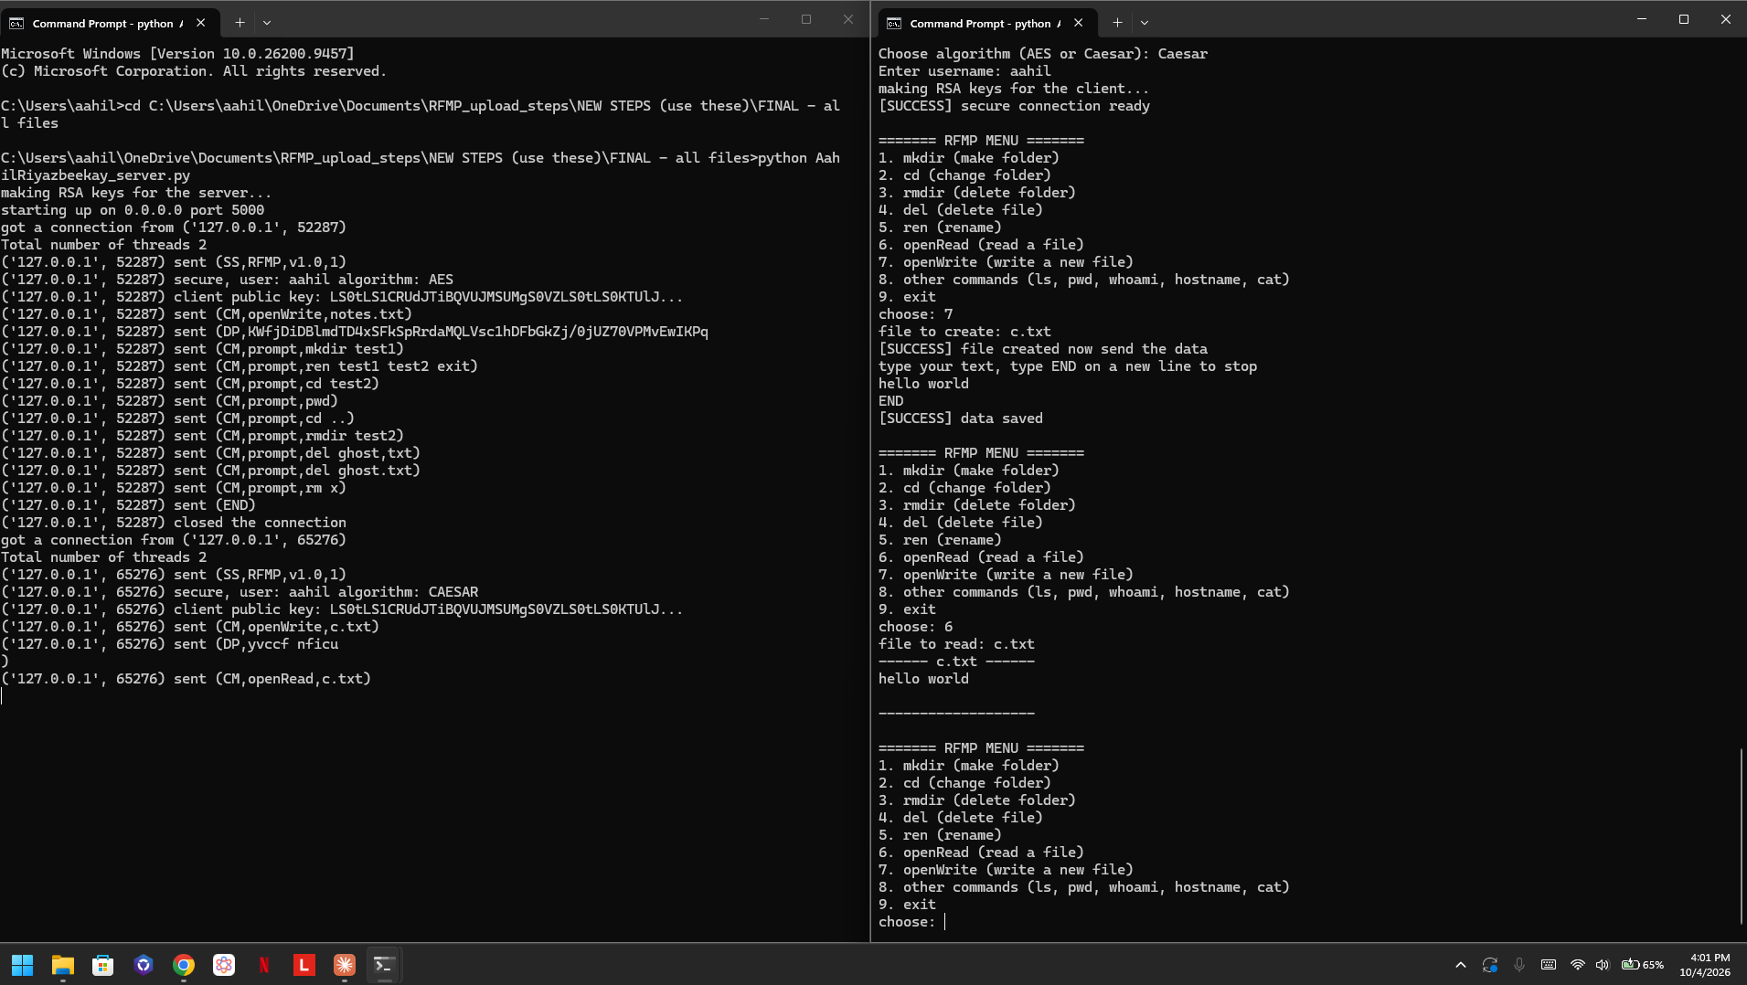
Figure 6: Secure mode with Caesar. The server gets the DP text with shifted letters (yvccf nficu) and the client reads it back as hello world.
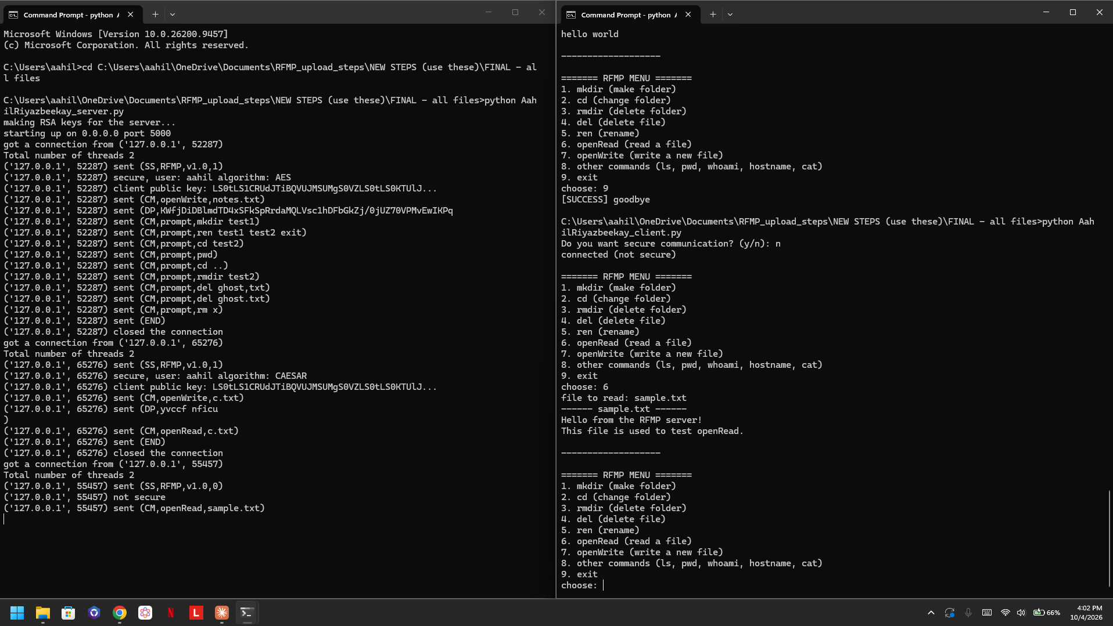
Figure 7: Not secure mode. openRead of sample.txt with no encryption.
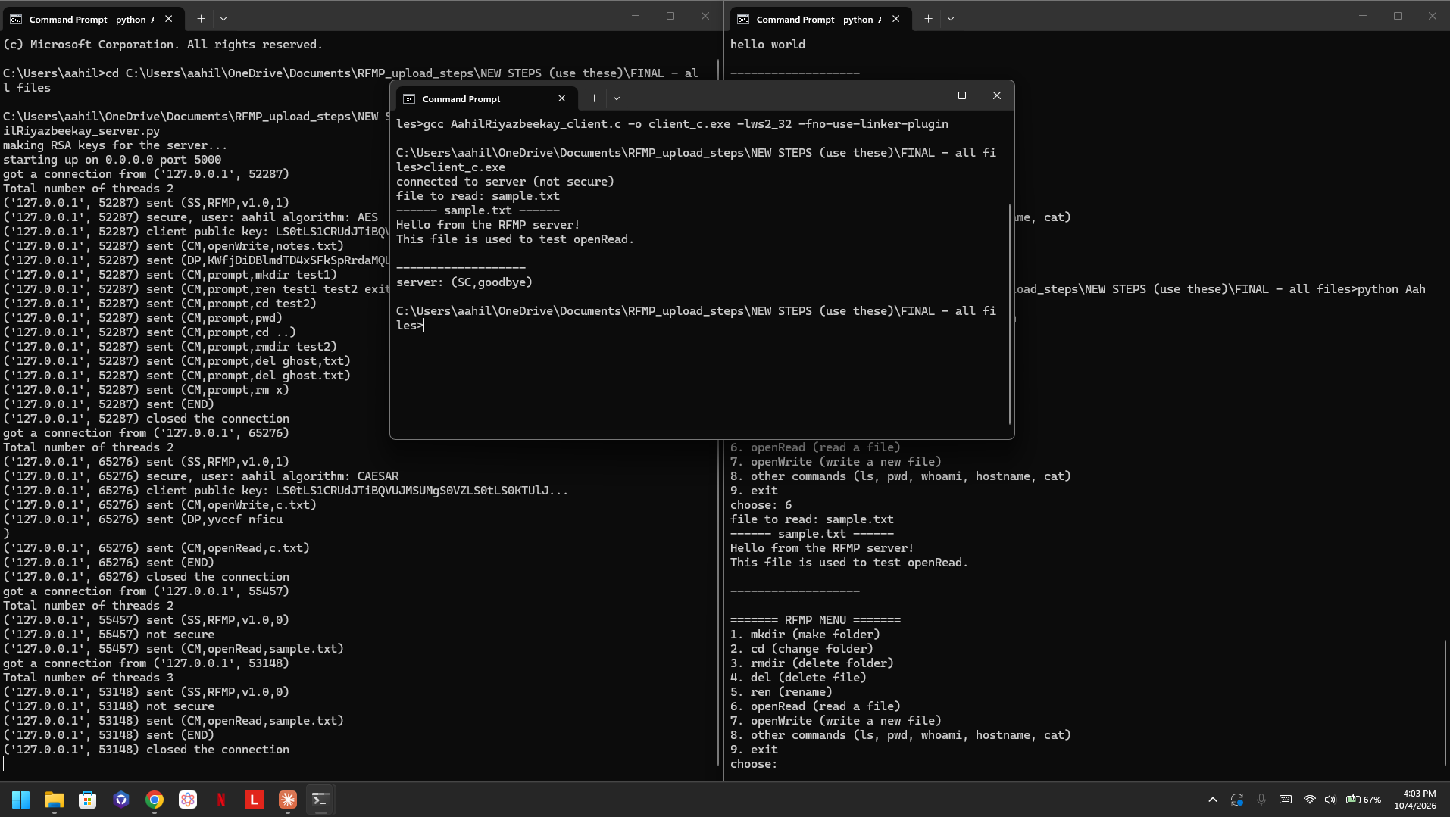
Figure 8: C client reading sample.txt while the Python client is still connected. The server shows Total number of threads 3 so it is multithreaded.

Python- Server Code:
# CSEC-201 Project - RFMP (Remote File Management Protocol)
# Server side
# the server waits for clients and runs the commands they send
# every client gets its own thread so more than one can connect
import socket
import threading
import os
import subprocess
import base64
from Crypto.PublicKey import RSA
from Crypto.Cipher import PKCS1_OAEP, AES
from Crypto.Util.Padding import pad, unpad
from Crypto.Random import get_random_bytes
HOST = "0.0.0.0"
PORT = 5000
# our error codes for EE packets
# 100 = bad packet
# 200 = file or folder not found
# 300 = command failed / not allowed
# 400 = encryption error
# the 5 extra commands we picked and their names on windows
extra_commands = {"ls": "dir", "pwd": "cd", "whoami": "whoami", "hostname": "hostname", "cat": "type"}
# server makes its RSA keys one time when it starts
print("making RSA keys for the server...")
server_key = RSA.generate(2048)
# base64 so the key is one line with no commas inside the packet
server_public_key = base64.b64encode(server_key.publickey().export_key()).decode()
def receive_packet(conn):
# TCP can split a big message into parts
# so we keep reading until the message ends with )
data = b""
while True:
part = conn.recv(4096)
if not part:
break
data = data + part
if data.endswith(b")"):
break
return data.decode()
def send_packet(conn, packet):
conn.sendall(packet.encode())
def send_error(conn, code, msg):
send_packet(conn, "(EE," + code + "," + msg + ")")
# ### Caesar cipher
def caesar_encrypt(text, shift):
result = ""
for ch in text:
if ch.isupper():
result = result + chr((ord(ch) - 65 + shift) % 26 + 65)
elif ch.islower():
result = result + chr((ord(ch) - 97 + shift) % 26 + 97)
else:
result = result + ch # numbers and symbols stay the same
return result
def caesar_decrypt(text, shift):
return caesar_encrypt(text, -shift)
# ### AES (CBC mode)
def aes_encrypt(text, key):
iv = get_random_bytes(16) # new random iv every time
cipher = AES.new(key, AES.MODE_CBC, iv)
encrypted = cipher.encrypt(pad(text.encode(), 16))
return base64.b64encode(iv + encrypted).decode() # iv is sent in front of the data
def aes_decrypt(text, key):
raw = base64.b64decode(text)
iv = raw[:16]
cipher = AES.new(key, AES.MODE_CBC, iv)
return unpad(cipher.decrypt(raw[16:]), 16).decode()
# algorithm is None when the client did not ask for security
def encrypt(text, algorithm, key):
if algorithm == "AES":
return aes_encrypt(text, key)
if algorithm == "CAESAR":
return caesar_encrypt(text, key)
return text
def decrypt(text, algorithm, key):
if algorithm == "AES":
return aes_decrypt(text, key)
if algorithm == "CAESAR":
return caesar_decrypt(text, key)
return text
# runs the prompt commands, returns the folder the client is in
# (it only changes when the command is cd)
def run_command(conn, command, cwd):
parts = command.split()
if len(parts) == 0:
send_error(conn, "100", "empty command")
return cwd
cmd = parts[0]
try:
if cmd == "mkdir":
os.mkdir(os.path.join(cwd, parts[1]))
send_packet(conn, "(SC,folder " + parts[1] + " created)")
elif cmd == "cd":
new_path = os.path.abspath(os.path.join(cwd, parts[1]))
if os.path.isdir(new_path):
cwd = new_path
send_packet(conn, "(SC,now in " + cwd + ")")
else:
send_error(conn, "200", "folder not found")
elif cmd == "rmdir" or cmd == "rd":
os.rmdir(os.path.join(cwd, parts[1])) # folder has to be empty
send_packet(conn, "(SC,folder " + parts[1] + " deleted)")
elif cmd == "del":
path = os.path.join(cwd, parts[1])
if os.path.isfile(path):
os.remove(path)
send_packet(conn, "(SC,file " + parts[1] + " deleted)")
else:
send_error(conn, "200", "file not found")
elif cmd == "ren":
os.rename(os.path.join(cwd, parts[1]), os.path.join(cwd, parts[2]))
send_packet(conn, "(SC," + parts[1] + " renamed to " + parts[2] + ")")
elif cmd in extra_commands:
if os.name == "nt": # windows uses different names
parts[0] = extra_commands[cmd]
result = subprocess.run(" ".join(parts), shell=True, cwd=cwd, capture_output=True, text=True)
if result.returncode == 0:
send_packet(conn, "(SC," + result.stdout + ")")
else:
send_error(conn, "300", "command failed")
else:
# we only allow our commands so nobody can run dangerous stuff on the server
send_error(conn, "300", "command not allowed")
except IndexError:
send_error(conn, "100", "missing name after the command")
except FileNotFoundError:
send_error(conn, "200", "file or folder not found")
except FileExistsError:
send_error(conn, "300", "already exists")
except OSError:
send_error(conn, "300", "command failed")
return cwd
# each client runs this function in its own thread
def handle_client(conn, addr):
print("got a connection from", addr)
cwd = os.getcwd() # every client has its own folder
write_file = None # the file opened with openWrite
algorithm = None # stays None if not secure
key = None
try:
# ### setup phase
packet = receive_packet(conn)
print(addr, "sent", packet)
fields = packet[1:-1].split(",")
# start packet should look like (SS,RFMP,v1.0,0) or (SS,RFMP,v1.0,1)
if len(fields) != 4 or fields[0] != "SS" or fields[1] != "RFMP":
send_error(conn, "100", "expected start packet")
return
if fields[3] == "0":
send_packet(conn, "(CC)")
print(addr, "not secure")
elif fields[3] == "1":
# send our public key, then the client sends the EC packet
send_packet(conn, "(CC," + server_public_key + ")")
packet = receive_packet(conn)
# (EC,Algorithm,session_key,username:client_public_key)
fields = packet[1:-1].split(",")
if len(fields) != 4 or fields[0] != "EC":
send_error(conn, "100", "expected encryption packet")
return
algorithm = fields[1].upper()
if algorithm != "AES" and algorithm != "CAESAR":
send_error(conn, "400", "algorithm must be AES or Caesar")
return
try:
# unlock the session key with our private key
rsa = PKCS1_OAEP.new(server_key)
session_key = rsa.decrypt(base64.b64decode(fields[2]))
username = fields[3].split(":")[0]
client_public_key = fields[3].split(":")[1]
except:
send_error(conn, "400", "could not decrypt the session key")
return
if algorithm == "AES":
key = session_key # 16 bytes
else:
key = int(session_key.decode()) # caesar shift number
print(addr, "secure, user:", username, "algorithm:", algorithm)
print(addr, "client public key:", client_public_key[:40] + "...")
send_packet(conn, "(SC,secure connection ready)")
else:
send_error(conn, "100", "last field must be 0 or 1")
return
# ### operation phase
while True:
packet = receive_packet(conn)
if packet == "":
print(addr, "disconnected")
break
print(addr, "sent", packet[:60])
if packet == "(END)":
# ### closing phase
send_packet(conn, "(SC,goodbye)")
print(addr, "closed the connection")
break
elif packet.startswith("(CM,"):
# (CM,command_type,arguments)
fields = packet[1:-1].split(",", 2)
if len(fields) != 3:
send_error(conn, "100", "bad command packet")
elif fields[1] == "prompt":
cwd = run_command(conn, fields[2], cwd)
elif fields[1] == "openRead":
path = os.path.join(cwd, fields[2])
if os.path.isfile(path):
f = open(path, "r")
content = f.read()
f.close()
# encrypt the file text before sending if secure
send_packet(conn, "(SC," + encrypt(content, algorithm, key) + ")")
else:
send_error(conn, "200", "file not found")
elif fields[1] == "openWrite":
try:
write_file = os.path.join(cwd, fields[2])
f = open(write_file, "w") # makes a new empty file
f.close()
send_packet(conn, "(SC,file created now send the data)")
except OSError:
write_file = None
send_error(conn, "300", "could not create the file")
else:
send_error(conn, "100", "unknown command type")
elif packet.startswith("(DP,"):
if write_file is None:
send_error(conn, "100", "use openWrite first")
continue
try:
text = decrypt(packet[4:-1], algorithm, key)
except:
send_error(conn, "400", "could not decrypt the data")
continue
f = open(write_file, "a")
f.write(text)
f.close()
send_packet(conn, "(SC,data saved)")
else:
send_error(conn, "100", "unknown packet")
except ConnectionResetError:
print(addr, "connection lost")
finally:
conn.close()
def main():
# create a TCP socket
server = socket.socket(socket.AF_INET, socket.SOCK_STREAM)
# so we can restart the server right away without "address already in use"
server.setsockopt(socket.SOL_SOCKET, socket.SO_REUSEADDR, 1)
# bind the socket to the port
server.bind((HOST, PORT))
# queue up to 5 requests
server.listen(5)
print('starting up on {} port {}'.format(HOST, PORT))
while True:
conn, addr = server.accept()
# new thread for every client
thread_obj = threading.Thread(target=handle_client, args=(conn, addr))
thread_obj.start()
print("Total number of threads", threading.active_count())
if __name__ == '__main__':
main()

Python- Client Code:
# CSEC-201 Project - RFMP (Remote File Management Protocol)
# Client side
# connects to the server and shows a menu so we can control the server
import socket
import base64
import random
from Crypto.PublicKey import RSA
from Crypto.Cipher import PKCS1_OAEP, AES
from Crypto.Util.Padding import pad, unpad
from Crypto.Random import get_random_bytes
SERVER = "127.0.0.1"
PORT = 5000
def receive_packet(sock):
# keep reading until the message ends with )
data = b""
while True:
part = sock.recv(4096)
if not part:
break
data = data + part
if data.endswith(b")"):
break
return data.decode()
def send_packet(sock, packet):
sock.sendall(packet.encode())
# ### Caesar cipher (same as the server)
def caesar_encrypt(text, shift):
result = ""
for ch in text:
if ch.isupper():
result = result + chr((ord(ch) - 65 + shift) % 26 + 65)
elif ch.islower():
result = result + chr((ord(ch) - 97 + shift) % 26 + 97)
else:
result = result + ch
return result
def caesar_decrypt(text, shift):
return caesar_encrypt(text, -shift)
# ### AES (same as the server)
def aes_encrypt(text, key):
iv = get_random_bytes(16)
cipher = AES.new(key, AES.MODE_CBC, iv)
encrypted = cipher.encrypt(pad(text.encode(), 16))
return base64.b64encode(iv + encrypted).decode()
def aes_decrypt(text, key):
raw = base64.b64decode(text)
iv = raw[:16]
cipher = AES.new(key, AES.MODE_CBC, iv)
return unpad(cipher.decrypt(raw[16:]), 16).decode()
def encrypt(text, algorithm, key):
if algorithm == "AES":
return aes_encrypt(text, key)
if algorithm == "CAESAR":
return caesar_encrypt(text, key)
return text
def decrypt(text, algorithm, key):
if algorithm == "AES":
return aes_decrypt(text, key)
if algorithm == "CAESAR":
return caesar_decrypt(text, key)
return text
# prints what the server answered
# (SC,message) or (EE,code,description)
def show_reply(reply):
if reply.startswith("(SC"):
print("[SUCCESS]", reply[4:-1])
elif reply.startswith("(EE"):
fields = reply[1:-1].split(",", 2)
print("[ERROR " + fields[1] + "]", fields[2])
else:
print("unknown reply from server:", reply)
# setup phase, returns the algorithm and the session key
# (None, None if not secure)
def setup(sock):
choice = input("Do you want secure communication? (y/n): ")
if choice != "y":
send_packet(sock, "(SS,RFMP,v1.0,0)")
reply = receive_packet(sock)
if reply != "(CC)":
print("server did not confirm:", reply)
sock.close()
exit()
print("connected (not secure)")
return None, None
algorithm = ""
while algorithm != "AES" and algorithm != "CAESAR":
algorithm = input("Choose algorithm (AES or Caesar): ").upper()
username = input("Enter username: ")
# 1. Makes the session key
if algorithm == "AES":
key = get_random_bytes(16) # 16 bytes = 128 bit key
session_key = key
else:
key = random.randint(1, 25) # caesar shift
session_key = str(key).encode()
# 2. Makes the client RSA keys
print("making RSA keys for the client...")
client_key = RSA.generate(2048)
client_public_key = base64.b64encode(client_key.publickey().export_key()).decode()
# 3. Starts the packet, 1 gives us security.
send_packet(sock, "(SS,RFMP,v1.0,1)")
reply = receive_packet(sock)
if not reply.startswith("(CC,"):
print("server did not send its public key:", reply)
sock.close()
exit()
server_public_key = RSA.import_key(base64.b64decode(reply[4:-1]))
# 4. Locks the session key with the server public key
rsa = PKCS1_OAEP.new(server_public_key)
locked_key = base64.b64encode(rsa.encrypt(session_key)).decode()
# 5. Sends the encrypted packet
send_packet(sock, "(EC," + algorithm + "," + locked_key + "," + username + ":" + client_public_key + ")")
reply = receive_packet(sock)
show_reply(reply)
if not reply.startswith("(SC"):
sock.close()
exit()
return algorithm, key
def main():
# creates a TCP socket
sock = socket.socket(socket.AF_INET, socket.SOCK_STREAM)
try:
sock.connect((SERVER, PORT))
except:
print("could not connect to the server, is it running?")
return
algorithm, key = setup(sock)
while True:
print()
print("======= RFMP MENU =======")
print("1. mkdir (make folder)")
print("2. cd (change folder)")
print("3. rmdir (delete folder)")
print("4. del (delete file)")
print("5. ren (rename)")
print("6. openRead (read a file)")
print("7. openWrite (write a new file)")
print("8. other commands (ls, pwd, whoami, hostname, cat)")
print("9. exit")
choice = input("choose: ")
if choice == "1":
name = input("folder name: ")
send_packet(sock, "(CM,prompt,mkdir " + name + ")")
show_reply(receive_packet(sock))
elif choice == "2":
path = input("path: ")
send_packet(sock, "(CM,prompt,cd " + path + ")")
show_reply(receive_packet(sock))
elif choice == "3":
name = input("folder name: ")
send_packet(sock, "(CM,prompt,rmdir " + name + ")")
show_reply(receive_packet(sock))
elif choice == "4":
name = input("file name: ")
send_packet(sock, "(CM,prompt,del " + name + ")")
show_reply(receive_packet(sock))
elif choice == "5":
old = input("old name: ")
new = input("new name: ")
send_packet(sock, "(CM,prompt,ren " + old + " " + new + ")")
show_reply(receive_packet(sock))
elif choice == "6":
name = input("file to read: ")
send_packet(sock, "(CM,openRead," + name + ")")
reply = receive_packet(sock)
if reply.startswith("(SC"):
# file text comes encrypted if we are secure
text = decrypt(reply[4:-1], algorithm, key)
print("------ " + name + " ------")
print(text)
print("-------------------")
else:
show_reply(reply)
elif choice == "7":
name = input("file to create: ")
send_packet(sock, "(CM,openWrite," + name + ")")
reply = receive_packet(sock)
show_reply(reply)
if reply.startswith("(SC"):
print("type your text, type END on a new line to stop")
text = ""
line = input()
while line != "END":
text = text + line + "\n"
line = input()
# encrypt before sending if secure
send_packet(sock, "(DP," + encrypt(text, algorithm, key) + ")")
show_reply(receive_packet(sock))
elif choice == "8":
cmd = input("command (ls, pwd, whoami, hostname, cat filename): ")
send_packet(sock, "(CM,prompt," + cmd + ")")
show_reply(receive_packet(sock))
elif choice == "9":
# closing phase
send_packet(sock, "(END)")
show_reply(receive_packet(sock))
break
else:
print("wrong choice try again")
sock.close()
if __name__ == '__main__':
main()

C- Client Code:
// CSEC-201 Project - RFMP C client
// simple version of the python client
// no encryption, it only sends openRead to get a file from the server
// compile on windows: gcc AahilRiyazbeekay_client.c -o client_c.exe -lws2_32
// compile on linux/mac: gcc AahilRiyazbeekay_client.c -o client_c
#include <stdio.h>
#include <string.h>
// windows and linux use different socket libraries
#ifdef _WIN32
#include <winsock2.h>
#else
#include <unistd.h>
#include <arpa/inet.h>
#include <sys/socket.h>
#define closesocket close
#endif
#define PORT 5000
char buffer[8192];
// keep reading until the message ends with )
int receive_packet(int sock) {
int total = 0;
while (total < sizeof(buffer) - 1) {
int n = recv(sock, buffer + total, sizeof(buffer) - 1 - total, 0);
if (n <= 0) {
break;
}
total = total + n;
if (buffer[total - 1] == ')') {
break;
}
}
buffer[total] = '\0';
return total;
}
int main() {
int sock;
struct sockaddr_in server;
char filename[100];
char packet[200];
#ifdef _WIN32
WSADATA wsa;
WSAStartup(MAKEWORD(2, 2), &wsa); // start winsock (windows only)
#endif
// create a TCP socket
sock = socket(AF_INET, SOCK_STREAM, 0);
server.sin_family = AF_INET;
server.sin_port = htons(PORT);
server.sin_addr.s_addr = inet_addr("127.0.0.1");
// connect to the server
if (connect(sock, (struct sockaddr *)&server, sizeof(server)) < 0) {
printf("could not connect to the server\n");
return 1;
}
// ### setup phase, 0 = not secure
strcpy(packet, "(SS,RFMP,v1.0,0)");
send(sock, packet, strlen(packet), 0);
receive_packet(sock);
if (strcmp(buffer, "(CC)") != 0) {
printf("server did not confirm: %s\n", buffer);
closesocket(sock);
return 1;
}
printf("connected to server (not secure)\n");
// ### operation phase, only openRead
printf("file to read: ");
scanf("%99s", filename);
sprintf(packet, "(CM,openRead,%s)", filename);
send(sock, packet, strlen(packet), 0);
receive_packet(sock);
if (strncmp(buffer, "(SC,", 4) == 0) {
buffer[strlen(buffer) - 1] = '\0'; // remove the last )
printf("------ %s ------\n", filename);
printf("%s\n", buffer + 4); // skip "(SC,"
printf("-------------------\n");
} else {
printf("error from server: %s\n", buffer);
}
// ### closing phase
strcpy(packet, "(END)");
send(sock, packet, strlen(packet), 0);
receive_packet(sock);
printf("server: %s\n", buffer);
closesocket(sock);
#ifdef _WIN32
WSACleanup();
#endif
return 0;
}

GenAI Prompts and Output (with comments):
We used Claude (Anthropic) mostly for the encryption part (RSA, AES, Caesar) as per the instructions, and we also used it to help us organize and debug the socket code. Below are the prompts we used, the code we got, and our comments on what each part does. We tested all of it and changed some parts so it fits our protocol.

Prompt 1 - RSA keys and sending the session key:
Prompt: how do i make RSA keys in python with 'pycryptodome' and send the public key over a socket, then use it on the other side to encrypt a small key so only the server can decrypt it?
Output (with our comments):
from Crypto.PublicKey import RSA
from Crypto.Cipher import PKCS1_OAEP
import base64

# our comment: makes the private key, 2048 bits is the normal size
server_key = RSA.generate(2048)
# our comment: public key comes from the private key, this one is ok to share
# base64 makes it one line with no commas so it fits in the (CC,key) packet
server_public_key = base64.b64encode(server_key.publickey().export_key()).decode()

# client side
# our comment: turn the text back into a key
server_public_key = RSA.import_key(base64.b64decode(text))
# our comment: PKCS1_OAEP is RSA with padding (plain RSA is not safe)
rsa = PKCS1_OAEP.new(server_public_key)
locked_key = base64.b64encode(rsa.encrypt(session_key)).decode()

# server side
# our comment: only the server has the private key so only it can unlock the session key
rsa = PKCS1_OAEP.new(server_key)
session_key = rsa.decrypt(base64.b64decode(locked_key))
What we changed: we put the locked key in the EC packet with username:client_public_key, and the client also makes its own RSA keys because the instructions ask for it.

Prompt 2 – AES:
Prompt: write simple aes_encrypt and aes_decrypt functions in python using 'pycryptodome' that returns the text so i can send it in a socket.
Output (with our comments):
from Crypto.Cipher import AES
from Crypto.Util.Padding import pad, unpad
from Crypto.Random import get_random_bytes

def aes_encrypt(text, key):
# our comment: iv is random every time so the same text looks different each time
iv = get_random_bytes(16)
# our comment: CBC mode mixes each block with the block before it
cipher = AES.new(key, AES.MODE_CBC, iv)
# our comment: AES works on 16 byte blocks so pad fills the last block
encrypted = cipher.encrypt(pad(text.encode(), 16))
# our comment: we send the iv in front, it does not have to be secret
return base64.b64encode(iv + encrypted).decode()

def aes_decrypt(text, key):
raw = base64.b64decode(text)
# our comment: first 16 bytes are the iv
iv = raw[:16]
cipher = AES.new(key, AES.MODE_CBC, iv)
# our comment: unpad removes the padding again
return unpad(cipher.decrypt(raw[16:]), 16).decode()
What we changed: we added encrypt() and decrypt() that check the algorithm. If it is None (not secure) the text is sent as it is.

Prompt 3 - Caesar cipher:
Prompt: make it so that the caesar cipher in python that shifts upper and lower case letters and leaves numbers and symbols, and a decrypt function.
Output (with our comments):
def caesar_encrypt(text, shift):
result = ""
for ch in text:
if ch.isupper():
# our comment: 65 is A, move the letter to 0-25, add the shift,
# % 26 goes back to A after Z
result = result + chr((ord(ch) - 65 + shift) % 26 + 65)
elif ch.islower():
# our comment: same thing, 97 is a
result = result + chr((ord(ch) - 97 + shift) % 26 + 97)
else:
# our comment: spaces numbers and symbols stay the same
result = result + ch
return result

def caesar_decrypt(text, shift):
# our comment: decrypt is just shifting back
return caesar_encrypt(text, -shift)
What we changed: the shift is our session key. The client picks a random number 1-25 and sends it locked with RSA like the AES key.

Prompt 4 - big messages getting cut:
Prompt: when i send a big file with python sockets recv(4096) sometimes it only reads part of it and excludes the rest. how do i make sure i get the whole message without that happening?
Output (with our comments):
def receive_packet(conn):
data = b""
while True:
part = conn.recv(4096)
# our comment: empty means the other side closed the connection
if not part:
break
data = data + part
# our comment: all our packets end with ) so then we know it is complete
if data.endswith(b")"):
break
return data.decode()
What we changed: we made every request get only one reply from the server (SC or EE), so two packets never come together. We did the same loop in the C client.

What we learned:
RSA uses two keys (public and private) and AES and Caesar use only one shared key. RSA is slow so we only use it one time to send the session key, then we use AES or Caesar to encrypt the file contents. Caesar is very weak because there are only 25 keys so it is only for learning, but AES with a random IV is what we predominantly used.

