**MONGODB**

**Making a solution in mongodb and verifying it in eclipse:**

**MONGODB:**

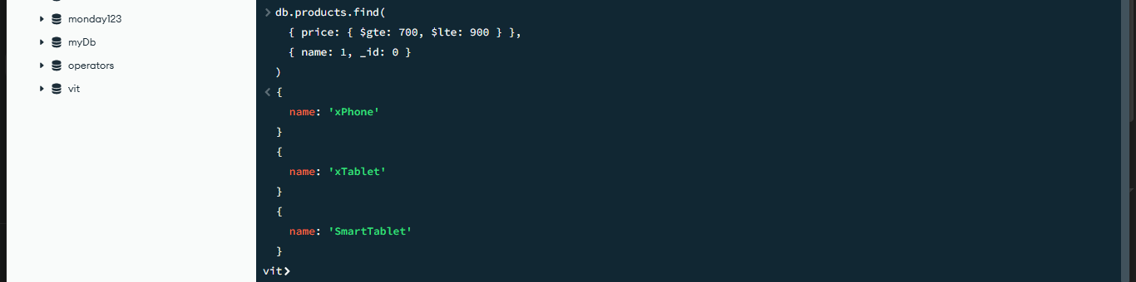

**Eclipse:**

package connection;

import org.bson.Document;

import com.mongodb.client.*;

import com.mongodb.client.model.Filters;

import com.mongodb.client.model.Projections;

import com.mongodb.client.model.Sorts;

public class Create {

public static void main(String[] args) {

MongoClient mongoClient = MongoClients.*create*("mongodb://localhost:27017");

MongoDatabase database = mongoClient.getDatabase("vit");

MongoCollection<Document> productsCollection = database.getCollection("products");

FindIterable<Document> result = productsCollection.find(

Filters.*and*(

Filters.*gte*("price", 700),

Filters.*lte*("price", 900)

))

.sort(Sorts.*descending*("name"))

.projection(Projections.*fields*(

Projections.*include*("name"),

Projections.*excludeId*()

));

for (Document doc : result) {

System.***out***.println(doc.toJson());

}

mongoClient.close();

}

}

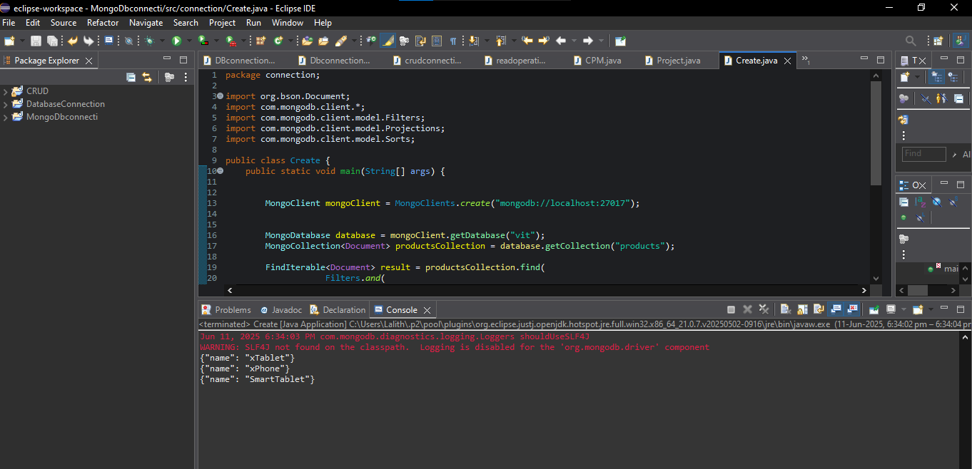

**AGREEGATE FUNCTION(AVG):**

package connection;

import org.bson.Document;

import com.mongodb.client.*;

import static com.mongodb.client.model.Aggregates.*;

import static com.mongodb.client.model.Accumulators.*;

import java.util.Arrays;

public class Create {

public static void main(String[] args) {

MongoClient mongoClient = MongoClients.*create*("mongodb://localhost:27017");

MongoDatabase database = mongoClient.getDatabase("vit");

MongoCollection<Document> productsCollection = database.getCollection("products");

AggregateIterable<Document> result = productsCollection.aggregate(Arrays.*asList*(

*group*(null, *avg*("averagePrice", "$price"))

));

for (Document doc : result) {

System.***out***.println(doc.toJson());

}

mongoClient.close();

}

}

**ECLLIPSE:**

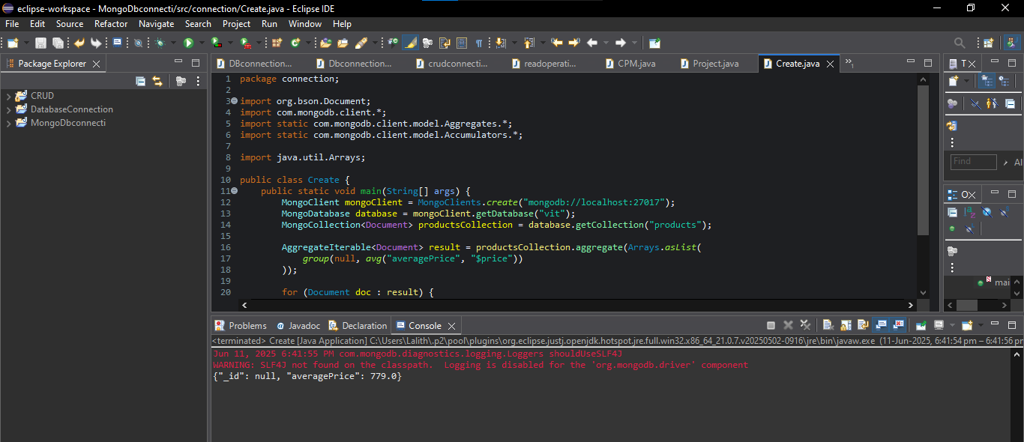

**MONGODB:**

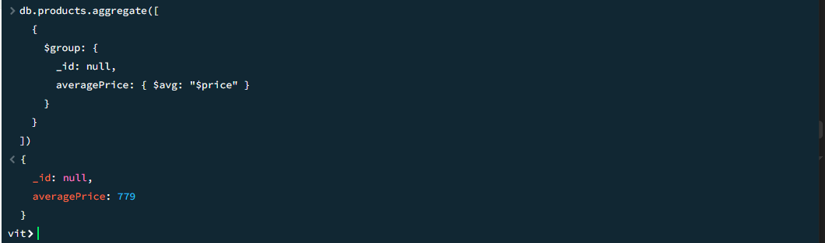

**Items and that contains maximum price:**

**MONGODB:**

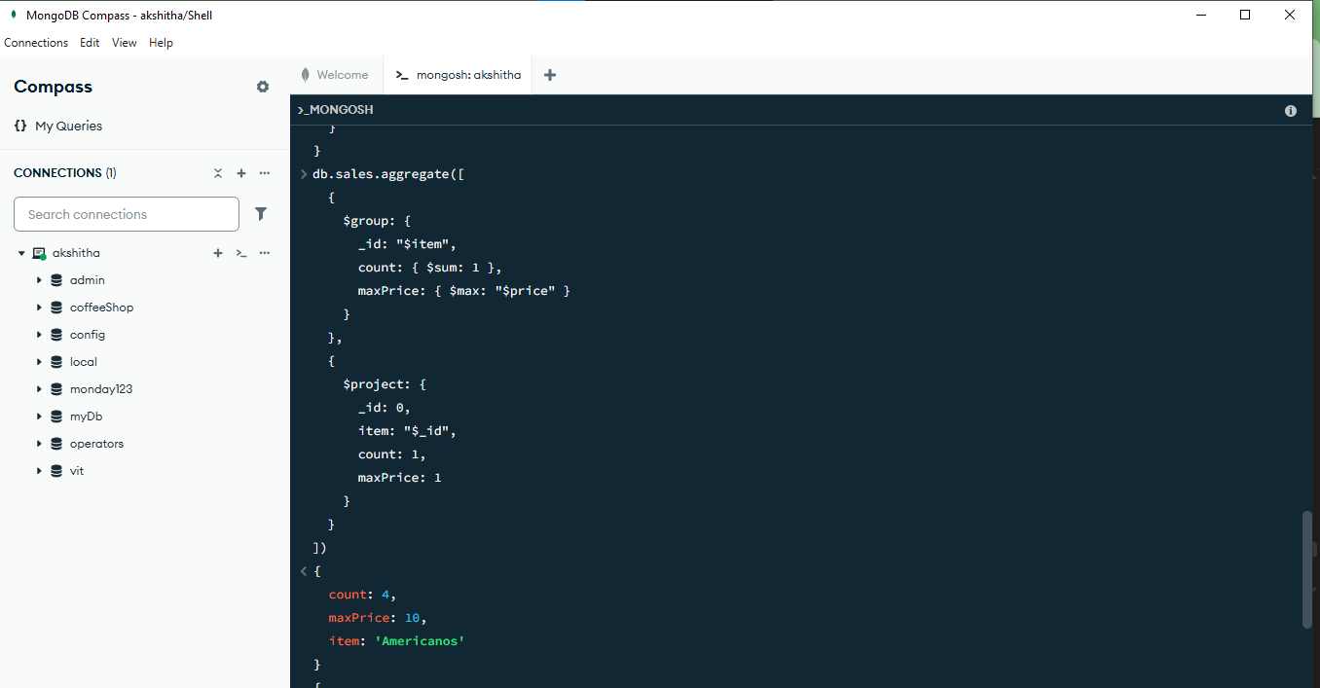

**ECLLIPSE:**

package connection;

import com.mongodb.client.*;

import org.bson.Document;

import java.util.Arrays;

public class Create {

public static void main(String[] args) {

MongoClient mongoClient = MongoClients.*create*("mongodb://localhost:27017");

MongoDatabase database = mongoClient.getDatabase("vit");

MongoCollection<Document> salesCollection = database.getCollection("sales");

AggregateIterable<Document> result = salesCollection.aggregate(Arrays.*asList*(

new Document("$group", new Document("_id", "$item")

.append("count", new Document("$sum", 1))

.append("maxPrice", new Document("$max", "$price"))

),

new Document("$project", new Document("_id", 0)

.append("item", "$_id")

.append("count", 1)

.append("maxPrice", 1)

)

));

for (Document doc : result) {

System.***out***.println(doc.toJson());

}

mongoClient.close();

}

}

