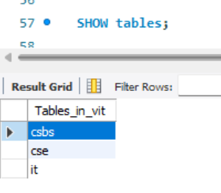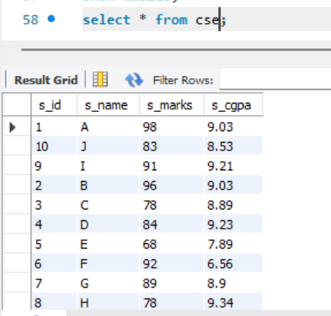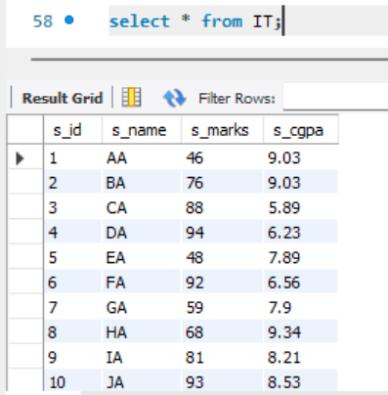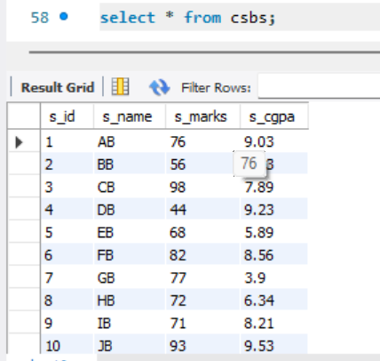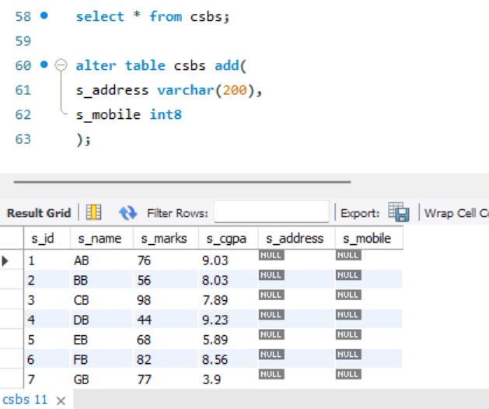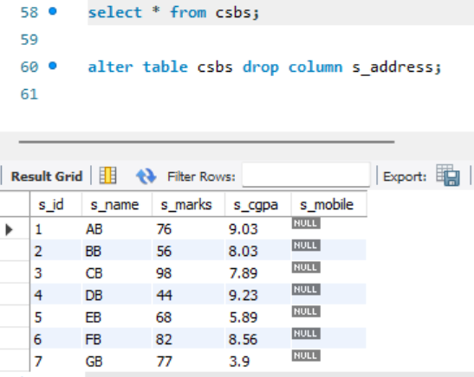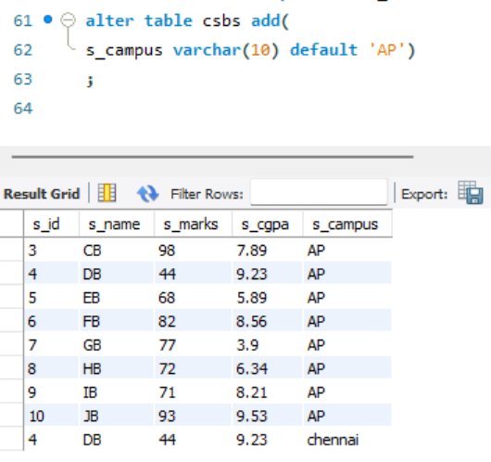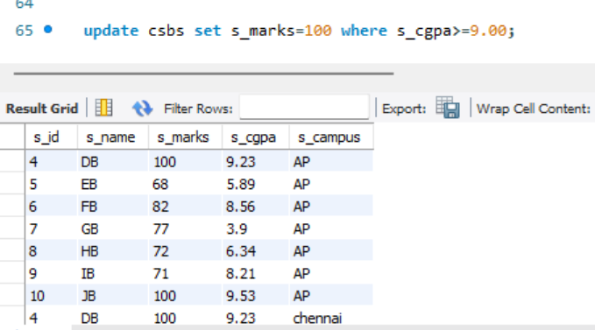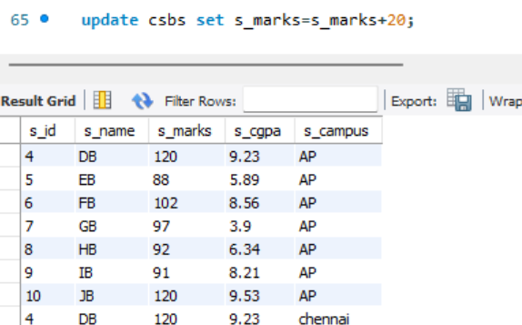show databases;

create database vit;

create table cse(

s_id int,

s_name varchar(40),

s_marks int,

s_cgpa float);

create table IT(

s_id int,

s_name varchar(40),

s_marks int,

s_cgpa float);

create table csbs(

s_id int,

s_name varchar(40),

s_marks int,

s_cgpa float);

use vit;

select * from cse;

show tables;

insert into cse values(2,'B',96,9.03);

insert into cse values(3,'C',78,8.89);

insert into cse values(4,'D',84,9.23);

insert into cse values(5,'E',68,7.89);

insert into cse values(6,'F',92,6.56);

insert into cse values(7,'G',89,8.90);

insert into cse values(8,'H',78,9.34);

insert into cse values(9,'I',91,9.21);

insert into cse values(10,'J',83,8.53);

insert into IT values(1,'AA',46,9.03);

insert into IT values(2,'BA',76,9.03);

insert into IT values(3,'CA',88,5.89);

insert into IT values(4,'DA',94,6.23);

insert into IT values(5,'EA',48,7.89);

insert into IT values(6,'FA',92,6.56);

insert into IT values(7,'GA',59,7.90);

insert into IT values(8,'HA',68,9.34);

insert into IT values(9,'IA',81,8.21);

insert into IT values(10,'JA',93,8.53);

insert into csbs values(1,'AB',76,9.03);

insert into csbs values(2,'BB',56,8.03,'vellore');

insert into csbs values(3,'CB',98,7.89);

insert into csbs values(4,'DB',44,9.23,'chennai');

insert into csbs values(5,'EB',68,5.89);

insert into csbs values(6,'FB',82,8.56);

insert into csbs values(7,'GB',77,3.90);

insert into csbs values(8,'HB',72,6.34);

insert into csbs values(9,'IB',71,8.21);

insert into csbs values(10,'JB',93,9.53);

SHOW tables;

select * from csbs;

alter table csbs drop column s_mobile;

alter table csbs add(

s_campus varchar(10) default 'AP')

;

update csbs set s_marks=s_marks+20;