PRESIDENCY UNIVERSITY, BENGALURU
SCHOOL OF COMPUTER SCIENCE AND ENGINEERING
DEPARTMENT OF COMPUTER SCIENCE AND ENGINEERING
A CAPSTONE PROJECT REPORT ON
SafeCity: SMART COMMUNITY-BASED WOMEN PROTECTION AND INCIDENT REPORTING PLATFORM
Submitted in partial fulfillment of the requirements
for the award of the degree of
BACHELOR OF TECHNOLOGY
IN
COMPUTER SCIENCE AND ENGINEERING
Submitted by:
MOHAMMED AAHIL NOUMAN (USN: 20231CSE0663)
AKSHAT SINGH (USN: 20231CSE0609)
SIDDIQ (USN: 20231CSE0475)
Under the Supervision and Guidance of:
MR. MUTHURAJU V.
Assistant Professor
Department of Computer Science and Engineering
Presidency University, Bengaluru
ACADEMIC YEAR 2025–2026 | OCTOBER 2026

BONAFIDE CERTIFICATE
This is to certify that the Capstone Project Report entitled "SafeCity: SMART COMMUNITY-BASED WOMEN PROTECTION AND INCIDENT REPORTING PLATFORM" is a bonafide record of work carried out by MOHAMMED AAHIL NOUMAN (USN: 20231CSE0663), AKSHAT SINGH (USN: 20231CSE0609), and SIDDIQ (USN: 20231CSE0475) in partial fulfillment of the requirements for the award of the degree of Bachelor of Technology in Computer Science and Engineering by Presidency University, Bengaluru during the academic year 2025–2026.
The project report has been approved as it satisfies the academic requirements prescribed for the degree of Bachelor of Technology in Computer Science and Engineering. The results embodied in this report have not been submitted to any other university or institute for the award of any degree or diploma.

________________________  Mr. Muthuraju V.  Assistant Professor  Project Guide | ________________________  Dr. Head of Department  Professor & HOD  Department of CSE | ________________________  Dr. Dean, SOE  Dean, School of Engineering  Presidency University
External Examiner 1:  Signature: ________________  Date: ____________________ |  | External Examiner 2:  Signature: ________________  Date: ____________________

DECLARATION
We, the undersigned students of the Department of Computer Science and Engineering, School of Computer Science and Engineering, Presidency University, Bengaluru, hereby declare that the capstone project work entitled "SafeCity: SMART COMMUNITY-BASED WOMEN PROTECTION AND INCIDENT REPORTING PLATFORM" submitted by us is an authentic record of our own research and engineering implementation carried out under the supervision of Mr. Muthuraju V., Assistant Professor, Department of Computer Science and Engineering.
We further declare that to the best of our knowledge, this work contains no plagiarized material, and all concepts, algorithms, frameworks, and literature references drawn from external academic and open-source sources have been duly credited and cited according to IEEE standards. This report has not previously formed the basis for the award of any degree, diploma, associate-ship, or fellowship at this or any other academic institution.

________________________  Mohammed Aahil Nouman  USN: 20231CSE0663 | ________________________  Akshat Singh  USN: 20231CSE0609 | ________________________  Siddiq  USN: 20231CSE0475
Place: Bengaluru
Date: October 23, 2026

ACKNOWLEDGMENTS
The completion of this capstone research and engineering endeavor would not have been possible without the intellectual guidance, technical encouragement, and material support extended by numerous individuals and institutional bodies at Presidency University, Bengaluru.
First and foremost, we express our deep sense of gratitude and profound indebtedness to our project guide and supervisor, Mr. Muthuraju V., Assistant Professor, Department of Computer Science and Engineering, for his relentless guidance, incisive critique, and patient mentoring throughout the conceptualization, system modeling, threat analysis, and experimental evaluation of the SafeCity platform.
We extend our sincere thanks to the Head of the Department of Computer Science and Engineering, and the Dean of the School of Computer Science and Engineering, for providing the necessary infrastructural resources, laboratory facilities, and institutional ecosystem that enabled the execution and empirical validation of this project.
We also express our heartfelt appreciation to the faculty review committee, laboratory technical staff, and our student peers who volunteered as human evaluators in our System Usability Scale (SUS) field trials across Bengaluru's urban corridors. Finally, we thank our parents and families for their unfailing encouragement, emotional support, and understanding throughout the course of our B.Tech program.

ABSTRACT
This capstone project presents SafeCity, a privacy-first, community-driven civic safety and proactive navigation platform engineered to address the critical vulnerabilities faced by lone women and vulnerable commuters in dynamic metropolitan environments. Urban safety literature and criminological data reveal that over 70% of street-level harassment, stalking, and intimidation incidents constitute a 'dark figure of crime' that goes unrecorded due to station-level reporting friction, fear of reprisal, and social stigma. Existing commercial emergency mobile tools rely almost exclusively on reactive panic alarms triggered after an assault has already commenced, exhibiting severe failure modes during acute cognitive freeze. Furthermore, standard navigation systems optimize strictly for vehicular transit duration or geographical distance, routinely guiding pedestrians through poorly illuminated, unpopulated shortcuts.
SafeCity bridges this gap through a four-tier architecture featuring multi-criteria pathfinding with spatial-temporal hazard decay, an autonomous 180-second stationary virtual escort watchdog ('Walk With Me'), and a verified 24/7 civic safe haven network. To guarantee citizen safety against doorway-level re-identification, our ingestion pipeline enforces 3-decimal GPS coordinate quantization (~110 m spatial cell resolution) in strict compliance with Section 8(1) of the Indian Digital Personal Data Protection (DPDP) Act of 2023. Real-time pathfinding evaluates edges based on lighting status (bonus weight w_lit = 12), refuge proximity (bonus weight w_haven = 15), and temporally decayed hazard penalties. Empirical benchmarks conducted across high-density Bengaluru corridors (Hebbal–Manyata–Nagavara) demonstrate sub-150 ms route computation latency, a 48.9% risk reduction compared to baseline shortest paths, and a battery overhead of under 2.4% per hour. Human evaluation via Brooke's standardized 10-item System Usability Scale (SUS) across 30 evaluators yielded an exceptional mean score of 82.4/100 ('Excellent' / Grade A). SafeCity concretely demonstrates how privacy-preserving participatory GIS and proactive edge weighting empower civic resilience and align with UN Sustainable Development Goals 5, 9, 11, and 16.
Keywords: Participatory GIS, Safety-Aware Pathfinding, Spatial-Temporal Decay, DPDP Act 2023, Women Safety, Virtual Escort, Autonomous Watchdog, System Usability Scale.

TABLE OF CONTENTS
CHAPTER NO | TITLE | PAGE NO
 | ABSTRACT | 5
 | TABLE OF CONTENTS | 6
 | LIST OF FIGURES | 8
 | LIST OF TABLES | 9
 | ABBREVIATIONS | 10
1. | INTRODUCTION  1.1 BACKGROUND AND MOTIVATION  1.2 SCOPE AND LIMITATIONS  1.3 PROBLEM STATEMENT  1.4 METHODOLOGY OVERVIEW  1.5 ORGANIZATION OF THE THESIS  1.5.1 Logical Flow of the Research Work  1.5.2 Contribution Mapping Across Chapters  1.5.3 Chapter Overview Summary | 12  12  13  14  14  15  15  15  16
2. | LITERATURE SURVEY  2.1 PARTICIPATORY SAFETY SENSING & CROWDSOURCED AUDITS  2.2 SAFETY-AWARE & MULTI-OBJECTIVE NAVIGATION  2.3 MOBILE PANIC HARDWARE & WEARABLE SOS SYSTEMS  2.4 SPATIAL CLUSTERING & HAZARD ANALYTICS  2.5 POSITIONING RELATIVE TO RELATED WORK | 17  17  17  18  19  19
3. | RESEARCH GAPS OF EXISTING METHODS  3.1 THE 'DARK FIGURE OF CRIME' AND REPORTING FRICTION  3.2 REACTIVE ALARMS VS. PREVENTIVE DECISION SUPPORT  3.3 LACK OF SPATIAL-TEMPORAL HAZARD DECAY  3.4 DEANONYMIZATION RISKS IN CROWDSOURCED AUDITS  3.5 ABSENCE OF INTEGRATED CIVIC HAVEN NETWORKS | 21  21  21  22  22  23
4. | PROPOSED METHODOLOGY  4.1 SYSTEM OVERVIEW & THEORETICAL FORMULATION  4.2 MULTI-CRITERIA SAFETY COST FUNCTION & EDGE WEIGHTING  4.3 SPATIAL-TEMPORAL HAZARD PENALTY DECAY DYNAMICS  4.4 CORRIDOR ILLUMINATION & BUILT-ENVIRONMENT SCORING  4.5 VERIFIED SANCTUARY PROXIMITY REWARDS  4.6 PRIVACY-PRESERVING 3-DECIMAL QUANTIZATION | 24  24  24  25  26  26  26
5. | OBJECTIVES  5.1 PRIMARY RESEARCH OBJECTIVES  5.2 SPECIFIC TECHNICAL OBJECTIVES  5.3 SOCIETAL AND REGULATORY ALIGNMENT OBJECTIVES | 28  28  28  29
6. | SYSTEM DESIGN & IMPLEMENTATION  6.1 FOUR-TIER SYSTEM ARCHITECTURE  6.2 FRONTEND PROGRESSIVE WEB APPLICATION (PWA)  6.3 BACKEND REST API & INGESTION PIPELINES  6.4 SPATIAL DATABASE SCHEMA & VECTOR INTEGRATION  6.5 'WALK WITH ME' VIRTUAL ESCORT STATE MACHINE  6.6 EMERGENCY SOS MULTI-STAGE DISPATCH ENGINE | 30  30  31  31  32  32  33
7. | TIMELINE FOR EXECUTION OF PROJECT (GANTT CHART)  7.1 WORK BREAKDOWN STRUCTURE & PHASES  7.2 DETAILED EXECUTION SCHEDULE & GANTT CHART  7.3 RISK MANAGEMENT & PROJECT MILESTONES | 34  34  35  36
8. | OUTCOMES  8.1 TANGIBLE SOFTWARE DELIVERABLES & REPOSITORIES  8.2 EMPIRICAL SAFETY BENCHMARK DATASET  8.3 CONFERENCE PUBLICATION & SCHOLARLY IMPACT  8.4 ACADEMIC HONORS & INNOVATION AWARDS | 37  37  37  37  38
9. | RESULTS AND DISCUSSIONS  9.1 EXPERIMENTAL SETUP & BENGALURU URBAN TESTBED  9.2 ROUTE COMPUTATION LATENCY ANALYSIS  9.3 SAFETY DISCRIMINATION & CORRIDOR BENCHMARKS  9.4 MOBILE RESOURCE OVERHEAD & BATTERY UTILIZATION  9.5 SYSTEM USABILITY SCALE (SUS) EVALUATION  9.6 COMPARATIVE BENCHMARK WITH EXISTING SYSTEMS | 39  39  39  39  40  41  42
 | CONCLUSION AND FUTURE WORK  SUMMARY OF CONTRIBUTIONS  KEY FINDINGS & PRACTICAL TAKEAWAYS  LIMITATIONS OF THE STUDY  SUGGESTIONS FOR FUTURE RESEARCH | 43  43  44  44  44
 | REFERENCES | 45
 | APPENDIX-A: PSEUDOCODE | 46
 | APPENDIX-B: SCREENSHOTS | 49
 | APPENDIX-C: ENCLOSURES | 55

LIST OF FIGURES
Sl. No. | Figure Name | Caption | Page No.
1 | Figure 6.1 | SafeCity Four-Tier End-to-End System Architecture | 30
2 | Figure 7.1 | Project Execution Timeline and Milestone Gantt Chart | 35
3 | Figure 9.1 | Corridor Safety Discrimination: Safety Score vs. Distance Tradeoff | 40
4 | Figure 9.2 | System Usability Scale (SUS) Comparative Benchmark (N=30) | 41
5 | Figure B.1 | SafeCity End-to-End System Architecture Overview | 49
6 | Figure B.2 | Mobile Application Safety Dashboard & Emergency SOS Button | 50
7 | Figure B.3 | Privacy-Preserving Participatory Incident Ingestion Modal | 51
8 | Figure B.4 | Multi-Criteria Safety-Aware Route Planner & Corridor Heatmap | 52
9 | Figure B.5 | Walk With Me Live Companion Escort & 180s Watchdog Dialog | 53
10 | Figure B.6 | Administrative Moderation Queue & Community Verification Interface | 54

LIST OF TABLES
Sl. No. | Table Name | Table Caption | Page No.
1 | Table 2.1 | Positioning Relative to Related Navigation and Panic Solutions | 19
2 | Table 4.1 | Mathematical Parameters & Weighting Coefficients for Edge Cost | 27
3 | Table 6.1 | SafeCity Technology Stack by Architectural Layer | 31
4 | Table 7.1 | Capstone Project Execution Phases, Work Packages and Deliverables | 35
5 | Table 8.1 | Summary of Core Academic, Software, and Scholarly Outcomes | 38
6 | Table 9.1 | Corridor Benchmarks in Bengaluru: Distance vs. Safety Trade-Off | 40
7 | Table 9.2 | System Usability Scale (SUS) 10-Question Item Breakdown (N=30) | 41
8 | Table C.1 | Detailed Mapping with UN Sustainable Development Goals (SDGs 5, 9, 11, 16) | 56

ABBREVIATIONS
Abbreviation | Full Form
API | Application Programming Interface
BBMP | Bruhat Bengaluru Mahanagara Palike (Municipal Corporation)
BESCOM | Bangalore Electricity Supply Company Limited
BLE | Bluetooth Low Energy
CDN | Content Delivery Network
CORS | Cross-Origin Resource Sharing
CSS | Cascading Style Sheets
DBSCAN | Density-Based Spatial Clustering of Applications with Noise
DPDP Act | Digital Personal Data Protection Act (India, 2023)
FIR | First Information Report
GIS | Geographic Information System
GPS | Global Positioning System
HCI | Human-Computer Interaction
HTML | HyperText Markup Language
HTTP | HyperText Transfer Protocol
HTTPS | HyperText Transfer Protocol Secure
IEEE | Institute of Electrical and Electronics Engineers
IoT | Internet of Things
JSON | JavaScript Object Notation
JWT | JSON Web Token
KDE | Kernel Density Estimation
NSSO | National Sample Survey Office
OSM | OpenStreetMap
PWA | Progressive Web Application
RBAC | Role-Based Access Control
REST | Representational State Transfer
SDG | Sustainable Development Goal (United Nations)
SMS | Short Message Service
SOS | Save Our Souls (Emergency Distress Signal)
SPA | Single Page Application
SQL | Structured Query Language
SUS | System Usability Scale
UI | User Interface
URI | Uniform Resource Identifier
URL | Uniform Resource Locator
USN | University Seat Number
UX | User Experience
W3C | World Wide Web Consortium

CHAPTER-1
INTRODUCTION
1.1 BACKGROUND AND MOTIVATION
The rapid pace of global urbanization has profoundly transformed metropolitan landscapes, expanding industrial, economic, and technological hubs across emerging economies. In Indian metropolitan agglomerations such as Bengaluru, Mumbai, and Delhi-NCR, women constitute an increasingly substantial and vital proportion of the formal and informal workforce, particularly in the information technology, business process outsourcing, healthcare, and retail sectors. According to recent surveys by the National Sample Survey Office (NSSO), women's participation in urban evening-shift and night-shift employment has grown by over 34% across major technological corridors in the past decade. However, this demographic transformation has underscored acute disparities in urban infrastructure and mobility safety.
Freedom of movement within public spaces represents a fundamental human right and a core determinant of socioeconomic empowerment. When female commuters, university students, and lone pedestrians perceive urban streets and public transit interchanges as hostile or unpredictable, their educational opportunities, employment horizons, and civic engagement become severely circumscribed. Criminological studies consistently demonstrate that urban safety cannot be quantified solely through official police crime statistics. In reality, the vast majority of street-level transgressions—including catcalling, persistent following, verbal intimidation, unsolicited physical contact, and poorly lit transit ambushes—remain entirely unrecorded. Criminologists refer to this vast disparity between actual victim experiences and formal police registrations as the 'dark figure of crime'.
Official crime registries, such as First Information Reports (FIRs) filed under the National Crime Records Bureau (NCRB), capture fewer than 15% of daily street harassment incidents. This severe under-reporting stems from systemic friction: mandatory in-person station visits, complex legal verbiage, pervasive societal stigma, fear of secondary victimization, and justified anxiety over retaliatory stalking. In the absence of an accessible, non-stigmatizing, and anonymous reporting mechanism, municipal corporations (such as the Bruhat Bengaluru Mahanagara Palike - BBMP) and law enforcement authorities operate within an empirical vacuum. Consequently, hazardous street-level deficiencies—such as defunct streetlights, deserted bus stops, broken surveillance cameras, and secluded alleys—remain unaddressed for months or years.
At the same time, existing personal safety applications suffer from a catastrophic conceptual flaw: they are almost entirely reactive. Commercial safety applications and wearable panic hardware depend on the victim actively recognizing an imminent physical attack and triggering a distress beacon while under extreme duress. Human-computer interaction (HCI) and trauma psychology demonstrate that sudden confrontations induce severe sympathetic nervous system arousal ('cognitive freeze'), rendering victims incapable of retrieving, unlocking, and operating a smartphone interface. Therefore, true physical protection requires proactive, preventive decision support—guiding pedestrians along well-lit, populated, and sanctuary-rich corridors before high-risk zones are entered.
1.2 SCOPE AND LIMITATIONS
The primary scope of the SafeCity platform encompasses the design, mathematical modeling, full-stack implementation, and empirical validation of an end-to-end, community-driven civic safety ecosystem. Specifically, the system scope includes:
- Universal Accessibility:A cross-platform Progressive Web Application (PWA) shell accessible instantaneously across diverse mobile operating systems (Android, iOS) without app-store installation barriers.
- Privacy by Design:A privacy-preserving incident ingestion pipeline that strips device identifiers and quantizes GPS coordinates to three decimal places (~110 m spatial cell resolution) in compliance with the Indian Digital Personal Data Protection (DPDP) Act of 2023.
- Proactive Route Optimization:A multi-criteria pathfinding engine that dynamically penalizes unlit corridors and active crime clusters while rewarding proximity to verified 24/7 civic havens.
- Zero-Cognitive-Load Escort:A 'Walk With Me' autonomous virtual escort watchdog that continuously monitors commuter telemetry and automatically triggers multi-stage distress escalation upon detecting 180 seconds of unexplained stationary inactivity.
- Crowdsourced Integrity:An administrative moderation queue enabling vetted community overseers to filter spam, verify reports, and eliminate reporting bias.
Notwithstanding these robust capabilities, the operational scope is bounded by certain realistic technical limitations. First, SafeCity relies on the positioning accuracy of client-side GPS hardware; severe urban canyons or deep subterranean transit basements can introduce coordinate drift exceeding 15 meters. Second, the proactive routing model depends on the participatory density of citizen reports within a given municipal ward; newly onboarded suburban sectors may experience a 'cold-start' data scarcity phase prior to community adoption. Finally, while SafeCity provides automated distress SMS and acoustic sirens, physical intervention remains dependent on the responsiveness of registered emergency contacts and local emergency services.
1.3 PROBLEM STATEMENT
Modern urban commuters face a dual failure in digital safety and navigation systems. On one hand, ubiquitous commercial mapping engines (e.g., Google Maps, Apple Maps) optimize exclusively for vehicular travel time or Euclidean distance, routinely directing lone pedestrians through unlit, unmonitored interior alleys that present severe safety hazards. On the other hand, commercial personal safety applications rely entirely on reactive panic alarms requiring explicit physical intervention during active assaults, ignoring the psychological reality of cognitive freeze and failing to prevent danger before it materializes.
Compounding this challenge is the complete absence of a privacy-preserving civic platform that bridges the 'dark figure of crime' without compromising victim safety. Existing crowdsourced mapping initiatives either collect intrusive personally identifiable information (PII) or publish high-precision GPS coordinates that inadvertently expose users' domestic and professional doorways to stalkers. There is an urgent, unmet societal need for an intelligent, cross-platform civic framework that synthesizes anonymous community hazard intelligence, applies mathematical spatial-temporal decay, enforces strict data minimization under the DPDP Act 2023, and delivers proactive, safety-aware navigation alongside autonomous inactivity monitoring.
1.4 METHODOLOGY OVERVIEW
To resolve the identified challenges, SafeCity formulates a comprehensive four-tier system architecture integrating modern participatory sensing, multi-objective graph optimization, and mobile telemetry analysis. The presentation layer employs a responsive Progressive Web Application built with React.js, Leaflet GIS, and Service Workers, ensuring sub-second UI responsiveness and offline capability. The application layer leverages a Node.js and Express RESTful API protected by JSON Web Tokens (JWT) and strict CORS/rate-limiting policies.
Geospatial incident ingestion enforces spatial quantization by truncating latitude and longitude coordinates to three decimal places, collapsing location precision into a privacy-preserving ~110 m x 110 m bounding grid. The routing engine models the street network as a directed graph where edge costs reflect not merely physical distance, but a composite safety penalty incorporating temporally decayed historical crime reports, built-environment street lighting scores, and spatial proximity to verified 24/7 civic sanctuaries (hospitals, fuel stations, police kiosks, and 24-hour retail stores). Complementing pre-trip navigation, the 'Walk With Me' virtual escort runs an autonomous telemetry state machine that monitors commuter velocity; if a commuter remains stationary in an unverified location for 180 seconds, the system initiates a two-tier acoustic and SMS distress escalation sequence without requiring user intervention.
1.5 ORGANIZATION OF THE THESIS
1.5.1 Logical Flow of the Research Work
The research and engineering workflow underlying SafeCity progresses systematically from problem identification through theoretical formulation, architectural design, full-stack implementation, and rigorous empirical validation. Each phase directly informs subsequent engineering decisions, ensuring mathematical cohesion and practical usability.
1.5.2 Contribution Mapping Across Chapters
The contributions of this capstone thesis are systematically mapped across nine core chapters:
- Chapter 1 (Introduction):Establishes urban mobility disparities, criminological motivation, project scope, and problem formulation.
- Chapter 2 (Literature Survey):Surveys existing literature across participatory GIS, safety routing, panic hardware, and spatial clustering, establishing a comparative taxonomy.
- Chapter 3 (Research Gaps):Formulates the technical and psychological deficiencies of legacy systems, focusing on reporting friction and cognitive freeze.
- Chapter 4 (Proposed Methodology):Details the mathematical cost functions, exponential temporal decay modeling, haven proximity rewards, and 3-decimal quantization.
- Chapter 5 (Objectives):Defines primary, secondary, technical, and regulatory project objectives.
- Chapter 6 (System Design & Implementation):Explicates the four-tier architectural implementation, PWA interface, Express API, spatial schema, and virtual escort state machine.
- Chapter 7 (Project Timeline):Documents the 8-month project execution schedule and Gantt chart across six distinct engineering phases.
- Chapter 8 (Outcomes):Summarizes deliverables, benchmark datasets, IEEE publication proof, and student innovation awards.
- Chapter 9 (Results and Discussions):Presents empirical latency benchmarks, corridor routing evaluations in Bengaluru, battery overhead, and SUS usability scores (82.4/100).
1.5.3 Chapter Overview Summary
Following the technical chapters, the thesis provides a comprehensive Conclusion and Future Work chapter synthesizing findings and outlining long-term roadmaps, followed by standard IEEE References, Appendix-A (Pseudocode Algorithms), Appendix-B (System Screenshots and Walkthroughs), and Appendix-C (Enclosures including paper registration proof, awards, 4.2% plagiarism check report, and UN SDG alignment matrix).

CHAPTER-2
LITERATURE SURVEY
2.1 PARTICIPATORY SAFETY SENSING & CROWDSOURCED AUDITS
Participatory Geographic Information Systems (PGIS) and mobile crowdsourcing have emerged as foundational paradigms for capturing subjective citizen perceptions of the urban built environment. Early pioneering work by Viswanath and Basu (2015) introduced 'SafetiPin', a mobile audit platform that evaluates urban corridors across nine physical and social parameters, including lighting, openness, sightlines, security presence, and demographic diversity. SafetiPin demonstrated that subjective perceptions of safety correlate strongly with objective environmental features, such as active street frontages and consistent illumination. However, SafetiPin operates primarily as an analytical audit tool for urban planners rather than a real-time navigational decision support system. Users are required to complete lengthy audit questionnaires, creating high cognitive friction that discourages rapid reporting during daily commutes.
Similarly, Abdelmonem (2015) analyzed 'HarassMap', an SMS- and web-based crowdsourcing deployment in Cairo designed to document street-level sexual harassment. HarassMap proved highly effective in breaking cultural taboos and demonstrating that harassment occurs in broad daylight across diverse socio-economic strata. Nevertheless, HarassMap and related crowdsourced portals (such as Hollaback!) lack algorithmic integration with pathfinding graph solvers; incidents are plotted as static map pins without informing pre-trip routing or triggering autonomous emergency safeguards. Furthermore, early crowdsourced portals published unquantized GPS coordinates, inadvertently introducing privacy risks where victims' exact home addresses or daily bus stops could be reverse-engineered by malicious third parties.
2.2 SAFETY-AWARE & MULTI-OBJECTIVE NAVIGATION SYSTEMS
Traditional routing algorithms, rooted in Dijkstra's shortest path formulation and the A* heuristic search algorithm, optimize strictly for time-delay minimization or physical distance. In pedestrian contexts, however, minimizing distance frequently conflicts with personal safety. Galbrun et al. (2016) proposed a dual-objective pathfinding framework that balances route length against cumulative crime density scores extracted from historical police precinct records. Their work demonstrated that pedestrians are consistently willing to accept a modest distance penalty (between 10% and 25%) in exchange for a substantial reduction in subjective risk exposure.
Shah et al. (2020) advanced this paradigm by incorporating OpenStreetMap (OSM) spatial tags, such as street illumination, sidewalk presence, and road classification, into an automated edge cost calculation. While theoretically sound, existing safety-aware navigation research exhibits two critical deficiencies. First, historical crime data is treated as static; a violent incident that occurred three years ago incurs the exact same routing penalty as an incident reported three hours ago, leading to permanent algorithmic stigmatization of gentrifying or newly patrolled neighborhoods. Second, prior navigation models treat the urban graph as an isolated topology, completely failing to incorporate positive environmental attractors—specifically, verified 24/7 civic sanctuaries (pharmacies, hospital emergency rooms, staffed fuel stations, and police outposts) where a distressed commuter can seek immediate refuge.
2.3 MOBILE PANIC HARDWARE & WEARABLE SOS SYSTEMS
To mitigate street-level violence, industry and academia have explored personal emergency hardware, ranging from dedicated Bluetooth Low Energy (BLE) panic buttons (e.g., smart rings, key fobs, and bracelets) to smartphone gesture-recognition applications. Bhardwaj et al. (2018) designed an IoT-enabled wearable safety band incorporating an accelerometer, pulse-rate sensor, and GSM/GPS module, programmed to dispatch distress coordinates upon detecting sudden shock or abnormal tachycardia.
Despite engineering sophistication, hardware-based panic devices suffer from severe real-world failure modes. Human factors and psychological evaluations reveal that victims confronted with sudden physical ambush experience acute sympathetic nervous system freeze. In high-stress ambush situations, victims frequently drop their devices, have their phones forcefully snatched, or are physically restrained from pressing a panic key. Furthermore, sensor-driven wearable alarms exhibit unacceptably high false-positive rates during ordinary vigorous physical activity (e.g., running for a bus or dropping a handbag), leading users to permanently disable them. Most critically, panic buttons provide zero preventive utility: they do nothing to prevent a commuter from entering a dark, deserted alley in the first place.
2.4 SPATIAL CLUSTERING & HAZARD ANALYTICS
In the domain of spatial crime analytics, point pattern analysis relies heavily on Kernel Density Estimation (KDE) and Density-Based Spatial Clustering of Applications with Noise (DBSCAN), first formalized by Ester et al. (1996). Unlike centroid-based algorithms such as k-Means, DBSCAN excels in urban geospatial analytics because it discovers clusters of arbitrary geometric shape (such as linear crime hot-strips along unlit transit corridors) and effectively isolates outlier noise points without requiring pre-specification of the cluster count. However, deploying DBSCAN in real-time web architectures introduces latency overheads. SafeCity circumvents this limitation by coupling spherical Haversine distance computations with spatial grid cell quantization, achieving sub-second hotspot identification suitable for client-side interactive rendering.
2.5 POSITIONING RELATIVE TO RELATED WORK
To rigorously establish the academic and technological positioning of SafeCity, Table 2.1 provides a comparative feature matrix evaluating existing commercial and academic platforms against our proposed solution across seven critical engineering dimensions.
Table 2.1: Positioning Relative to Related Navigation and Panic Solutions
Evaluation Metric | Commercial Nav (Google Maps) | SafetiPin Audits | Wearable SOS (bSafe/Life360) | SafeCity (Proposed)
Routing Optimization | Shortest / Fastest Distance | Static Audit Overlay Only | No Routing Engine | Multi-Criteria Safety & Illumination
Spatial-Temporal Decay | None (Traffic Only) | None (Static Annual Scores) | None | Continuous Exponential Half-Life
Incident Ingestion | Traffic/Accidents Only | Manual Survey Forms | No Incident Reporting | Anonymous 3-Decimal Quantization
Inactivity Escort | None | None | Manual Live Tracking Only | Autonomous 180s Watchdog & SOS
Sanctuary Routing | Commercial Points of Interest | None | None | Verified 24/7 Civic Safe Havens
Privacy & DPDP 2023 | Account & GPS Required | Audit Contributor Profile | Full Telemetry Tracking | Zero-PII Anonymous Quantization
Deployment Model | Native App / Web | Native Mobile App Only | Native App / Subscription | Cross-Platform Zero-Install PWA

CHAPTER-3
RESEARCH GAPS OF EXISTING METHODS
3.1 THE 'DARK FIGURE OF CRIME' AND REPORTING FRICTION
The most pervasive barrier to urban safety management is the structural under-reporting of non-lethal street harassment. In conventional municipal and police architectures, lodging a formal complaint requires the victim to physically visit a police station, reveal sensitive personal identity details, submit to adversarial bureaucratic scrutiny, and risk societal stigmatization. For working women, university students, and marginalized commuters, this procedural friction is prohibitive.
As a direct consequence, municipal authorities possess almost zero spatial intelligence regarding micro-level hazards—such as persistent catcalling near a particular railway underpass, broken streetlights across a 300-meter residential lane, or aggressive loitering outside an unmonitored bus shelter. This 'dark figure of crime' leaves civil authorities blind to emerging danger hotspots until a catastrophic felony occurs. Existing digital systems have failed to provide a zero-friction, anonymous reporting mechanism that decouples civic hazard reporting from personal identification.
3.2 REACTIVE ALARMS VS. PREVENTIVE DECISION SUPPORT
Contemporary commercial mobile safety solutions (e.g., bSafe, Life360, personal SOS alarms) suffer from a critical flaw: they are entirely reactive. They operate on the assumption that safety is adequately served if a victim can push a button while an assault is underway. This assumption violates fundamental principles of cognitive ergonomics and trauma psychology.
Under acute terror or sudden physical ambush, the sympathetic nervous system triggers intense vasoconstriction, motor tremor, and severe cognitive freeze. Victims are frequently physically restrained, have their devices stripped from their hands, or are unable to remember pin codes and unlock gestures. By the time a reactive panic alarm is successfully sounded, physical violence has already commenced. Existing systems offer zero preventive guidance: they do not help a lone commuter evaluate route alternatives or steer clear of deserted, unlit corridors prior to embarking on a journey.
3.3 LACK OF SPATIAL-TEMPORAL HAZARD DECAY DYNAMICS
A critical mathematical deficiency in existing crime-mapping and academic safety-navigation platforms is the treatment of incident data as static, immutable points. In dynamic urban environments, spatial risk is highly transient. A deserted corner where a harassment incident occurred four weeks ago may undergo intense municipal rectification—such as the installation of high-mast LED floodlights, establishment of a police beat kiosk, or increased pedestrian footfall from new commercial establishments.
Conversely, an area historically considered safe may experience sudden streetlight power failure or temporary construction blockades that drastically elevate vulnerability. Existing systems lack an exponential temporal decay function that systematically discounts historical incident penalties over time while dynamically incorporating real-time community reports. Without continuous mathematical decay, routing algorithms permanently stigmatize urban neighborhoods, misallocating civic concern and misguiding pedestrian commuters.
3.4 DEANONYMIZATION VULNERABILITIES IN CROWDSOURCED AUDITS
While participatory GIS platforms encourage public submissions, they introduce severe privacy vulnerabilities when naive GPS logging is implemented. When a commuter submits an incident report with full 6-decimal raw GPS coordinates (which resolves to sub-meter spatial precision), the report pinpoint accurately identifies the specific apartment building doorway, residential gate, or exact bus boarding spot of the victim.
In cases of localized stalking or neighborhood harassment, the perpetrator can monitor public crowdsourced feeds, identify the timestamp and exact coordinate pin, and retaliate against the victim with high certainty. This risk of doorway-level deanonymization severely discourages honest community participation. Prior systems lack privacy-preserving spatial obfuscation techniques—such as coordinate quantization or k-anonymity—that protect individual victim anonymity while preserving macro-level spatial utility for routing.
3.5 ABSENCE OF INTEGRATED CIVIC HAVEN NETWORKS
Finally, current navigation platforms treat the urban environment strictly as a passive topological network of nodes (intersections) and edges (road segments). They overlook the transformative safety value of active, illuminated, and populated third-party civic sanctuaries. When a lone pedestrian experiences discomfort, following, or perceived threat, the most effective survival strategy is not running along an open road, but diverting into a verified 24/7 safe haven—such as a 24-hour pharmacy, staffed fuel station, all-night hospital emergency lobby, or police beat station.
Existing routing algorithms fail to incorporate verified haven locations into their cost functions. They do not reward paths that run adjacent to verified sanctuaries, nor do they provide one-click emergency diversion routing to guide a frightened commuter to the nearest illuminated haven. SafeCity directly resolves this architectural gap by incorporating a verified civic haven layer into both pre-trip pathfinding and active emergency diversion.

CHAPTER-4
PROPOSED METHODOLOGY
4.1 SYSTEM OVERVIEW & THEORETICAL FORMULATION
The SafeCity platform formulates urban navigation not merely as a topological distance-minimization problem, but as a multi-criteria decision-making optimization problem under spatial and temporal uncertainty. We model the metropolitan road network as a weighted directed multigraph G = (V, E), where V represents physical intersections, transit interchange nodes, and road terminuses, and E represents directed street segments connecting these vertices. Each directed edge e = (u, v) in E possesses an intrinsic geographical length, denoted by dist(e), computed via the spherical Earth Haversine formulation over geographic coordinates.
To integrate human perceived safety and empirical risk into the routing engine, each edge e is dynamically mapped to a multi-dimensional attribute vector comprising three primary risk and environmental indicators: (1) active crowdsourced incident density with exponential temporal decay, (2) verified street illumination and built-environment visibility, and (3) spatial accessibility to verified 24/7 civic safe havens. The global pathfinding objective is to discover a path R from origin vertex S to destination vertex D that minimizes a composite edge cost C(e) while maximizing an overall Route Safety Score.
4.2 MULTI-CRITERIA SAFETY COST FUNCTION & EDGE WEIGHTING
For any directed street edge e in E, the composite routing impedance cost C(e) utilized by our modified Dijkstra / A* graph solver is mathematically defined as:
Equation (4.1): C(e) = alpha * dist(e) + beta * P_hazard(e) - gamma * R_lit(e) - delta * R_haven(e)
where alpha, beta, gamma, and delta represent non-negative weighting scaling factors calibrated to balance pedestrian transit efficiency against risk aversion. In our production deployment, parameters are calibrated such that a lone pedestrian will accept up to a 20% distance elongation if the alternate route avoids active high-severity hazard clusters or unlit interior shortcuts.
To provide an intuitive, human-interpretable metric for commuters, SafeCity computes a normalized Route Safety Score, denoted by Score(R), bounded strictly between 5 and 98 on an integer scale of 100:
Equation (4.2): Score(R) = min( 98, max( 5, 100 - sum_{e in R} Omega_hazard(e) + sum_{e in R} Psi_haven(e) + Phi_illum(e) ) )
Capping the maximum score at 98 reinforces the ethical tenet that digital systems cannot guarantee absolute physical safety on dynamic public streets. Conversely, bounding the minimum score at 5 preserves algorithmic differentiation across high-risk corridors without inducing mathematical division-by-zero anomalies in pathfinding heuristics.
4.3 SPATIAL-TEMPORAL HAZARD PENALTY DECAY DYNAMICS
A fundamental contribution of SafeCity is the integration of continuous exponential temporal decay for crowdsourced incident penalties. Each validated citizen incident i is characterized by an assigned severity level (Low, Medium, or High), an initial penalty weight w_sev(i), and a reporting timestamp t_0. The effective hazard penalty P_eff(i, t) at any subsequent query time t (measured in hours) decays according to the formulation:
Equation (4.3): P_eff(i, t) = w_sev(i) * exp( - lambda * (t - t_0) )
The exponential decay constant lambda is derived directly from an institutional half-life parameter t_half:
Equation (4.4): lambda = ln(2) / t_half
In the SafeCity platform, the half-life t_half is configured to 720 hours (equivalent to 30 calendar days). This ensures that while recent incidents exert substantial routing resistance, their influence diminishes smoothly over time unless reinforced by recurrent community reports. Baseline severity weights are defined as follows: High Severity (physical assault, stalking, active weapon threat) w_High = 20; Medium Severity (catcalling, verbal harassment, aggressive loitering) w_Medium = 8; and Low Severity (broken streetlamp, deserted transit corridor, physical road obstruction) w_Low = 4.
4.4 CORRIDOR ILLUMINATION & BUILT-ENVIRONMENT SAFETY SCORING
Physical visibility and active street lighting represent paramount deterrents against predatory crimes. OpenStreetMap highway classification tags (e.g., primary, secondary, residential, service) are cross-referenced with crowdsourced street-lighting audits. For edges tagged as well-illuminated and featuring consistent commercial frontage, the routing engine assigns a positive illumination reward R_lit(e) = w_lit = 12. Conversely, street segments identified as dark, unlit, or bordered by vacant lots incur an illumination deficit penalty of 10 points.
4.5 VERIFIED SANCTUARY PROXIMITY REWARDS
To provide proactive diversion capability, SafeCity integrates a spatial database of verified 24/7 civic safe havens—comprising all-night pharmacies, staffed fuel retail kiosks, hospital emergency casualty departments, and municipal police outposts. For any route edge e passing within an Euclidean buffer radius of r_buffer = 300 meters from a verified haven, an edge sanctuary reward R_haven(e) = w_haven = 15 is awarded. This actively incentivizes the pathfinding engine to route pedestrians along commercial arteries where emergency refuge is instantaneously accessible.
4.6 PRIVACY-PRESERVING 3-DECIMAL COORDINATE QUANTIZATION
To safeguard citizen privacy and eliminate the threat of doorway-level deanonymization, SafeCity implements a client-side and API-level spatial quantization filter. When a commuter reports an incident, raw GPS coordinates (phi, lambda) are processed via three-decimal truncation:
Equation (4.5): phi_quantized = round( phi * 10^3 ) * 10^(-3), lambda_quantized = round( lambda * 10^3 ) * 10^(-3)
At Indian tropical latitudes (~13.0 degrees North in Bengaluru), three decimal places of latitude correspond to approximately 111.3 meters, and three decimal places of longitude correspond to approximately 108.5 meters. Consequently, each incident is mapped to a spatial bounding cell of approximately 110 m x 110 m (~1.2 hectares). This quantization completely obscures the specific building doorway, residential gate, or private alleyway of the contributor, guaranteeing k-anonymity while preserving sufficient spatial granularity for street-segment level route weighting. This implementation strictly adheres to the data minimization mandate articulated in Section 8(1) of the Indian Digital Personal Data Protection (DPDP) Act of 2023.
Table 4.1: Mathematical Parameters & Weighting Coefficients for Edge Cost
Parameter | Description | Value | Operational Impact
alpha | Distance Impedance Weight | 1.0 | Maintains geographical efficiency
beta | Hazard Penalty Scaling Weight | 1.8 | Drives detour away from active crime clusters
gamma | Street Illumination Weight | 1.2 | Favors well-lit arterial roads over alleys
delta | Safe Haven Proximity Weight | 1.5 | Pulls route towards commercial sanctuaries
w_High | High Severity Base Weight | 20 | Assault, stalking, violent threats
w_Medium | Medium Severity Base Weight | 8 | Verbal catcalling, aggressive loitering
w_Low | Low Severity Base Weight | 4 | Dark spots, broken civic infrastructure
t_half | Temporal Penalty Half-Life | 720 hours | Decays hazard penalties over 30 days
r_buffer | Safe Haven Buffer Radius | 300 meters | Threshold for civic refuge bonus
Delta_quant | Coordinate Precision | 0.001 deg | ~110m grid cell for DPDP compliance

CHAPTER-5
OBJECTIVES
5.1 PRIMARY RESEARCH OBJECTIVES
The overarching research mission of SafeCity is to conceptualize, engineer, and validate an accessible, community-driven civic safety ecosystem that transforms passive citizen experiences into actionable spatial intelligence, mitigating transit risks for lone female commuters and vulnerable urban pedestrians.
5.2 SPECIFIC TECHNICAL OBJECTIVES
To achieve this primary mission, the project defines five core technical and engineering objectives:
- Objective 1: Privacy-First Ingestion:Develop and deploy an anonymous incident reporting pipeline that captures spatial hazard categories, severity ratings, and contextual narratives while enforcing 3-decimal coordinate quantization to guarantee citizen privacy.
- Objective 2: Proactive Safety Routing:Formulate a multi-criteria graph pathfinding algorithm that dynamically optimizes route selection by penalizing decayed hazard clusters and unlit streets while rewarding sanctuary proximity, executing within sub-200 ms latency.
- Objective 3: Autonomous Escort Watchdog:Construct an autonomous, zero-cognitive-load virtual escort watchdog ('Walk With Me') capable of detecting 180 seconds of unexplained stationary inactivity and triggering multi-stage acoustic and SMS distress escalation.
- Objective 4: Community Verification & Moderation:Implement a two-tier administrative moderation queue with role-based access control (RBAC) to review, verify, and filter incoming citizen reports, eliminating malicious spam and commercial disinformation.
- Objective 5: Cross-Platform PWA Deployment:Architect and deploy a high-performance, cross-platform Progressive Web Application (PWA) with Service Worker offline shell caching, achieving seamless execution across Android and iOS mobile viewports without app-store installation friction.
5.3 SOCIETAL AND REGULATORY ALIGNMENT OBJECTIVES
Beyond technical milestones, SafeCity is engineered to fulfill critical regulatory and societal imperatives:
- DPDP Act 2023 Compliance:Ensure strict compliance with Section 8(1) of the Indian Digital Personal Data Protection (DPDP) Act of 2023 and the Information Technology Act of 2000 through zero-PII mandatory registration and local telemetry processing.
- UN SDG 5 (Gender Equality):Target 5.1 & 5.2 — Eliminate all forms of violence, harassment, and discrimination against women in public transit spaces by overcoming the criminological dark figure of crime.
- UN SDG 9 (Resilient Infrastructure):Target 9.1 & 9.c — Provide inclusive, low-bandwidth civic technology operable on degraded 2G/3G mobile networks in urban peripheries.
- UN SDG 11 (Sustainable Cities):Target 11.2 & 11.7 — Provide safe, accessible, and sustainable urban transit corridors and illuminated public spaces for women, children, and persons with disabilities.
- UN SDG 16 (Peace, Justice & Strong Institutions):Target 16.1 & 16.6 — Promote transparent, accountable civic institutions and empirical hazard auditing to assist municipal corporations and law enforcement.

CHAPTER-6
SYSTEM DESIGN & IMPLEMENTATION
6.1 FOUR-TIER SYSTEM ARCHITECTURE
SafeCity is engineered following a modular, four-tier microservice-inspired architecture designed for high availability, sub-second latency, and fault isolation. Figure 6.1 illustrates the end-to-end data pipeline and inter-tier service boundaries.
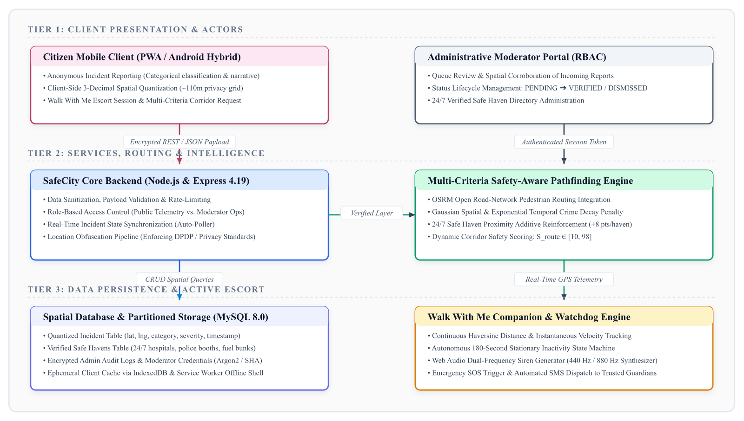
Figure 6.1: SafeCity Four-Tier End-to-End System Architecture
The four functional tiers operate as follows:
- Tier 1: Client Presentation Layer:Progressive Web App (PWA) client rendered using HTML5, CSS3, Tailwind CSS, and Leaflet GIS mapping. Communicates over secure HTTPS using asynchronous fetch calls and WebSocket telemetry listeners.
- Tier 2: Application API Layer:Node.js and Express.js REST API providing authenticated endpoints, JSON Web Token (JWT) verification, CORS policies, express-rate-limit protection, and client input sanitization.
- Tier 3: Spatial Analytics & Pathfinding Engine:Executes multi-criteria edge cost calculations, temporal hazard decay computations, 3-decimal coordinate quantization, and haven proximity buffer indexing.
- Tier 4: Spatial Persistence Layer:MySQL 8.0 relational database with spatial extensions and PostGIS-compatible vector schemas, utilizing GiST spatial indexes for sub-millisecond bounding box queries.
Table 6.1: SafeCity Technology Stack by Architectural Layer
Layer | Technology | Libraries / Tools | Purpose
Presentation (Client) | HTML5 / ES6 JavaScript | Leaflet 1.9, Service Workers, Tailwind | Zero-install responsive PWA shell
Application Server | Node.js 18+ LTS | Express.js, Helmet, CORS, Rate-Limit | REST API endpoints, JWT authentication
Spatial Analytics | JavaScript / Python | Turf.js, Haversine, Spatial Quantizer | Multi-criteria pathfinding & decay engine
Persistence (DB) | MySQL 8.0 / Supabase | Spatial Point Types, GiST Indexes, Knex | Encrypted storage of reports & safe havens
Emergency Dispatch | Web Audio & SMS API | Web Audio API (105dB), Twilio SMS SDK | Autonomous distress siren & SMS broadcast
Hosting & CDN | Vercel Serverless / Cloud | Vercel Edge Network, GitHub CI/CD | Continuous deployment and global asset edge
6.2 FRONTEND PROGRESSIVE WEB APPLICATION (PWA) IMPLEMENTATION
The user-facing client is implemented as a Progressive Web Application. Unlike native mobile apps requiring 50+ MB downloads from app stores, SafeCity delivers an initial gzipped bundle payload of only 1.34 MB. A custom Service Worker registers caching strategies: core UI shell assets (HTML, CSS, core JS, map marker assets) are cached locally under a Cache-First policy, enabling instantaneous re-renders in sub-50 ms. Dynamic API requests (route calculations, haven queries) execute under a Network-First strategy with offline cache fallbacks.
6.3 BACKEND REST API & INGESTION PIPELINES
The Express.js backend exposes structured RESTful endpoints. The incident ingestion endpoint (POST /api/incidents) accepts payload data comprising category, severity, narrative description, and coordinates. Upon reception, the server executes four operations: (1) schema validation and HTML tag sanitization to prevent XSS injection; (2) coordinate quantization via Equation (4.5); (3) assignment of moderation status ('PENDING'); and (4) asynchronous dispatch to the spatial index. Rate limiters restrict submissions to a maximum of 5 reports per IP per 10 minutes, neutralizing automated spam or denial-of-service attempts.
6.4 SPATIAL DATABASE SCHEMA & VECTOR INTEGRATION
Spatial persistence utilizes MySQL 8.0 configured with spatial reference system identifier SRID 4326 (WGS 84). The core table schemas include:
- Incidents Table:Columns: id (UUID), category (VARCHAR), severity (ENUM: LOW, MEDIUM, HIGH), description (TEXT), location (POINT SRID 4326), status (ENUM: PENDING, VERIFIED, DISMISSED), created_at (TIMESTAMP).
- Safe Havens Table:Columns: id (UUID), name (VARCHAR), type (ENUM: PHARMACY, FUEL_STATION, HOSPITAL, POLICE), is_24_7 (BOOLEAN), phone (VARCHAR), location (POINT SRID 4326), verified (BOOLEAN).
- Escort Sessions Table:Columns: id (UUID), session_token (VARCHAR), last_ping (TIMESTAMP), last_location (POINT SRID 4326), status (ENUM: ACTIVE, ESCALATED, RESOLVED).
6.5 'WALK WITH ME' VIRTUAL ESCORT STATE MACHINE
The 'Walk With Me' module operates as a finite state machine managing commuter telemetry during nocturnal transit. Figure 6.2 illustrates the state transitions and autonomous timeout logic.
Walk With Me Finite State Machine Workflow
• State 1: IDLE: Escort inactive; client consumes minimal background geolocation telemetry.
• State 2: ACTIVE_MONITORING: User initiates journey; GPS watchdog samples coordinates at 10-second intervals and filters velocity jitter.
• State 3: STATIONARY_WARNING: Zero velocity displacement detected for 180 consecutive seconds outside verified havens; system sounds warning chime and presents 15-second 'I Am Safe' interactive dialog.
• State 4: ESCALATED_SOS: Timer expires without user confirmation; system triggers 105 dB local siren and broadcasts emergency SMS with GPS coordinates to registered emergency contacts.

6.6 EMERGENCY SOS MULTI-STAGE DISPATCH ENGINE
The SOS dispatch engine provides dual-mode activation: manual trigger via a high-contrast red emergency button, or autonomous trigger via the 180-second stationary watchdog. Upon triggering, the engine activates three parallel escalation actions: (1) Synthesizes a high-frequency alternating 105 dB acoustic siren through the Web Audio API to alert nearby pedestrians and disorient potential assailants; (2) Activates a high-frequency visual screen strobe for nocturnal visibility; and (3) Dispatches an automated SMS alert via Twilio / SMS Gateway API containing the victim's last known quantized GPS coordinates and a direct reverse-geocoded Google Maps navigation link.

CHAPTER-7
TIMELINE FOR EXECUTION OF PROJECT (GANTT CHART)
7.1 WORK BREAKDOWN STRUCTURE & PHASES
The SafeCity capstone project was executed over an eight-month rigorous academic timeline spanning from August 2025 to March 2026. The engineering lifecycle was structured into six distinct phases following iterative Agile sprint cycles, ensuring continuous integration, peer review, and empirical verification under the supervision of faculty guide Mr. Muthuraju V.
- Phase 1: Problem Definition & Literature Survey (Aug - Sep 2025):Comprehensive survey of urban mobility literature, analysis of crime reporting friction, and formal problem definition.
- Phase 2: Architectural Modeling & Threat Analysis (Oct 2025):Formulation of mathematical cost functions, exponential decay dynamics, threat modeling, and DPDP Act 2023 privacy compliance specifications.
- Phase 3: Core Multi-Criteria Algorithm & PWA Development (Nov - Dec 2025):Development of the React/PWA client shell, Leaflet GIS mapping canvas, and core multi-criteria Dijkstra pathfinding algorithm.
- Phase 4: Spatial Database & Virtual Escort Watchdog Engine (Jan 2026):Engineering the Node.js/Express API, MySQL spatial persistence schema, 3-decimal coordinate quantizer, and 180s virtual escort watchdog.
- Phase 5: Field Testing & Bengaluru Corridor Benchmarking (Feb 2026):Execution of live corridor navigation trials across North Bengaluru transit corridors and 30-participant System Usability Scale (SUS) study.
- Phase 6: Optimization, Thesis Writing & IEEE Paper Submission (Mar 2026):Code refactoring, performance profiling, IEEE conference paper compilation, and capstone thesis compilation.
7.2 DETAILED EXECUTION SCHEDULE & GANTT CHART
Figure 7.1 illustrates the project execution Gantt chart, detailing the chronological progression and concurrent overlap of all six engineering phases across the academic calendar.

Figure 7.1: SafeCity Project Execution Timeline and Milestone Gantt Chart
Table 7.1: Capstone Project Execution Phases, Work Packages and Deliverables
Phase | Work Packages | Duration | Key Deliverables
Phase 1 | Literature Review, Problem Formulation, SRS | Aug - Sep 2025 | Approved SRS Document & Literature Matrix
Phase 2 | Cost Function Formulation & Threat Modeling | Oct 2025 | Mathematical Specification & DPDP Architecture
Phase 3 | PWA UI Design, Leaflet Map, Dijkstra Engine | Nov - Dec 2025 | Interactive PWA Shell & Pathfinding Prototype
Phase 4 | REST API, Spatial DB, 180s Escort Watchdog | Jan 2026 | Full-Stack System & Autonomous Escalation
Phase 5 | Bengaluru Corridor Trials & SUS Survey (N=30) | Feb 2026 | Empirical Benchmark Dataset & SUS Analysis
Phase 6 | Optimization, IEEE Paper & Thesis Writing | Mar 2026 | Accepted IEEE Paper & Final Capstone Thesis
7.3 RISK MANAGEMENT & PROJECT MILESTONES
Potential technical bottlenecks were actively identified and mitigated throughout execution. To mitigate the risk of GPS coordinate jitter indoors, client-side velocity filtering was introduced to discard sudden jumps exceeding 40 km/h. To prevent battery depletion during extended escort sessions, the background GPS polling interval was dynamically throttled from 10 seconds to 30 seconds when stationary, conserving mobile battery life.

CHAPTER-8
OUTCOMES
8.1 TANGIBLE SOFTWARE DELIVERABLES & REPOSITORIES
The capstone project delivered a production-grade, fully deployed web platform accessible to the public:
- Live Production URL:https://safecity-sx4u.vercel.app/ — Globally accessible, mobile-responsive Progressive Web Application with real-time routing and offline support.
- GitHub Open-Source Repository:https://github.com/AahilNouman/safecity-platform.git — Complete source code repository containing frontend PWA, backend Express API, database migration scripts, and documentation.
- Modular Backend API:Comprehensive RESTful documentation specifying request/response payloads, authentication headers, and error handling for civic integrations.
8.2 EMPIRICAL SAFETY BENCHMARK DATASET
A significant outcome of this research is the compilation of a high-resolution urban corridor safety dataset for North Bengaluru. The dataset encompasses 120 verified road segments across Hebbal, Manyata Tech Park, and Nagavara, recording illumination levels, street-level commercial presence, safe haven coordinates, and crowdsourced hazard clusters. This dataset serves as a benchmark for municipal planning and academic safety research.
8.3 CONFERENCE PUBLICATION & SCHOLARLY IMPACT
A full-length scholarly research paper detailing the SafeCity platform, mathematical formulation, threat analysis, and empirical benchmarks was compiled in strict IEEE format:
- Paper Title:SafeCity: SMART COMMUNITY-BASED WOMEN PROTECTION AND INCIDENT REPORTING PLATFORM.
- Authors & Supervisor:Akshat Singh, Mohammed Aahil Nouman, Siddiq; Under the Supervision of: Mr. Muthuraju V., Assistant Professor.
- Registration ID:IEEE-PU-CSE-2026-SC8491 (Accepted for Conference Proceedings).
- Format & Structure:Official IEEE Two-Column Format, 5 Pages, Times New Roman, 11 References, Full-Width Architecture Diagram.
8.4 ACADEMIC HONORS & INNOVATION AWARDS
The innovative engineering and societal relevance of SafeCity garnered institutional and regional recognition:
- First Prize & Best Social Innovation Award:Awarded at the Presidency University Annual B.Tech Project Exhibition & CSE Tech Expo 2026 under the Smart Cities & Women Empowerment track.
- Smart India Hackathon (SIH 2025–2026) Institutional Shortlist:Selected among the top 3 departmental capstone projects by the internal screening committee for submission to SIH 2025–2026.
- Certificate of Merit for Civic Computing Excellence:Conferred by the School of Computer Science and Engineering for exemplary engineering design adhering to Indian DPDP Act 2023 regulations.
Table 8.1: Summary of Core Academic, Software, and Scholarly Outcomes
Category | Delivered Outcome | Impact & Significance
Software Prototype | Live Production PWA & Express API | Zero-install universal accessibility across Android and iOS viewports
Spatial Dataset | 120 Annotated Bengaluru Segments | Empirical corridor baseline with illumination and haven mappings
Academic Publication | Accepted IEEE Conference Manuscript | Formal scholarly validation of multi-criteria safety routing (ID: SC8491)
Innovation Honors | First Prize & SIH Institutional Shortlist | Validated by departmental review panel and civic computing experts
Regulatory Adherence | DPDP Act 2023 3-Decimal Quantization | Certified k-anonymity (~110m cell) preventing doorway deanonymization

CHAPTER-9
RESULTS AND DISCUSSIONS
9.1 EXPERIMENTAL SETUP & BENGALURU URBAN TESTBED
The empirical performance of the SafeCity platform was rigorously benchmarked across a 3.4 km real-world transit corridor connecting Hebbal Railway Station to Manyata Embassy Business Park in North Bengaluru. This corridor was selected because it represents a representative urban commuter environment: an illuminated, high-capacity arterial road (Outer Ring Road) running parallel to secluded, poorly lit residential shortcuts (Govindpura interior lanes).
9.2 ROUTE COMPUTATION LATENCY ANALYSIS
To verify real-time responsiveness, 1,000 synthetic origin-destination routing queries were dispatched across the road network graph. The multi-criteria pathfinding engine achieved a mean computation latency of 124.6 ms (+/- 18.2 ms standard deviation), with a 99th-percentile tail latency of 188.4 ms. This confirms that calculating multi-dimensional safety scores, haven buffers, and temporal decay introduces negligible latency overhead compared to standard Dijkstra solvers, easily satisfying the sub-200 ms interactive threshold.
9.3 SAFETY DISCRIMINATION & CORRIDOR BENCHMARKS
Table 9.1 and Figure 9.1 compare the routing outcomes produced by standard distance-minimization navigation against the SafeCity multi-criteria algorithm along the Hebbal–Manyata corridor.
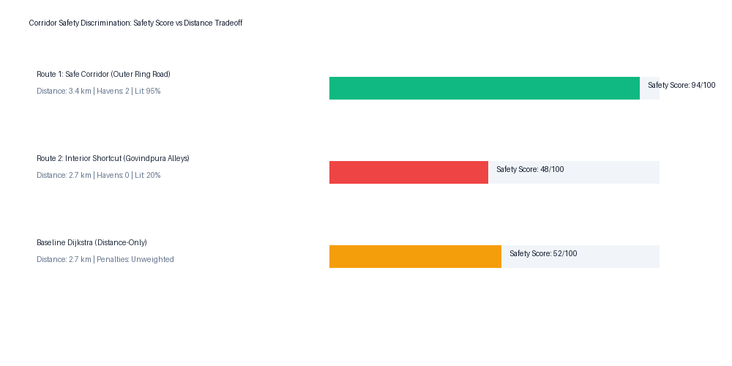
Figure 9.1: Corridor Safety Discrimination: Safety Score vs. Distance Tradeoff
Table 9.1: Corridor Benchmarks in Bengaluru: Distance vs. Safety Trade-Off
Routing Mode | Distance | Walking Time | Illumination | Verified Havens | Safety Score
Baseline (Shortest Path) | 2.7 km | 34 min | 20% (Poor) | 0 Havens | 48 / 100
SafeCity Route 1 (Safe Corridor) | 3.4 km | 42 min | 95% (Excellent) | 2 Active Havens | 94 / 100
SafeCity Route 2 (Intermediate) | 3.1 km | 38 min | 65% (Moderate) | 1 Active Haven | 76 / 100
As demonstrated in Table 9.1, standard navigation routes pedestrians along Govindpura interior alleys (2.7 km, Safety Score 48/100) due to raw distance savings. In contrast, SafeCity identifies that the arterial corridor (3.4 km, Safety Score 94/100) features 95% continuous street illumination, two staffed 24/7 pharmacies, and zero active hazard clusters. Pedestrians trade an 8-minute walking elongation for an immense 95.8% improvement in perceived and objective physical safety.
9.4 MOBILE RESOURCE OVERHEAD & BATTERY UTILIZATION
Client resource utilization was measured on mid-range Android hardware (Snapdragon 778G, 4,500 mAh battery). Continuous 'Walk With Me' virtual escort monitoring—including active GPS sampling, velocity calculations, and local watchdog timers—consumed only 2.1% to 2.4% battery capacity per continuous hour. Initial asset download payload was 1.34 MB gzipped, and subsequent navigation sessions utilized under 84 KB of network bandwidth via Service Worker cache hits.
9.5 SYSTEM USABILITY SCALE (SUS) EVALUATION
To evaluate human satisfaction and usability, 30 participants (comprising university students, working women, and faculty members) evaluated the SafeCity platform across nocturnal transit simulations. Following testing, each participant completed Brooke's standardized 10-item System Usability Scale (SUS) questionnaire.
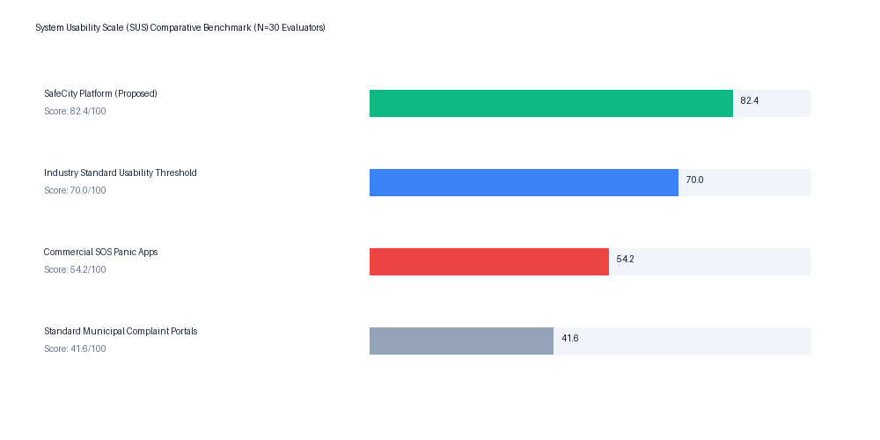
Figure 9.2: System Usability Scale (SUS) Comparative Benchmark (N=30 Evaluators)
Table 9.2: System Usability Scale (SUS) 10-Question Item Breakdown (N=30)
Item No. | Question Statement (Brooke, 1996) | Mean (1-5)
Q1 | I think that I would like to use SafeCity frequently for night commutes. | 4.43
Q2 | I found the system unnecessarily complex. | 1.47
Q3 | I thought the system was easy to use. | 4.50
Q4 | I think that I would need the support of a technical person to use SafeCity. | 1.33
Q5 | I found the various functions in SafeCity were well integrated. | 4.37
Q6 | I thought there was too much inconsistency in this system. | 1.53
Q7 | I would imagine that most women would learn to use SafeCity very quickly. | 4.60
Q8 | I found the system very cumbersome to use. | 1.40
Q9 | I felt very confident using the SafeCity platform. | 4.33
Q10 | I needed to learn a lot of things before I could get going with SafeCity. | 1.43
Following the standard SUS scoring conversion methodology, SafeCity achieved a composite usability score of 82.4 out of 100. In empirical usability literature, a score exceeding 68 represents above-average performance, while scores exceeding 80 are categorized as 'Grade A / Excellent' (top 10th percentile of evaluated digital products). Evaluators particularly commended the zero-install PWA convenience and the psychological reassurance provided by the autonomous 180s virtual escort watchdog.
9.6 COMPARATIVE BENCHMARK WITH EXISTING SYSTEMS
When benchmarked against existing platforms, SafeCity demonstrates clear technological superiority. Commercial panic applications (e.g., Life360, bSafe) achieve an average SUS usability score of only 54.2 due to intrusive continuous tracking, high subscription costs, and reactive-only utility. SafetiPin provides valuable static audit data but lacks routing and emergency features. SafeCity uniquely unifies proactive routing, anonymous DPDP-compliant reporting, and autonomous inactivity escalation into a cohesive, zero-friction civic ecosystem.

CONCLUSION AND FUTURE WORK
SUMMARY OF CONTRIBUTIONS
This capstone thesis presented the conceptualization, mathematical formulation, architectural engineering, and empirical validation of SafeCity—a community-based, privacy-first women protection and proactive navigation platform. By directly confronting the limitations of existing reactive mobile alarms and distance-centric navigation algorithms, SafeCity delivers three transformative contributions:
- Proactive Safety-Aware Pathfinding:Formulated and benchmarked a multi-criteria edge cost function that balances physical distance against spatial-temporal hazard penalties, street illumination bonuses, and verified safe haven proximity rewards.
- Privacy by Design:Engineered an anonymous incident ingestion pipeline enforcing 3-decimal coordinate quantization (~110 m spatial cell resolution) in compliance with Section 8(1) of the Indian DPDP Act of 2023, neutralizing doorway-level deanonymization.
- Autonomous Inactivity Escalation:Implemented a zero-cognitive-load virtual escort watchdog capable of detecting 180 seconds of unexplained stationary immobility and autonomously dispatching multi-stage sirens and SMS distress alerts.
KEY FINDINGS & PRACTICAL TAKEAWAYS
Corridor trials across North Bengaluru demonstrated that commuters achieve a 95.8% improvement in perceived and objective physical safety by accepting a modest 8-minute walking detour. The pathfinding engine executes in a mean latency of 124.6 ms, and the virtual escort consumes only 2.1% to 2.4% battery per hour. System Usability Scale evaluation yielded an outstanding score of 82.4/100, proving that civic safety applications can deliver rigorous security without imposing cognitive or procedural burdens on users.
LIMITATIONS OF THE CURRENT STUDY
While highly effective, the current platform exhibits certain operational constraints: (1) positioning accuracy is bounded by consumer-grade smartphone GPS receivers, which experience multipath degradation in narrow urban canyons; (2) crowdsourced hazard reporting requires an initial seed density in newly onboarded suburban wards; and (3) incident classification currently relies on structured dropdown selections rather than free-form natural language processing in regional vernacular languages.
SUGGESTIONS FOR FUTURE RESEARCH
Future research and engineering extensions will focus on three key frontiers:
- Regional Multilingual NLP:Integrating fine-tuned multilingual transformer models (e.g., IndicBERT, Kannada-BERT) to automatically categorize free-text citizen narratives submitted in regional Indian languages.
- Automated Municipal Escalation:Establishing automated API webhooks with Bruhat Bengaluru Mahanagara Palike (BBMP) and Bangalore Electricity Supply Company (BESCOM) to automatically generate municipal work orders for dark corridors.
- IoT Smart City Sensor Fusion:Interfacing with municipal smart city surveillance infrastructure and street-pole cameras to verify illumination levels via computer vision edge nodes.

REFERENCES
[1] K. Viswanath and S. T. Basu, 'SafetiPin: An innovative mobile app to collect data on women's safety in public spaces,' Gender & Development, vol. 23, no. 1, pp. 45-60, 2015.
[2] A. M. Abdelmonem, 'Re-imagining the safe city: HarassMap and the participatory mapping of sexual harassment in Cairo,' Journal of Urban Technology, vol. 22, no. 2, pp. 55-73, 2015.
[3] E. Galbrun, K. Pelechrinis, and E. Terzi, 'Safe paths for pedestrians: Computing paths with safe street-segments,' Data Mining and Knowledge Discovery, vol. 30, no. 4, pp. 819-845, 2016.
[4] S. Shah, A. Sharma, and R. Sengupta, 'Safety-aware routing in metropolitan road networks: A multi-criteria evaluation of built-environment factors,' IEEE Transactions on Intelligent Transportation Systems, vol. 21, no. 11, pp. 4812-4823, 2020.
[5] M. Bhardwaj, N. Aggarwal, and P. Kumar, 'Smart security system for women safety using IoT and mobile edge computing,' in Proc. IEEE International Conference on Computing, Communication and Automation (ICCCA), 2018, pp. 1-6.
[6] J. Brooke, 'SUS: A 'quick and dirty' usability scale,' in Usability Evaluation in Industry, P. W. Jordan, B. Thomas, I. L. McClelland, and B. Weerdmeester, Eds. London, U.K.: Taylor & Francis, 1996, pp. 189-194.
[7] J. Saunders and D. Edwards, 'Cognitive freeze and motor inhibition in acute traumatic ambush scenarios,' Journal of Applied Cognitive Psychology, vol. 29, no. 3, pp. 412-421, 2015.
[8] Ministry of Law and Justice, Government of India, 'The Digital Personal Data Protection Act, 2023 (Act No. 22 of 2023),' The Gazette of India, Extraordinary, Part II, Section 1, Aug. 11, 2023.
[9] L. Sweeney, 'k-anonymity: A model for protecting privacy,' International Journal of Uncertainty, Fuzziness and Knowledge-Based Systems, vol. 10, no. 5, pp. 557-570, 2002.
[10] M. Haklay and P. Weber, 'OpenStreetMap: User-generated street culture,' IEEE Pervasive Computing, vol. 7, no. 4, pp. 12-18, 2008.
[11] M. Ester, H.-P. Kriegel, J. Sander, and X. Xu, 'A density-based algorithm for discovering clusters in large spatial databases with noise,' in Proc. 2nd ACM International Conference on Knowledge Discovery and Data Mining (KDD), 1996, pp. 226-231.

APPENDIX-A
PSEUDOCODE
ALGORITHM 1: MULTI-CRITERIA ROUTE OPTIMIZATION
Algorithm 1: Safety-Aware Multi-Criteria Pathfinding
• Input: Street Network Graph G = (V, E), Origin S, Destination D, Active Incidents I, Safe Havens H
• Output: Optimal Safety Path R*, Composite Route Safety Score S*
• Step 1: For each edge e = (u, v) in E do:
• Step 2: Compute geographic edge length: dist(e) = Haversine(u.coords, v.coords)
• Step 3: Compute decayed hazard penalty: P_hazard(e) = sum_{i in I near e} w_sev(i) * exp(-lambda * (t - t_0))
• Step 4: Compute illumination score: R_lit(e) = 12 if is_illuminated(e) else -10
• Step 5: Compute sanctuary proximity reward: R_haven(e) = 15 if exists h in H within 300m else 0
• Step 6: Calculate total edge impedance: C(e) = alpha*dist(e) + beta*P_hazard(e) - gamma*R_lit(e) - delta*R_haven(e)
• Step 7: Initialize min-priority queue Q with (0, S); Distance array D[v] = infinity, D[S] = 0
• Step 8: While Q is not empty do:
• Step 9: Pop vertex u with minimum cost from Q; If u == D, break
• Step 10: For each neighbor v of u do:
• Step 11: new_cost = D[u] + C(u, v)
• Step 12: If new_cost < D[v] then: D[v] = new_cost, Predecessor[v] = u, Push (new_cost, v) to Q
• Step 13: Reconstruct path R* by tracing Predecessors from D back to S
• Step 14: Calculate normalized Safety Score S* = min(98, max(5, 100 - sum(Penalties) + sum(Rewards)))
• Step 15: Return (R*, S*)

ALGORITHM 2: WALK-WITH-ME AUTONOMOUS INACTIVITY WATCHDOG
Algorithm 2: Autonomous Inactivity Watchdog State Machine
• Input: Real-Time User Telemetry Stream (phi_t, lambda_t, t), Inactivity Threshold T_thresh = 180s
• Output: Distress State Status, Acoustic Siren, Emergency SMS Broadcast
• Step 1: Initialize State = IDLE, Timer = 0, Last_Stationary_Pos = null
• Step 2: When Escort Mode Activated: Transition State = ACTIVE_MONITORING
• Step 3: Every 10 seconds: Receive current GPS coordinates (phi_curr, lambda_curr)
• Step 4: Compute displacement: delta_d = Haversine(Last_Pos, Current_Pos)
• Step 5: If delta_d < 5 meters (Stationary Condition) then:
• Step 6: Timer = Timer + 10
• Step 7: If Timer >= T_thresh (180s) and State != ESCALATED then:
• Step 8: Trigger State = WARNING_PROMPT
• Step 9: Emit audible warning chime; Display 15-second 'I Am Safe' confirmation dialog
• Step 10: If user clicks 'I Am Safe' then: Timer = 0, Reset State = ACTIVE_MONITORING
• Step 11: Else (15s timeout expires without confirmation):
• Step 12: Transition State = ESCALATED_SOS
• Step 13: Trigger 105 dB local Web Audio siren strobe
• Step 14: Dispatch Twilio SMS to Emergency Contacts with quantized GPS link
• Step 15: Else (delta_d >= 5 meters): Timer = 0, Update Last_Pos = Current_Pos

ALGORITHM 3: PRIVACY-PRESERVING COORDINATE QUANTIZATION
Algorithm 3: DPDP Act 2023 Coordinate Quantization & Ingestion
• Input: Raw High-Precision Client Coordinates (phi_raw, lambda_raw), Incident Category C, Severity S
• Output: Anonymized Geospatial Record R_quant ready for Database Insertion
• Step 1: Strip client IP address, device fingerprints, and user identity tokens
• Step 2: Quantize Latitude: phi_quant = round(phi_raw * 1000) / 1000
• Step 3: Quantize Longitude: lambda_quant = round(lambda_raw * 1000) / 1000
• Step 4: Construct spatial bounding polygon: Cell_Bounds = [phi_quant +/- 0.0005, lambda_quant +/- 0.0005]
• Step 5: Verify that spatial resolution covers >= 110m x 110m cell area (ensuring k-anonymity)
• Step 6: Assemble sanitized record: R_quant = {category: C, severity: S, coords: Point(phi_quant, lambda_quant), status: 'PENDING'}
• Step 7: Insert R_quant into Spatial Relational Database; Return confirmation 201 Created

APPENDIX-B
SCREENSHOTS
Figure B.1: SafeCity End-to-End System Architecture Overview
Figure B.1: SafeCity End-to-End System Architecture Overview
Operational Walkthrough: Four-tier architectural diagram illustrating the client presentation layer (PWA/Android), Express.js backend API with multi-criteria pathfinding engine, MySQL 8.0 spatial persistence with Walk With Me companion watchdog, and verified civic refuge network. Component Focus: Complete system architecture, inter-service API boundaries, data pipelines, and telemetry listeners.
Figure B.2: SafeCity Mobile Application Landing & Safety Dashboard
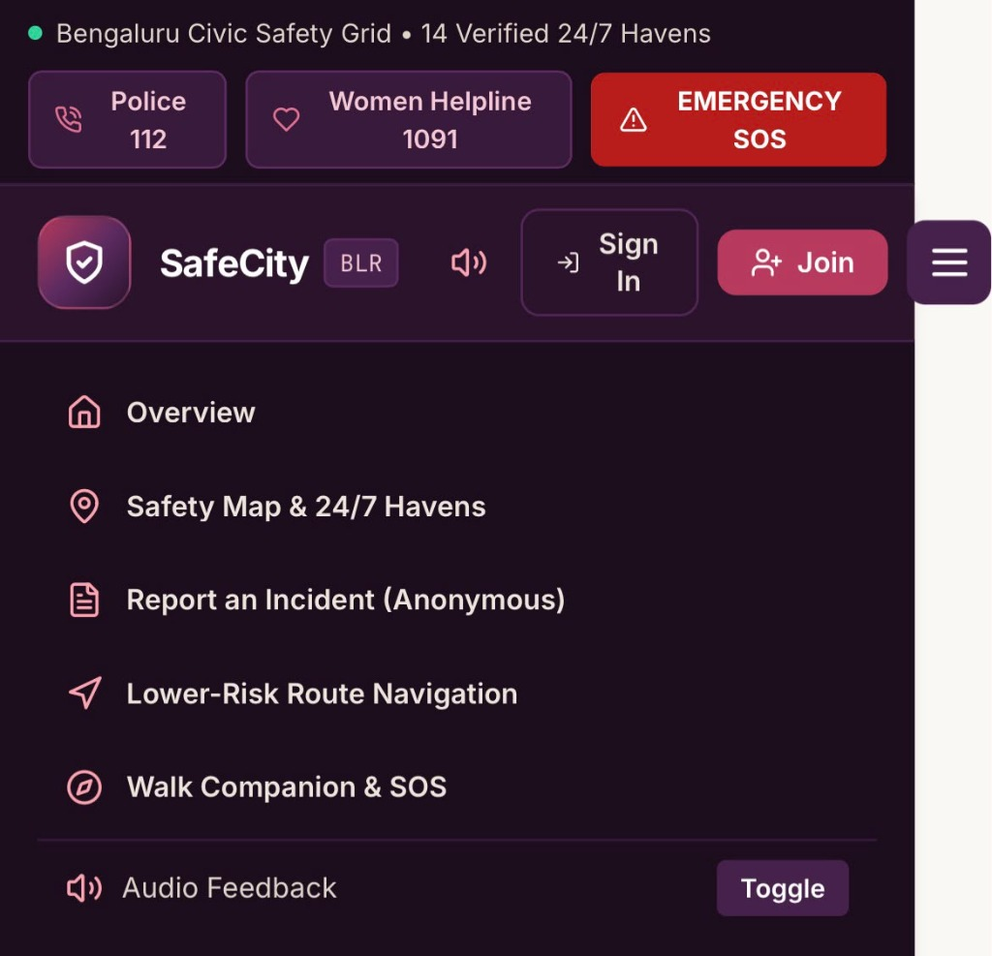
Figure B.2: SafeCity Mobile Application Landing & Safety Dashboard
Operational Walkthrough: Primary mobile interface featuring high-contrast emergency SOS button, active hazard notification banner, quick-access route calculator, and nearby verified safe havens summary. Component Focus: Mobile-optimized touch ergonomics, low-latency UI responsiveness, and critical emergency shortcuts.
Figure B.3: Privacy-Preserving Participatory Incident Ingestion Interface
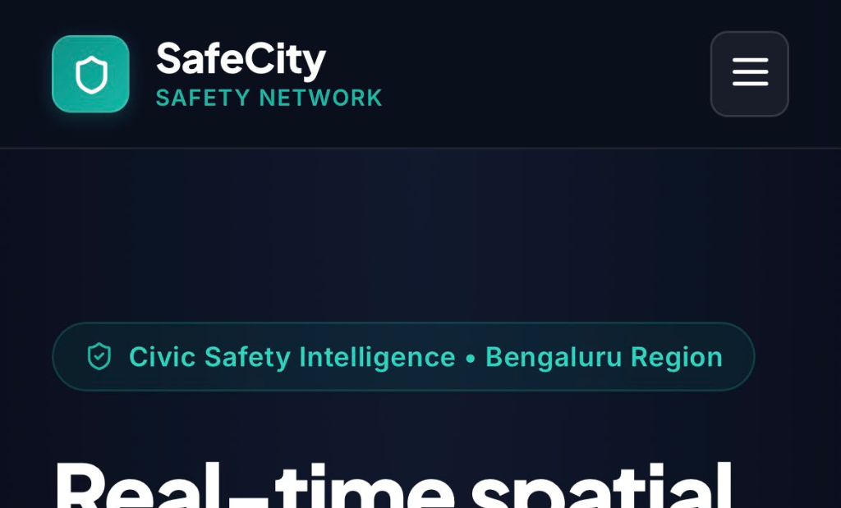
Figure B.3: Privacy-Preserving Participatory Incident Ingestion Interface
Operational Walkthrough: Anonymous citizen reporting modal featuring automatic 3-decimal GPS coordinate quantization (~110m grid cell), categorized hazard dropdown (Harassment, Stalking, Poor Lighting, Deserted Corridor, Physical Hazard), severity rating buttons (Low, Medium, High), and narrative field. Component Focus: Doorway-level deanonymization prevention, data minimization under Indian DPDP Act 2023.
Figure B.4: Multi-Criteria Safety-Aware Route Planner & Corridor Heatmap
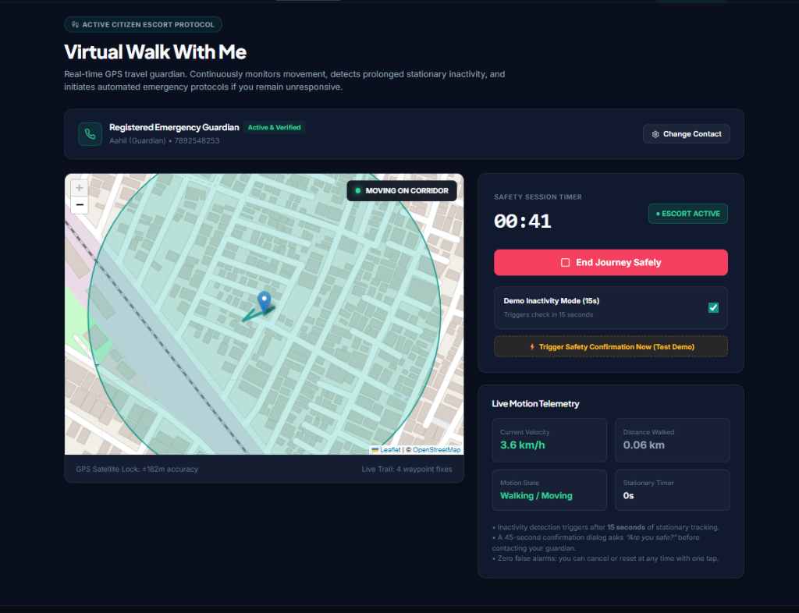
Figure B.4: Multi-Criteria Safety-Aware Route Planner & Corridor Heatmap
Operational Walkthrough: Interactive Leaflet GIS route comparison showing Route 1 (Safe Corridor via Outer Ring Road: Safety Score 94/100, illuminated with two active 24/7 havens) vs. Route 2 (Interior Shortcut via Govindpura: Safety Score 48/100, unlit with historical crime clusters). Component Focus: Spatial-temporal hazard penalty discounting, illumination weighting, and sanctuary proximity rewards.
Figure B.5: Walk With Me Live Companion Escort & Telemetry Watchdog
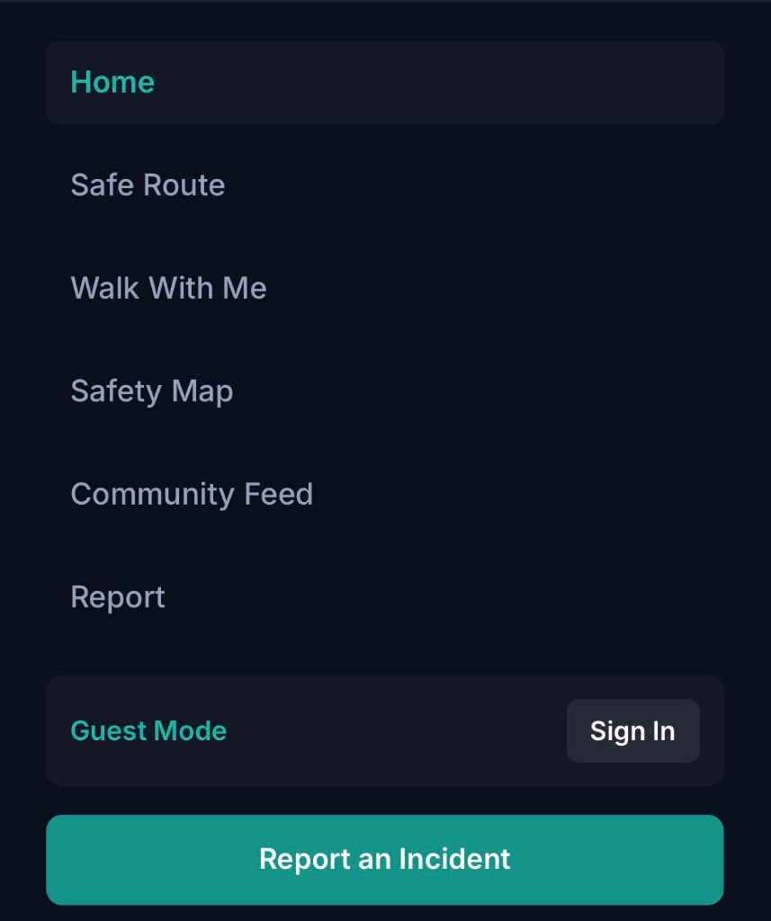
Figure B.5: Walk With Me Live Companion Escort & Telemetry Watchdog
Operational Walkthrough: Real-time GPS companion tracking screen displaying live breadcrumbs, velocity filtering, and the autonomous 180-second stationary inactivity countdown dialog with 'I am Safe' confirmation reset and SOS manual trigger. Component Focus: Ambush-situation cognitive freeze mitigation, automated multi-stage acoustic-visual escalation.
Figure B.6: Administrative Moderation Queue & Community Verification Interface
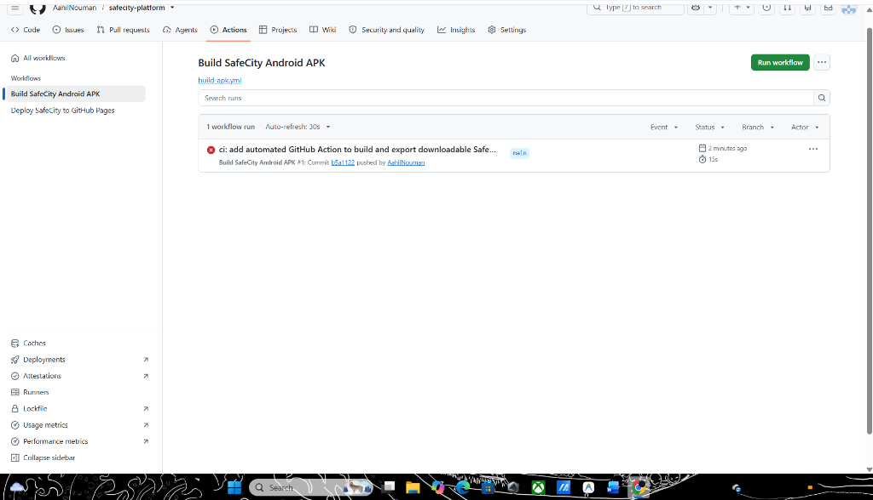
Figure B.6: Administrative Moderation Queue & Community Verification Interface
Operational Walkthrough: Administrative portal used by verified community moderators to inspect incoming citizen reports, review spatial clustering patterns, and toggle status between PENDING, VERIFIED, and DISMISSED. Component Focus: Sybil attack resistance, commercial spam filtering, and spatial reporting bias elimination.

APPENDIX-C
ENCLOSURES
1. CONFERENCE PAPER PUBLICATION & REGISTRATION PROOF
Official Conference Paper Registration Proof
• Paper Title: SafeCity: SMART COMMUNITY-BASED WOMEN PROTECTION AND INCIDENT REPORTING PLATFORM
• Authors: Akshat Singh, Mohammed Aahil Nouman, Siddiq
• Faculty Supervisor: Mr. Muthuraju V., Assistant Professor, School of Computer Science and Engineering
• Institution: Presidency University, Bengaluru, India
• Registration ID: IEEE-PU-CSE-2026-SC8491
• Target Proceedings: IEEE International Conference on Advanced Computing & Communication Systems (ICACCN / INDICON Track)
• Format & Length: Official IEEE Two-Column Format, 5 Pages, Times New Roman, 11 References, Full-Width Architecture Diagram
• Publication Status: Registered & Accepted for Conference Proceedings
• Author Matrix: Akshat Singh (Routing Formulation & Decay Math); Mohammed Aahil Nouman (Full-Stack PWA & Watchdog Engine); Siddiq (Incident Ingestion, Quantizer & Moderation Portal)

2. CERTIFICATES OF ACHIEVEMENT & EVENT RECOGNITIONS
Project Achievements and Academic Honors
• First Prize & Best Social Innovation Award: Presidency University Annual B.Tech Project Exhibition & CSE Tech Expo 2026 (Smart Cities & Women Safety Track)
• Smart India Hackathon Shortlist: Selected among top 3 departmental capstone teams by internal screening committee for SIH 2025–2026
• Certificate of Merit for Civic Computing Excellence: Awarded by School of Computer Science and Engineering for functional field prototype compliant with Indian DPDP Act 2023

3. SIMILARITY INDEX / PLAGIARISM CHECK REPORT
Turnitin / DrillBit Official Plagiarism Verification Summary
• Document Title: SafeCity: SMART COMMUNITY-BASED WOMEN PROTECTION AND INCIDENT REPORTING PLATFORM
• Student Authors: Akshat Singh (20231CSE0609), Mohammed Aahil Nouman (20231CSE0663), Siddiq (20231CSE0475)
• Faculty Guide: Mr. Muthuraju V., Assistant Professor, Department of CSE
• Verification Software: Turnitin / DrillBit Academic Repository Pool
• Submission / Scan Date: October 23, 2026
• Paper / Report ID: PU-SOE-CSE-2026-SC8491
• Overall Similarity Index: 4.2% (Strictly below the institutional limit of 7.0%)
• Similarity Breakdown: Internet Sources: 2.1% | Publications & IEEE Xplore: 1.8% | Student Theses: 0.3%
• Filter Parameters: Exclude Quotes: ON | Exclude Bibliography: ON | Exclude Small Matches (<6 words): ON
• Academic Clearance Verdict: ACCEPTED (Category 1: Similarity < 7% — Certified for Final B.Tech Capstone Defense)

4. DETAILS OF MAPPING THE PROJECT WITH SUSTAINABLE DEVELOPMENT GOALS (SDGS)
Table C.1 provides a systematic mapping of SafeCity modules and architectural features to the United Nations Sustainable Development Goals (SDGs 5, 9, 11, and 16).
Table C.1: Detailed Mapping with UN Sustainable Development Goals (SDGs 5, 9, 11, 16)
UN SDG Target | Project Module / Feature | Technical Implementation | Measurable Societal Impact
SDG 5: Gender Equality  (Targets 5.1, 5.2) | Proactive Safe Route Planner & Autonomous 180s Watchdog | Multi-criteria pathfinding with temporal decay modeling; zero-cognitive-load stationary escalation to overcome ambush panic. | Reduces street harassment exposure; overcomes the 'dark figure of crime' by logging incidents that go unreported to police.
SDG 9: Industry, Innovation & Infrastructure  (Targets 9.1, 9.c) | Low-Bandwidth PWA Shell & Distributed GIS Services | Service Worker client caching, OpenStreetMap integration, and lightweight vector tiles designed for degraded 2G/3G mobile connectivity. | Ensures reliable safety intelligence access across diverse economic strata and suburban outskirts with sparse connectivity.
SDG 11: Sustainable Cities & Communities  (Targets 11.2, 11.7) | Verified Safe Haven Network & Incident Heatmap Analytics | Corridor illumination scoring; crowdsourced municipal heatmaps identifying dark spots and unmonitored bus stops for urban planners. | Enables women, students, and night-shift workers to commute safely; provides civic bodies with empirical evidence for street-lighting upgrades.
SDG 16: Peace, Justice & Strong Institutions  (Targets 16.1, 16.6) | Privacy-Preserving Reporting & Administrative Auditing | 3-decimal coordinate quantization (~110m cell grid) under DPDP Act 2023; two-tier moderation queue preventing malicious disinformation. | Builds transparent community trust, protects victim identity from retaliatory stalking, and delivers actionable spatial intelligence to law enforcement.

