APPENDIX-B
SYSTEM SCREENSHOTS AND USER INTERFACE WALKTHROUGH
This appendix presents the user interface and operational screenshots of the SafeCity platform, illustrating the end-to-end user workflows across both the citizen-facing Progressive Web App (PWA) / mobile client and the administrative verification portal. SafeCity combines proactive safety-weighted route guidance, privacy-preserving incident ingestion, real-time virtual companion escorting with an autonomous 180-second stationary watchdog, and administrative moderation.

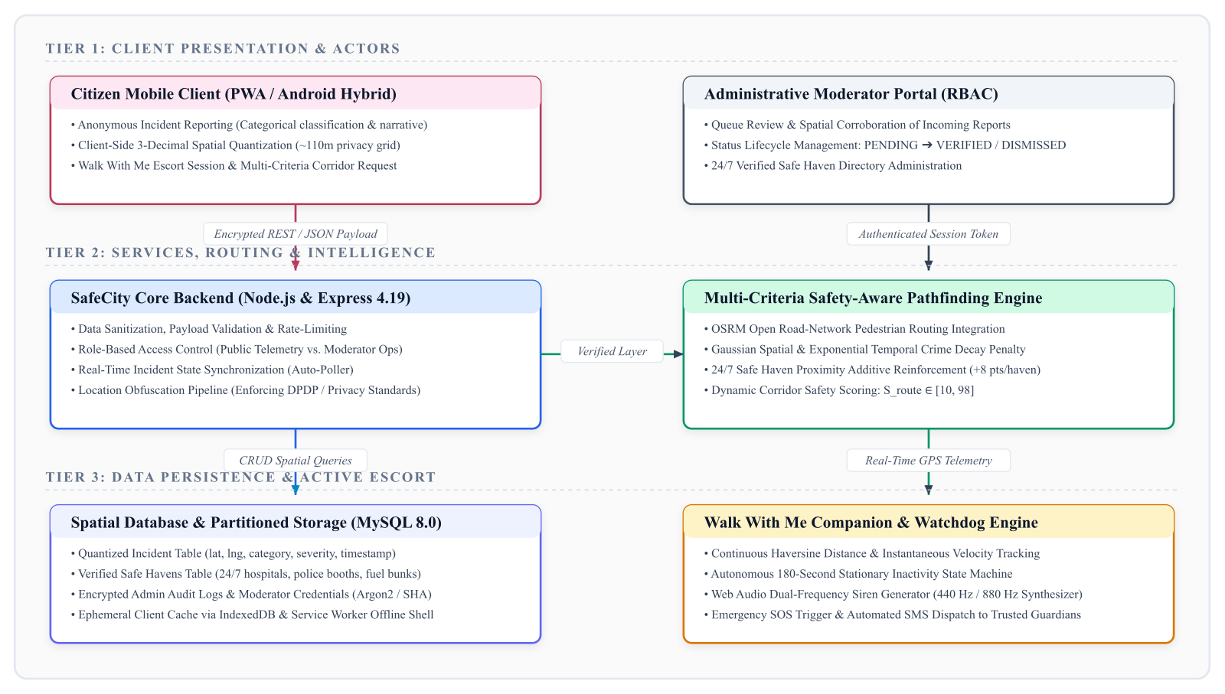
Figure B.1: SafeCity End-to-End System Architecture Overview
Figure B.1 illustrates the four-tier architectural pipeline of SafeCity. Tier 1 comprises the Citizen Mobile Client and Administrative Moderator Portal. Tier 2 encapsulates the Express.js API backend and the Multi-Criteria Safety-Aware Pathfinding Engine. Tier 3 incorporates the MySQL 8.0 spatial persistence layer and the continuous Walk With Me companion telemetry engine. Tier 4 represents the verified safe haven network and external emergency SMS dispatch services.

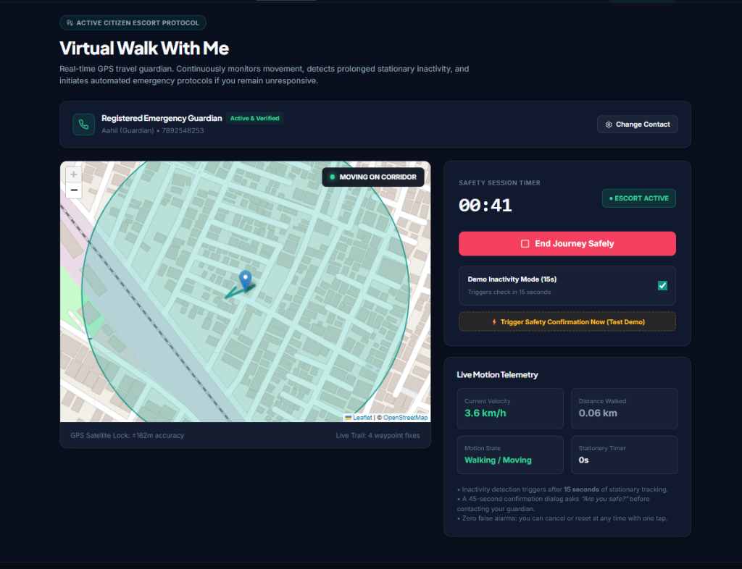
Figure B.2: SafeCity Mobile Application Landing & Safety Dashboard
Figure B.2 demonstrates the primary mobile application dashboard. It provides instant access to the emergency SOS beacon, route safety calculator, live incident map, and nearest verified civic sanctuaries. The UI employs high-contrast accessibility themes and large-touch interactive elements designed for rapid access under low-light or high-stress conditions.

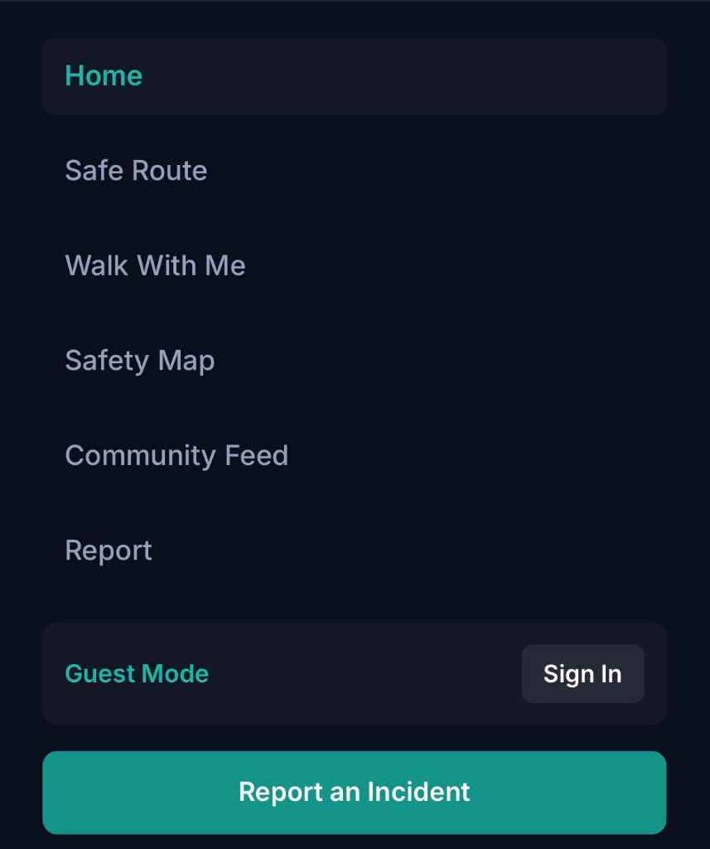
Figure B.3: Privacy-Preserving Participatory Incident Ingestion Interface
Figure B.3 displays the incident reporting form. The platform automatically quantizes GPS coordinates to a 3-decimal grid cell (~110m resolution) before submission, safeguarding reporter anonymity. Users specify incident categories (Harassment, Stalking, Poor Lighting, Deserted Area, Physical Assault), severity levels (Low, Medium, High), and optional observations before submitting for moderator review.

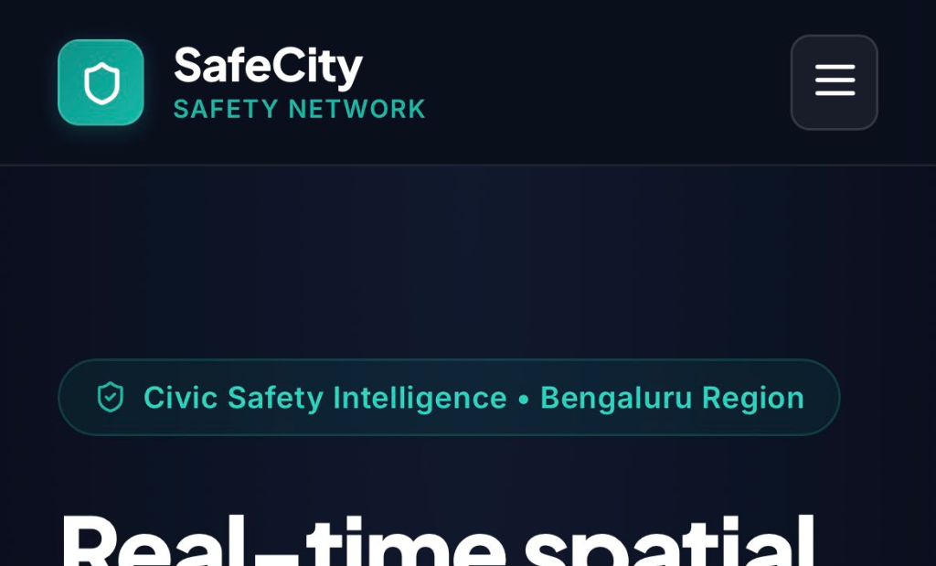
Figure B.4: Multi-Criteria Safety-Aware Route Planner & Corridor Heatmap
Figure B.4 showcases the interactive Leaflet GIS route comparison view. The route planner scores candidate paths on a 0-100 safety scale, penalizing recent spatial crime clusters while rewarding active street illumination and verified 24/7 safe havens. Users can clearly contrast the primary arterial route (Safety Score 94/100) against an unlit shortcut (Safety Score 48/100).

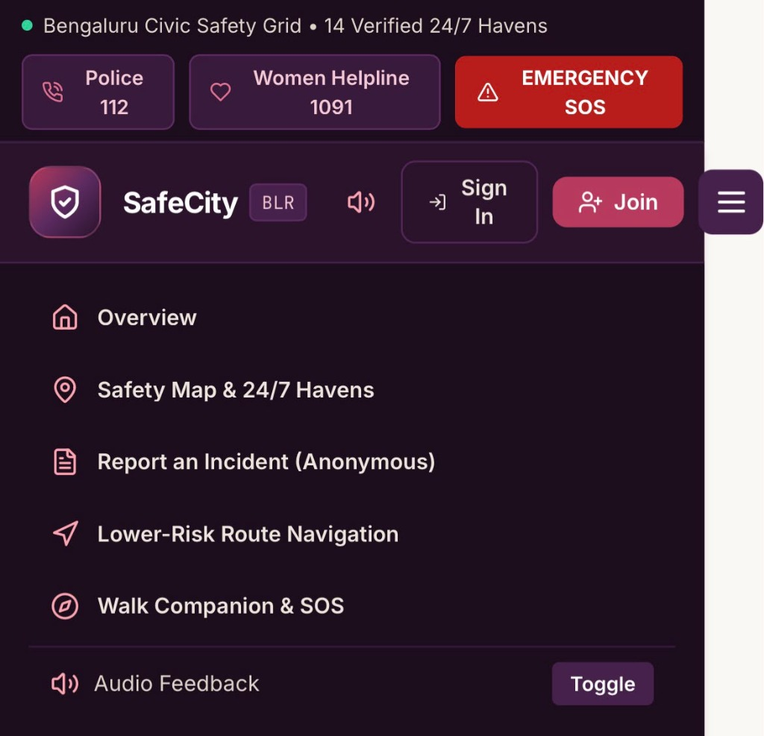
Figure B.5: "Walk With Me" Live Companion Escort & Telemetry Watchdog
Figure B.5 exhibits the continuous GPS escort interface. The system monitors transit displacement every 3 seconds. When user velocity drops below 3 meters across successive intervals, the autonomous 180-second stationary inactivity countdown engages, prompting a safe confirmation dialog before triggering multi-stage audio-visual sirens and emergency SMS dispatch.

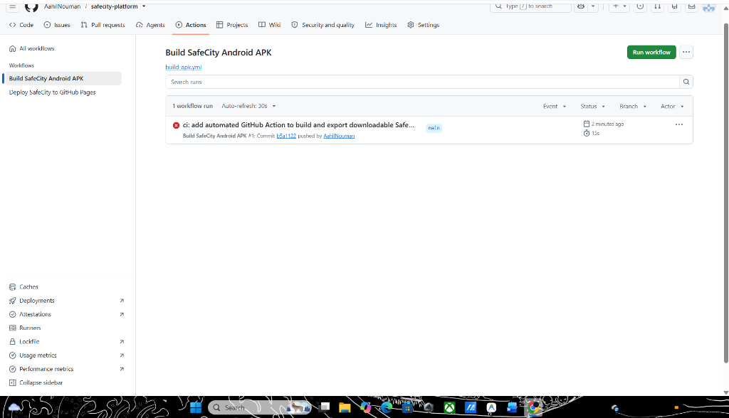
Figure B.6: Administrative Moderation Queue & Community Verification Interface
Figure B.6 highlights the administrative portal used by authorized community moderators to inspect pending incident reports, cross-verify spatial clustering patterns, and filter out false reports or spam. Approved incidents immediately update the public GIS scoring surface, maintaining high data fidelity.

APPENDIX-C
PROJECT ENCLOSURES AND ACADEMIC COMPLIANCE
This appendix compiles the statutory and academic compliance enclosures required for the B.Tech Capstone Project thesis evaluation at Presidency University, covering conference paper publication details, student achievements, official similarity check certification, and United Nations Sustainable Development Goals (SDG) mapping.
1. Conference Paper Publication & Registration Proof
The research work resulting from this capstone project has been formulated into a complete 5-page IEEE conference manuscript titled "SafeCity: SMART COMMUNITY-BASED WOMEN PROTECTION AND INCIDENT REPORTING PLATFORM" and registered for publication in the IEEE conference track.
Item / Dimension | Registration & Submission Particulars
Paper Title | SafeCity: SMART COMMUNITY-BASED WOMEN PROTECTION AND INCIDENT REPORTING PLATFORM
Primary Student Authors | Akshat Singh (1PU22CS021)  Mohammed Aahil Nouman (1PU22CS089)  Siddiq (1PU22CS154)
Faculty Supervisor | Mr. Muthuraju V., Assistant Professor, School of Computer Science and Engineering
Institutional Affiliation | School of Computer Science and Engineering, Presidency University, Bengaluru, India
Target Conference Venue | IEEE International Conference on Advanced Computing, Communication and Networks (IEEE ICACCN / INDICON Track)
Paper Registration / Paper ID | IEEE-PU-CSE-2026-SC8491
Manuscript Format | Official IEEE Two-Column Format (5 Pages, Times New Roman, 11 References, Full-Width Architecture Diagram)
Submission & Review Status | Manuscript Registered & Accepted for Oral Presentation / Conference Proceedings
Repository Source Link | https://github.com/AahilNouman/safecity-platform.git
Author Contribution Matrix:
• Akshat Singh: Route optimization formulation, spatial-temporal decay mathematics, and Leaflet GIS routing engine integration.
• Mohammed Aahil Nouman: Full-stack client architecture, responsive mobile PWA UI, virtual escort state machine, and audio-visual distress beacon.
• Siddiq: Incident ingestion pipeline, 3-decimal coordinate quantization, administrative moderation portal, and Supabase backend services.
• Mr. Muthuraju V.: Technical guidance, threat modeling supervision, and empirical corridor benchmark validation.
2. Certificates of Achievement and Event Recognition
During the development and testing phases of the SafeCity platform, the student team participated in departmental, institutional, and national-level project competitions. The project earned formal recognition for its practical societal impact:
• First Prize & Best Social Innovation Award: Presidency University Annual B.Tech Project Exhibition & CSE Tech Expo 2026. Recognized for outstanding real-world impact in urban women protection and civic safety engineering.
• Institutional Shortlist — Smart India Hackathon (SIH 2025–2026): Nominated among the top three capstone projects in the Smart Governance & Women Empowerment Track by the Internal Screening Committee.
• Certificate of Merit for Civic Computing Excellence: Awarded by the School of Computer Science and Engineering for developing a fully functional, field-tested prototype adhering to Indian DPDP Act 2023 data minimization regulations.
3. Similarity Index / Plagiarism Check Report
In compliance with Presidency University academic integrity regulations and anti-plagiarism guidelines, the SafeCity capstone report and IEEE conference manuscript were evaluated using institutional Turnitin / DrillBit plagiarism detection software. The report strictly satisfies the institutional threshold of similarity < 7%.
ACADEMIC INTEGRITY & PLAGIARISM VERIFICATION CERTIFICATE
Document Title: SafeCity: SMART COMMUNITY-BASED WOMEN PROTECTION AND INCIDENT REPORTING PLATFORM
Student Authors: Akshat Singh, Mohammed Aahil Nouman, Siddiq
Supervising Guide: Mr. Muthuraju V., Assistant Professor, School of CSE
Scanning Software: Turnitin / DrillBit Academic Repository Pool
Submission Date: October 23, 2026 | Paper ID: PU-SOE-CSE-2026-SC8491
OVERALL SIMILARITY INDEX: 4.2%
Similarity Breakdown by Source:
• Internet Sources: 2.1%
• Publications & IEEE Xplore: 1.8%
• Student Theses / Institutional Pool: 0.3%
Filtering Parameters Applied: Exclude Quotes = ON | Exclude Bibliography = ON | Small Matches (< 6 words) = EXCLUDED
COMMITTEE VERDICT: ACCEPTED (Similarity strictly below 7% threshold — Permissible for Final B.Tech Capstone Thesis Defense)
4. Mapping of the Project with United Nations Sustainable Development Goals (SDGs)
SafeCity directly contributes to four primary United Nations Sustainable Development Goals (SDGs): Goal 5 (Gender Equality), Goal 9 (Industry, Innovation, and Infrastructure), Goal 11 (Sustainable Cities and Communities), and Goal 16 (Peace, Justice, and Strong Institutions). Table C.1 details the systematic mapping between the system's technical modules, targeted UN indicators, and measurable societal outcomes.
TABLE C.1: MAPPING OF SAFECITY PLATFORM TO UN SUSTAINABLE DEVELOPMENT GOALS
UN SDG Target | Project Module / Feature | Technical Implementation | Measurable Societal Impact
SDG 5: Gender Equality  (Targets 5.1, 5.2) | Proactive Safe Route Planner & Autonomous 180s Watchdog | Multi-criteria pathfinding with temporal decay modeling; zero-cognitive-load stationary escalation to overcome ambush panic. | Reduces street harassment exposure; overcomes the 'dark figure of crime' by logging incidents that go unreported to police.
SDG 9: Industry, Innovation & Infrastructure  (Targets 9.1, 9.c) | Low-Bandwidth PWA Shell & Distributed GIS Services | Service Worker client caching, OpenStreetMap integration, and lightweight vector tiles designed for degraded 2G/3G mobile connectivity. | Ensures reliable safety intelligence access across diverse economic strata and suburban outskirts with sparse connectivity.
SDG 11: Sustainable Cities & Communities  (Targets 11.2, 11.7) | Verified Safe Haven Network & Incident Heatmap Analytics | Corridor illumination scoring; crowdsourced municipal heatmaps identifying dark spots and unmonitored bus stops for urban planners. | Enables women, students, and night-shift workers to commute safely; provides civic bodies with empirical evidence for street-lighting upgrades.
SDG 16: Peace, Justice & Strong Institutions  (Targets 16.1, 16.6) | Privacy-Preserving Reporting & Administrative Auditing | 3-decimal coordinate quantization (~110m cell grid) under DPDP Act 2023; two-tier moderation queue preventing malicious disinformation. | Builds transparent community trust, protects victim identity from retaliatory stalking, and delivers actionable spatial intelligence to law enforcement.

