**Building and Deploying a Calculator DApp**

**Setting up the Environment**

2.1 Install Node.js and npm

• Download and install Node.js from https://nodejs.org/.

• Verify installation:

node −v

npm −v

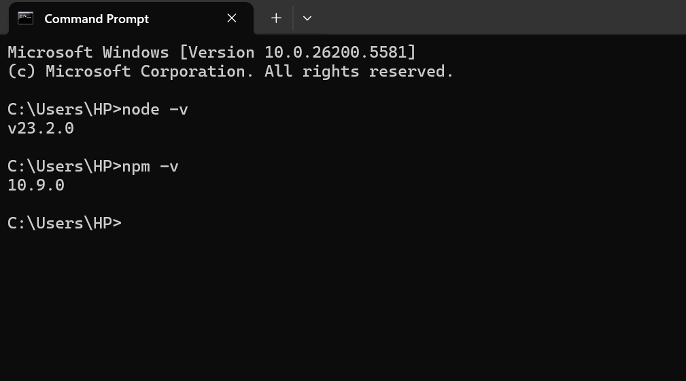

**2.3 Install MetaMask**

• Install MetaMask extension in Chrome or Firefox.

• Create a wallet or import using seed phrase.

• Connect to the Ganache network:

– Network Name: Ganache

– New RPC URL: http://127.0.0.1:7545 (or the port Ganache is using,

often 8545 for Ganache CLI)

– Chain ID: 1337 (or the Chain ID displayed by your Ganache instance)

– Currency Symbol: ETH

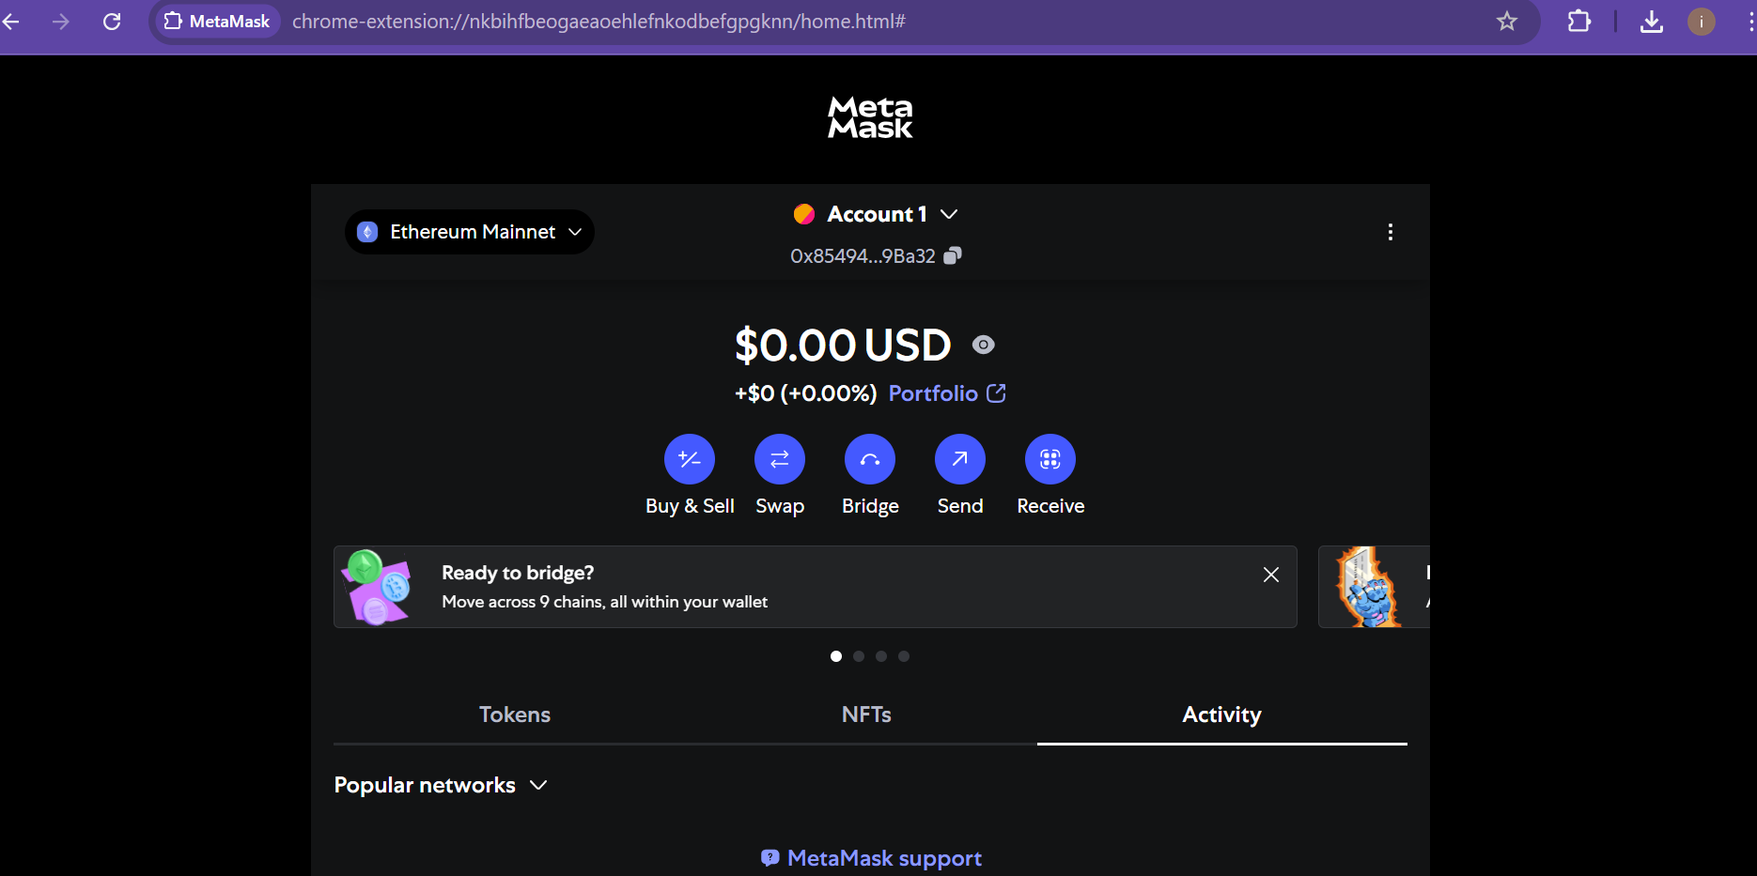

**Install Ganache**

• Download Ganache from https://trufflesuite.com/ganache/ and in-

stall.

• Launch Ganache and start a new workspace.

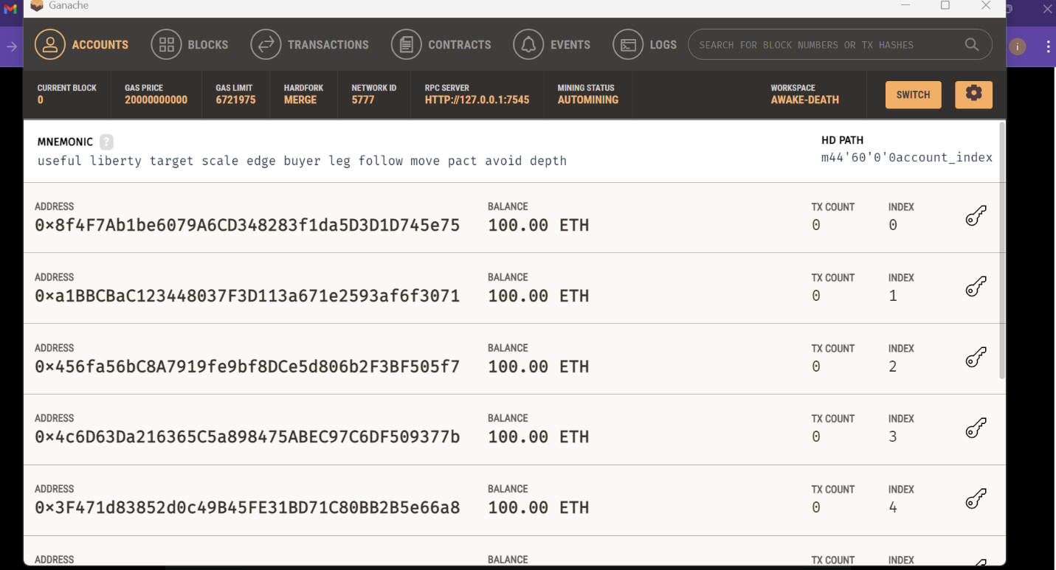

**Project Setup (Node.js)**

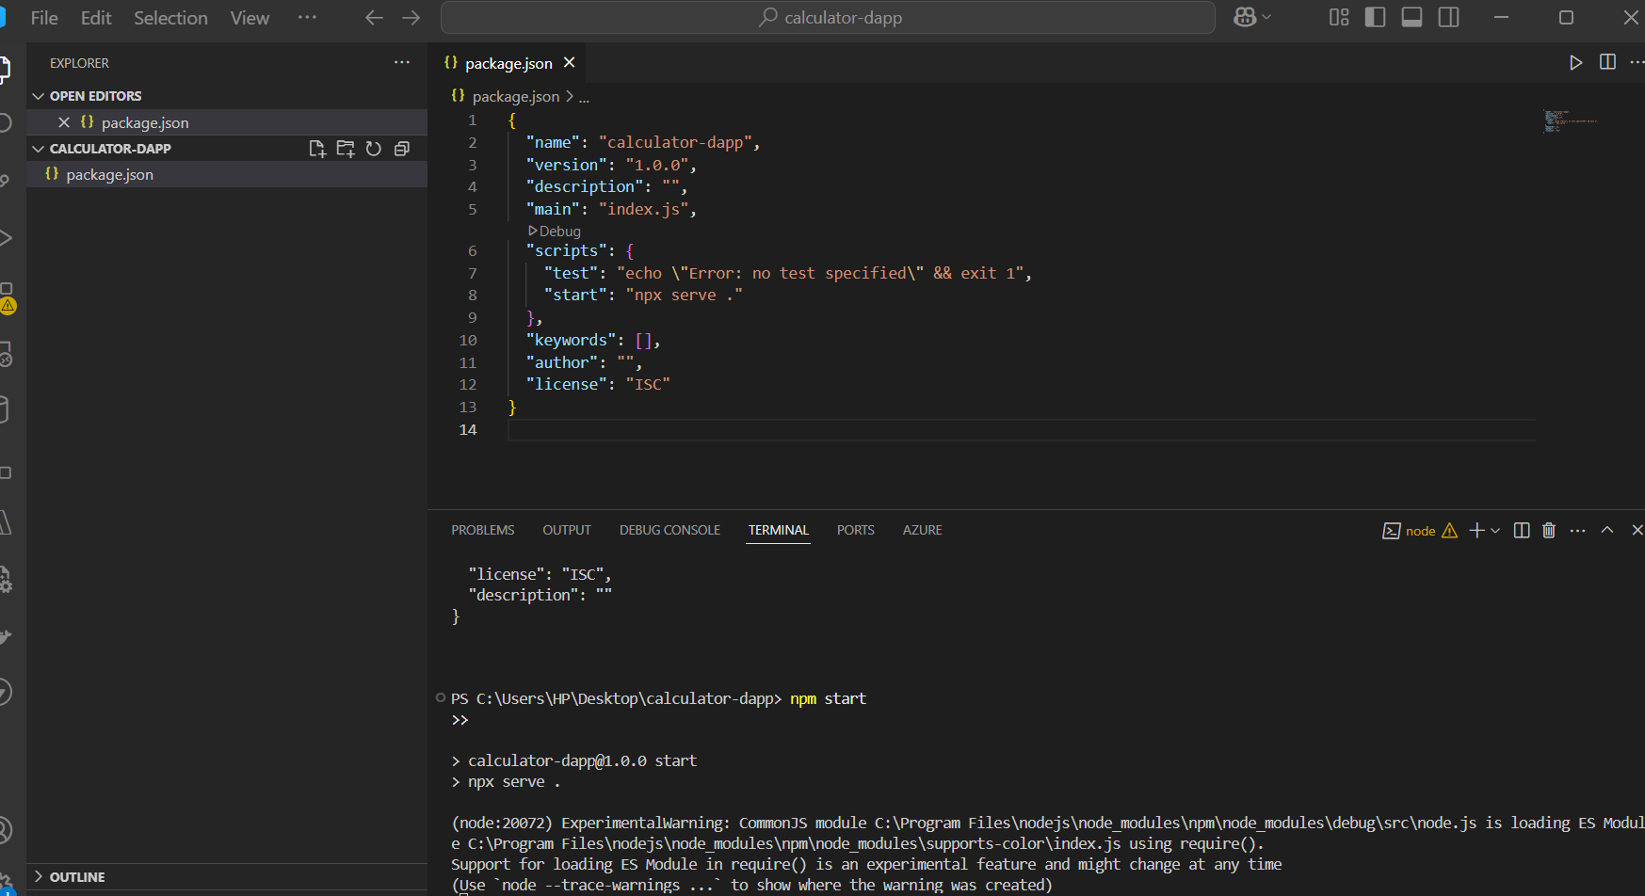

**Writing the Smart Contract**

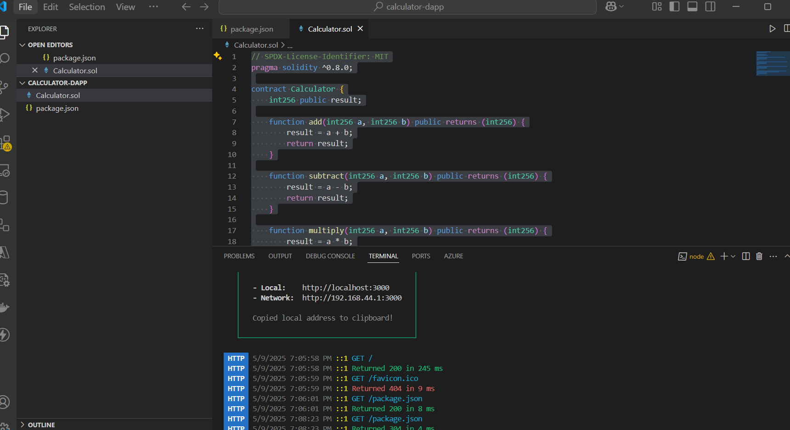

**Deploying the Smart Contract**

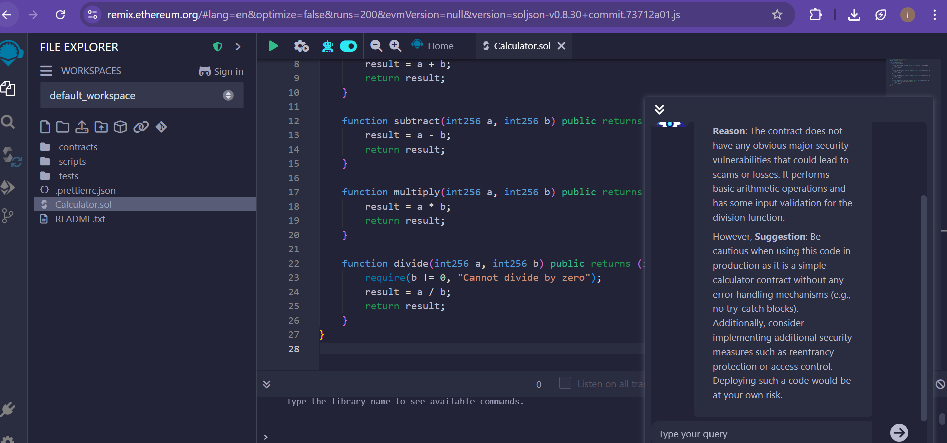

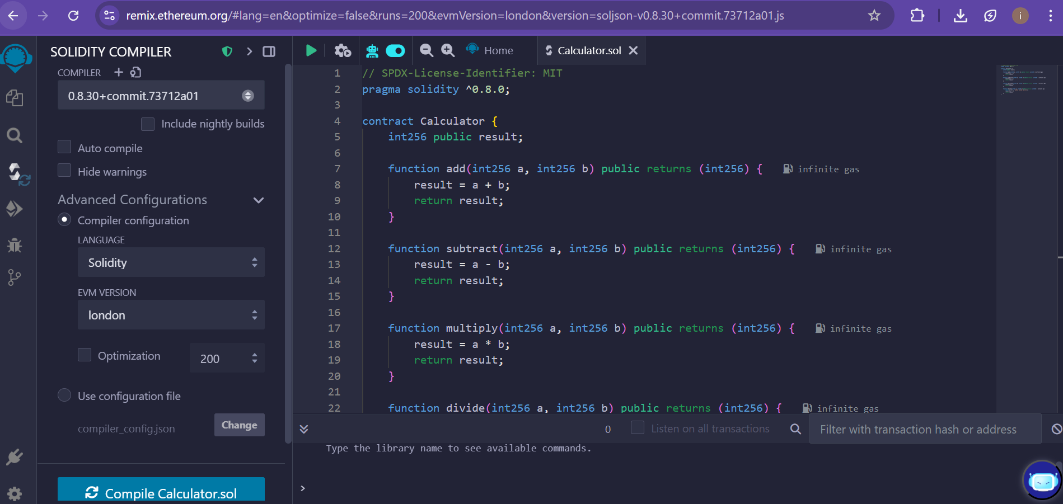

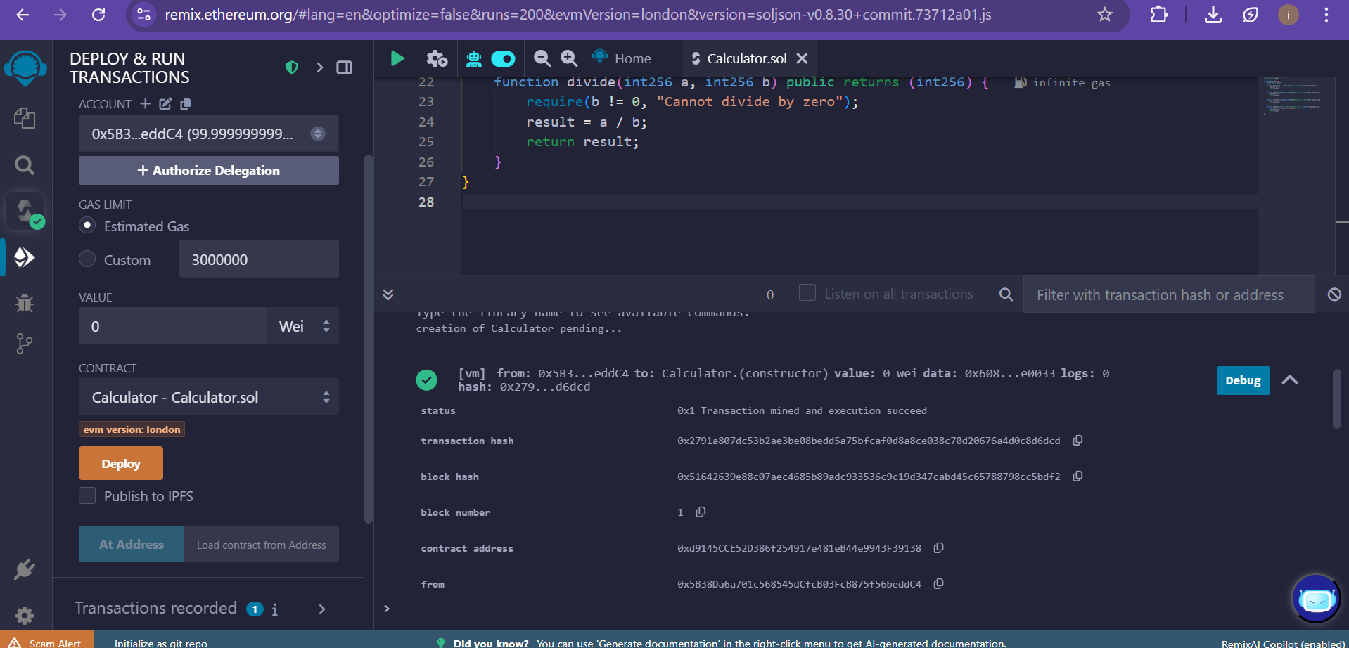

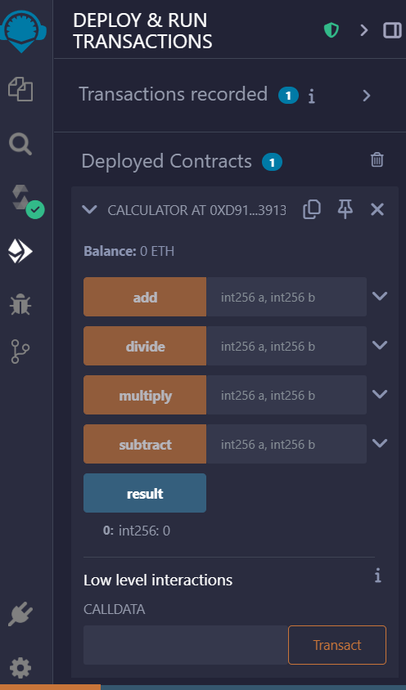

**Creating the Frontend**

