

|  |
| --- |
| Software requirements and design document |
| For  Legal Eagle Case Management System |
| December 4  Syeda Laraib Fatima 21i-0865  Aaimlik Abbasi 21i-2540 |

# Introduction

## Purpose

The purpose of the Legal Eagle Case Management System is to provide a comprehensive and efficient platform for legal professionals, case managers, and other stakeholders to manage legal cases seamlessly. The system aims to streamline various aspects of case management, including status tracking and updates, client communication, voice-activated commands, reports and analytics generation, legal research, and document control, Case creation. By offering these functionalities, the system enhances collaboration, communication, and decision-making within legal organizations, ultimately contributing to improved case outcomes.

## Product Scope

## The Legal Eagle Case Management System is a versatile platform designed to enhance organizational efficiency and collaboration through a set of core functionalities:

1. Information Management:

Facilitates the tracking and updating of information related to cases, ensuring stakeholders stay informed.

1. Communication Hub:

Serves as a centralized communication hub, enabling seamless interactions between users, clients, and relevant parties.

1. Voice-Activated Controls:

Introduces a hands-free, voice-activated feature for intuitive system navigation and control.

1. Data Insights:

Empowers users with robust reporting and analytics tools for informed decision-making and performance assessment.

1. Research and Resource Management:

Provides tools for efficient research and resource organization, fostering knowledge management within the system.

1. Document Control Center:

Allows for the efficient management, organization, and control of documents associated with diverse organizational processes.

The system's generic scope aims to offer adaptability, efficiency, and collaboration across various domains within an organization, fostering a seamless and integrated user experience.

Title:

Legal Eagle Case Management System - Streamlining Legal Operations and Collaboration

### Project Aim:

The Legal Eagle Case Management System aims to streamline legal operations and collaboration by providing a comprehensive platform for efficient case management and communication within legal organizations.

### Immediate Solution:

The system offers a set of core functionalities, including case status tracking, client communication, voice-activated controls, reports and analytics, legal research support, and document management. This immediate solution enhances collaboration, improves information management, and empowers users with tools for better decision-making, ultimately optimizing the efficiency of legal processes.

Objectives:

Operational Efficiency: Enhance overall operational efficiency by optimizing case management processes, ensuring timely updates and accurate information for legal professionals.

Communication Excellence: Establish a centralized communication platform to foster efficient and effective communication between legal professionals and clients, improving overall organizational responsiveness.

User-Friendly Navigation: Implement innovative and user-friendly features, such as voice-activated controls, to enhance system navigation and user experience for all stakeholders.

Data-Driven Decision Support: Provide legal professionals with advanced reporting and analytics tools to support data-driven decision-making, contributing to organizational effectiveness.

Knowledge Management: Facilitate efficient legal research and resource organization to enhance knowledge management within the system, aiding professionals in staying informed and up-to-date.

Document Lifecycle Optimization: Streamline document management processes to optimize the creation, storage, and retrieval of legal documents, ensuring a seamless document lifecycle.

## Problem Statement:

The project addresses the prevalent challenges associated with manual and fragmented processes within legal organizations. Before the introduction of the Legal Eagle Case Management System, inefficient case tracking, communication gaps, and document management complexities hindered the seamless operation of legal workflows. The project's feasibility lies in its potential to foster collaboration, minimize manual efforts, and enhance overall organizational productivity. The system aims to provide a holistic solution to the generic challenges faced by legal professionals in their day-to-day operations.

# DESCRIPTION

Product Perceptive:

The Legal Eagle Case Management System, a revolutionary self-contained legal tech solution, represents an innovation in the realm of legal industry tools. Unlike a follow-on member or a replacement, it stands as a new, singular product designed to modernize traditional case management practices. Although independent, it interfaces seamlessly with external tools, ensuring collaborative functionality with email, calendars, and legal research platforms. Positioned as a crucial component within a broader legal ecosystem, it aligns its features with the requirements of the larger system, enhancing overall interoperability and integration. This transformative product addresses the challenges faced by law firms, introducing efficiency, security, and compliance into legal workflows.

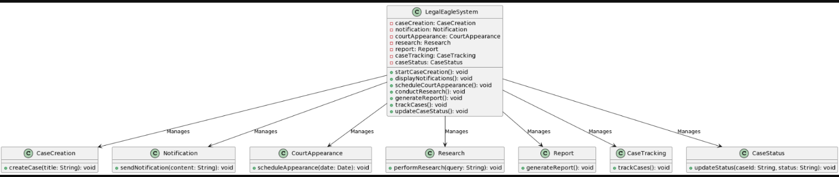

Product Function:

Case Creation

* Allow users to create new legal cases with relevant details.
* Capture information such as case title, parties involved, and case type.
* Assign cases to specific legal professionals or teams.

Notification

* Provide a notification system for real-time updates on case developments.
* Enable users to customize notification preferences.
* Send alerts for critical events, court dates, and case status changes.

Court Appearance

* Schedule and manage court appearances for each legal case.
* Send reminders and notifications for upcoming court dates.
* Integrate with calendar applications for seamless scheduling.

Research

* + Grant access to legal databases and resources for research purposes.
  + Implement bookmarking and annotating features for easy reference.
  + Integrate with external legal research tools to enhance capabilities.

Report

* + Generate comprehensive reports on case progress, outcomes, and legal expenses.
  + Provide analytical tools for insights into case trends and performance metrics.
  + Customize report parameters to meet specific user requirements.

Case Tracking

* + Track and display real-time status updates for each legal case.
  + Allow users to update case progress, add notes, and attach relevant documents.
  + Prioritize and categorize cases based on urgency and importance.

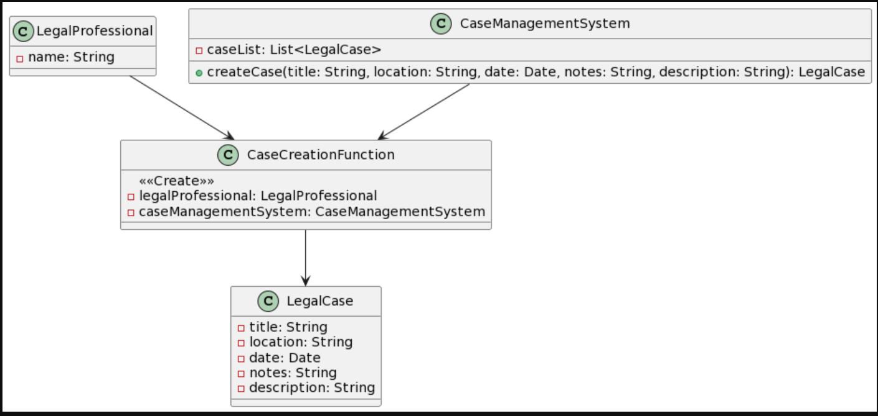

List of Use Case:

Case Creation

Description Allow users to create new legal cases with relevant details.

Input

* + Case Title
  + Location
  + Date
  + Notes
  + Description

Output

Newly created case with assigned case ID.

Notification

Description Provide a notification system for real-time updates on case developments.

Input

Username

Output

Real-time notifications for critical events, court dates, and case status changes.

Court Appearance

Description Schedule and manage court appearances for each legal case.

Input

* + Case ID
  + Schedule date
  + Schedule Time
  + Location
  + Description

Output Confirmation of scheduled court appearance.

Research

Description Grant access to legal databases and resources for research purposes.

Input

Research Query

Output

Results from legal research.

Report

Description Generate comprehensive reports on case progress, outcomes, and legal expenses.

Input

Report Parameters (e.g., date range, case type)

Output

-Detailed report based on specified parameters.

Case Tracking

Description Track and display real-time status updates for each legal case. Allow users to update the status of a legal case

Input

* + Case ID
  + New Status

Output

* + Real-time status updates, notes, and attached documents for the specified case.
  + Confirmation of the updated case status.

Extended Use Case:

Notification

Scope: Legal Eagle Case Management System

Level: User Goal

Primary Actor: User

Stakeholders and Interests:

User: Wants to receive notifications and system alerts for important events and updates.

System: Must provide a reliable notification and alert system.

Preconditions: User is logged in and has notification preferences

Postcondition: User receives relevant notifications and system alerts

Main Success Scenario:

ACTOR SYSTEM

|  |  |
| --- | --- |
| user navigate to their notification and setting | System displays notification settings screen |
| User configures preferences for receiving notifications (e.g., email, in-app ,SMS). | System records user preferences for notification delivery |
| System send notification for events such as case update, court appearances and system alerts | System check for the relevant event example (case update ,court appearance system alerts) |
|  | System validates and saves the notification preference |

Case Creation

Scope: Legal Eagle Case Management System

Level: User Goal

Primary Actor: User

Stakeholders and Interests:

User: Wishes to create new legal cases and assign them to specific professionals or teams.

Legal Professionals: Need cases assigned for handling.

System: Must facilitate case creation and assignment process.

Preconditions: User is logged in and has appropriate permissions.

Postcondition: New case is created and assigned to specified professional/team.

Main Success Scenario:

ACTOR SYSTEM

|  |  |
| --- | --- |
| User select “create new case” option | System display new case form |
| User enter the relevant case detail(title, type and detail) | System record and validate the enter case detail |
| User assign the case to specific legal profession | System provide option to select legal profession or team |
| System confirm successful case creation and assignment | System display a confirmation message indicating successful case creation and assignment |
|  | System record the assign legal profession or team for case |

Court Appearance

Scope: Legal Eagle Case Management System

Level: Sub function

Primary Actor: Legal Professional

Stakeholders and Interests:

Legal Professional: Wants to schedule, manage, and receive reminders for court appearances efficiently.

Client: Interested in being informed about upcoming court dates related to their case.

Preconditions:

* + The Legal Eagle Case Management System is accessible and the Legal Professional is logged in.
  + The Legal Professional has an active case that requires a court appearance.

Post-conditions:

* + The court appearance is scheduled and recorded in the system.
  + Reminders for the court appearance are set for the Legal Professional.

Main Success Scenario:

ACTOR SYSTEM

|  |  |
| --- | --- |
| Legal profession selects “schedule New court Appearance” |  |
| Legal profession navigates to court appearance section | System display option “schedule new course appearance “or view existing appearance” |
|  |  |
| System send up remainder and notification | System validates information |

Case Tracking

Use case name: Case Status tracking and update  
 Scope the system under design: The Legal Eagle case management system   
 Level: High-level use case

Primary actor: Legal professional, case manager

e. Stakeholders and interests

- Legal Professionals: Need accurate and up-to-date case statuses for effective case management.

- Case Managers: Require updated case status for monitoring and coordination.

- Clients: Desire real-time information on the progress of their cases.

- Administrative Staff: Need to ensure accurate data for administrative purposes.

  Preconditions

* + The user is logged into the Legal Eagle Case Management System.
  + The case to be updated exists in the system.

Postcondition

* + The case status is successfully updated in the system.
  + Relevant stakeholders are notified of the update if configured.

Main success scenario

Legal Professional action Case manager response

|  |  |
| --- | --- |
| 1. The Legal Professional selects a specific case from the dashboard. |  |
| 2. The Legal Professional initiates a status update for the selected case. |  |
| 3. Legal Professionals select a new status category (e.g., "In Progress"). |  |
| 4. Legal Professional enters any relevant case notes or updates. |  |
| 5. The Legal Professional confirms and submits the status update. |  |
|  | 6. The Case Manager reviews the updated case status. |
|  | 7. If configured, the manager sends notifications to relevant parties. |
|  | 8. The system records the status update in the case history, including a timestamp. |

Report

 Use case name: Reports and analytics

Scope the system under design: The Legal Eagle case management system.

Level: High-Level use case

Primary actor: Legal professional

Stakeholders and interests:

- Legal Professionals: Need to generate insightful reports and analytics to make informed decisions and track case progress effectively.

- Case Managers: Require reports for monitoring and coordinating multiple cases efficiently.

- Administrative Staff: Interested in high-level analytics to make strategic decisions regarding resource allocation and case management policies.

  Preconditions:

The user is logged into the Legal Eagle Case Management System.

Postcondition:

- Relevant reports and analytics are generated and accessible for the selected parameters.

h. Main success scenario:

|  |  |
| --- | --- |
| Actions by legal professional | System response |
| 1. Legal Professional navigates to the Reports and Analytics section. |  |
| 2. Legal Professional selects the desired report type, e.g., "Case Progress Report". |  |
|  | 3. System shows various options to customize the report. |
| 4. Legal Professionals customize the parameters, selecting specific cases, date ranges, or other relevant filters. |  |
| 5. A Legal Professional initiates the report generation. |  |
|  | 6. The system successfully generates the report and presents it to the Legal Professional. |
| 7. Legal Professional can further analyze, save, or export the report as needed. |  |

Research

 Use case name: Legal Research

Scope the system under design: The legal eagle case management system.

Level: High-level use case

Primary actor: Legal professional

Stakeholders and interests:

- Legal Professionals: Need to conduct legal research efficiently and manage research materials for cases.

- Case Managers: Require access to organized legal research data for efficient case management.

- Administrative Staff: Interested in optimizing the system for seamless operations and ensuring compliance with legal research policies.

Preconditions:

The user is logged into the legal eagle case management system.

Postcondition:

- Relevant legal research is conducted, managed, and accessible for the selected parameters.

Main success scenario:

|  |  |
| --- | --- |
| Actions by Legal Professional | Response by the system |
| 1. Legal Professional navigates to the Legal Research and Management section. |  |
| 2. A Legal Professional initiates a legal research query, specifying the topic or keywords. |  |
| 3. The Legal Professional enters the query and initiates the search. |  |
|  | 4. The system generates the results. |
| 5. Legal Professional reviews and selects relevant legal resources. |  |
| 5. Legal Professional saves selected resources to the case or research repository. |  |

Use Case Diagram:

Case Tracking

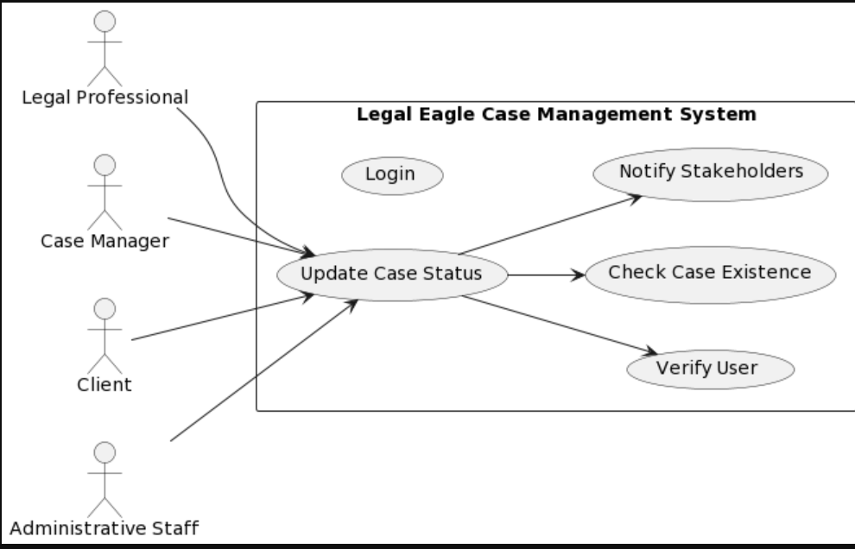

Research

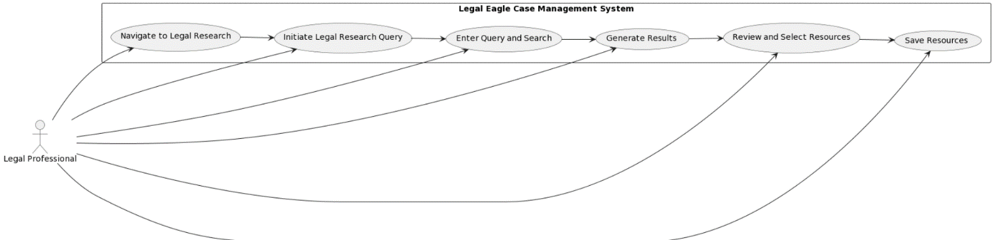

Report

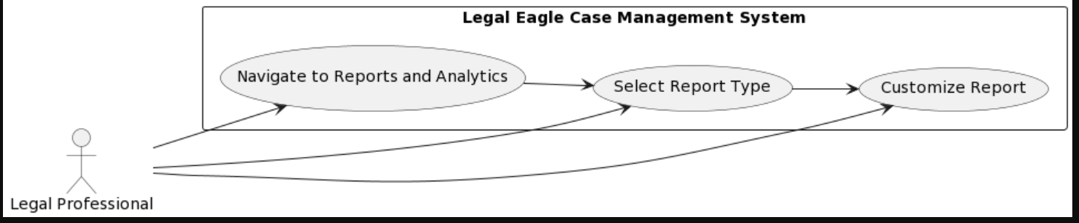

Court Appearance

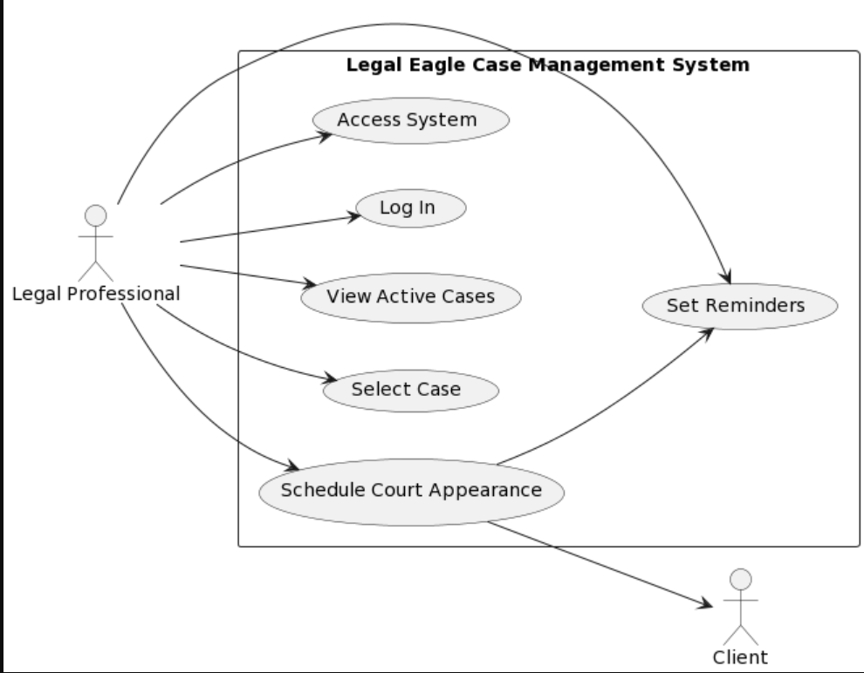

Case Creation

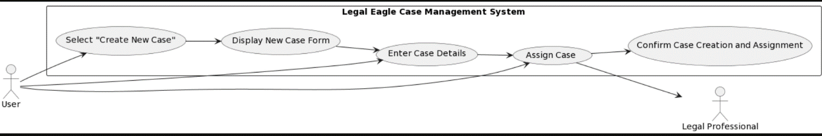

Notification

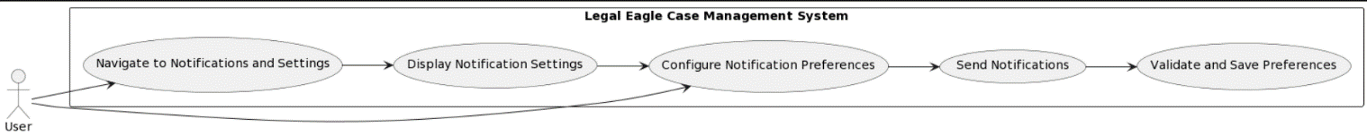

Nonfunctional diagram:

Performance Requirement:

Case Creation

Response Time: The system should create a new legal case within 3 seconds of user input.

Throughput: The system should support the creation of at least 100 legal cases per hour.

Resource Utilization:The memory usage during case creation should not exceed 100 MB.

Notification

Response Time: Real-time notifications should be delivered within 1 second of the triggering event.

Throughput: The system should handle notifications for at least 100 legal cases simultaneously.

Resource Utilization: Notification processing should not consume more than 5% of CPU capacity.

Court Appearance

Response Time: Scheduling and managing court appearances should occur within 5 seconds.

Throughput: The system should handle at least 50 court appearance scheduling requests per hour.

Resource Utilization: Court appearance scheduling should not consume more than 50 MB of memory.

Research

Response Time: Legal research queries should return results within 2 seconds.

Throughput: The system should handle at least 20 research queries concurrently.

Resource Utilization: Legal research operations should not consume more than 30 MB of memory.

Report

Response Time: Report generation should be completed within 10 seconds.

Throughput: The system should support the generation of at least 30 reports per hour.

Resource Utilization: Report generation should not consume more than 150 MB of memory.

Case Tracking

Response Time: Real-time case status updates should be displayed within 2 seconds of the event.

Throughput: The system should handle status updates for at least 150 legal cases simultaneously.

Resource Utilization: Case tracking and status update operations should not consume more than 80 MB of memory.

Safety requirement:

1.Secure Information:

- Requirement: Keep legal information safe by using strong security measures, like locks on important files.

2. Control Access:

- Requirement: Only let authorized people see or change case details. It's like having a special key for certain rooms.

3. Keep Track of Actions:

- Requirement: Write down everything people do in the system so we can see if someone does something they're not supposed to.

4. Follow Data Rules:

- Requirement: Do what the law says about handling data—like keeping client info private and following rules such as GDPR.

5. Emergency Recovery:

- Requirement: Make sure we have a plan to get our data back quickly if something goes wrong, like a computer breaking.

6. Security Checks:

- Requirement: Ask outside experts to regularly check if our system is strong against cyber-attacks.

7. Learn to Stay Safe:

- Requirement:Teach everyone using the system how to keep things safe, like having strong passwords and not falling for tricks online.

8. Quick Response Plan:

- Requirement: Have a plan ready in case something bad happens, so we can act fast to fix it and keep everything running smoothly.

Security requirement:

1. User Authentication:

Requirement: Users must prove their identity securely before accessing the system, using methods like passwords or multi-factor authentication.

2. Data Encryption:

- Requirement: Encrypt data during transmission and storage from end to end, keeping it safe from unauthorized access.

3. Role-Based Access Control (RBAC):

Requirement: Assign specific permissions based on user roles, ensuring access is limited to necessary functionalities.

4. Regular Security Audits:

Requirement: Conduct routine security audits to identify and fix vulnerabilities, maintaining the system's resilience against potential threats.

5. Secure APIs and Integrations:

Requirement: Implement secure communication protocols for external integrations and APIs to prevent unauthorized access.

7. Data Backup and Recovery:

Requirement: Regularly back up data and establish a reliable recovery process to minimize data loss in case of system failures.

Security Certification:

ISO/IEC 27001 Certification:

Description: ISO/IEC 27001 is an international standard for information security management systems (ISMS).

Rationale: Achieving this certification demonstrates a commitment to implementing and maintaining robust security practices, providing assurance to clients and stakeholders.

Software Quality Attribute:

1. Usability:

Attribute: Achieve a user satisfaction score of at least 80% through a user-friendly interface and clear navigation.

2. Reliability:

Attribute: Maintain a system uptime of 99.9%, ensuring consistent performance without unexpected errors.

3. Security:

Attribute: Attain ISO/IEC 27001 compliance and maintain a zero-record of security breaches to safeguard sensitive legal information.

4. Maintainability:

Attribute: Target a maintainability index score of 80%, making the system easily maintainable with clear code documentation.

5. Interoperability:

Attribute: Pass interoperability tests with popular legal research databases and office productivity tools to ensure seamless integration.

6. Adaptability:

Attribute: Implement regular updates based on user feedback, with a quarterly release cycle, to adapt to evolving legal processes.

7. Scalability:

Attribute: Support a 20% annual growth in user base and case volume without significant performance degradation.

8. Flexibility:

Attribute: Allow users to personalize at least 70% of the system's interface and notification settings for enhanced flexibility.

Business Rule:

1. User Authentication:

Rule: Only registered users with valid credentials can access the system.

2. Case Assignment:

Rule: Only authorized legal professionals or teams can be assigned to handle specific cases.

3. Data Access:

Rule: Users can only access case-related data based on their assigned roles and permissions.

4. Notification Preferences:

Rule: Users have the autonomy to customize their notification settings according to personal preferences.

5. Document Editing:

Rule: Only assigned legal professionals can edit and update case-related documents.

6. Court Appearance Scheduling:

Rule: Scheduling and managing court appearances is restricted to authorized users.

7. Client Communication:

Rule: Secure channels for communication with clients are limited to authorized legal professionals.

8. System Configuration:

Rule: Administrative tasks, such as managing user accounts and system settings, are exclusive to administrators.

The Legal Eagle Case Management System is designed to operate in a standard business environment, with the following specifications:

Operating Environment:

1. Hardware Platform:

* + The software is compatible with standard desktop and laptop computers.
  + It is optimized for modern processors and requires a minimum of 4 GB RAM.

2. Operating System:

* + The system is compatible with Windows (version 10 or later), macOS (version 10.12 or later), and Linux distributions (Ubuntu 18.04 LTS or equivalent).

3. Web Browser Compatibility:

* + The application supports the latest versions of popular web browsers such as Google Chrome, Mozilla Firefox, Microsoft Edge, and Safari.

4. Database Management System:

* + The system relies on MySQL (version 5.7 or later) for data storage and retrieval.

5.Java Runtime Environment (JRE):

* + The application requires Java Runtime Environment 8 (JRE 8) or later for executing Java-based components.

6. Network Connectivity:

* + A stable internet connection is necessary for seamless access to online features and external integrations.

7. External Software:

* + The system coexists peacefully with standard office productivity software for document editing, such as Microsoft Office and Google Workspace.

8. Email and Calendar Integration:

* + Integration capabilities with common email clients (e.g., Outlook, Gmail) and calendar applications for streamlined communication and court appearance scheduling.

9. Security Software:

* + Compatibility with standard antivirus and firewall software to ensure a secure operating environment.

User Interface:

1. Overall Design:

- Similar to the previous interface, this layout includes a two-pane structure with an Anchor Pane.

- The color scheme maintains consistency with dark backgrounds and contrasting text.

2. Buttons and Navigation:

- Navigation buttons ("Case Creation Tracking," "Court Appearance," "Reports," "Research," "Case Creation," and "Notification") allow users to access various functionalities within the application.

3. Input Fields:

- Input fields include "CASE ID," "schedule date" (via DatePicker), "schedule time," "Location," and "Description," allowing users to enter details related to court appearances.

- There's an additional "CASE ID" field under the "Display" section for viewing case details.

4. Display Section:

- A "Display" section includes a "CASE ID" field for users to enter the case ID they want to retrieve or display.

5. Display and Submit Buttons:

- "SUBMIT" buttons for both entering court appearance details and displaying case information.

6. User Interaction:

- Users can interact by entering case details, selecting dates, and submitting or displaying the information.

7. Responsiveness:

- Responsiveness to user actions and proper alignment of UI components for a positive user experience.

8. Consistency with Previous Interface:

- Maintains consistency with the previous interface in terms of font styles, sizes, and general design principles.

DOMAIN MODEL:

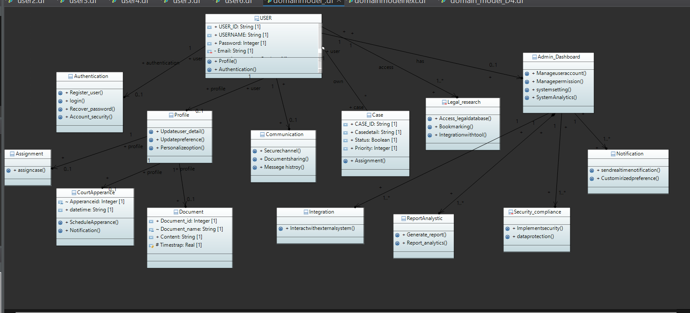

SYSTEM SEQUENCE DIAGRAM:

Notification:

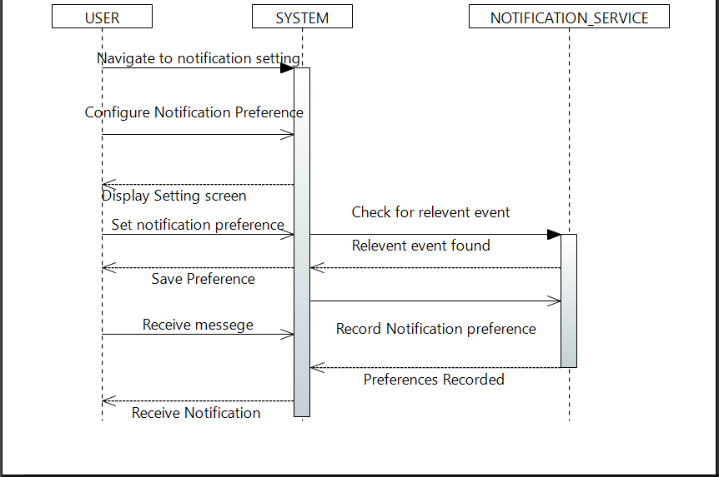

Case creation:

# 

Court APPERANCE:

# 

REPORT: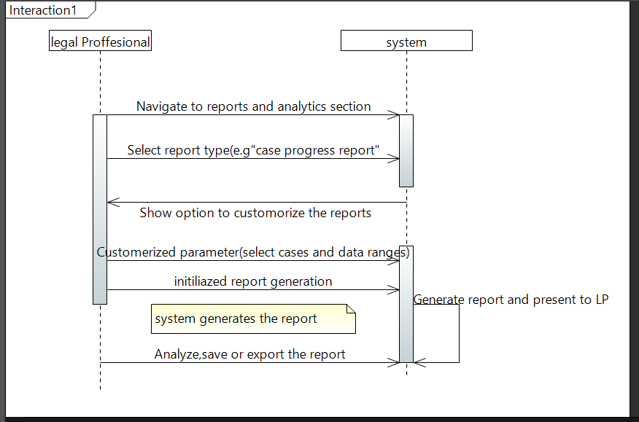

Research: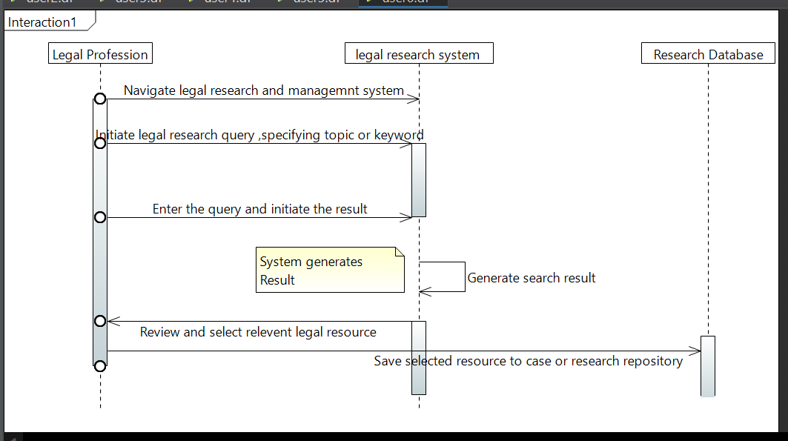

Case tracking:

# 

SYSTEM SEQUENCE DIAGRAM:

Notification:

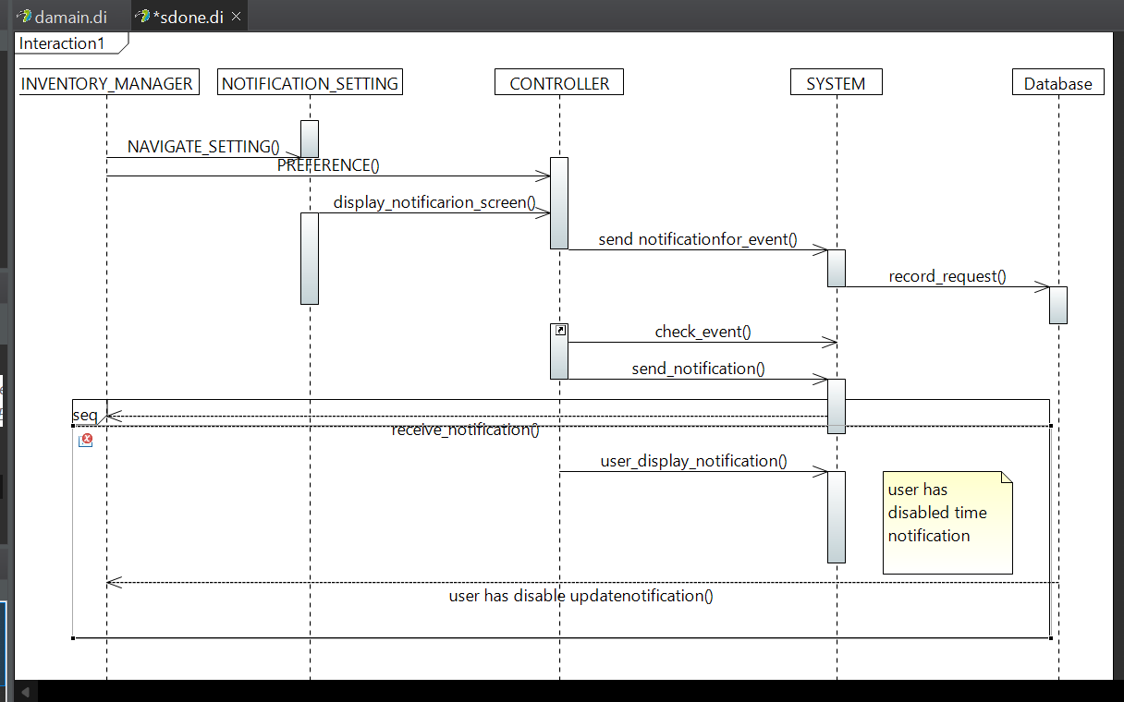

Case creation:

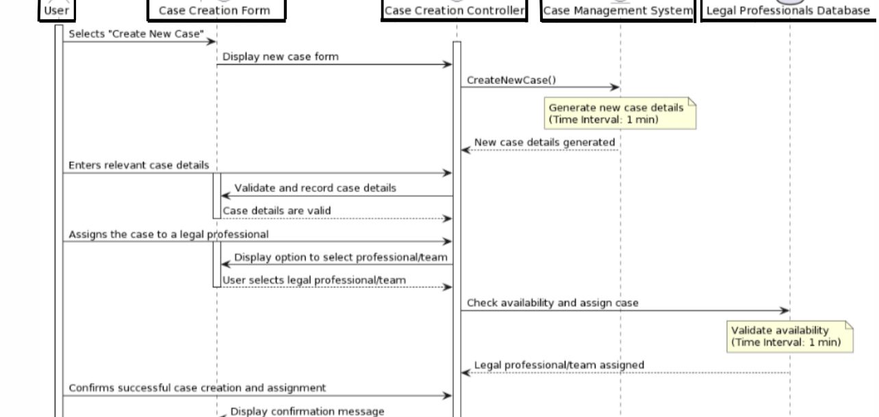

Court APPERANCE:

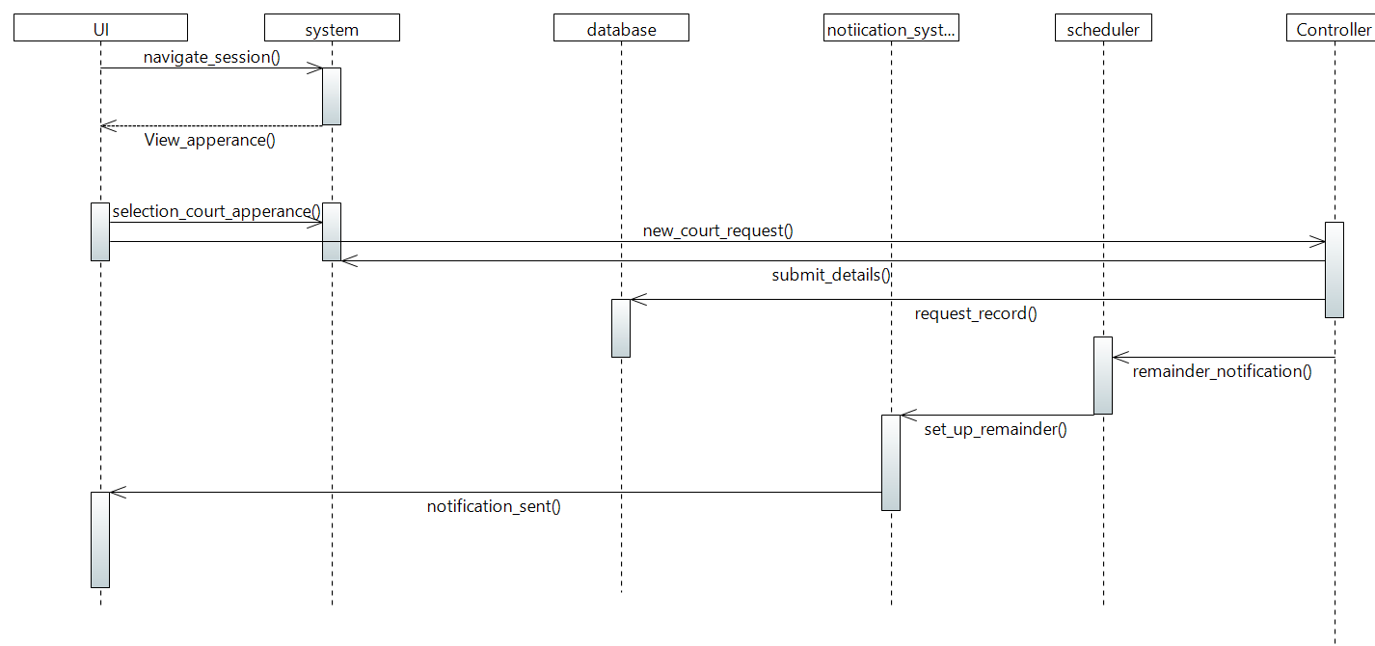REPORT:

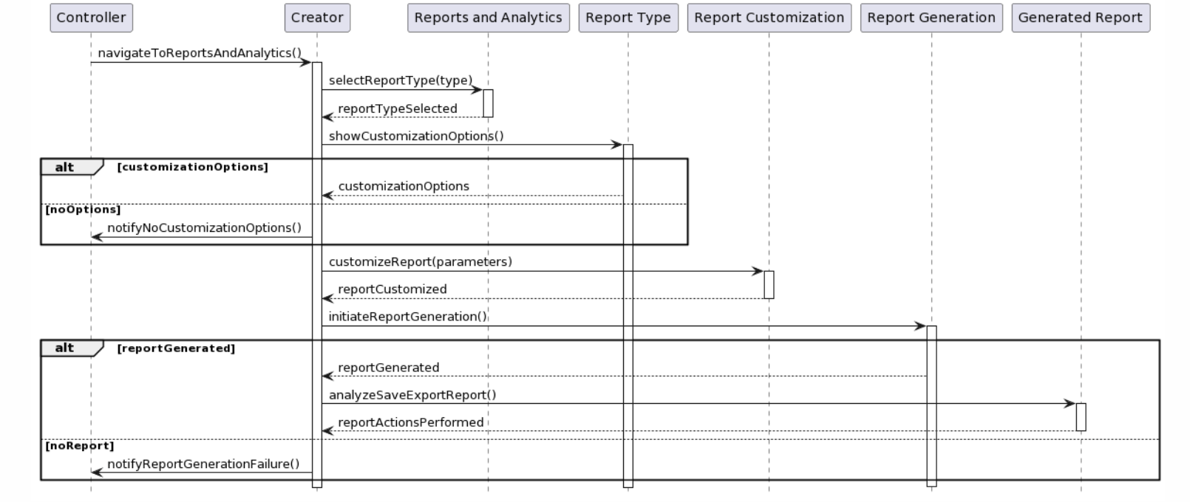

Research:

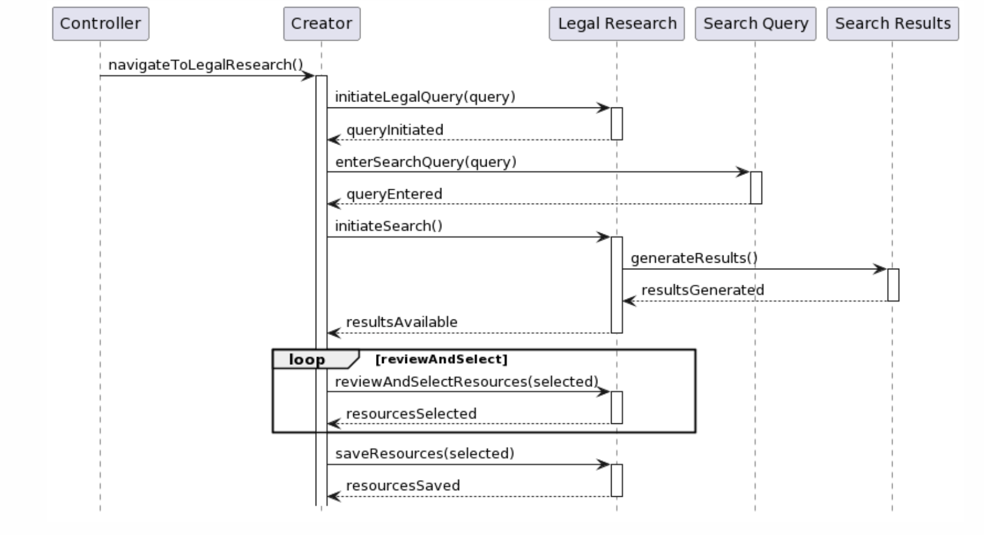

Case tracking:

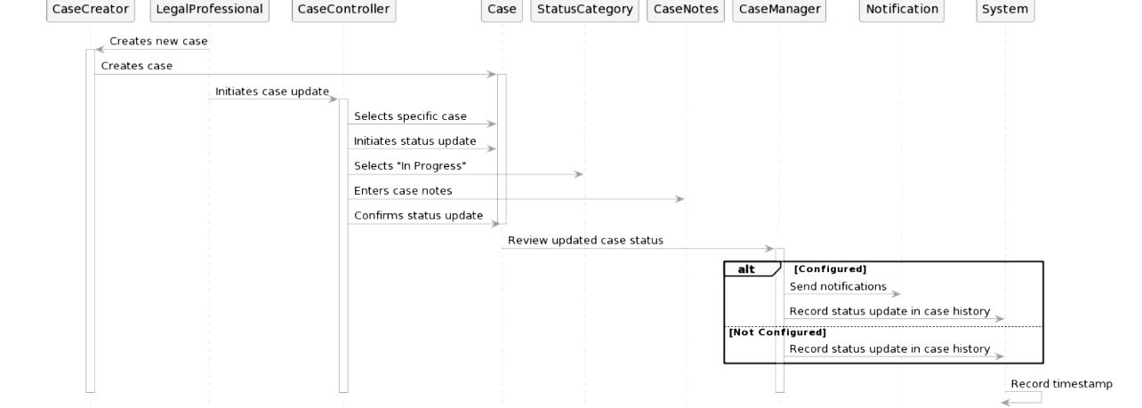

Class Diagram

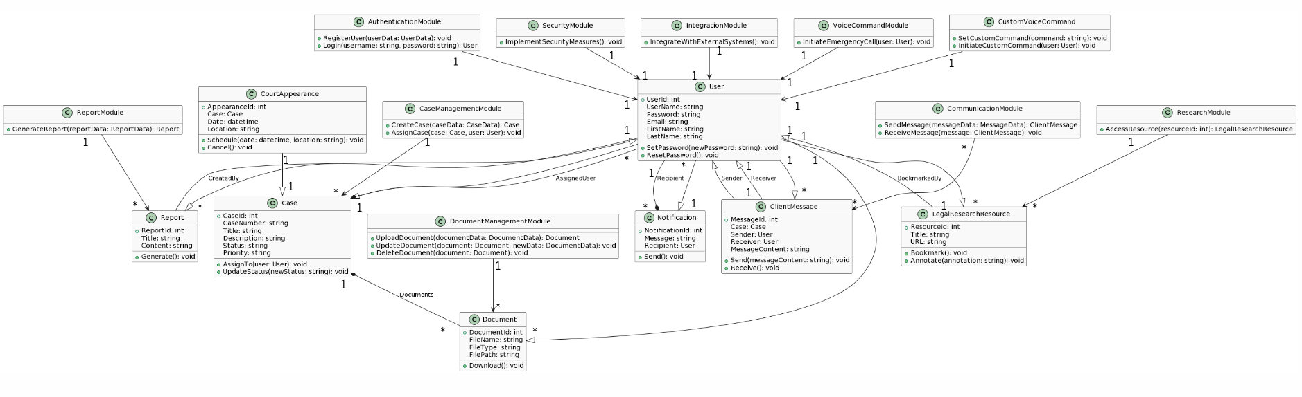

Deployment Diagram

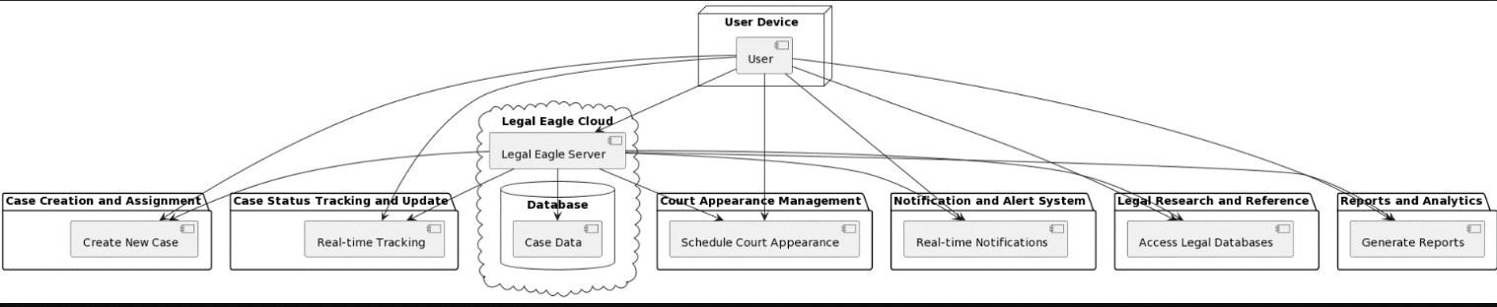

Package Diagram:

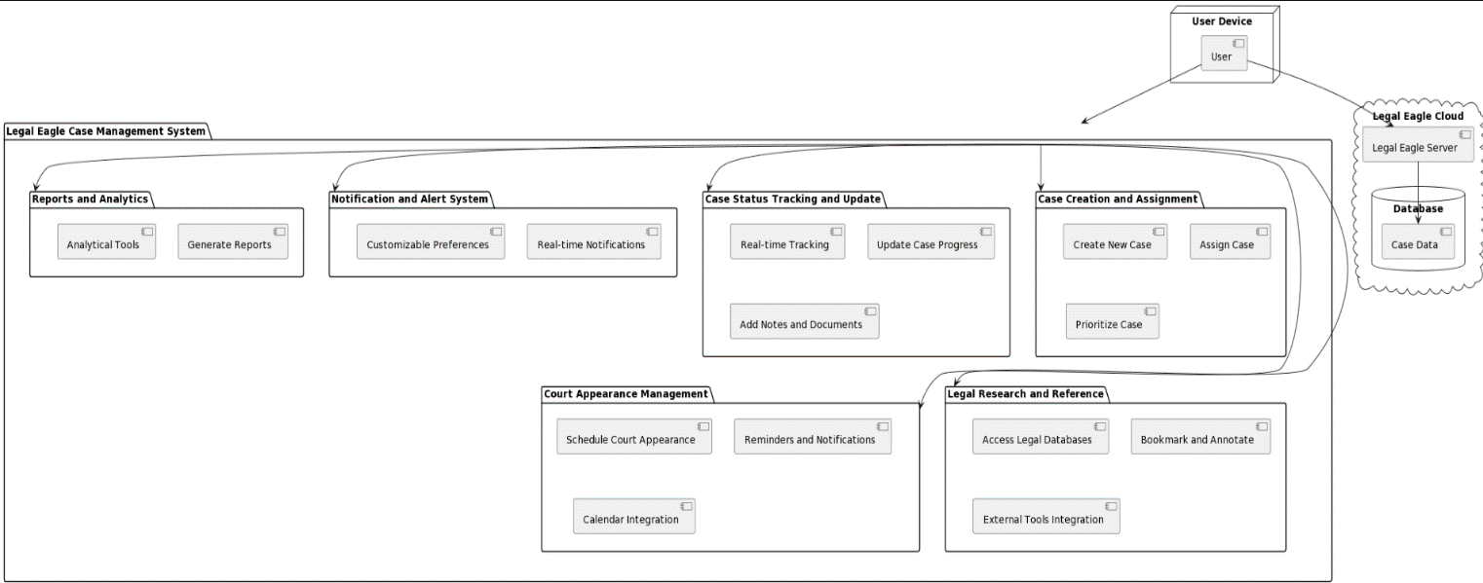

LOGIN Diagram

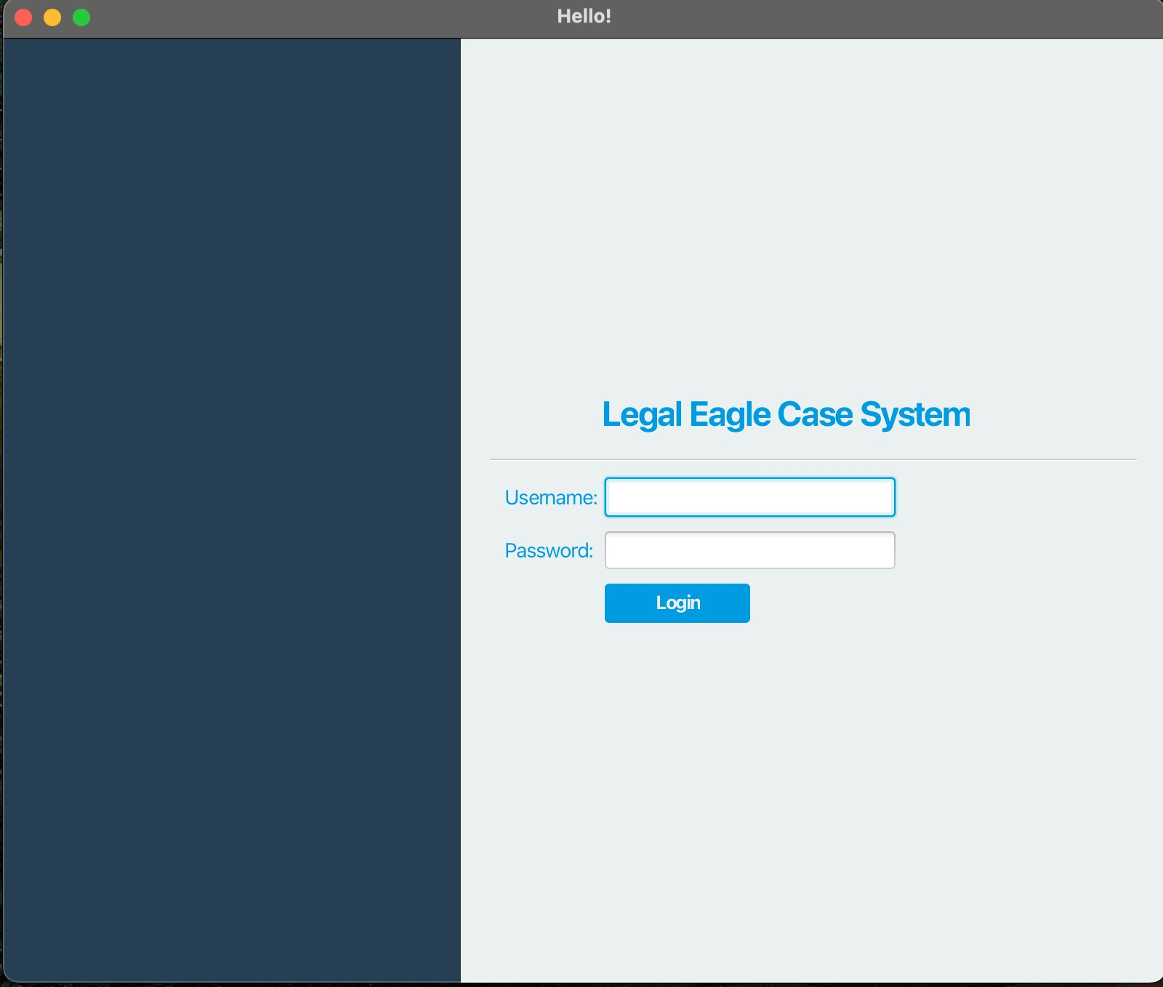

Case Status

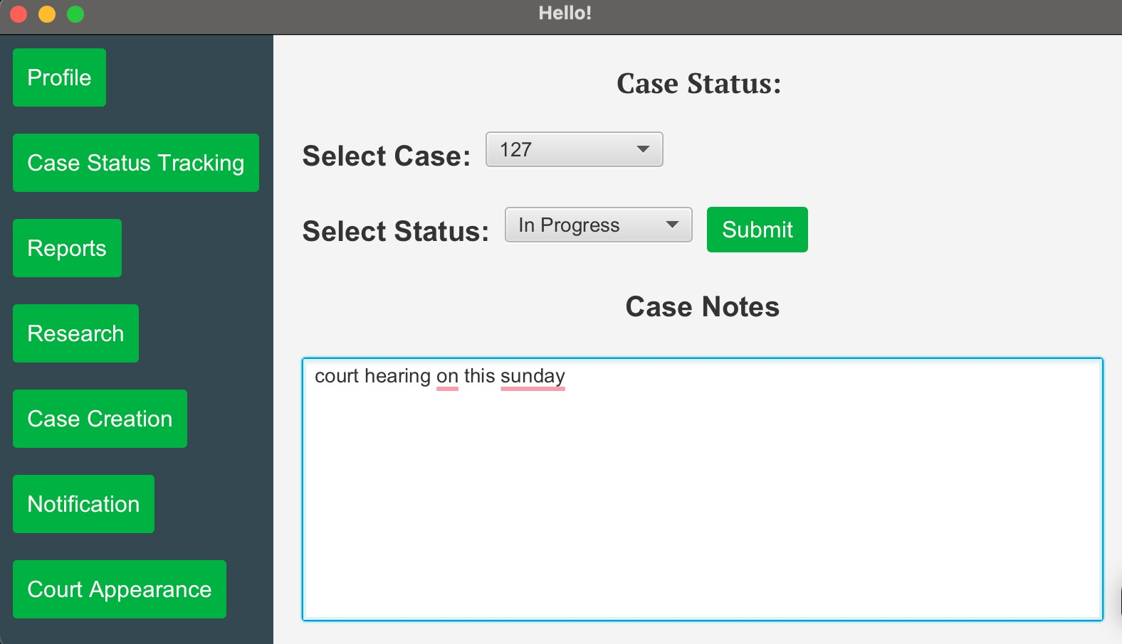

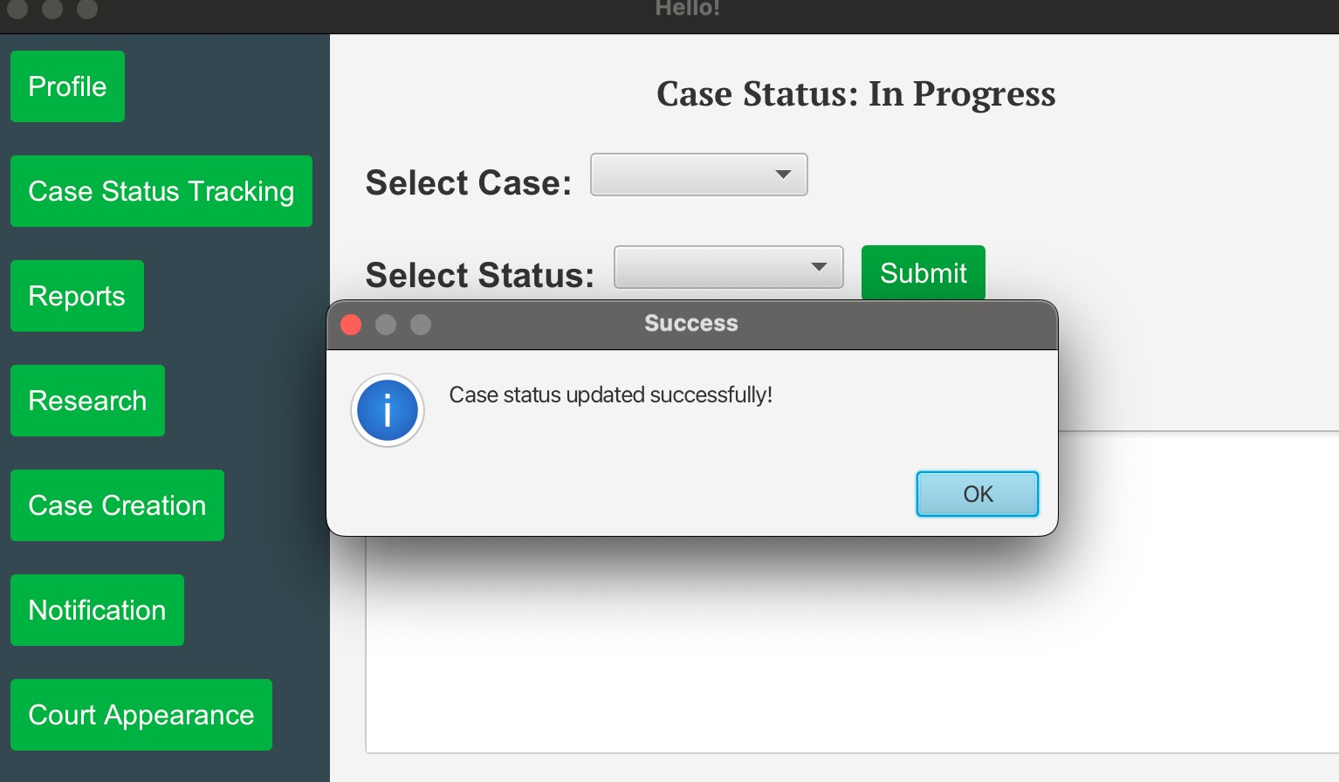

Report

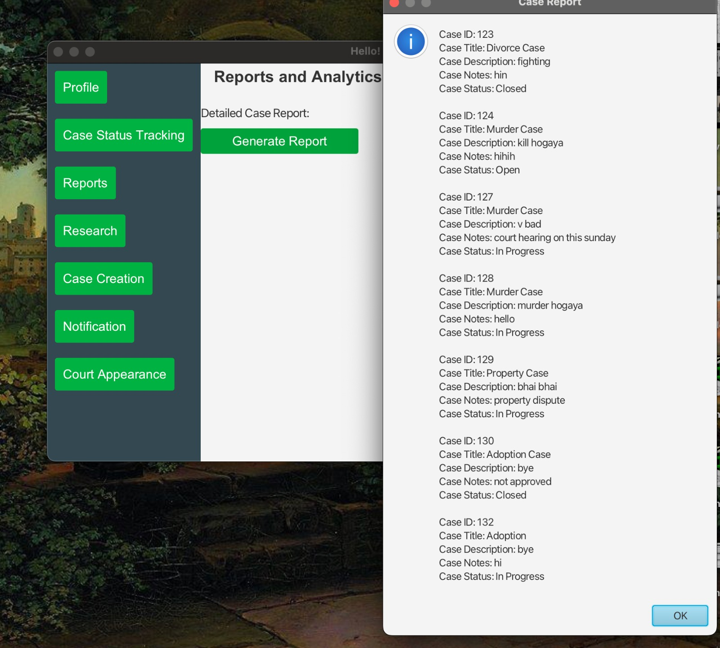

Research

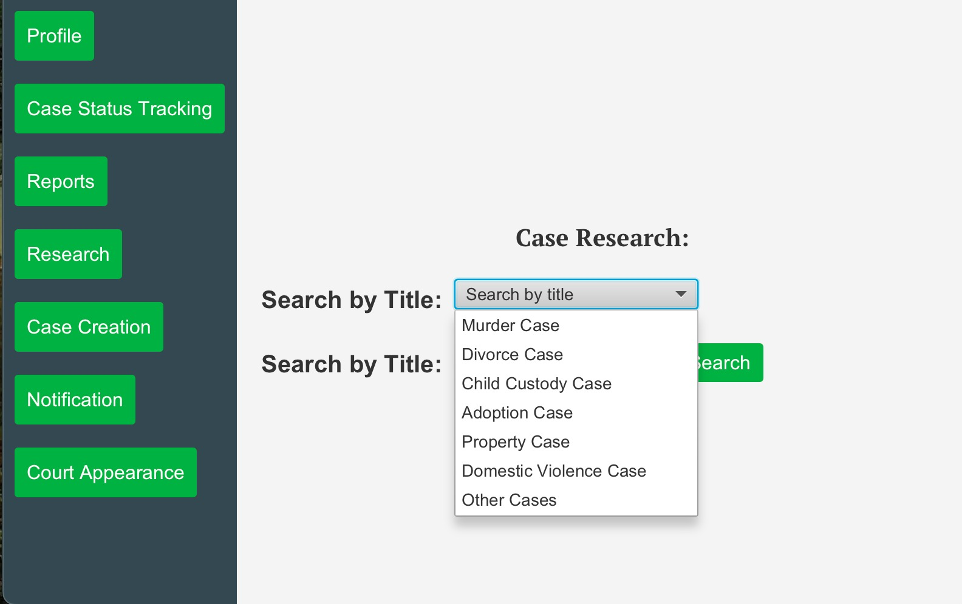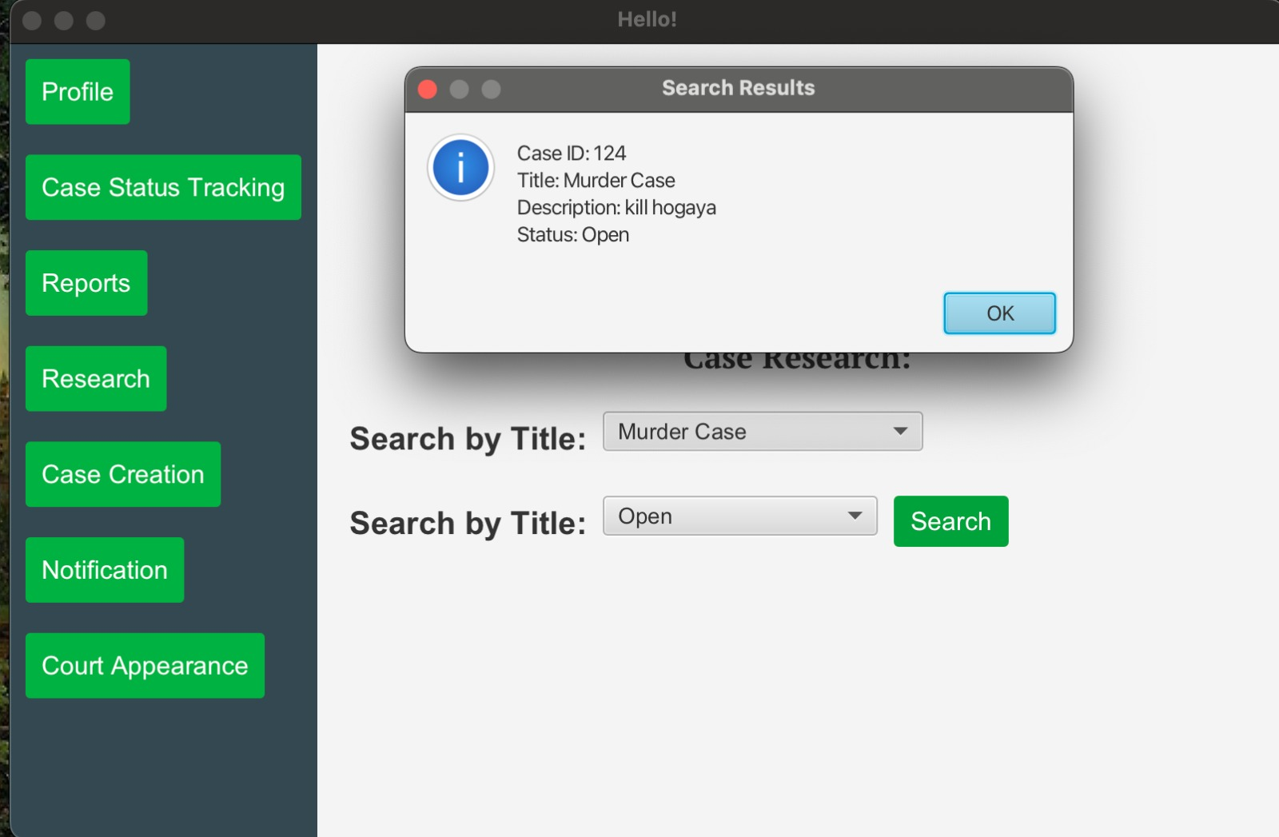

Case Creation

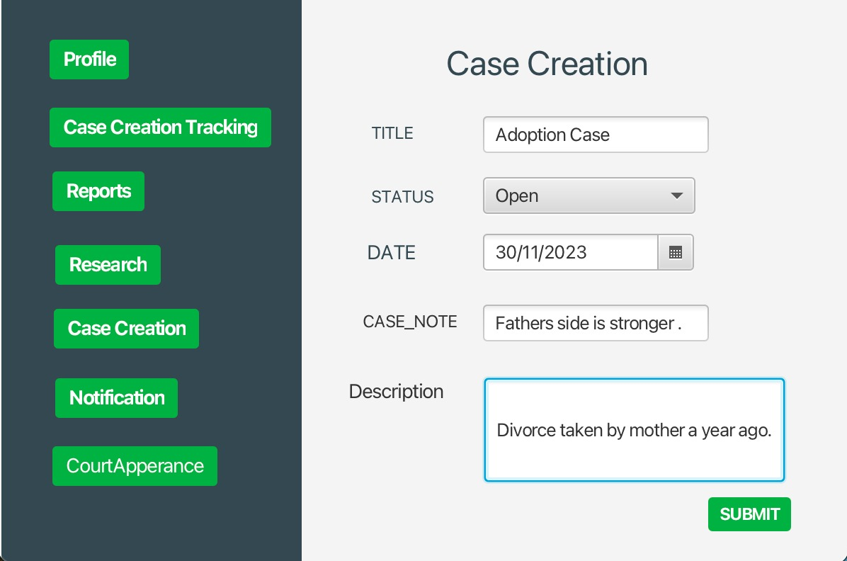

Court Appearance

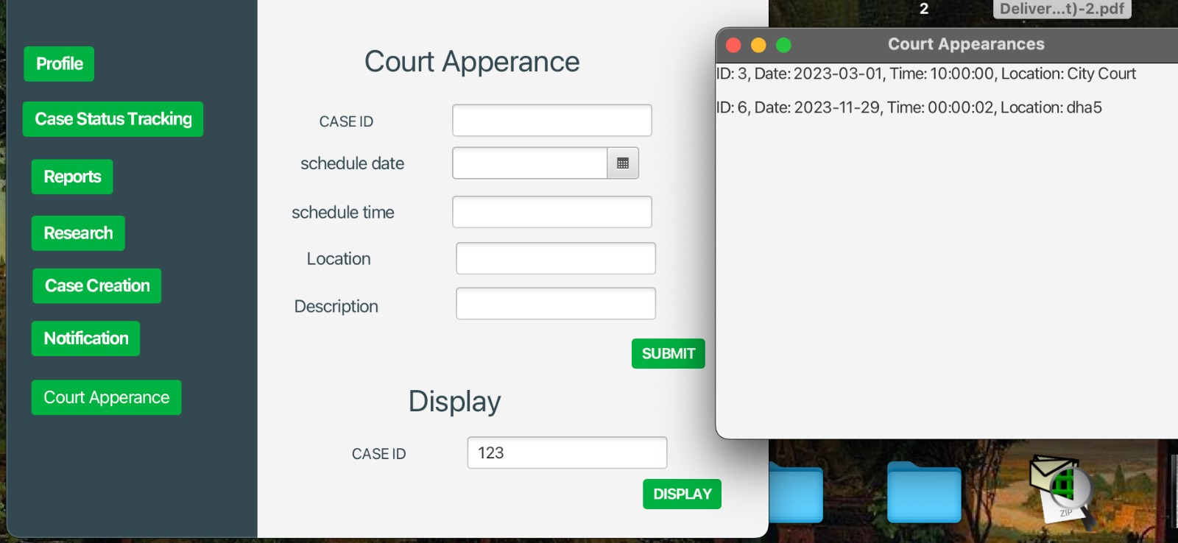

Notification

