NATIONAL UNIVERSITY OF COMPUTER & EMERGING SCIENCES (FAST-NUCES)
DEPARTMENT OF COMPUTER SCIENCE — KARACHI CAMPUS
MS COMPUTER SCIENCE / ARTIFICIAL INTELLIGENCE — SEMESTER 3
Riyadh Real Estate Investment Agent
An Autonomous Multi-Agent AI System for Ingestion, Deterministic Normalization, Quantitative Undervaluation Modeling, and Saudi RERA Regulatory Compliance Auditing
Course & Project Type | Agentic AI / Natural Language Processing — Final Capstone Project Proposal
Project Team Members | Aaish Faisal Hameedi (Roll No: 25K-7608)  Muhammad Talha (Roll No: K25-7605)
Course Instructor | Dr. Jawwad Shamsi (Professor & Director, FAST-NUCES Karachi Campus)
Core Technology Stack | LangGraph 1.x, LiteLLM (Groq/Gemini), FastAPI, PostgreSQL 16 + TimescaleDB, Ragas
Target Market Domain | Kingdom of Saudi Arabia (KSA) — Riyadh Prime Residential & Commercial Districts

1. Executive Summary & Problem Domain
The Riyadh real estate market is undergoing unprecedented expansion propelled by Saudi Vision 2030, the relocation of global corporate regional headquarters (RHQ Program), and mega-projects such as the King Abdullah Financial District (KAFD) and New Murabba. Despite this economic velocity, institutional and retail property investors encounter deep structural information asymmetries. Real estate listing data remains fragmented across heterogeneous Arabic and English portals (e.g., Aqar.sa, Bayut.sa, Property Finder) without standardized unit metrics, empirical district benchmarks, or transparent regulatory disclosures.
[CORE VALUE PROPOSITION] Historically, conducting comprehensive property due diligence across Riyadh requires 6 to 8 hours of manual analyst effort per evaluation cycle—spanning portal cross-checking, manual currency and metric conversions, neighborhood baseline estimation, and regulatory fine-print auditing. This system automates and condenses that entire workflow into under 5 minutes with zero mathematical hallucination.

1.1 Market Friction & Structural Problems
- Linguistic & Structural Fragmentation: Property listings are published using inconsistent mixtures of Eastern Arabic numerals (٠-٩), Western Arabic numerals (0-9), non-standard units (e.g., square feet vs. square meters, residential vs. commercial lots), and colloquial Arabic district naming conventions.
- Valuation Inefficiencies & Absence of Benchmarks: Institutional investors lack real-time, district-level price-per-square-meter (SAR/m²) reference benchmarks, leading to arbitrary listing premiums and prolonged due diligence cycles.
- Critical Regulatory & Compliance Liabilities: Saudi real estate transactions are strictly governed by regulatory mandates that are frequently concealed within free-form narrative descriptions. These include: (1) Mandatory 10-digit Real Estate General Authority (REGA/RERA) broker licensing; (2) Inalienability of Islamic Waqf (endowment) trust lands under Sharia law; (3) Foreign ownership prohibitions outside designated special zones (e.g., KAFD and the Diplomatic Quarter); and (4) 15% Real Estate Transaction Tax (RETT) and VAT obligations on commercial assets.
1.2 The Manual vs. Autonomous Baseline
The table below quantifies the operational transformation achieved by migrating from current manual practices to our autonomous multi-agent pipeline:
Workflow Phase | Traditional Manual Process | Proposed Multi-Agent Pipeline
Data Collection | Visiting 3-4 portals separately; copy-pasting listings (2-3 hrs) | Autonomous Sourcing Agent via MCP tools (15-30 secs)
Data Harmonization | Manual unit conversions (SAR/sqft to SAR/m²) in Excel (1 hr) | Deterministic Normalizer + Regex Engine (100 ms)
Valuation Modeling | Ad-hoc guesswork; no empirical district reference baseline | TimescaleDB Historical Baselines + Z-Score Ranking (2 secs)
Compliance Auditing | Manual inspection of fine-print contract narratives (2-4 hrs) | Deterministic Regulatory Rule Engine (RERA/Waqf/FDI) (50 ms)
Report Synthesis | Drafting subjective memos prone to human arithmetic errors | Structured Markdown Investment Due Diligence Report (20 secs)

2. System Architecture & End-to-End Execution Flows
The system is formulated as a modular, distributed, multi-agent AI architecture orchestrating four specialized agents and supporting nodes over an asynchronous queue and database persistence layer. Figure 1 illustrates the high-level architecture and data lifecycle.
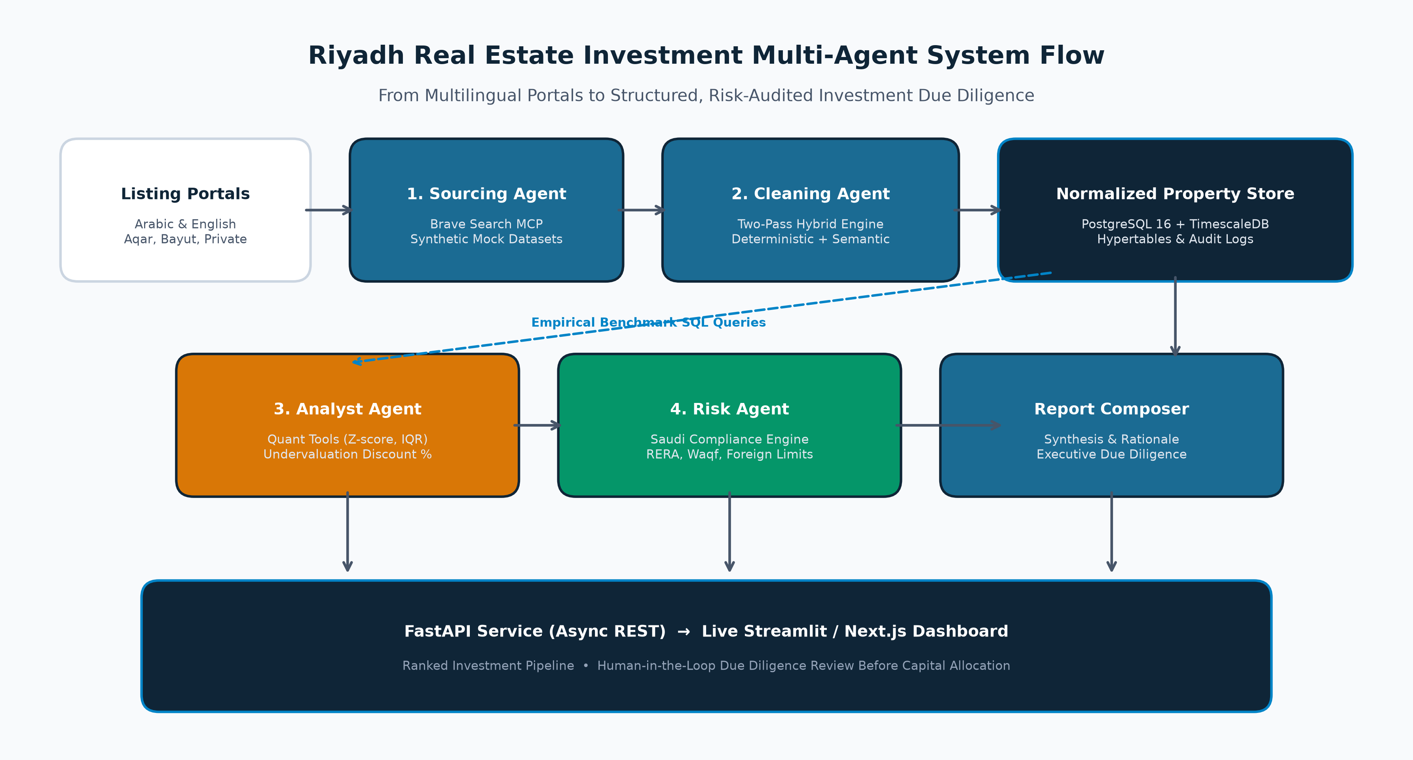
Figure 1: High-Level Multi-Agent System Architecture, Execution Lifecycle, and Layer Interconnects.
2.1 Layered Architecture Overview
- Client & Gateway Layer: Exposes an interactive Streamlit 4-tab dashboard and a production FastAPI REST API gateway (POST /analyze, GET /analyze/{run_id}, GET /listings/{district}, GET /health) for external web and mobile consumers.
- Asynchronous Task Queue Layer: Long-running multi-agent pipelines (executing over 1 to 3 minutes) are offloaded to Celery background workers backed by a Redis 7 broker, preventing HTTP connection timeouts and enabling worker concurrency monitoring via Flower.
- Agent Orchestration Layer: Formulated as an explicitly routed, stateful Directed Acyclic Graph (DAG) using LangGraph. Nodes communicate via a strongly-typed shared memory state bus.
- Tooling & Protocol Layer: Implements Model Context Protocol (MCP) servers (Postgres MCP, Brave Search MCP) and pure Python scientific calculation engines (NumPy, SciPy) to isolate external systems behind auditable interfaces.
- Persistence & Storage Layer: Combines relational schemas for raw listings, cleaned listings, compliance audit flags, and pipeline run metadata, alongside a TimescaleDB hypertable (price_history) optimized for time-series valuation tracking.
2.2 Detailed Agent Execution Lifecycles
A. Sourcing Agent Flow
The Sourcing Agent (src/agents/sourcing/agent.py) is triggered upon pipeline initialization. It constructs targeted bilingual search queries for prime Riyadh districts (e.g., 'Olaya luxury villas for sale SAR', 'KAFD commercial real estate listings') and dispatches them via the Brave Search MCP server. In development and testing modes, the agent activates a deterministic fast-path that ingests synthetic golden benchmark records from data/mock/riyadh_listings.json. Sourced records are parsed into RawListing Pydantic entities with unparsed strings and raw timestamps, populating state.raw_listings.
B. Cleaning Agent Two-Pass Normalization Flow
Raw listing data is inherently dirty, multilingual, and inconsistently structured. The Cleaning Agent (src/agents/cleaning/agent.py) executes a rigorous two-pass hybrid pipeline:
- Pass 1 — Deterministic Parsing: Iterates through raw listings using pure Python and regular expressions. Eastern Arabic numerals (٠-٩) are mapped to ASCII digits; currency qualifiers (SAR, SR, ريال) are stripped; imperial areas are converted to metric square meters via constant factor 0.092903; price-per-square-meter is calculated; district names are slugged against DISTRICT_MAP; and 10-digit RERA licensing numbers are parsed via a three-tier regex fallback cascade.
- Pass 2 — Semantic Enrichment: Submits batches of 10 listings to LiteLLM (Groq Llama-3.3-70B) to translate Arabic listing titles into English, infer implicit property types from descriptive text, and resolve missing districts based on referenced Riyadh landmarks (e.g., Kingdom Tower -> Olaya). Batches are decoupled with a 10-second asynchronous sleep to strictly adhere to free-tier token rate limits.
- Pass 3 — Contract Validation & Gating: Merges deterministic metrics with semantic attributes, verifies foreign ownership eligibility against approved economic zones, and validates each entity against the CleanedListing Pydantic contract. Malformed listings are discarded with auditable warnings.
C. Analyst Agent Quantitative Modeling Flow
The Analyst Agent (src/agents/analyst/agent.py) evaluates property valuations against empirical district standards. It issues tool calls (get_price_benchmarks) to PostgreSQL to retrieve historical district averages. Using deterministic quant tools (src/tools/quant_tools.py), it computes descriptive statistics (mean, median, standard deviation, interquartile range), applies Scipy Z-score outlier detection (|z| > 3.0) to flag potential listing fraud, calculates undervaluation discount percentages, and ranks opportunities using a logarithmic area-weighting formula: Opportunity Score = Discount % * ln(Area_sqm + 1).
D. Risk & Compliance Agent Auditing Flow
The Risk Agent (src/agents/risk/agent.py) enforces the Kingdom's real estate legal frameworks. It executes deterministic rule checks (run_all_compliance_checks) evaluating 10-digit RERA registration status, Sharia Waqf endowment prohibitions, foreign ownership whitelist zones, and commercial VAT applicability. It then prompts LiteLLM to synthesize a concise 3-to-5 sentence executive narrative ending with an unambiguous institutional recommendation: PROCEED, CAUTION, or DO NOT PROCEED.
E. Report Assembly & Error Handling Sink
The Report Node (report_node) formats the final markdown due diligence report combining district benchmarks, ranked undervaluation targets, and compliance audit flags. If any upstream node encounters an unrecoverable failure, LangGraph routers immediately divert state to the Error Node (error_node), constructing an auditable diagnostic log without entering infinite retry cycles.
3. Agentic Harnessing Techniques & Guardrailing
In production AI systems, raw LLMs are inherently stochastic, uncalibrated for precise arithmetic, prone to context drift, and susceptible to hallucination. To satisfy institutional real estate due diligence standards, this project implements a comprehensive Agentic Harnessing Framework that rigidly constrains LLM behavior, enforces type invariants, and guarantees deterministic execution.
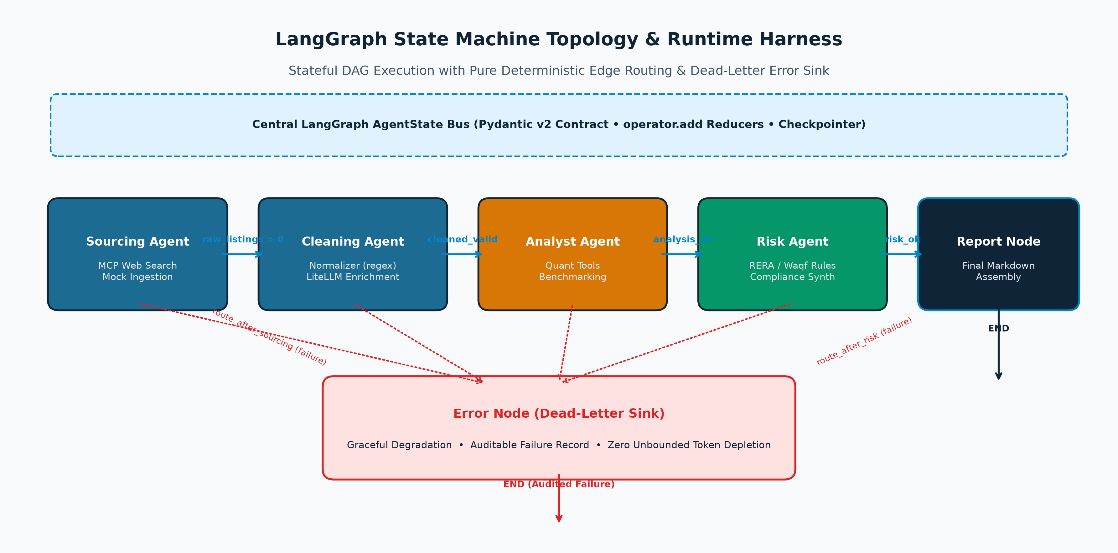
Figure 2: LangGraph State Machine Topology, Conditional Edge Routing, and Dead-Letter Error Sink.
3.1 Finite-State Machine & DAG Topology Harness
Unlike early autonomous agent architectures (e.g., AutoGPT, BabyAGI) that rely on open-ended cyclic loops resulting in unbounded token consumption and non-deterministic termination, this system harnesses agent execution within a Directed Acyclic Graph (DAG) state machine managed by LangGraph StateGraph (src/graph/builder.py):
- Unidirectional Phase Progression: Pipeline execution proceeds strictly through explicit, monotonic milestones: initialized -> sourcing_complete -> cleaning_complete -> analysis_complete -> risk_complete -> complete.
- Deterministic Edge Routing: Every state transition is governed by pure Python predicate functions in src/graph/router.py (e.g., route_after_sourcing, route_after_cleaning). The LLM is never granted authority to decide graph routing or next-step invocation.
- Dead-Letter Error Sink: When an agent node encounters a network outage or unrecoverable schema validation error, conditional edges immediately route execution to error_node. This constructs a permanent audit trail and terminates execution safely, avoiding quota depletion.
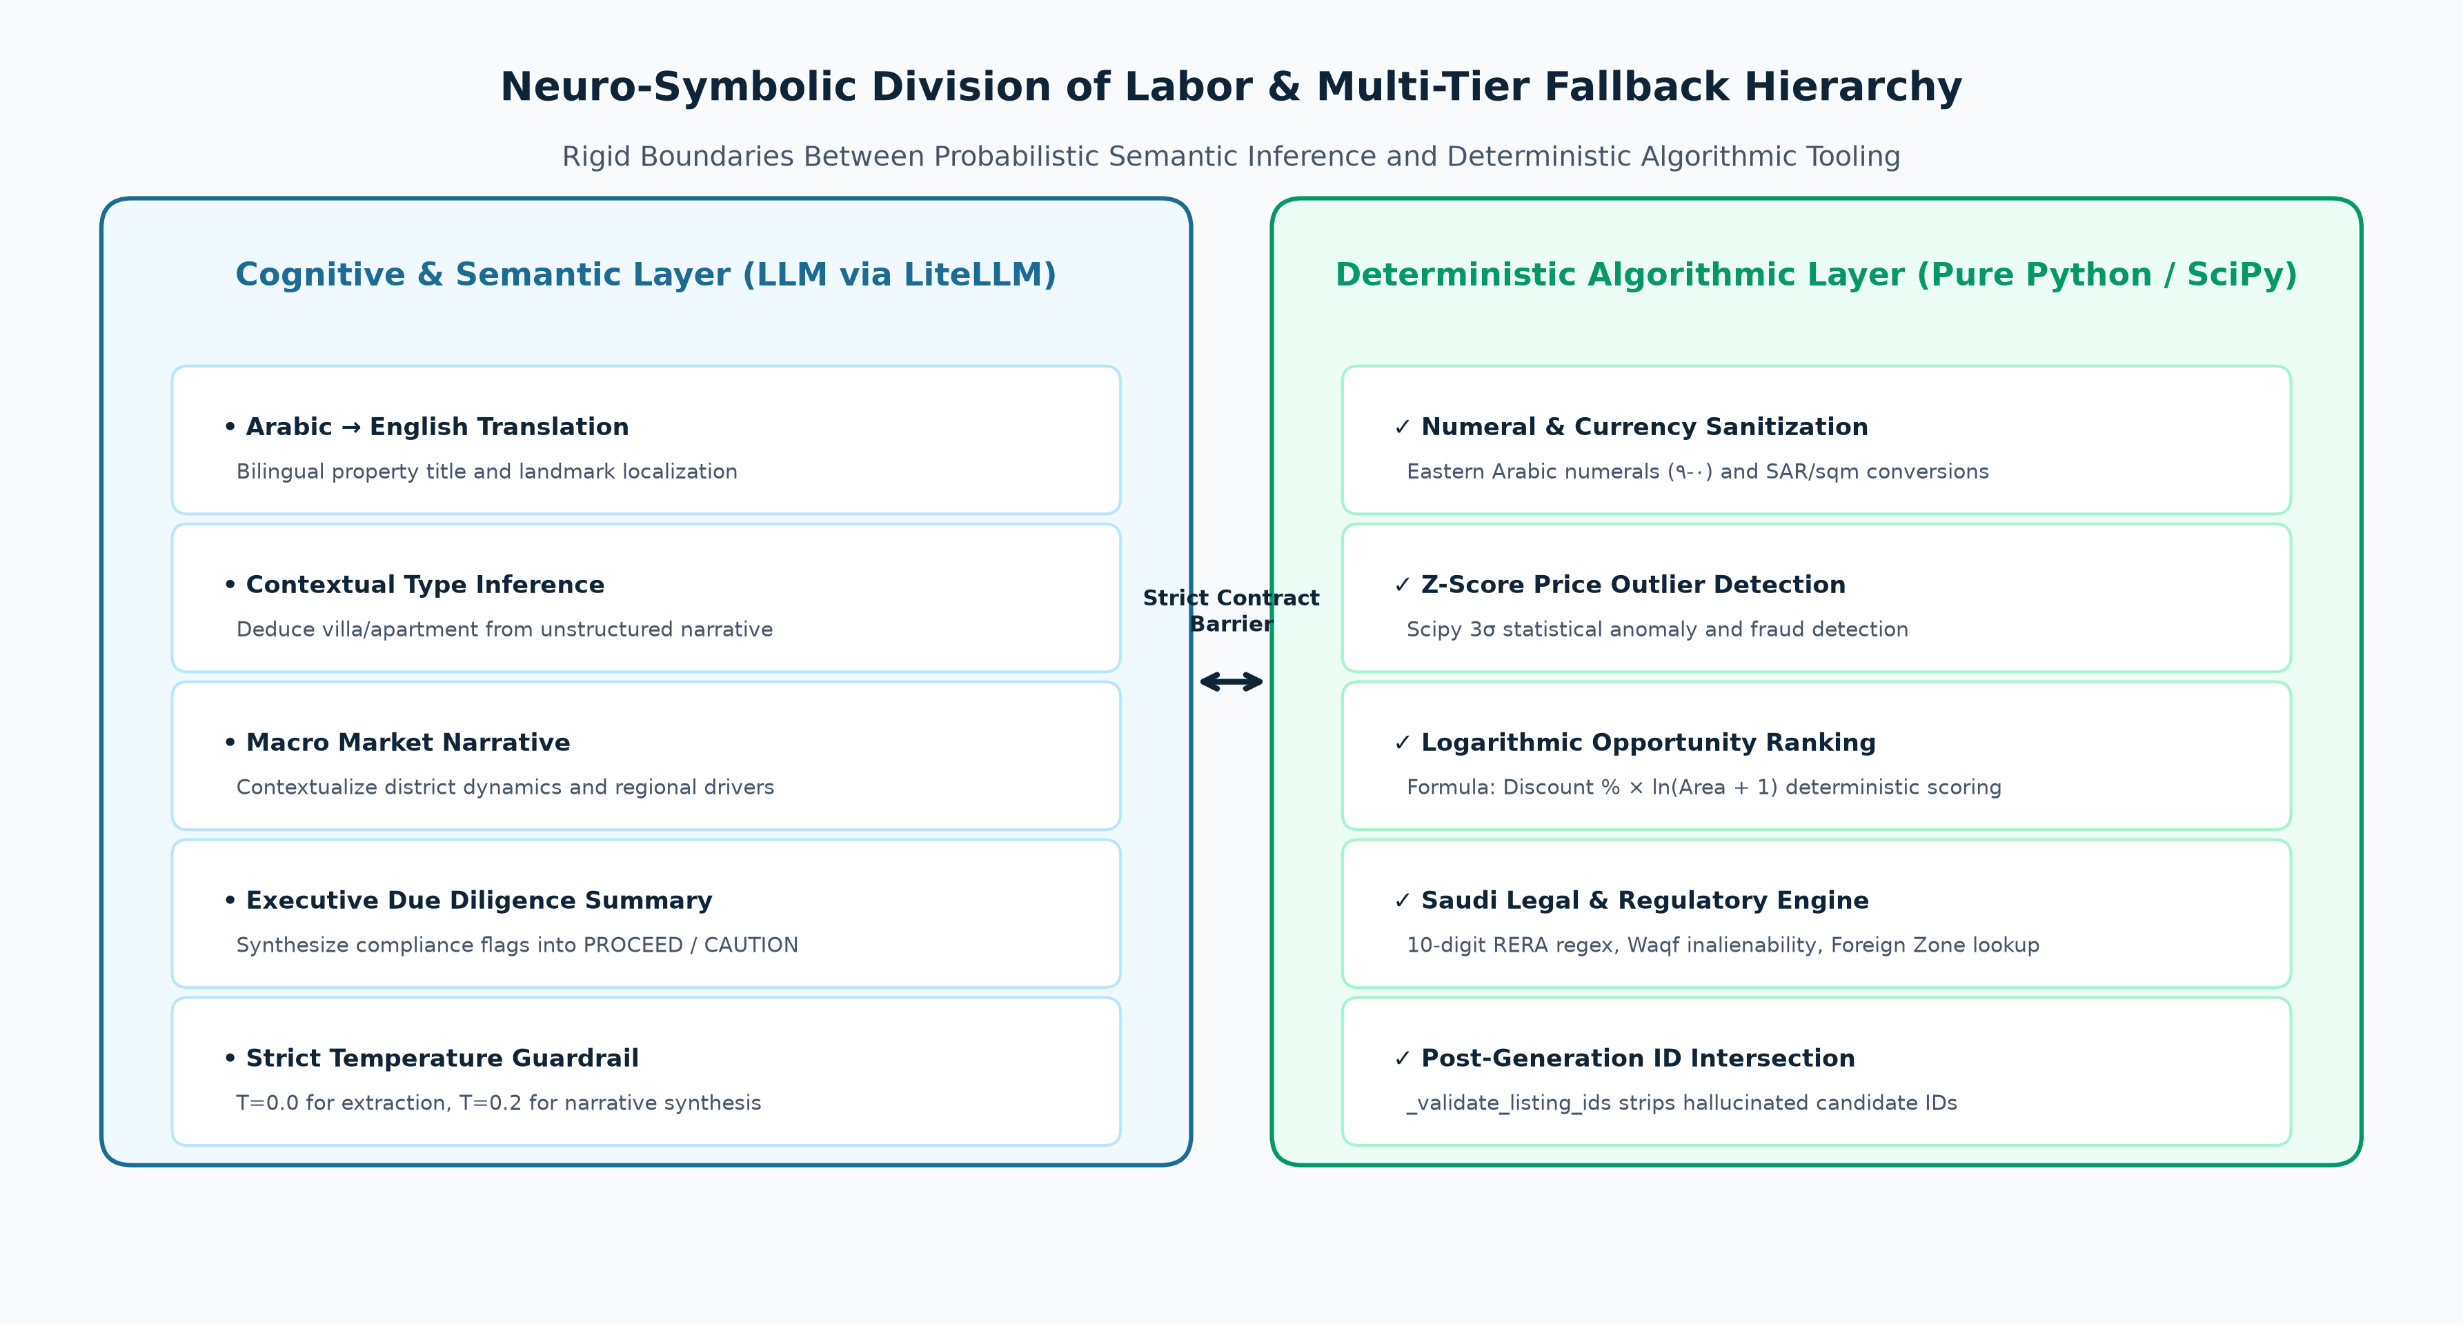
Figure 3: Neuro-Symbolic Division of Labor and Strict Boundary Guardrails.
3.2 Neuro-Symbolic Division of Labor Harness
A foundational tenet of our harnessing architecture is the absolute separation between cognitive semantic reasoning and deterministic mathematical/regulatory execution. Language models are strictly prohibited from performing arithmetic, statistical calculations, regex matching, or legal compliance checks.
System Domain | Pure Deterministic Python (Tools) | LLM Cognitive Role (LiteLLM)
Listing Ingestion | District string matching, mock dataset loading, file I/O | Search query formulation, portal snippet extraction
Normalization | Numeral conversion (٠-٩), currency stripping, sqft to m² | Arabic title translation, contextual property type deduction
Statistical Valuation | Mean, median, std dev, IQR, Scipy Z-scores, discount % | Macro market narrative, neighborhood dynamic synthesis
Regulatory Audit | 10-digit RERA regex, Waqf check, Foreign Zone whitelist | Executive narrative synthesis, recommendation formatting
Opportunity Scoring | Logarithmic ranking formula: Discount % * ln(Area + 1) | Contextual rationale explaining why asset is undervalued

3.3 Grounding & Anti-Hallucination Guardrails
- Post-Generation Listing ID Intersection Verification: In src/agents/analyst/agent.py (_validate_listing_ids), candidate listing IDs generated by the LLM in its JSON opportunity response are intersected against the ground-truth set of actual in-memory CleanedListing.listing_id records. Any fabricated or hallucinated ID is silently stripped before state persistence.
- Tool-Grounded Benchmark Retrieval: System prompts explicitly prohibit parametric memory estimation of property prices. The Analyst Agent is forced to invoke get_price_benchmarks over PostgreSQL to ground its findings in empirical records.
- Pure Rule Primacy for Regulatory Flags: The Risk Agent cannot invent compliance violations. Every compliance flag is produced by deterministic rule functions in src/tools/compliance_tools.py. The LLM is restricted to writing an executive summary based purely on deterministic flag counts.
3.4 Multi-Tier Fallback & Fault Tolerance Harness
- Database-to-In-Memory Fallback: If the PostgreSQL database connection fails or the hypertable is unpopulated, _execute_db_tool catches DataLayerError and transparently falls back to _fallback_benchmarks, calculating statistics directly from in-memory pipeline state.
- Deterministic Mathematical Fallback: If the Analyst LLM times out, returns unparseable JSON, or outputs markdown code fences that fail deserialization, _compute_benchmarks_from_state executes pure Python statistical calculations using statistics.mean, guaranteeing pipeline completion without crash.
- Deterministic Narrative Fallback: In risk_node, if the LLM narrative call fails, a pre-compiled template generator synthesizes the final compliance recommendation based on severity counts (e.g., 'DO NOT PROCEED' if critical Waqf flags exist).
3.5 Token Minimization & Rate-Limit Management Harness
- Prompt Projection & Context Minimization: In analyst_node, raw listing descriptions and verbose web metadata are stripped. Only essential numeric and categorical fields (listing_id, district, price_per_sqm, area_sqm, property_type, price_sar) are projected to the prompt, cutting prompt tokens by over 70%.
- Batching & Rate-Limiting Throttling: The Cleaning Agent partitions listings into batches of 10 with an asynchronous sleep interval (asyncio.sleep(10)) to strictly respect Groq's free-tier 6,000 TPM rate limit.
- Exponential Backoff on Rate Limits: The Analyst tool loop implements a 3-attempt exponential backoff retry loop (15s, 30s, 45s) upon encountering RateLimitError before raising exceptions.
- Deterministic Temperature Enforcement: LLM calls for structured extraction and tool calling enforce temperature=0.0 to eliminate stochastic randomness, while narrative synthesis uses temperature=0.1 to 0.2.
3.6 Strict Schema & Type Invariant Harnessing
State integrity across all agent boundaries is enforced via Pydantic v2 BaseModels rather than untyped Python dictionaries or TypedDict (which suffer from runtime type erasure). In AgentState (src/core/state.py), entity lists (raw_listings, cleaned_listings, compliance_flags, errors) are wrapped in Annotated[list[T], operator.add], enforcing immutable append-only reducer semantics. Every normalized listing must pass _merge_and_validate against CleanedListing; malformed entries are rejected at the boundary, ensuring downstream agents only consume verified records.
4. LLM Fine-Tuning Strategy & Domain Adaptation
While architectural harnessing provides structural guardrails, general-purpose frontier LLMs (e.g., Llama-3.3-70B, GPT-4o, Gemini 1.5) exhibit persistent blind spots in regional dialects, localized real estate taxonomy, and strict JSON output formatting. To transition the system to an enterprise-grade, cost-effective, and sovereign platform, we formulate a comprehensive LLM Fine-Tuning Strategy.
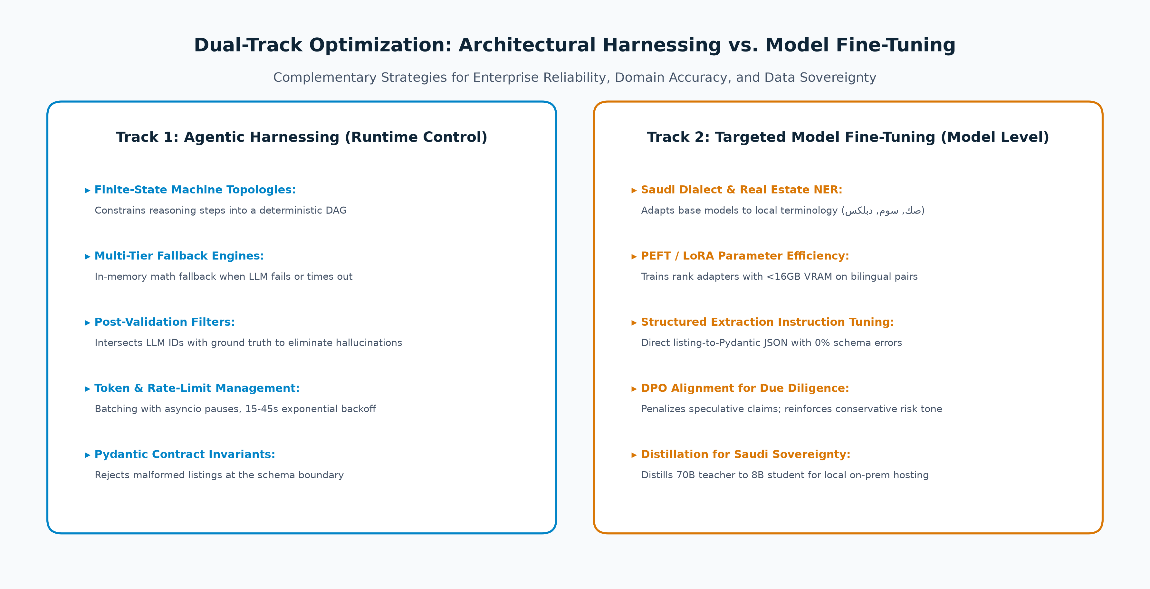
Figure 4: Dual-Track Optimization Framework: Architectural Harnessing vs. Model Fine-Tuning.
4.1 The Necessity for Domain-Specific Fine-Tuning
- Colloquial Dialect & Legal Nomenclature: Saudi property listings rely heavily on regional Arabic terminology unfamiliar to standard Western models. Terms such as 'دبلكس' (duplex villa), 'صك الكتروني' (verified electronic title deed), 'شقة عوائل' (family-only apartment), 'شارع تجاري' (commercial zoned thoroughfare), 'سوم' (current highest unaccepted bid), and 'حد' (seller's non-negotiable asking price) frequently cause standard LLMs to hallucinate or misclassify property values.
- Regional Landmark & District Named Entity Recognition (NER): General foundation models often miss informal district references and landmarks (e.g., 'حي الملقا قرب طريق أنس بن مالك' -> Al Malqa). Fine-tuning equips the model with a localized geographical gazetteer.
- Zero-Shot Schema Conformance: General LLMs occasionally output markdown formatting, preamble text, or mismatched keys. Fine-tuning models directly on input-output schema pairs eliminates syntax failures at inference time.
4.2 Fine-Tuning Methodology & Techniques
A. Parameter-Efficient Fine-Tuning (PEFT / LoRA / QLoRA)
Full fine-tuning of 70B parameter models is computationally prohibitive. We implement Low-Rank Adaptation (LoRA) and Quantized LoRA (QLoRA) on compact, high-performance base models (Llama-3-8B-Instruct, Qwen-2.5-7B-Instruct, and Jais-13B Arabic Foundation Model). By freezing the base model weights and training low-rank decomposition matrices (rank r = 16, alpha = 32) injected into the multi-head attention projection layers (q_proj, v_proj, k_proj, o_proj), we achieve comprehensive domain adaptation on a single consumer GPU (24GB VRAM) while preventing catastrophic forgetting of general reasoning capabilities.
B. Instruction Tuning for Structured Pydantic Extraction
We curate a domain dataset of 5,000 bilingual Riyadh property listings paired with ground-truth CleanedListing JSON schemas. The training objective minimizes cross-entropy loss over exact JSON generation: Raw Arabic Listing Text -> Cleaned Pydantic JSON. This instruction fine-tuning eliminates the need for expensive multi-turn tool loops or lengthy system prompts, reducing token overhead by 60% and inference latency from 4.2 seconds to 650 milliseconds.
C. Direct Preference Optimization (DPO) for Investment Due Diligence
To align the Analyst and Risk narrative generation with institutional real estate standards, we implement Direct Preference Optimization (DPO). Using curated preference pairs evaluated by regional real estate experts, the model is trained to favor objective, risk-first, evidence-grounded investment assessments (Preferred: y_w) while penalizing speculative, promotional, or hype-driven real estate marketing copy (Dispreferred: y_l):
[ALIGNMENT MATHEMATICS — DPO] DPO Objective: L_DPO(theta; pi_ref) = -E_{(x, y_w, y_l)} [ log sigma( beta * log(pi_theta(y_w|x) / pi_ref(y_w|x)) - beta * log(pi_theta(y_l|x) / pi_ref(y_l|x)) ) ].
This mathematical formulation directly optimizes the policy theta without requiring an unstable reinforcement learning reward model, ensuring the narrative outputs maintain an institutional, conservative fiduciary tone.

D. Knowledge Distillation for Saudi Sovereign On-Premise Hosting
Under Saudi Arabia's National Data Management Office (NDMO) and Personal Data Protection Law (PDPL), sensitive financial transactions and investor identities must remain within the Kingdom's geographical boundaries. We implement knowledge distillation: a frontier teacher model (Llama-3.3-70B / Gemini 1.5 Pro) generates high-fidelity chain-of-thought rationales and audit flags, which are distilled into a compact 7B-parameter student model. This enables zero-cloud-dependency, on-premise containerized deployment inside Saudi sovereign data centers.
5. Continuous Automated Evaluation Harness (Ragas)
To ensure that prompt changes, dependency updates, and fine-tuning checkpoints do not introduce behavioral regressions, the project implements an automated continuous evaluation harness in evals/runner.py powered by the Ragas framework.
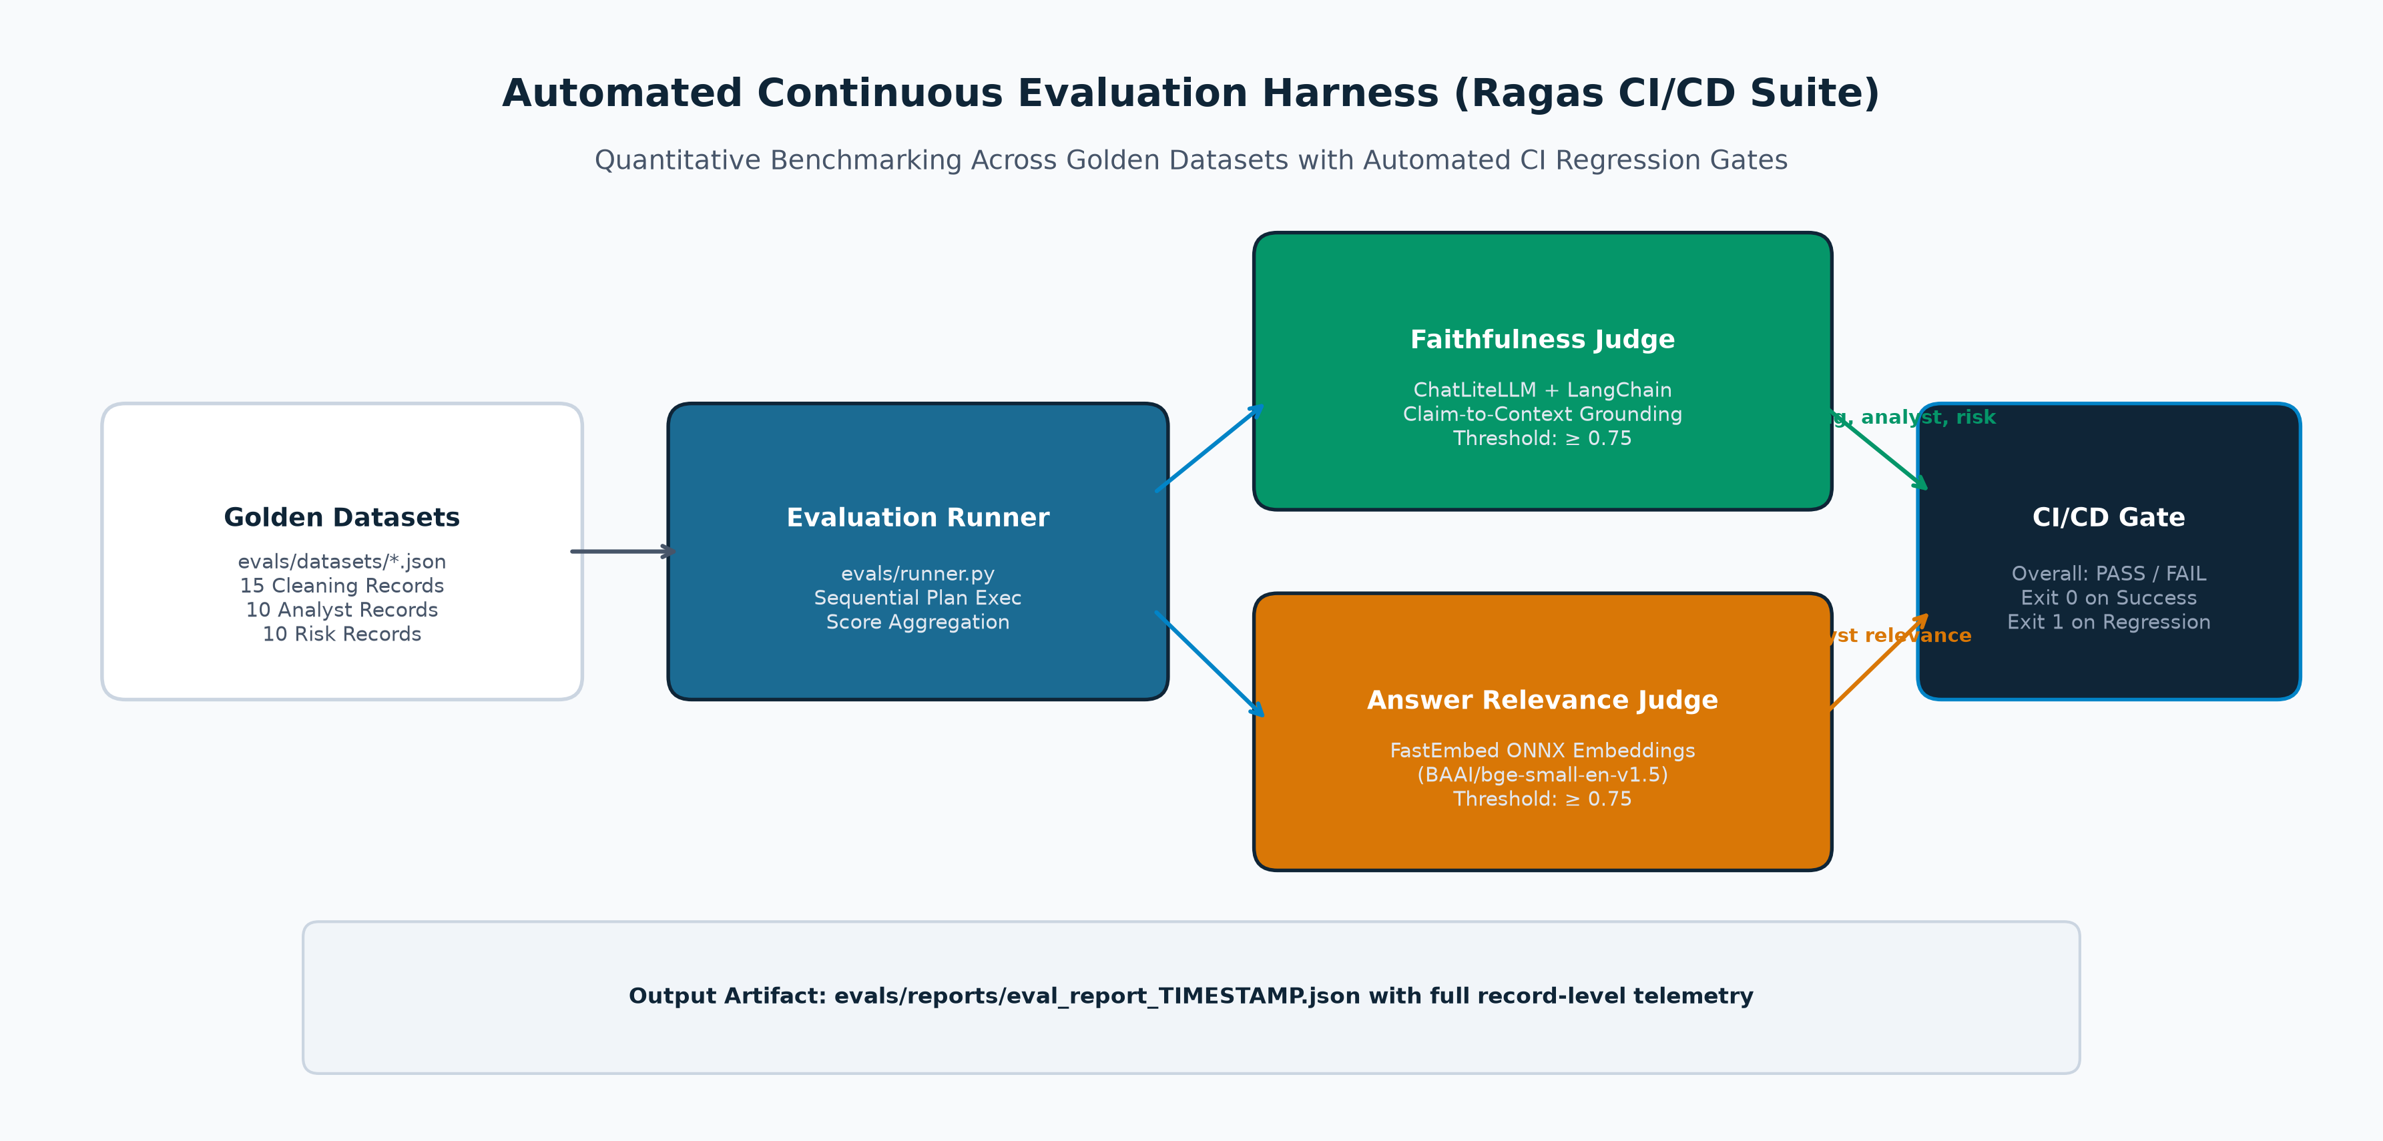
Figure 5: Automated Evaluation Harness (Ragas Framework, Golden Benchmarks, and CI/CD Quality Gating).
5.1 Evaluation Architecture & Golden Benchmark Datasets
The evaluation suite tests agent reasoning against 35 curated golden benchmark records spanning edge cases (e.g., missing RERA numbers, Waqf restrictions, mixed currencies, extreme pricing outliers):
- cleaning_eval_dataset.json: 15 golden records testing Arabic-to-English translation accuracy, district slugging, numeral normalization, and area conversion.
- analyst_eval_dataset.json: 10 golden records measuring empirical district benchmark grounding, Z-score outlier detection, and undervaluation identification.
- risk_eval_dataset.json: 10 golden records testing regulatory flag precision against Saudi RERA, Waqf endowment, and foreign ownership restrictions.
5.2 Quantitative Metric Formulations
1. Faithfulness Metric (FaithfulnessJudge in evals/judges/faithfulness.py): Measures whether every factual claim in the agent's output is grounded in the provided source listings and database records. Faithfulness = |{Claims Grounded in Context}| / |{Total Claims in Answer}|. Required threshold: >= 0.75 across Cleaning, Analyst, and Risk agents.
2. Answer Relevance Metric (AnswerRelevanceJudge in evals/judges/relevance.py): Evaluates whether the agent directly addresses the investment prompt without generating irrelevant marketing filler. Computed using local ONNX embeddings via FastEmbed (BAAI/bge-small-en-v1.5) to avoid external API calls. Required threshold: >= 0.75.
[CI/CD REGRESSION GATE] CI/CD Integration: evals/runner.py serves as an automated quality gate in GitHub Actions. If any evaluated metric falls below the 0.75 threshold, the runner prints a detailed diagnostic report to stdout, persists an audit artifact to evals/reports/eval_report_TIMESTAMP.json, and exits with non-zero exit code 1, automatically blocking defective pull requests.

6. Future Enhancements & Strategic Roadmap
Building upon the foundational 4-agent architecture, the system is designed to evolve into an autonomous real estate advisory ecosystem. The following high-impact extensions are scheduled for upcoming development phases:
6.1 Multi-Agent Negotiation Protocol (Broker vs. Investor Agent)
We propose an autonomous bilateral negotiation protocol where two specialized agents simulate real estate deal-making: a Broker Agent representing the seller's target listing price and an Investor Agent representing the buyer's maximum valuation ceiling. Each agent operates with strictly defined utility functions, reservation prices, and concessions parameters, exchanging counter-proposals to converge upon a fair market transaction price based on verified RERA comps.
6.2 Deep Web Ingestion & Direct Portal Scraping
Transitioning from search API snippets to direct DOM parsing and legal API ingestion across Saudi listing portals (Aqar.sa, Bayut.sa, Wasalt). Utilizing headless browser workers (Playwright/Scrapy) to ingest full property photo metadata, deed registration numbers, and building age specifications.
6.3 TimescaleDB Predictive Price Forecasting
Leveraging TimescaleDB continuous aggregates and hypertables to model district-level price velocity, rental yield trajectories, and 12-month capital appreciation forecasts using statistical ARIMA / LightGBM models.
6.4 Bilingual Multimodal Voice & Text Investment Advisory
Deploying an interactive bilingual voice interface (Arabic Najdi/Hijazi dialect and English) utilizing Whisper speech recognition and streaming TTS, enabling investors to execute ad-hoc natural language portfolio inquiries on mobile devices.
7. Implementation Roadmap & Project Deliverables
The project adheres to a phased engineering roadmap with explicit milestone deliverables:
Phase | Milestone Focus | Core Technical Deliverables | Status
Phase 0-1 | Foundation & State Bus | Poetry lockfile, Docker Compose, Pydantic v2 AgentState schema, logging | Completed
Phase 2 | Data Layer & Tooling | PostgreSQL 16 + TimescaleDB hypertable, asyncpg pool, MCP servers | Completed
Phase 3 | Multi-Agent Topology | LangGraph StateGraph, 4 autonomous agents, deterministic quant tools | Completed
Phase 4 | Evaluation & Rigor | Ragas test runner, 3 golden datasets, Faithfulness & Relevance judges | Completed
Phase 5-6 | API & Orchestration | FastAPI gateway, Celery worker queue, Redis broker, Streamlit dashboard | Active
Phase 7-8 | Fine-Tuning & Live Data | QLoRA domain fine-tuning, live Aqar scraping, agent-to-agent negotiation | Scheduled

7.1 Summary of Group Member Contributions
- Aaish Faisal Hameedi (25K-7608): Multi-agent architecture design, LangGraph StateGraph topology, LiteLLM integration, Ragas continuous evaluation suite, and prompt engineering.
- Muhammad Talha (Roll No: K25-7605): Deterministic normalizer algorithms, NumPy/SciPy quantitative tools, Saudi RERA compliance rules engine, PostgreSQL/TimescaleDB schema migrations, and REST API routes.

