**Lab#3**

**Objective: To learn RMI basics:Generate the stubs and skeletons and run client and server.**

Task#01: Create RMI program in which server performs basic arithmetic operations.

serverinterface.java

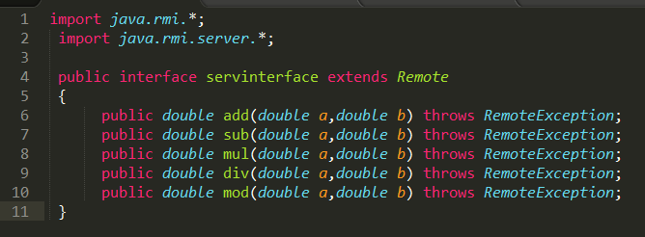

serverimpl.java

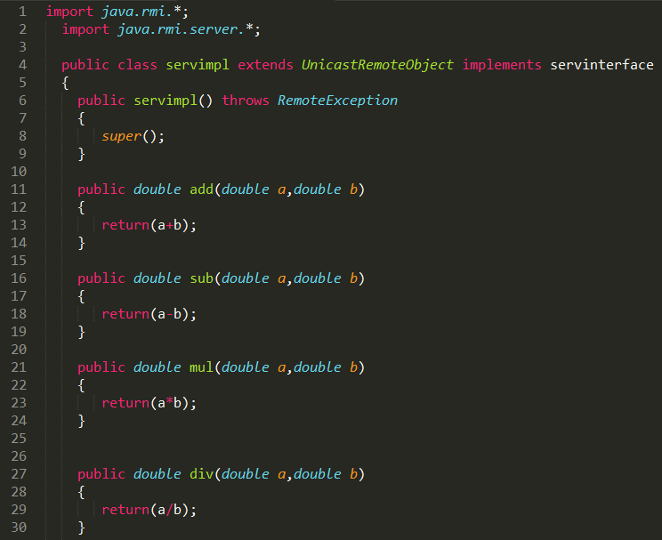

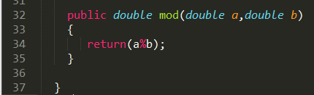

server.java

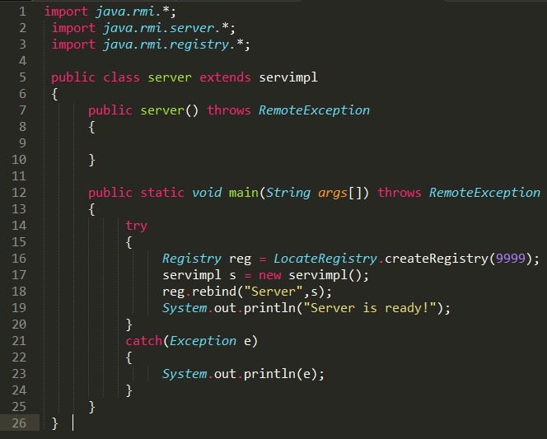

client.java

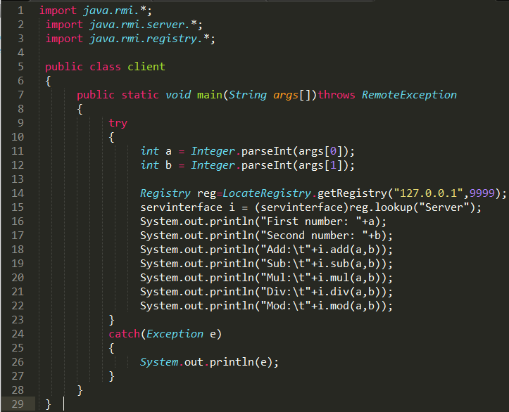





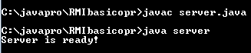

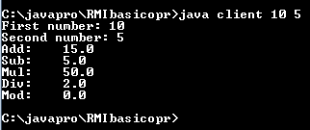

Task#02: Create RMI program in which server sorts the numbers in ascending order.

exp10_sort.java

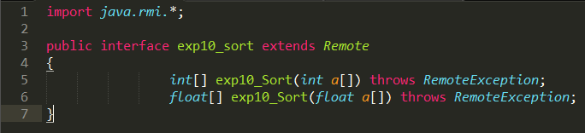

experiment10.java

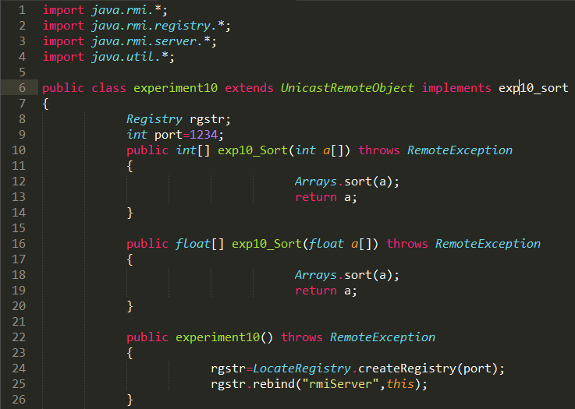

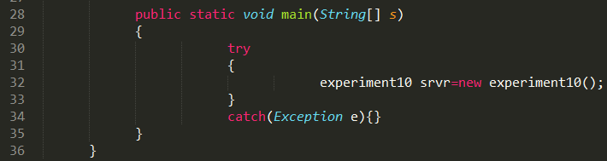

client.java

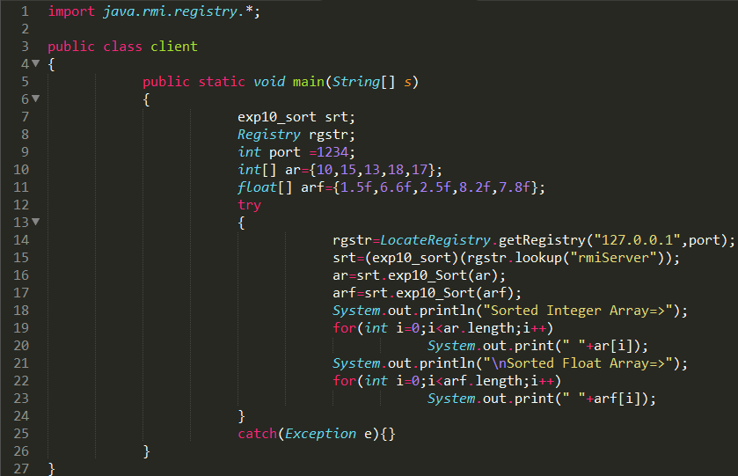

1st way

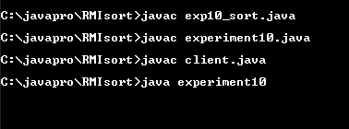

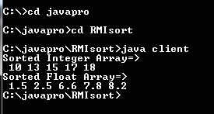

2nd way

